The Sharemarket

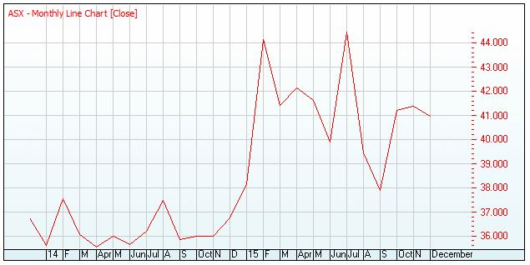

T

Date | Sep 14 | Oct 14 | Nov 14 | Dec 14 | Jan 15 | Feb 15 | Mar 15 | Apr 15 | May 15 | Jun 15 | Jul 15 | Aug 15 | Sep 15
Closing Price $ | 35.86 | 35.99 | 36.00 | 36.74 | 38.14 | 44.14 | 41.41 | 42.15 | 41.63 | 39.90 | 44.45 | 39.44 | 37.88

The above table and chart tracks the share price history for ASX 200 from September 2014 to September 2015. The share price has gone up and at other times it has also gone down.

What would your profit/loss in dollars and as a percentage be if you had bought 1000 ASX shares in September 2014 and sold them in September 2015?

