HUMAN BIOLOGY

Unit 1

2016

Name: _______________________________________________________

Teacher: ___________________________________________________

TIME ALLOWED FOR THIS PAPER

Reading time before commencing work: Ten minutes
Working time for the paper: Two hours 30 minutes.

MATERIALS REQUIRED/RECOMMENDED FOR THIS PAPER

To be provided by the supervisor:
- This Question/Answer Booklet
- Multiple Choice Answer Sheet

To be provided by the candidate:
- Standard items: Pens, pencils, eraser or correction fluid, ruler, highlighter, ruler.

- Special items: Calculators satisfying the conditions set by the Schools
Curriculum and standards authority for this subject.

IMPORTANT NOTE TO CANDIDATES

- No other items may be taken into the examination room. It is your responsibility to ensure that you do not have any unauthorised notes or other items of a non-personal nature in the examination room. If you have any unauthorised material with you, hand it to the supervisor before reading any further.

Structure of this paper

Section | Suggested working time | Number of questions available | Number of questions to be attempted | Marks | Percentage
SECTION ONE:  Multiple-choice | 40 minutes | 30 | All | 30 | 30
SECTION TWO:  Short answers | 70 minutes | 7 | All | 100 | 50
SECTION THREE:  Extended answers | 40 minutes | 3 | 2 | 40 | 20
 |  |  | Total marks | 170 | 100

Instructions to candidates

1. The rules for the conduct of Western Australian external examinations are detailed in the Year 12 Information Handbook 2016. Sitting this examination implies that you agree to abide by these rules.

2. Answer the questions according to the following instructions.

Section One: Answer all questions on the separate Multiple-choice Answer Sheet provided. For each question shade the box to indicate your answer. Use only a blue or black pen to shade the boxes. If you make a mistake, place a cross through that square, do not erase or use correction fluid, and shade your new answer. Marks will not be deducted for incorrect answers. No marks will be given if more than one answer is completed for any question.

Sections Two and Three: Write your answers in this Question/Answer Booklet.

3. You must be careful to confine your responses to the specific questions asked and to follow any instructions that are specific to a particular question.

4. Spare pages are included at the end of this booklet. They can be used for planning your responses and/or as additional space if required to continue an answer.
- Planning: If you use the spare pages for planning, indicate this clearly at the top of the page.
- Continuing an answer: If you need to use the space to continue an answer, indicate in the original answer space where the answer is continued, i.e. give the page number. Fill in the number of the question(s) that you are continuing to answer at the top of the page.

Section One: Multiple-choice 30% (30 Marks)

This section has 30 questions. Answer all questions on the separate Multiple-choice Answer Sheet provided. For each question shade the box to indicate your answer. Use only a blue or black pen to shade the boxes. If you make a mistake, place a cross through that square, do not erase or use correction fluid, and shade your new answer. Marks will not be deducted for incorrect answers. No marks will be given if more than one answer is completed for any question.

Suggested working time: 40 minutes.

- In an experiment, measurements are made and the results are recorded in a table. Sometimes there are numbers that are well beyond the range of the rest of the measurements. Such numbers are referred to as

(a) trials.
(b) outliers.
(c) mean averages.
(d) mode averages.

- A person weighing 115 kg lost 4 kg in a month. What was the percentage decrease of their weight?

- 7.2%
- 115%
- 28.75%
- 3.47%

Look at the results table below and answer the question that follows.

Temperature ( ̊C) | Enzyme Activity (mg of maltose produced)
10 | 4
15 | 7.5
20 | 11
25 | 14
30 | 17
35 | 19
37 | 23
40 | 22
45 | 18

- What type of data is shown and which graph would best represent this data?

- Discontinuous and bar graph
- Discontinuous and line graph
- Continuous and line graph
- Continuous and bar graph

- The cell theory could best be described as

- all living organisms are made up of cells and materials produced by cells.
- all living organisms are made up of cells and progressively become more complex.
- the structure of all living organisms and the way they function result from the activity of all its cells.
- all living organisms cells are small so they can exchange materials effectively.

- In which order would cellular wastes flow, to reach the plasma?

- Intercellular fluid Intracellular fluid Extracellular fluid
- Intracellular fluid Intercellular fluid Extracellular fluid
- Extracellular fluid Intracellular fluid Intercellular fluid
- Extracellular fluid Intercellular fluid Intracellular fluid

- When body systems work together to make sure the cellular environment is kept constant, this is known as

- cellular respiration.
- endocytosis.
- homeostasis.
- pinocytosis.

- The two types of carrier-mediated transport are

- diffusion and osmosis.
- diffusion and endocytosis.
- facilitated diffusion and active transport.
- facilitated diffusion and osmosis.

- Phagocytosis is best represented as which of the following transfer mechanisms?

- Active transport
- Exocytosis
- Pinocytosis
- Endocytosis

- Which of the following lists best shows the levels of structural organisation of the human body?

- Atoms, Molecules, Tissues, Organs
- Cells, Tissues, Organs, Systems
- Molecules, Atoms, Cells, Tissues
- Molecules, Tissues, Organs, Systems

- Which of the following lists best describe the smallest parts of a carbohydrate and a lipid, respectively?

- Monosaccharides and Triglycerides and fatty acids.
- Monosaccharides and Triglycerides and nucleic acids
- Saccharides and Triglycerides and fatty acids.
- Polysaccharides and amino acids.
Use the diagram below of a nephron and its associated blood supply to answer the following TWO questions.
A
B
C

D
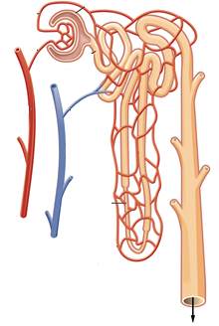

E

F

- The proximal convoluted tubule is indicated by label

- A.
- B.
- C.
- D.

- Glomerular filtration would involve structure(s) labeled

- A.
- A and B.
- D.
- D and E.

- Which of the following chemical equations shows the process of deamination?

- Ammonia + carbon dioxide + energy urea + water
- Oxygen + carbohydrate energy + water + carbon dioxide
- Oxygen + lipid carbohydrate + ammonia
- Amino acid + oxygen carbohydrate + ammonia

- A student used a 10X ocular lens and a 40X objective lens to view a sample of tissue. A field of view of 300μm was measured. When the objective lens was changed to 10X, what would be the new field of view?

- 1.2 mm
- 7.5 mm
- 120 μm
- 75 μm

- The white blood cell, red blood cell and platelet, could also be described as:

- Erythrocyte, leucocyte and thrombocyte.
- Thrombocyte, leucocyte and erythrocyte.
- Leucocyte, thrombocyte and erythrocyte.
- Leucocyte, erythrocyte and thrombocyte.

- Carbon dioxide is carried in a number of ways in the blood. Which of the following methods carries the most in the blood?

- The carbon dioxide is dissolved in the plasma.
- The carbon dioxide binds to haemoglobin to form carbaminohaemoglobin.
- The carbon dioxide is carried in the plasma as bicarbonate ions.
- The carbon dioxide is carried in the plasma as hydrogen ions.

- The cardiac cycle is the sequence of events that occurs in one complete beat of the heart. Which of the following phases occurs after atrial systole?

- ventricular systole
- ventricular diastole
- atrial diastole
- ventricular systole and atrial diastole

- Which of the lists BEST describe the sequential order of vessels that blood would flow through?

- Capillary, venule, artery
- Aorta, capillary, vein
- Capillary, vein, vena cava
- Arteriole, capillary, venule

- A blood sample was mixed with plasma that contained Anti-A and, in a separate test, with plasma containing Anti-B. The blood sample coagulated in the presence of the Anti–A but NOT in the presence of the Anti-B.

The blood sample could be classified into which of the following blood groups?

- blood type B
- blood type A
- blood type O
- blood type AB

- Which of the following is NOT a problem associated with the respiratory system?

- asthma
- bronchitis
- pneumonia
- meningitis

- Name the structure that contains vocal cords:

- pharynx
- larynx
- epiglottis
- adenoids

- Which of the following respiratory disorders is NOT contagious?

- influenza
- pneumonia
- emphysema
- tuberculosis

- The gall bladder stores which chemical and releases it into which organ respectively?

- gastric juice and duodenum
- bile and stomach
- gastric protease and duodenum
- bile and duodenum

- The removal of metabolic wastes from the body is best described as

- elimination.
- defecation.
- asphyxiation.
- excretion.

- People with coeliac disease are unable to tolerate a protein called gluten. The only treatment is to follow a gluten-free diet. Which of the following foods should a person with coeliac disease avoid?

- dairy products
- wheat based products
- rice based products
- carbohydrates

- Which of the following properties all allow muscles to work together to create movement?

- Contractibility, extensibility and elasticity
- Contractibility, extensibility, elasticity and tension
- Contractibility and extensibility
- Contractibility and elasticity

27. The axial skeleton includes the

- clavicle.
- pelvis.
- humerus.
- coccyx.

- When a muscle is at rest, it is not completely relaxed but is in a state of partial
contraction. This is referred to as

- flexion.
- muscle fatigue.
- muscle tone.
- muscle protraction.

29. Sutures are a type of:

- synovial joints.
- immovable joints.
- pivot joints.
- gliding joints.

30. Which one of the following refers to the membrane which tightly encloses vertebrate
bones, to which muscles and tendons are attached?

- sarcolemma
- periosteum
- peristome
- peridermis

End of Section One

Section Two: Short answer 50% (100 Marks)

This section has seven (7) questions. Answer all questions. Write your answers in the spaces provided.

Spare pages are included at the end of this booklet. They can be used for planning your responses and/or as additional space if required to continue an answer.
  - Planning: If you use the spare pages for planning, indicate this clearly at the top of the page.
  - Continuing an answer: If you need to use the space to continue an answer, indicate in the original answer space where the answer is continued, i.e. give the page number. Fill in the number of the question(s) that you are continuing to answer at the top of the page.

Suggested working time: 70 minutes.

Question 31 (13 marks)

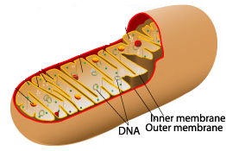

Identify the organelle above. ____________________________________ (1 mark)

Skeletal muscle cells contain many of these organelles. Explain why this is the case.

____________________________________________________________________________________________________________________________________________________________________________________________________________________________________________________________________________________
(3 marks)

- Using either a word or chemical equation, describe the chemical reaction that would occur within the organelle above and explain how this can result in the formation of ATP.
________________________________________________________________________________________________________________________________________________________________________________________________________________________________________________________________________________________
(2 marks)
The following hypothetical cells are cuboidal in shape, with the length, breadth and heights as indicated.

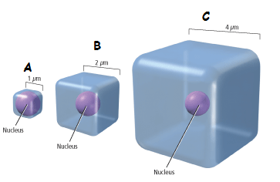

- Which of the cells in the diagram above (A, B or C) would have the smallest surface area to volume ratio?

______________________________________________________________________
(1 mark)

- Which of the cells in the diagram above (A, B or C) would supply its organelles with the substances they require most efficiently? Explain your reasoning.

________________________________________________________________________________________________________________________________________________________________________________________________________________________________________________________________________________________
______________________________________________________________________
(4 marks)

- Name two (2) inputs and two (2) outputs of typical animal cells.

Inputs ______________________________________________________________

Outputs ____________________________________________________________
(2 marks)

Question 32 (15 marks)
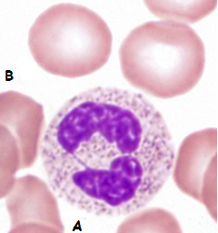

- Looking at the picture above, state which of the four main tissue types is being shown.

__________________________________________________________________
(1 mark)

- Provide a reason for your answer in part (a).

__________________________________________________________________
__________________________________________________________________
(1 mark)
- Identify each of these cells and state their basic function.
- ___________________
Function: __________________________________________________________
- ___________________
Function: __________________________________________________________
(4 marks)
- Describe three (3) reasons why the cells labeled with a “B” in the picture above are well suited to their function.
__________________________________________________________________ __________________________________________________________________
__________________________________________________________________ __________________________________________________________________
__________________________________________________________________ __________________________________________________________________ __________________________________________________________________
(6 marks)
- With reference to the lymphatic system, explain why exercising can reduce the chances of you getting a bacterial infection.
(3 marks)
________________________________________________________________________________________________________________________________________________________________________________________________________________________________________________________________________________________________________________________________________________________________________________________________________________________

Question 33 (13 marks)
The diagram shown below is a representation of the human digestive system.

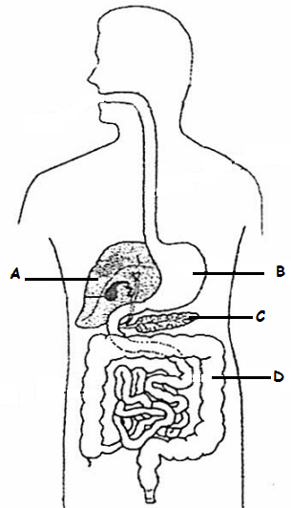

(a) State one (1) function for each of the parts listed in the above diagram. (4 marks)
A: _______________________________________________________________
B:
C: ________________________________________________________________
D: ________________________________________________________________

The diagrams below show structures found in the small intestine and lungs.

Structural Feature 1 Structural Feature 2
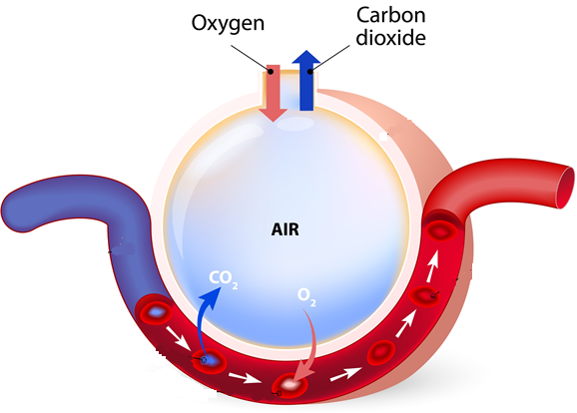
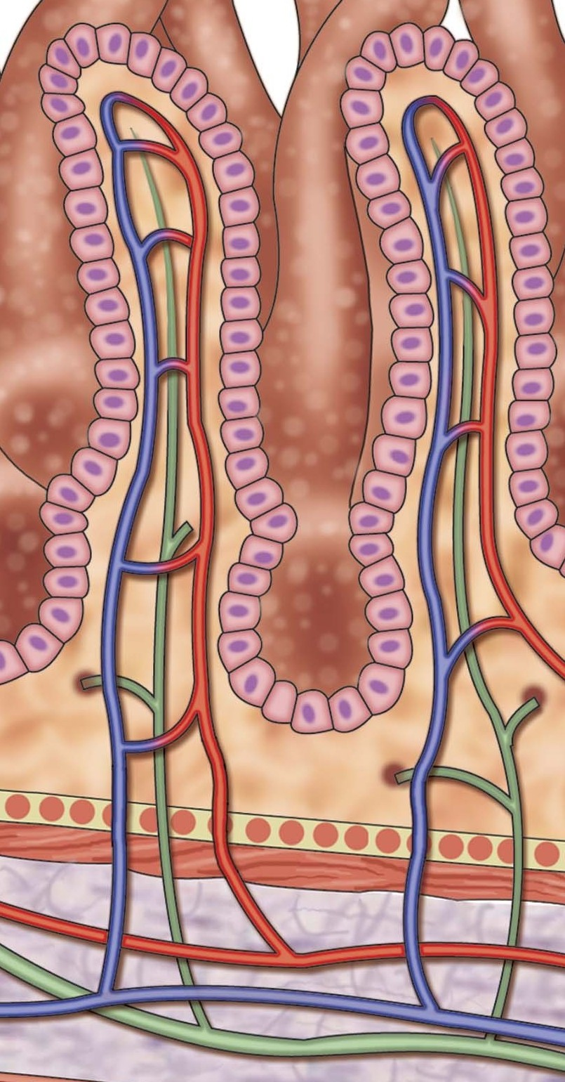
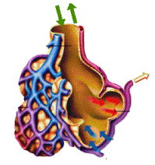
The exchange surfaces of the small intestine and lungs rely on concentration differences so that substances can cross the surfaces rapidly and constantly.
(b) Identify structural features 1 and 2 and describe four (4) similarities that allow them to
maintain the concentration gradient.
(6 marks)

Question 34
Cartilage is a connective tissue, just like bone. Name the three (3) different types of cartilage and describe the features of each.

Question 34 (15 marks)

This question refers to the diagram shown below.
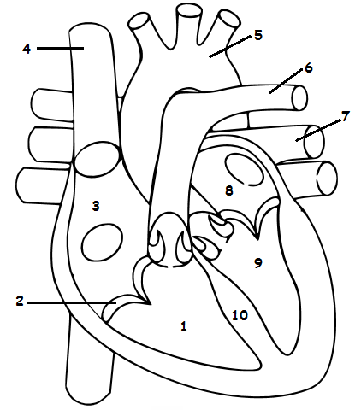

- Identify the above labeled structures:

1.
2.
7.
8.
10.
(5 marks)

- What are the functions of structures 2, 5 and 6?

2. ___________________________________________________________________
5. ___________________________________________________________________
6. ___________________________________________________________________
(3 marks)

- Label all the veins and arteries on the diagram above, with a “V” and an “Ar” respectively.
(2 marks)

- How does the heart muscle receive nutrients and remove metabolic wastes?
__________________________________________________________________ (2 marks)

- Arteries differ in structure and function to that of the veins.

Give two (2) structural differences and one (1) functional difference between arteries and veins.
Structural difference 1 ________________________________________________
__________________________________________________________________

Structural difference 2 ________________________________________________
__________________________________________________________________

Functional difference _________________________________________________

__________________________________________________________________

(3 marks)

Question 35 (12 marks)

Study the diagram below and answer the questions that follow.

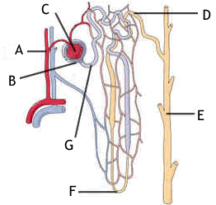

- Provide labels for structures:

A __________________________
B __________________________

E __________________________
F __________________________
(4 marks)

- Briefly explain how the afferent arteriole and efferent arteriole assist Structure C to carry out its function.
________________________________________________________________________________________________________________________________________________________________________________________________________________________
(2 marks)

Water is reabsorbed via the cells that line the whole length of the nephron. The method of transport used to absorb the water in the proximal convoluted tubule (PCT) and Loop of Henle is different to the method used in the distal convoluted tubule (DCT) and collecting duct (CD).

- State which of the four tissue types the cells that regulate water reabsorption could be classified into.
__________________________________________________________________________________________________________________________________________ (1 mark)
- Explain how water molecules move from the PCT and Loop of Henle into the blood stream.
____________________________________________________________________________________________________________________________________________________________________________________________________________________________________________________________________________________
(3 marks)
- Name and describe how most of the water moves from the DCT and CD into the bloodstream.
_______________________________________________________________________________________________________________________________________________________________________________________________________________
(2 marks)

Question 36 (20 marks)

In the 1960s a doctor working for the Red Cross in the Congo region of Africa, saw pregnant women drinking tea from the leaves of the Kalata-Kalata plant. These women believed that drinking the tea increased the speed at which they gave birth.

Scientist later discovered that a protein (named Kalata B1) in the leaf caused the contractions of the uterus in women. In an effort to help women who were overdue, scientists wanted to find out what concentration of Kalata B1 was needed to start contractions in women, who were in their 41st week of pregnancy, as soon as possible after consuming the tea.

Five different concentrations of Kalata B1were tested. Each concentration was tested on 5 different women, who were all tested in the one hospital.

The results from this experiment can be seen below.

Concentration of Kalata B1 (g/mL) | Time elapsed before contractions started (seconds)
 | Trials
 | 1 | 2 | 3 | 4 | 5 | Average
0.01 | 35 000 | 38 000 | 36 500 | 33 240 | 37 005 | 35 949
0.02 | 28 000 | 27 000 | 26 980 | 29 009 | 27 101 | 27 618
0.03 | 26 000 | 27 809 | 25 807 | 26 500 | 27 709 | 26 765
0.04 | 23 000 | 22 908 | 23 776 | 22 809 | 23 005 | 23 100
0.05 | 18 000 | 17 986 | 18 203 | 18 246 | 18 009

- Write a suitable hypothesis for this experiment. (1 mark)

_______________________________________________________________________________________________________________________________________________________________________________________________________________

- Name the:
(i) Independent variable __________________________________
(ii) Dependent variable ___________________________________ (2 marks)

- Calculate the average time elapsed for the 0.05 g/mL Kalata B1 concentration and place it in the table above. (1 mark)

- Plot the results on the graph paper supplied on the next page. (5 marks)

- Two groups should be used in any experiment. State the name of the two groups and explain how they are different to each other.
____________________________________________________________________________________________________________________________________________________________________________________________________________________________________________________________________________________
- marks)

- A placebo should have been used as this experiment was trialing a drug.
Define what a placebo is and describe how it should have been used in this experiment.
_______________________________________________________________________________________________________________________________________________________________________________________________________________
(3 marks)

- Excluding the placebo, name a controlled variable that was used in this experiment and explain why it was used.
_______________________________________________________________________________________________________________________________________________________________________________________________________________
(2 marks)

- The same factors that influence the activities of enzymes, affect proteins.

Explain two (2) reasons why scientists were amazed that the Kalata B1 protein remained active and had an effect on the women’s uterus.

_________________________________________________________________________________________________________________________________________________________________________________________________________________________________________________________________________________________________________________________________________________________
(3 marks)

Question 37 (12 marks)

The table below shows three different stages of a muscle contracting using the sliding filament model.

- Complete the table by numbering the stages in their correct order, starting with a relaxed muscle. Provide an appropriate title to indicate what is occurring during each stage. (4 marks)
Picture | Stage | Title

- Label the parts shown in the diagrams above:

A ___________________
B ___________________
C ___________________ (3 marks)
- State what occurs to parts A, B and C when the whole muscle fibre contracts.
________________________________________________________________________________________________________________________________________________________________________________________________________________________________________________________________________
(3 marks)
- Identify whether the process of muscle contraction is a passive or active process and explain your answer.
____________________________________________________________________________________________________________________________________
(2 marks)
End of Section Two
Section Three: Extended answer 20% (40 Marks)

This section contains three (3) questions. You must answer two (2) questions. Make sure you clearly indicate which question you are answering and write your answers in the space provided.

Spare pages are included at the end of this booklet. They can be used for planning your responses and/or as additional space if required to continue an answer.
  - Planning: If you use the spare pages for planning, indicate this clearly at the top of the page.
  - Continuing an answer: If you need to use more space to continue an answer, indicate in the original answer space where the answer is continued, i.e. give the page number. Write the number of the question(s) that you are continuing to answer at the top of the additional space page.

Responses could include clearly labeled diagrams with explanatory notes; lists of points with linking sentences; clearly labeled tables and graphs; and annotated flow diagrams with introductory notes.

Suggested working time: 40 minutes.

Question 38 (20 marks)

- Draw and label the structures that have a role in the movement of air into the lungs.
(5 marks)

- A common war injury is the “Sucking chest” wound. This is where shrapnel or a bullet has penetrated the victim’s sternum and pleura. A hissing sound can be heard as the person attempts to breathe. This injury can be fatal within a few minutes, as their lung(s) will collapse.

Describe the process that normally occurs to increase and decrease the volume of the chest cavity during inspiration and expiration and explain why a “Sucking chest” wound would make breathing physically impossible and cause the collapse of the affected lung.
(10 marks)

- Describe the process that can lead to the development of a “smoker’s cough” and explain how the “smoker’s cough” can lead to the sufferer developing emphysema. Explain why the sufferer needs to consciously make an effort to exhale.
(5 marks)

Question 39 (20 marks)

- Mammals have a double circulatory system. Explain what is meant by double circulation and describe how it works. What is the advantage of double circulation?
(12 marks)

- Draw a table of the ABO and Rh blood groups, showing the antigens and antibodies present in each group, to explain why an adverse reaction occurs when incompatible blood types are mixed. State why people with blood type O negative can donate their blood to anyone, whereas people with blood type AB positive can receive blood from anyone.
(8 marks)

Question 40 (20 marks)

There are six main methods in which materials are transported across cell membranes.

- Describe how four (4) of these methods occur, the type of material that is transferred and a specific example of where it occurs in the body. (6 marks)

(6 marks)

- There are 6 different types of synovial joints within the human body. State what a synovial joint is and explain the types of movement the hinge, saddle and gliding joint provide. In your answer, give an example of where each of these types of joint could be found in a human body.
(8 marks)

End of questions.

Question number: ________________
________________________________________________________________________________________________________________________________________________________________________________________________________________________________________________________________________________________________________________________________________________________________________________________________________________________________________________
________________________________________________________________________________________________________________________________________________________________________________________________________________________________________________________________________________________________________________________________________________________________________________________________________________________________________________
________________________________________________________________________________________________________________________________________________________________________________________________________________________________________________________________________________________________________________________________________________________________________________________________________________________________________________
________________________________________________________________________________________________________________________________________________________________________________________________________________________________________________________________________________________________________________________________________________________________________________________________________________________________________________
________________________________________________________________________________________________________________________________________________________________________________________________________________________________________________________________________________________________________________________________________________________________________________________________________________________________________________________________________________________________________________________________________________________________________________________________________________________________________________________________________________________________________________________________________________
Question number: ________________
________________________________________________________________________________________________________________________________________________________________________________________________________________________________________________________________________________________________________________________________________________________________________________________________________________________________________________________________________________________________________________________
________________________________________________________________________________________________________________________________________________________________________________________________________________________________________________________________________________________________________________________________________________________________________________________________________________________________________________
________________________________________________________________________________________________________________________________________________________________________________________________________________________________________________________________________________________________________________________________________________________________________________________________________________________________________________
________________________________________________________________________________________________________________________________________________________________________________________________________________________________________________________________________________________________________________________________________________________________________________________________________________________________________________
________________________________________________________________________________________________________________________________________________________________________________________________________________________________________________________________________________________________________________________________________________________________________________________________________________________________________________________________________________________________________________________________________________________________________________________________________________________________________________________________________
Question number: ________________
________________________________________________________________________________________________________________________________________________
________________________________________________________________________
________________________________________________________________________________________________________________________________________________________________________________________________________________________________________________________________________________________________________________________________________________________________________________________________________________________________________________
________________________________________________________________________________________________________________________________________________________________________________________________________________________________________________________________________________________________________________________________________________________________________________________________________________________________________________
________________________________________________________________________________________________________________________________________________________________________________________________________________________________________________________________________________________________________________________________________________________________________________________________________________________________________________
________________________________________________________________________________________________________________________________________________________________________________________________________________________________________________________________________________________________________________________________________________________________________________________________________________________________________________
________________________________________________________________________________________________________________________________________________________________________________________________________________________________________________________________________________________________________________________________________________________________________________________________________________________________________________________________________________________________________________________
Question number: ________________
________________________________________________________________________________________________________________________________________________________________________________________________________________________
________________________________________________________________________
________________________________________________________________________________________________________________________________________________________________________________________________________________________________________________________________________________________________________________________________________________________________________________________________________________________________________________
________________________________________________________________________________________________________________________________________________________________________________________________________________________________________________________________________________________________________________________________________________________________________________________________________________________________________________
________________________________________________________________________________________________________________________________________________________________________________________________________________________________________________________________________________________________________________________________________________________________________________________________________________________________________________
________________________________________________________________________________________________________________________________________________________________________________________________________________________________________________________________________________________________________________________________________________________________________________________________________________________________________________
________________________________________________________________________________________________________________________________________________________________________________________________________________________________________________________________________________________________________________________________________________________________________________________________________________________________________________
Question number: ________________
________________________________________________________________________________________________________________________________________________________________________________________________________________________________________________________________________________________________
________________________________________________________________________
________________________________________________________________________________________________________________________________________________________________________________________________________________________________________________________________________________________________________________________________________________________________________________________________________________________________________________
________________________________________________________________________________________________________________________________________________________________________________________________________________________________________________________________________________________________________________________________________________________________________________________________________________________________________________
________________________________________________________________________________________________________________________________________________________________________________________________________________________________________________________________________________________________________________________________________________________________________________________________________________________________________________
________________________________________________________________________________________________________________________________________________________________________________________________________________________________________________________________________________________________________________________________________________________________________________________________________________________________________________
________________________________________________________________________________________________________________________________________________________________________________________________________________________________________________________________________________________________________________________________________________________________________
Additional working space
Question number: ________________
________________________________________________________________________________________________________________________________________________________________________________________________________________________________________________________________________________________________________________________________________________________________________
________________________________________________________________________
________________________________________________________________________________________________________________________________________________________________________________________________________________________________________________________________________________________________________________________________________________________________________________________________________________________________________________
________________________________________________________________________________________________________________________________________________________________________________________________________________________________________________________________________________________________________________________________________________________________________________________________________________________________________________
________________________________________________________________________________________________________________________________________________________________________________________________________________________________________________________________________________________________________________________________________________________________________________________________________________________________________________
________________________________________________________________________________________________________________________________________________________________________________________________________________________________________________________________________________________________________________________________________________________________________________________________________________________________________________
________________________________________________________________________________________________________________________________________________________________________________________________________________________
Additional working space
Question number: ________________
________________________________________________________________________________________________________________________________________________________________________________________________________________________________________________________________________________________________________________________________________________________________________________________________________________________________________________________________________________________________________________________
________________________________________________________________________
________________________________________________________________________________________________________________________________________________________________________________________________________________________________________________________________________________________________________________________________________________________________________________________________________________________________________________
________________________________________________________________________________________________________________________________________________________________________________________________________________________________________________________________________________________________________________________________________________________________________________________________________________________________________________
________________________________________________________________________________________________________________________________________________________________________________________________________________________________________________________________________________________________________________________________________________________________________________________________________________________________________________
________________________________________________________________________________________________________________________________________________________________________________________________________________________________________________________________________________________________________________________________________________________________________________________________________________________________________________________________________________________________________________________
Additional working space
Question number: ________________
________________________________________________________________________________________________________________________________________________________________________________________________________________________________________________________________________________________________________________________________________________________________________________________________________________________________________________________________________________________________________________________________________________________________________________________________________________________________________________________________________________________________________________________________________________
________________________________________________________________________
________________________________________________________________________________________________________________________________________________________________________________________________________________________________________________________________________________________________________________________________________________________________________________________________________________________________________________
________________________________________________________________________________________________________________________________________________________________________________________________________________________________________________________________________________________________________________________________________________________________________________________________________________________________________________
________________________________________________________________________________________________________________________________________________________________________________________________________________________________________________________________________________________________________________________________________________________________________________________________________________________________________________
________________________________________________________________________________________________________________________________________________________________________________________________________________________________________________________________________________________________

Additional working space
Spare Grid for Question 36 (c)

References

Question 11
File:2611_Blood_Flow_in_the_Nephron.jpg. Retrieved November 17, 2015, from https://commons.wikimedia.org/wiki/File:2611_Blood_Flow_in_the_*******.jpg#filelinks

Question 31(a)
Organelle jpg. Retrieved November 17, 2015, https://adapaproject.org/bbk_temp/tiki-index.php?page=Leaf%3A+How+does+the+electron+transport+chain+provide+cells+with+energy%3F

Question 31 (d)
Cell%20Surface%20to%20volume.gif Retrieved October 24, 2015, from. http://baileyb.pbworks.com/f/1391453862/Cell%20Surface%20to%20volume.gif

Question 32
Image by Spike Walker in Wellcome Images under the Creative Commons license
CC BY-NC 3.0 AU

Question 33 (a)
55026021948267c7c5d943. Retrieved October 17, 2015, from http://www.oldschool.com.sg/modpub/55026021948267c7c5d943.

Question 33 (c)
Retrieved January 17, 2016 from
Image, used under license from Shutterstock.com

Question 33 (c)
Top picture.
Retrieved January 17, 2016 from
Image, used under license from Shutterstock.com

Question 33 (c)
Bottom picture.
Pic45.gif
http://www.mcqueens.net/mcqueen-ntl/dis/toc_/Pt20.html.

Question 34
images?q=tbn:ANd9GcSS_bhcvEHHsehEmokG61-MCNLrAleEO3I5JvYknT7U4oSlhaWcEQ
http://freecoloringpages.co.uk/?q=h****%20parts%20not%20labeled

Question 35 (a)
n_lettered.gif. Retrieved October 17, 2015, from
https://en.wikipedia.org/wiki/G*********_(k*****)

Question 37
Sliding-Filament_Theory.jpg. Retrieved January 19, 2016, from https://ehumanbiofield.wikispaces.com/musclehomeworking

