Scams Task 1

TYPE: Response
OUTCOMES: Outcome 2: Understanding ICT, Outcome 4: ICT in Society
CONTENT: Social Implications and Trends
UNIT LEARNING CONTEXT: Impacts of technology

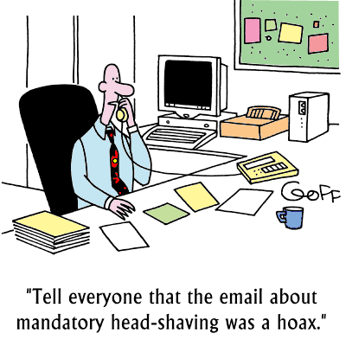TASK 1: Scams (50 marks) (10%)
We have all heard of a number of scams going around on the internet—inherited wealth, Lottery Wins and so on. Your task is to investigate what scams are going around, collect some statistics, and identify warning signs and what to do. During your task, you will collect data on the scams and store it in a spread sheet. Once you have this data, you will have to extract it to answer a number of questions in a report format.

Task Overview:
Your report will contain the following elements:
- cover page with your name, subject, task and the teacher’s name.
- headers and footers with your name, subject, task, page numbers and an automatic table of contents.
- appropriate page formatting, fonts, graphics and font sizes.
- Reference your work both in the document and in a Bibliography

The report to be handed in is to answer the following questions. These questions are to be used as headings that appear in the table of contents.
- What is a scam?
- How do they work?
- Why do they work?
- What works best?
- What are the impacts on people who fall for them?
- What are the warning signs of a scam?
- How do they get their target information?
- How can you avoid it?

From your gathered data, provide reports/graphs for the following:
- Most successful scam
- Costs of different scams
- Number of scams of different types
- Success rates of different scams.
These graphs are to be inserted into your report.

Here’s a Reference to get you started –
http://www.abs.gov.au/ausstats
http://www.hoax-slayer.com/common-internet-scams.html
http://netforbeginners.about.com/od/scamsandidentitytheft/ss/top10inetscams.htm
http://www.scamwatch.gov.au/content/index.phtml/tag/Scamwatch/
http://www.cybersmart.gov.au/
http://www.acma.gov.au/

What you are required to do

Step 1
Research the different types of scams found on the internet. Create a word processing document called initial planning and place any notes and references you need into it.

Step 2
Create a data file that stores relevant information of each type of scam to help you answer the questions. Use a spread sheet file to store your data.

Step 3
Create your report shell with a cover page, table of contents, subheadings and headers and footers as well as appendices to locate planning and draft documents.

Step 4
Review your data and answer the questions. Create graphs to answer questions and insert them into your report.

Step 5
Review your report to make sure all questions have been answered and all task requirements have been met.

Marking Guide
Task 1: Scams Total: 35 marks

Presentation  Coverpage (Task, Student Name, Teachers Name, Date)  Well organised easy to follow, broken up into logical sections  Files presented in a simple and well managed fashion  Presented in a complete and full manner  Correct use of Header and footers (page/name/unit/task)  Correct use of Styles (consistent formatting) | /1  /1  /1  /1  /1  /1
 | /6
Investigate  Defines the term scam  Outlines how different (at least three) scams work  Describes how different scams work  Outlines why different scams are effective  Explains why different scams are effective  Identifies most effective scams  Outlines impacts of scams on individuals  Discusses impact of scams on individuals and communities  Outlines warning signs of a scam  Outlines methods scammers use to gain information about their targets  Describes methods scammers use to gain information about their targets  Outlines how to avoid scams  Gives detailed advice on how to avoid scams  Gives complete and comprehensive advice on how to avoid scams | /1  /1  /1  /1  /1  /1  /1  /1  /1  /1  /1  /1  /1  /1
 | /14
Presenting Data  Provides data on:  - Most successful scam  - Costs of different scams  - Number of scams of different types  - Success rates of different scams  Produces informational graphics of a good standard on:  - Most successful scam  - Costs of different scams  - Number of scams of different types  - Success rates of different scams  Uses a consistent style to present graphical data  Uses consistent naming and labelling conventions in graphical data  Provides adequate explanation of graphical data | /1  /1  /1  /1  /1  /1  /1  /1  /1  /1  /1
 | /11
Referencing  References from a variety of sources  Referenced correctly within the document  Bibliography  Well formatted Bibliography | /1  /1  /1  /1
 | /4
 | /35

