Yr 9 Maintaining balance – Research assignment
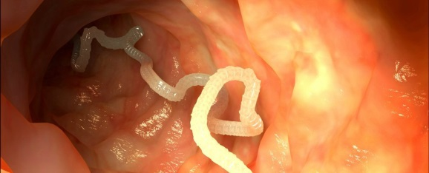
Homeostasis is the maintenance of stable internal environment. Sometimes animals and plants contract a pathogen, a disease-causing organism, or experience a deficiency or excess of a nutrient that throws homeostasis out of balance.

Research ONE of the following diseases and be sure to include the following criteria, if applicable, in your research:

- Origin of the pathogen;
- Nature of the disease; i.e. contagious/ communicable.
- How it is contracted;
- Signs and symptoms;
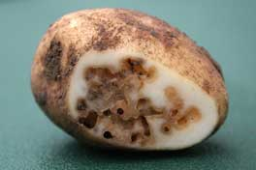
- Impact on homeostasis- how it causes homeostatic imbalance. Relate to body systems.
- Prevention and treatment;
- Bibliography.

Choose ONE from the following list.

- Intestinal worms;
- Potato blight;
- Diabetes;
- Malaria;
- Goitre
- Gout
- Tuberculosis
- Ringworm
- Dieback (root rot)
- Meningitis
- HPV
- Ergot
- Other of your choice (See your teacher first).

Due Date: Thursday August 10 2017.

Marking Key

Criteria | Marks
Origin / nature of disease | /1
Signs and symptoms | /2
How it is contracted | /1
Impact on homeostasis | /2
Prevention of treatment | /2
Bibliography | /1
Presentation | /1
Total | /10

[-1 mark] for a very brief account for every section (not enough detail)

[-1 mark] for not including all criteria

