Digestive System
LESSON OBJECTIVES:
- Describe the process of digestion
- Identify the digestive organs and explain the function of at least 2 organs
- Explain how the body is made of systems, connecting the cell to the system

Focus question: Is digestion a process of physical or chemical change?
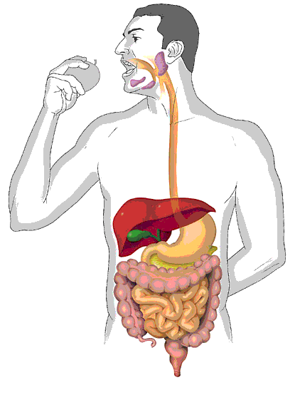

Vocabulary Digestive System
Diffusion:
The movement of molecules from high to low concentration until they are evenly distributed
Osmosis:
The movement of water through a semi-permeable membrane from high to low concentration
Metabolism:
All the physical and chemical processes in an organism that create energy and maintain growth, from digestion to cell respiration
Enzyme:
A catalyst molecule for chemical reactions
Mitochondria:
The cell organelle where respiration takes place and energy is created
Villi:
Small projections on the inside wall of the small intestine that absorb nutrients
Carbohydrate:
Foods (molecules) that contain starch and glucose
Protein:
Foods (molecules) that are made of amino acids
Lipid:
Foods (molecules) that are made of fats
Catalyst:
A substance that accelerates a chemical reaction

DIGESTIVE ORGAN FUNCTIONS
ORGAN | CHEMICAL  DIGESTION? | PHYSICAL DIGESTION? | FUNCTIONS
Mouth:
Oesophagus:
Stomach:
Pancreas:
Liver:
Gallbladder:
Small intestine:
Large intestine:
Rectum:
Anus:
