Diagram of a basic mixture: | Diagram of an element: | Diagram of molecule O2: | What type of substances make up this mixture?  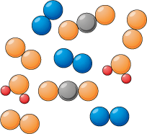 | Name and number the atoms present in this compound: CH₃COOH
Diagram of a mixture of air: | Diagram of the compound (and molecule) CO2: | Is this a mixture or a compound?  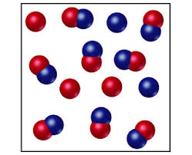 | Name and number the atoms present in this compound:  FeS | Draw a diagram of a molecule of H2:
Draw a diagram of the compound (and molecule) H20: | Name and number the atoms present in this compound:  C6H1206 | Name and number the atoms present in this compound:  NaNO3 | Classify the following as mixtures, compounds:  Milk –  Sugar –  Cup of Tea –  Soil –  Tap Water – | Draw a diagram of a lattice:

