Word Bank
Immune system
Broken-up Pathogen
Protection
Antibodies
External Barrier
Non – Specific Internal Response
B Cells (white blood cells)
Skin
Weakened Pathogen
Second Line of Defence
Fever
Memory Cells
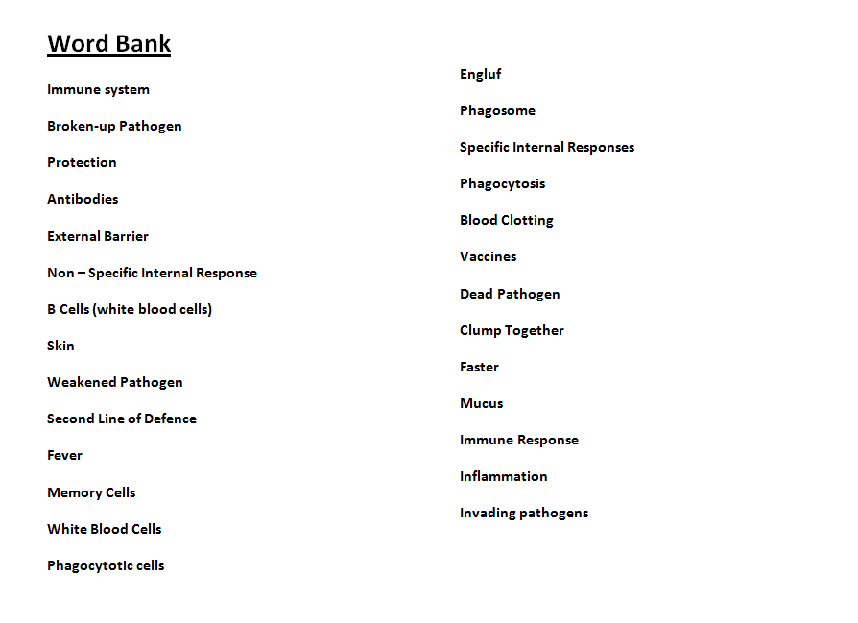
White Blood Cells
Phagocytotic cells
Engluf
Phagosome
Specific Internal Responses
Phagocytosis
Blood Clotting
Vaccines
Dead Pathogen
Clump Together
Faster
Mucus
Immune Response
Inflammation
Invading pathogens

