Non-ohmic conductors
A bulb is a non-ohmic conductor. Its voltage-current graph does not follow a straight line. Instead, it gives a curve with an increasing gradient. It shows that the resistance increases as the current increases.
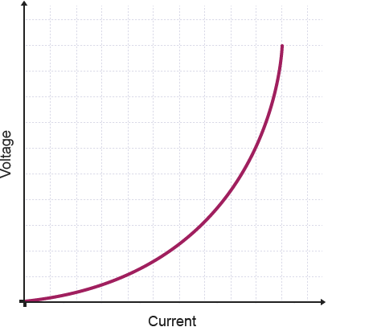
The voltage-current graph for a non-ohmic resistor is curve
As the voltage across a non-ohmic conductor such as a bulb increases, the electrons carry more energy. When they collide with metal atoms in the conductor, they transfer more energy. This makes the atoms vibrate more and more. This increases the resistance and the temperature, and causes the shape of the graph seen above.

Ohmic conductors
An ohmic conductor is a component that obeys Ohm’s law. A graph of voltage on the vertical axis against current on the horizontal axis (a voltage-current graph) gives a straight line with a positive gradient. The steeper the gradient, the higher the resistance will be.
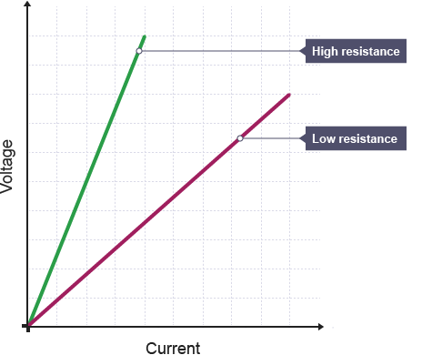
Voltage-current graphs for two ohmic resistors
The higher the resistance, the larger the voltage needed to get a given current to flow.
For example, no current flows at 0 V, but 5 A flows at 30 V:
resistance = (30 – 0) ÷ (5 – 0) = 30 ÷ 5 = 6 Ω

What causes resistance?
Metals are good conductors of electricity. The structure of metals consists of positively charged metal ions surrounded by a ‘sea’ of negatively charged electrons.
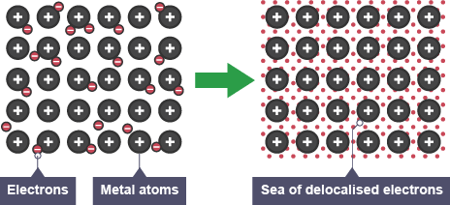
The structure of metals (heat)
The electric current in a metal conductor such as a wire is the flow of electrons through the metal. The electrons are the charge carriers in a metal. Electrical resistance is due to these charge carriers colliding with metal atoms as they flow through the metal.

Effect of temperature
In a metal, the charge carriers (the electrons) collide with metal atoms. This causes them to vibrate more, which in turn causes:
- an increase in collisions, which increases the resistance, and
- an increase in the temperature of the metal
The resistance increases as a wire gets hotter.

A good example of an Ohmic conductor is the resistor. The voltage drop across a resistor is directly correlated to the current that is flowing through it. But, this is only true when the resistor is kept within the temperature range that it is rated for. As more current flows through a resistor, it generates more and more heat. This heat, when it becomes excessive, can cause the resistor to become non-Ohmic and the resistance would also increase. Even ordinary wires are also considered as Ohmic conductors. Ordinary wires still have resistance but are often designed to be extremely low to minimize losses.
Non-Ohmic conductors do not follow Ohms law and have their own characteristics. There are a number of examples of non-Ohmic conductors; including bulb filaments and semiconductors like diodes and transistors. Let’s take the diode. A diode provides a near constant voltage drop even if you vary the current, so it does not follow Ohm’s law. The opposite happens in a light bulb filament; even as you increase the voltage significantly, it only allows a certain amount of current to pass through.
Even if non-Ohmic conductors do not follow Ohm’s law, they have their own specialized uses that aid greatly in electrical and electronic circuits. Incandescent light bulbs have been lighting our homes for more than a century and semiconductors have made a lot of things possible. Almost all electronic gadgets like phones, computers, even ordinary watches and remotes use semiconductors.

