Student worksheet answers

7.6 Each action has an equal and opposite reaction

Pages 166–167

Newton’s third law: FAB = –FBA

For each of the following four situations, describe the action and reaction forces. Remember that each force acts on a different item in the object pair.

Note: In all instances, although not stated in the answers, the reaction force is of the same size (magnitude) as the action force.

|  |  |  |  |
| --- | --- | --- | --- |
|  | Situation | Action | Reaction |
| a | A rocket taking off from its launch pad.  SW0723_01095-r | The action force is the rocket engine pushing out the hot exhaust gases. | The reaction force is the hot exhaust gases pushing the rocket upwards. |
| b | A tennis racquet hitting a tennis ball.  SW0724_01095-r | The action force is the tennis racket hitting the tennis ball. | The reaction force is the tennis ball pushing back on the tennis racket. |
| c | A sprinter pushing off from the starting blocks.  SW0725_01095-r | The action force is the sprinter’s feet pushing against the starting blocks (ground). | The reaction force is the starting blocks (ground) pushing back on the sprinter. |
| d | A footballer marking a football.  SW0726_01095-rf | The action force is the footballer’s two hands pushing against the football. | The reaction force is the football pushing back on the footballer’s two hands. |

Extend your understanding

6 A horse is pulling on a cart. If the cart exerts an equal and opposite force on the horse, how is it possible for the horse to pull the cart so that it moves? Use your understanding of Newton’s laws of motion to explain this situation.

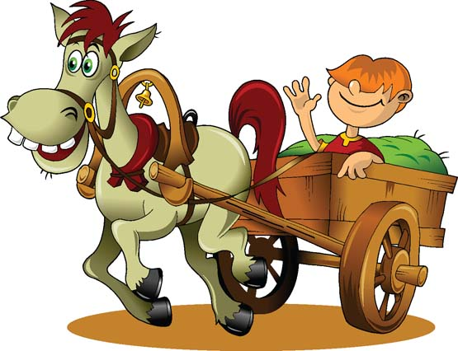

The cart does exert an equal and opposite force on the horse to that exerted by the horse on the cart. However, this action and reaction pair of forces doesn’t contribute to their motion.

Instead, you need to think about how a horse without a cart moves forwards. This is achieved in the same manner as how we are able to walk or run.

The action force is provided by the horse’s hooves pushing backwards against the ground. So, according to Newton’s third law, the reaction force will be the ground pushing the horse’s hooves, and hence the horse itself, forwards.

7 The photograph below shows a stationary gymnast hanging from a set of rings. What is the reaction force to the action of the weight force acting on the gymnast? Explain your answer.

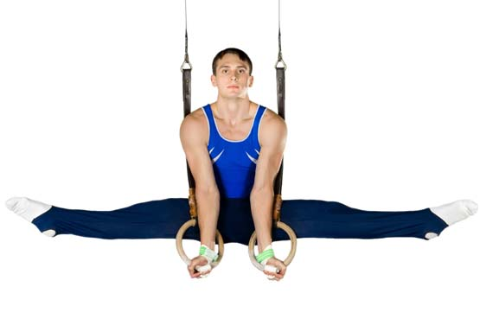

The weight force acting on the gymnast is the action force and is provided by the gravitational force that the Earth exerts on the gymnast.

So, according Newton’s third law, the reaction force must be the gravitational force that the gymnast exerts on the Earth.

Remember that both of these forces are equal in size to each other, but they act in opposite directions.