**Movie Marketing Madness: Finding Dory**

https://christhilk.com/2016/06/15/finding-dory-marketing/

|  |
| --- |
| Macintosh HD:Users:a.perrella:Desktop:Dory.jpg |

**The Posters**

**1. What does Chris Thilk think was clever about the "Four fun one-sheets" that were released?**

|  |
| --- |
|  |

**2. Thilk writes that the original theatrical one-sheet (film poster) markets the film's characters, plot and setting. How?**

|  |
| --- |
|  |

**The Trailers**

Thilke analyses the following three film trailers:

Trailer #1: *"It's a cute trailer that doesn't trade too deeply on the nostalgia we have for the first movie and effectively sets up the broad outline of the plot for this story".*

Trailer #2: *"There's not a whole lot of substance to the trailer but it's still pretty fun. It's more about selling the overall look and feel of the movie, specifically DeGeneres' performance than anything else, and on that front it performs pretty well".*

Trailer #3: *"There's... a lot of Nemo and his Dad in this trailer, almost as much as there is of Dory herself. It's clear here that the studio is selling the movie as a direct sequel to Finding Nemo, leaning hard on the audience's affection for those characters and not very much on selling it as Dory's solo adventure"*.

**3. View each trailer yourself. Which do you think "pitches" most effectively to the audience of *Finding Nemo* fans? Why?**

**Online and Social Media**

**4. List five marketing "offerings" of the official *Finding Dory* website:**

i)

ii)

iii)

iv)

v)

**5. What did the marketers include on the film's** Facebook **page and** Twitter**?**

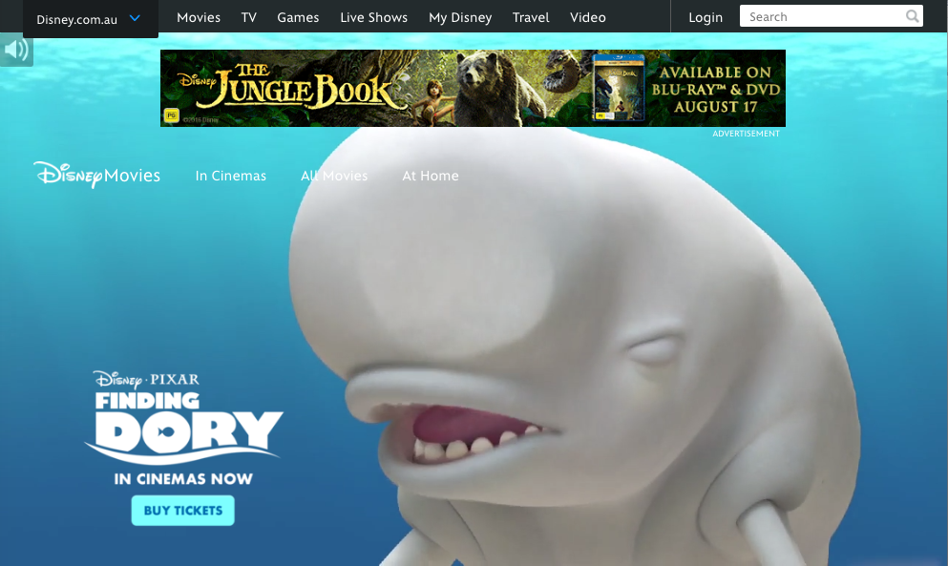

Advertising and Cross-Promotion

**6. Read through the extensive list of the film's business partners.**

**Which 3 marketing techniques do you believe are most effective in attracting an audience of children?**

i)

ii)

iii)

Media and Publicity

7. i) What was director Andrew Stanton's April Fool's Day promotion?

ii) How did Stanton promote the film at a "major press event" after the film's release?

iii) How did the marketers exploit Ellen DeGeneres' talk show host 'celebrity status'?