Immune System
What is the immune system?
The immune system helps to protect us against diseases caused by tiny invaders (called pathogens) such as viruses, bacteria, and parasites. The immune system is made up of specialized organs, cells, and tissues that all work together to destroy these invaders. Some of the main organs involved in the immune system include the spleen, lymph nodes, thymus, and bone marrow.
How does it work?
The immune system develops all kinds of cells that help to destroy disease causing microbes. Some of these cells are specifically designed for a certain kind of disease. All throughout the body, disease fighting cells are stored in the immune system waiting for the signal to go to battle.
The immune system is able to communicate throughout the entire body. When pathogens are detected, messages are sent out, warning that the body is being attacked. The immune system then directs the correct attacking cells to the problem area to destroy the invaders.
Antigens and Antibodies
Scientists call the invaders that can cause disease antigens. Antigens trigger an immune response in the body. One of the main immune responses is the production of proteins that help to fight off the antigens. These proteins are called antibodies.
How do the antibodies know which cells to attack?
In order to work properly, the immune system must know which cells are good cells and which are bad. Antibodies are designed with specific binding sites that only bind with certain antigens. They ignore "good" cells and only attack the bad ones.
You can see from the picture below that the antibodies each have a specially designed binding site. They will only bind with the antigen that has a "marker" that matches up perfectly.
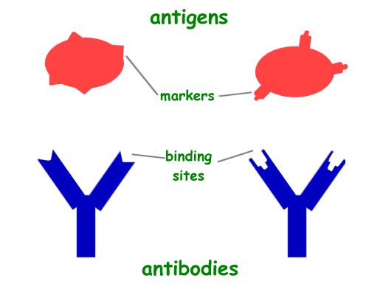
Types of Immunity Cells
The immune system has cells that perform specific functions. These cells are found in the blood stream and are called white blood cells.
- B cells - B cells are also called B lymphocytes. These cells produce antibodies that bind to antigens and neutralize them. Each B cell makes one specific type of antibody. For example, there is a specific B cell that helps to fight off the flu.
- T cells - T cells are also called T lymphocytes. These cells help to get rid of good cells that have already been infected.
- Helper T cells - Helper T cells tell B cells to start making antibodies or instruct killer T cells to attack.
- Killer T cells - Killer T cells destroy cells that have been infected by the invader.
- Memory cells - Memory cells remember antigens that have already attacked the body. They help the body to fight off any new attacks by a specific antigen.
How do we get immunity?
The immune system is very smart and can adapt to new infections. Our bodies gain immunities in two ways: natural and acquired.
- Natural - When we are born, our bodies already have some immunity. Babies get antibodies from their mother as they are growing in the womb. They may also gain some antibodies from their mother's milk.
- Acquired - Our bodies also learn immunities over time. When we get sick, our body learns how to fight off the disease. The next time that disease invades, our body is ready for it and can quickly produce antibodies to prevent infection. We can also gain immunity from vaccines.
How Vaccines Work
Vaccines introduce microbes that are already killed or modified so we don't get sick. However, the immune system doesn't know this. It builds up defenses and antibodies against the disease. When the real disease tries to attack, our body is ready and can quickly neutralize the antigens.
Interesting Facts about the Immune System
- Some immunity eventually goes away, so we need a new vaccine after a period of time.
- Different people have different levels of immunity to certain diseases. This is why some people get sick more often than others.
- Sometimes the immune system can get confused and attack good cells. Type I diabetes is caused when T cells attack insulin producing cells in the pancreas.
- T cells and B cells are stored in lymph nodes throughout the body. They enter the blood stream when they are needed to defend against disease.
- Your body responds much faster and stronger the second time it sees an antigen

