Student worksheet answers

Graphing and interpreting data

1 What are the four features that all graphs have in common?

• Descriptive title of what the graph shows

• Grid that is used to plot the points or data

• Independent variable on the horizontal axis

• Dependant variable on the vertical axis

2 What is the most common type of graph used to represent data in science?

Line graph

3 What do the following graph shapes mean in terms of the dependant and independent variables?

a Positive slope upwards

Dependant variable increases as the independent variable increases

b Horizontal line

Dependant variable is not affected by the independent variable

c Negative slope downwards

Dependant variable decreases as the independent variable decreases

4 What is the name of the relationship when the data experiences

a a positive slope upwards?

Directly proportional relationship

b a negative slope downwards?

Inversely proportional relationship

5 A student reacted two chemicals together and recorded the temperature of the reaction for 8 minutes.

|  |  |
| --- | --- |
| **Time (mins)** | **Temperature (ºc)** |
| 0 | 20 |
| 1 | 30 |
| 2 | 40 |
| 3 | 50 |
| 4 | 60 |
| 5 | 65 |
| 6 | 68 |
| 7 | 69 |
| 8 | 70 |

a Create a line graph of the set of data that was obtained.

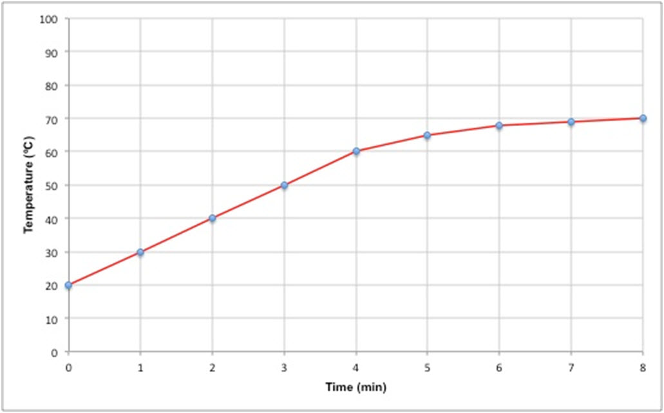

b What is the shape of the graph?

Positive slope upward, but not directly proportional as it starts to plateau

c What is the relationship between the independent variable and the dependant variable?

As time increases, temperature increases

Extend your understanding

Mathematics can often be used to determine the relationship between variables on a graph. For most graphs you can calculate the slope of the graph as .

6 A student wishes to test two methods of heating water. In the first method he uses a Bunsen burner, and in the second method he uses a hotplate.

a Graph the results of the two methods below.

|  |  |  |  |  |  |  |  |  |  |  |  |  |  |  |  |  |  |  |  |  |  |  |  |  |  |  |  |  |  |
| --- | --- | --- | --- | --- | --- | --- | --- | --- | --- | --- | --- | --- | --- | --- | --- | --- | --- | --- | --- | --- | --- | --- | --- | --- | --- | --- | --- | --- | --- |
| Bunsen burner   |  |  | | --- | --- | | **Time (min)** | **Temp (ºc)** | | 0 | 18 | | 1 | 34 | | 2 | 50 | | 3 | 66 | | 4 | 82 | | 5 | 98 | | Hotplate   |  |  | | --- | --- | | **Time (min)** | **Temp (ºc)** | | 0 | 18 | | 1 | 26 | | 2 | 34 | | 3 | 42 | | 4 | 50 | | 5 | 58 | |

b Using the graphs drawn in part a, calculate the slope of each graph.

Bunsen burner: Hotplate:

 

c Which heating method is more effective? Use your answers in part b to support your answer.