Year 10 Science – Test 1 Revision Sheet

- What is the big bang theory?

- Briefly describe the evidence that supports the Big Bang Theory.

- Explain the process that produces the tremendous amount of heat and light generated by the Sun.

- Place the letters next to the correct terms in the life cycle of a low mass star.

LOW MASS STAR

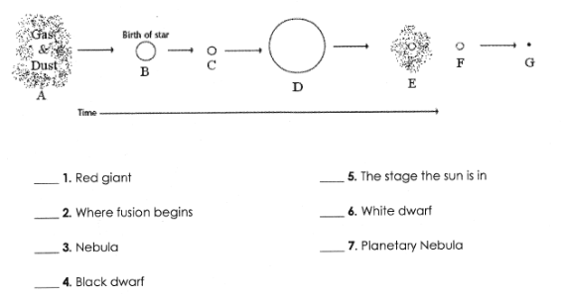

- Place the letters next to the correct terms in the life cycle of a high mass star.

HIGH MASS STAR

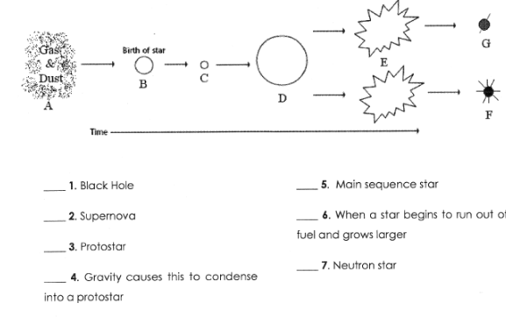

- Explain how our solar system was formed.

- How does the Sun affect our skin?

- What can we do to reduce the damage from the Sun?

- What is the ozone layer and why is it important to life on Earth?

