Year 10 Earth and Space Science Week 6
Objectives:
Effect of Ocean currents on Western Australia’s Climate and marine life.
• Describe how the warm Leeuwin Current affects distribution of tropical species at southern latitudes e.g. Rottnest,
• Describe how the warm Leeuwin Current moderate’s climate, regulating temperature and rainfall in SW WA.

El Nino La Nina
- Describe the factors that control the El Nino climate phenomena. Eg air pressure controlling strength of Trade winds, redistribution of warm surface waters decreasing rainfall in E Australia.
- Understand that la Nina is the opposite causing wetter conditions.

Climate Change.
- Recognise that climate change (CC) has occurred in the geological past. eg, ice-ages and inter-glacial

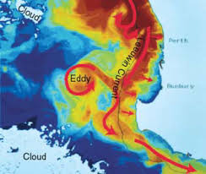
Western Australian Currents – The Leeuwin Current
The Leeuwin current is a warm oceanic current that flows in a southerly direction along the coast towards Cape Leeuwin. It can reach as far as Tasmania. The Leeuwin current is at its weakest from November to March where strong winds blow northwards, and, at its strongest in April to August when the opposing southerly winds are weak.

Leeuwin Currents effect on Tropical Species
This warm temperature of the current gives rise to coral reefs off Rottnest Island & Abrolhos Islands and the transport of tropical marine species down the west coast.

This warm water is provided by the southerly flowing Leeuwin Current, which also transports the eggs, larvae and juveniles of all kinds of oceanic life, and affects the movement and distribution patterns of many marine species.

Adults WA Salmon arrive in the south-west between Cape Leeuwin and Busselton for mating.
They spawn in late autumn and early winter when eastward flowing Leeuwin Current is strong.
This enables transport of pelagic larvae to the south-east, where they spend 3-4 years before migrating back to WA.

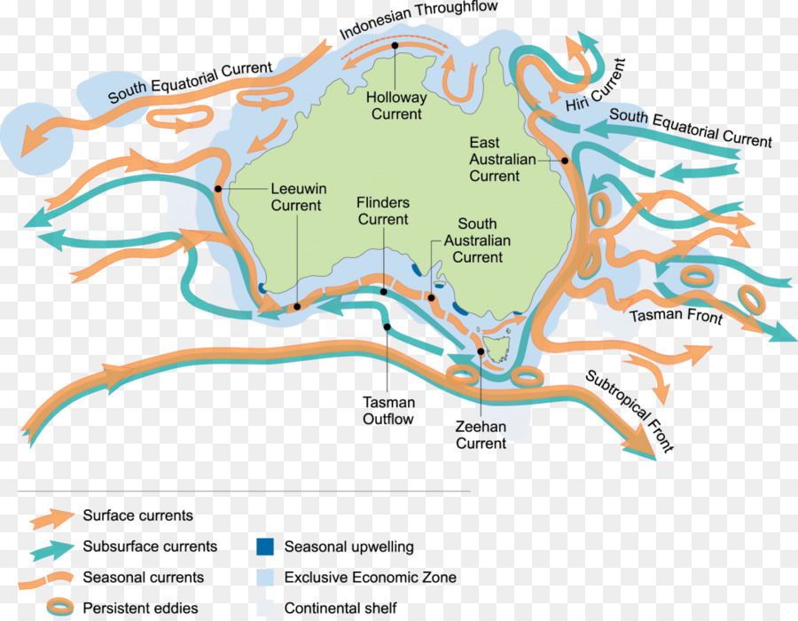
Rock lobsters are only found in temperate waters on the continental shelf off the coast, with most living between Perth and Geraldton. They take longer to mature when temperatures are cooler and shorter when temperatures are warmer. The Leeuwin current helps to carry them towards the rocky shelf where they take a new habitat and undergo several moults to become adults.

Leeuwin Currents effect on Climate in WA
Because being weak in summer and strong in autumn and winter, the Leeuwin Current contributes to Western Australia’s rainfall patterns, and winter air & ocean temperatures.

El Nino
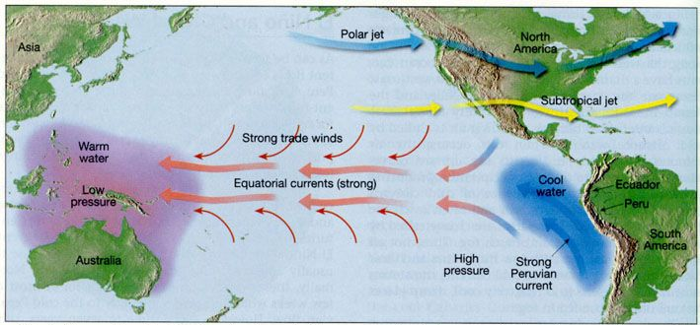
El Niño events are associated with a warming of the central and eastern tropical Pacific, while La Niña events are the reverse, with a sustained cooling of these same areas.

These ‘normal’ conditions mean that the western Pacific is 8-10ºC warmer than the eastern Pacific. Ocean surface temperature is around 28-30ºC north and northeast of Australia, whereas, surface ocean temperature near South America is around 20ºC. Easterly trade winds bring warm moist air towards the Indonesian region. Here, moist air rises over the warm seas to high altitude in the atmosphere, resulting in rainfall over Indonesia and providing a source of moisture for rainfall over Australia. This rise of warm moist air in the west is due to low surface air pressure.

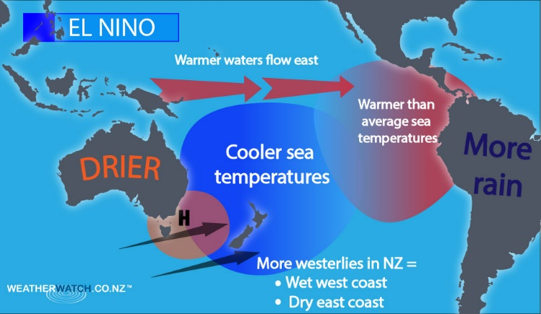
In an event of El Niño, the cold water flow in the eastern Pacific weakens, and the central and eastern Pacific may become almost as warm as the western Pacific. This is due to Westerlies moving warm waters towards the eastern Pacific and creating a low pressure zone near South America that results in rainfall, and, high pressure area over the maritime continent which produces dry conditions. Oceans around Australia cool and less moisture is fed into the region.

The effect of El Niño on rainfall in WA and NSW is variable.
While major droughts in Australia are associated with El Niño, its presence does not necessarily spell drought. El Niño also has a strong influence on temperatures over Australia. During winter/spring, daytime temperatures are warmer which serves to worsen the effect of below normal rainfall by increasing evaporation. Conversely, reduced cloudiness and rainfall mean temperatures at night fall rapidly leading to severe frost. In 1994 El Niño event, temperature at Charlotte Pass on June 29 was recorded to be –23ºC.

La Nina
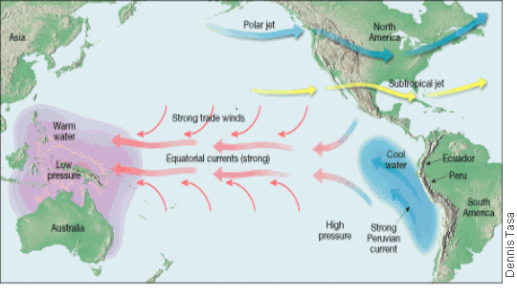
La Niña event takes place when the eastern Pacific Ocean is much cooler than normal and the SOI is positive. The easterlies trade winds are stronger than usual. This usually brings widespread rain and flooding to Australia.

Recent La Niña events include 1973-4 (Brisbane flood of the century); 1988-9 (rainfall in vast areas of inland Australia); 1998-2000 (rainfall over most northern and eastern Australia; 2nd wettest year on record). During La Niña phase, temperature tend to be below normal with cooling being strongest between October to March, affecting northern and eastern Australia.
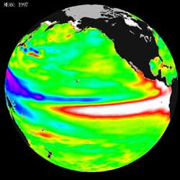

Climate Change
Is a change in the average weather conditions or in the time variation of weather over a period of 30 years or more.It is caused by factors such as:
- Biotic processes;
- Volcanic eruptions;
- Variations in solar radiation received by Earth;
- Plate tectonics;
Often the term ‘climate change’ is often used to refer specifically to anthropogenic climate change; although, there have been many shifts in climate over geological times before humans existed.

Biodiversity relates to the variety of life found in an area. This includes the different plants, animals and microorganisms, their genes and the ecosystems of which they are a part. The number and variety of species is a simple measure of its “health”, its ability to respond to change at a natural rate. Mass extinctions require over 50% of species to become extinct. There have been five mass extinctions and many minor extinction events.

Major changes in planetary biodiversity Not all major changes to the range of species present on Earth are only directly attributable to climatic changes. It is thought that the amazing 550 million year old soft-bodied Ediacaran fossils found in South Australia were only preserved in sea floor sands because predators had not yet evolved. When traces of worms and other burrowing scavengers appear in the rocks above, all these species became extinct. The new species that appeared in the overlying layers of rock may contain the ultimate ancestor of animal life, as we know it. Major climate changes, usually tied to tectonic events have massively impacted on biodiversity.

Desertification and extinction events
Massive belts of red desert sandstone crossing many tectonic plates infer large continents and extremely hot climate extending over geologically long periods. This dune sandstone is from Permian times (220mya) when the climate slowly became very hot and dry resulting in the largest mass extinction on Earth. During the “Great Dying” 6% of all marine species, 70% of all terrestrial species, 57% of all families and 80% of all genera were lost. Desertification and species loss progressed over a 30 million year period. It took more than 10 million years for life on the planet to recover and a further ten million years before coral reefs were established in the sea and forests regained the land.

Past Ice Ages and extinction events During the Permian (250 to 220my), Ordovician (450my) and Pre Cambrian (600 – 900my) glacial deposits on all continents, including those at low latitudes, suggest that ice covered most of the planet almost reaching the equator. During these “Snowball Earth” episodes life became almost extinct. Although the “Snowball Earth” period ended with the extinction of many life forms, the rapid increase of oxygen in the atmosphere afterwards resulted in “Eden Earth” when there was a massive growth of new, more complex and specialised species. The pale stripes (striae) on the gneiss from near Minginew in our Central Wheat belt are scratches from rocks trapped in ice at the bottom of glaciers during the Permian glaciation.

Ice Ages
Some factors controlling surface temperature variation: Milankovic Cycles Recently we have uncovered evidence that Earth’s surface temperature cycles between 12oC to 22oC over fairly regular 100,000-year cycles. These are named Milankovic Cycles after the Serbian scientist who first researched and described them when held as a prisoner of war during WW1. They result from: Variable solar output due to Sun activity Variable distance between Earth and Sun due to gravity variations from planets on an elliptical orbit (orbital eccentricity, axial obliquity and precession) Interplanetary dust . Comparison of ancient and recent climate change rates. Although radical changes occurred in the past and were responsible for extinctions, they occurred slowly over tens of millions of years. This is much slower than the rate of warming over the last century. We can also read the “fingerprints” of recent climate change to interpret possible cause. Increase in the Sun’s radiation would be expected to warm both upper and lower atmosphere and result in days warming more than nights. In contrast greenhouse warming would result in cooling of the stratosphere, as heat would be retained in lower levels of the atmosphere and cause nights to be warmer than days. That global climate patterns slowly change is a given. With the exception of rare severe changes, which cause global extinctions most organisms have time to respond to the changes by moving their geographic range, changing their behaviours or natural selection favours those who most suit the new conditions and their characteristics become dominant with the group.

Historic influence of man

“Whatever befalls the Earth befalls the sons of the Earth. Man does not weave the web of life; he is merely a strand in it. Whatever he does to the web, he does to himself.” (Chief Seattle, 1854)

The Pleistocene (Ice Age) represents the last cold stage from which we are recovering to enter into a warmer period. During the Pleistocene the population of modern humans in the world was reduced to about 600 breeding pairs living in tropical Africa as great glaciers covered most of the landmasses except between the tropics. We know this from genetic evidence collected during National Geographic’s human genome project. Other hominid species such as the Neanderthals and Denisovans died out at the end of the Ice Age in the Northern Hemisphere. When the ice retreated modern humans spread out to cover the great plains of the world inhabiting all of the continents except (until recently) Antarctica.

In Western Australia over the last 50,000 years there have been major changes in species diversity. The arrival of man and his fire-stick culture, along with climatic change, have resulted in a more arid period. Soft leaved trees were replaced by sclerophylls such as eucalyptus. Some scientists believe that humankind’s arrival in Australia was the critical tipping factor involved in the extinction of our mega fauna about 30,000 years ago. Europeans, who arrived about 300 years ago, introduced plants, animals and European farming practices that rapidly accelerated this loss of local plant and animal species.

Evidence for Ice Ages
Scouring of Rock faces
Rock scouring and scratching, glacial moraines, drumlins, valley cutting, and the deposition of till or tillites and glacial erratics. Successive glaciations tend to distort and erase the geological evidence, making it difficult to interpret. Furthermore, this evidence was difficult to date exactly; early theories assumed that the glacials were short compared to the long interglacial. The advent of sediment and ice cores revealed the true situation: glacials are long, interglacial short. It took some time for the current theory to be worked out.

Radiation
he chemical evidence mainly consists of variations in the ratios of isotopes in fossils present in sediments and sedimentary rocks and ocean sediment cores. For the most recent glacial periods ice cores provide climate proxies from their ice, and atmospheric samples from included bubbles of air. Because water containing heavier isotopes has a higher heat of evaporation, its proportion decreases with colder conditions. This allows a temperature record to be constructed. This evidence can be confounded, however, by other factors recorded by isotope ratios.

Fossil evidence
During a glacial period cold-adapted organisms spread into lower latitudes, and organisms that prefer warmer conditions become extinct or are squeezed into lower latitudes. This evidence is also difficult to interpret because it requires (1) sequences of sediments covering a long period of time, over a wide range of latitudes and which are easily correlated; (2) ancient organisms which survive for several million years without change and whose temperature preferences are easily diagnosed; and (3) the finding of the relevant fossils.

Distribution of species of flora and fauna
Falling sea levels during ice ages allow animals to walk between places that have since become separated by oceans

Questions:

  - What is the El Nino and La Nina Ocean current?

  - What impact does the Leeuwin Current have on Western Australia’s Climate?

  - Discuss how Two (2) species are affected by the Leeuwin Current?

  - Which four major factors influence climate change? Explain how each factor can do this.

  - Explain how Milankovic Cycles cause Ice ages.

  - How can Scientists prove that the Ice age really occurred?

