**Revision Questions – Vectors, Distance, Displacement, Speed, Velocity**

1. 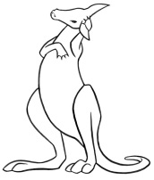Skippy the Kangaroo is off saving people again. Skippy is having a rest when he hears a call. He jumps 1.50 km north to find Sonny (in trouble again). Sonny gives Skippy a message to take to Matt. Skippy jumps 7.00 x 102 m south to find Matt where Skippy delivers the message and again saves Sonny.
2. What distance in metres did Skippy travel from when he heard the call to delivering the message? (1 mark)
3. What was Skippy’s displacement in metres? (2 marks)
4. 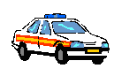j0199105Dangerous Dan has escaped from Jail. He steals a car and drives 40 km to the north, then turns and drives 30.0 km to the west where he is stopped by the police, caught and then returned to jail. **(Leave answers in kilometres.)**
5. What distance did he travel in his car before being caught? (1 mark)
6. What was his displacement in his car before being caught? (3 marks)
7. 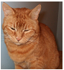My cat Fern is off hunting for the night. She firstly travels 0.200 km north, then 0.150 km east where she meets a dog. She then rapidly runs 0.100 km south (chasing the dog of cause) where she rests before travelling the shortest way home. What was her displacement from her home while she was resting? (You may leave the answer in kilometres.) (3 marks)

*Fern after her tiring night hunting*

1. j0240061You are riding your bike on the weekend. Firstly you ride at a velocity of 3.28 ms-1 East, then you speed up to travel at 6.60 ms-1 East. What was your change in velocity?

(2 marks)

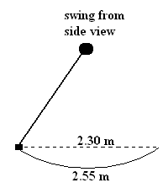

1. Veronica is on her swing. The diagram to the right shows the side view of her swing. If she swings from the back to the front in 3.80 s,
   1. What was her speed? (2 marks)
   2. What was her velocity (no direction needed)? (3 marks)
2. j0336911Captain Courageous can fly 7.00 x 102 km in 1.10 hours. What speed was he travelling

in ms-1? (2 marks)

1. j0215495Dudley Duck is skateboarding south for the winter. If he is able to skate at 30.0 kmh-1 (he is an amazing duck!), what was his displacement after 25.0 minutes? (2 marks)