**Year 10 Chemical Sciences**

**Week 1 - Atoms and Ions**

**Objectives:**

* Compare charge and mass for protons, neutrons, and electrons.
* Describe the composition of the nucleus and outer region.
* Define and show an understanding of Atomic number and Mass number.
* Use  notation to compare the composition of various atoms and isotopes.

# Compare the structure of an atom and its ion by considering the numbers of sub atomic particles and the electronic configuration using the 2,8,8 model.

# Relate electron configuration shells and valence electrons to position in the periodic table.

**Matter** is anything that takes up space and has mass and all matter is made of atoms. **Atoms** are the building blocks of matter, sort of how bricks are the building blocks of houses.

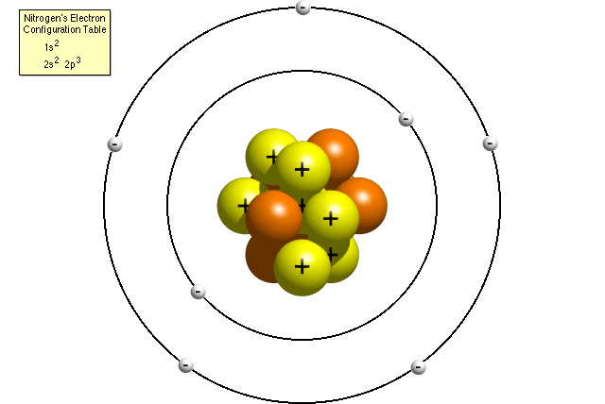

An atom has three parts:

* **Proton** = positive
* **Neutron** = no charge
* **Electron** = negative

The proton and neutron are found in the centre of the atom, a place called the **nucleus**. The **electrons** orbit the nucleus.

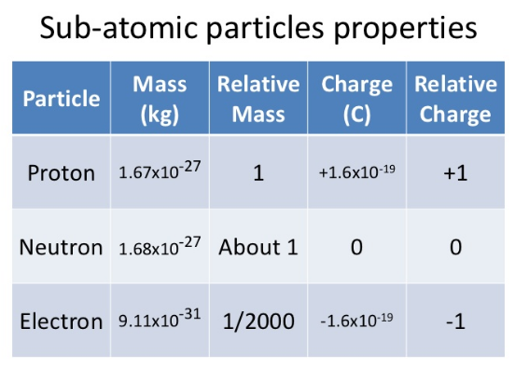

The table on the left outlines the properties of each of the particles in an atom.

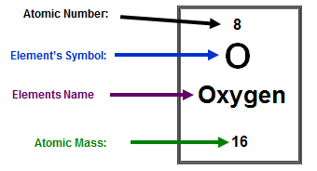**Atomic Number** is the number of protons in an element and also the number of electrons in a neutral atom of an element.

**Atomic Mass (mass number)** is the number of protons + neutrons in an isotope of an element.

These are represented on the periodic table as shown in the diagram on the right.

**[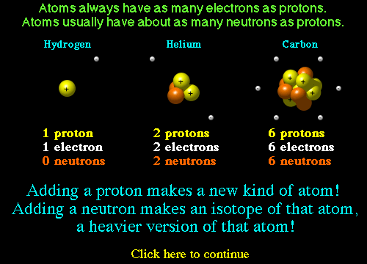](http://education.jlab.org/atomtour/fact3.html)**

**Isotopes** are atoms with the same number of protons but different number of neutrons. Different isotopes are named by their mass number as they weigh a different amount because of the different amount of neutrons they contain. Remember number of protons + neutrons = mass number.

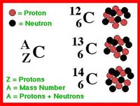

All carbons have 6 protons

C-12 has 6 neutrons

C-13 has 7 neutrons

C-14 has 8 neutrons

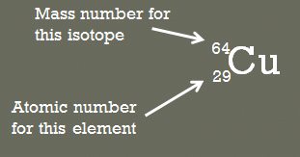Chemists often write out isotopes using a shorthand notation:



Where: A is the mass number

Z is the atomic number

X is the Element symbol

Electrons live in something called **shells or energy levels**. You can’t just shove all of the electrons in an atom into the first electron shell. Only so many can be in any certain shell as seen in the diagram below. The **electron configuration** of an atom shows the number of electrons in each shell. The electrons in the outer most shell of any element are called **valence electrons**. When an atom has an outer shell (valence shell) with **8** valence electrons then it is the most stable. That is why most atoms lose or gain electrons to form **ions** or share electrons with other atoms in order to be more stable.

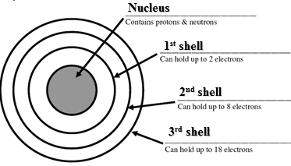

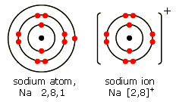For example, sodium (Na) contains 11 electrons, so a sodium atom would have an electron configuration of 2, 8, 1.

In order for sodium to be most stable it would need an electron configuration similar to the nearest noble gas. Therefore sodium loses 1 electron to have a full outer shell and becomes a positive ion in the process. The electron configuration for the sodium ion (Na+1) is therefore 2, 8

Names and Symbols of Monatomic Ions

|  |  |  |  |  |  |  |  |
| --- | --- | --- | --- | --- | --- | --- | --- |
| **1+** | | **2+** | | **3+** | | **4+** | |
| Hydrogen  lithium  sodium  potassium silver copper(I) gold(I) | H+ Li+ Na+  K+ Ag+ Cu+ Au+ | magnesium calcium barium manganese(II) iron(II) copper(II) zinc mercury(II) tin(II) lead(II)  strontium nickel(II) cobalt(II) cadmium(II) | Mg2+ Ca2+ Ba2+ Mn2+ Fe2+ Cu2+ Zn2+ Hg2+ Sn2+ Pb2+ Sr2+ Ni2+ Co2+ Cd2+ | aluminium iron(III) chromium(III)  gold(III) | Al3+ Fe3+ Cr3+ Au3+ | tin(IV) lead(IV) | Sn4+ Pb4+ |

|  |  |  |  |  |  |  |  |
| --- | --- | --- | --- | --- | --- | --- | --- |
| **1-** | | **2-** | | **3-** | |  |  |
| hydride fluoride chloride bromide iodide | H- F- CI- Br- I- | oxide  sulfide | O2- S2- | nitride | N3- |  |  |

Names and Formulae of Polyatomic Ions.

|  |  |  |  |  |  |
| --- | --- | --- | --- | --- | --- |
| **1–** | | **2–** | | **3–** | |
| hydroxide nitrate nitrite hydrogencarbonate hydrogensulfate ethanoate (acetate) permanganate cyanide *perchlorate  *chlorate  *chlorite  *hypochlorite | OH- NO3- NO2- HCO3- HSO4- CH3COO- MnO4- CN- ClO4- ClO3- ClO2- ClO- | carbonate  sulfate  sulfite  dichromate  chromate  hydrogenphosphate  oxalate  peroxide | CO32- SO42- SO32- Cr2O72- CrO42- HPO42- C2O42- O22- | phosphate | PO43- |
|  |  |  |  |  |  |
| **1+** | | **2+** | |  |  |
| ammonium | NH4+ | mercury(I) | Hg22+ |  |  |

* These names do not need to be learned.

**Week 1 Revision Questions**

1. Draw a labelled 2D sketch showing the components of a Lithium 7 atom
2. Complete the following table:

|  |  |  |  |  |  |  |
| --- | --- | --- | --- | --- | --- | --- |
| SYMBOL | NAME | ATOMIC NUMBER | MASS NUMBER | NUMBER OF PROTONS | NUMBER OF NEUTRONS | NUMBER OF ELECTRONS |
| 12  C  6 | Carbon | 6 | 12 | 6 | 6 | 6 |
| 16  O  8 |  |  | 16 |  |  | 8 |
|  | Nickel |  | 59 | 28 |  |  |
| 137  Ba  56 |  |  |  |  |  |  |
|  |  | 82 |  |  |  | 82 |
|  | Copper |  |  |  |  | 29 |
|  | Aluminium ion |  |  |  |  |  |
| 23 +  Na  11 |  |  |  |  |  |  |
|  | Sulphide ion |  |  |  |  |  |
| 14 3-  P  7 |  |  |  |  |  |  |

1. Complete the following table

|  |  |  |  |  |  |
| --- | --- | --- | --- | --- | --- |
| **Element name** | **Electron shell diagram of atom** | **Electron configuration of atom** | **Ion name** | **Electron shell diagram of ion** | **Electron configuration of ion** |
| lithium |  |  |  |  |  |
| oxygen |  |  |  |  |  |
| nitrogen |  |  |  |  |  |
| chlorine |  |  |  |  |  |
| calcium |  |  |  |  |  |
| aluminium |  |  |  |  |  |