**HUMAN DIGESTIVE SYSTEM**

A flap of skin closes the windpipe as you swallow so that food goes to your stomach, not your lungs.

Chewing **mechanically** breaks up food into smaller pieces. This exposes more food surfaces for digestion.

**TEETH**

**1**

**EPIGLOTTIS**

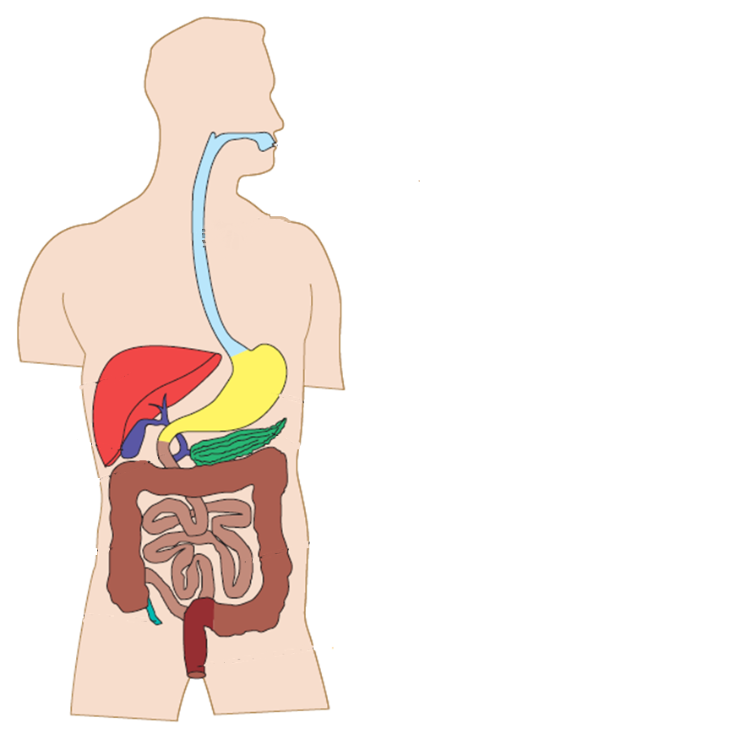

**PANCREAS**

**Not part of digestive tract**

**8**

**ANUS**

**7**

**6**

**5**

**4**

**3**

**2**

**MECHANICAL DIGESTION**

**CHEMICAL DIGESTION**

**CONSISTS OF**

**PERISTALSIS**

**PERISTALSIS**

**ABSORPTION**

**STORES**

**REABSORPTION**

**BACTERIA**

FOLDS which increase the surface area of the inner wall. Intestine is shorter (1.5m) than small intestine but a lot **wider**.

Water and vitamins are absorbed into blood stream. Consequently the contents become more solid. Mucus is secreted .for lubrication

Live In the intestine and break down remaining organic compounds. Some produce vitamins which are absorbed.

**LARGE INTESTINE**

**SECRETES**

**DUODENUM**

**Start** of Small Intestine

**RECEIVES**

**PRODUCES**

**SMALL INTESTINE**

**SECRETES**

**SECRETES**

**MUSCLES**

**LINED WITH**

No apparent digestive function in humans.

Its muscular wall continues to squeeze and churn food mixing it and breaking down further.

BILE through bile **duct** and

PANCREATIC JUICE through pancreatic **duct**.

INTESTINAL JUICE which contains enzymes which break down sugars, fats and peptides.

**BILE**: a greenish liquid which breaks up fat like a detergent does when washing dishes. Secreted into Duodenum.

**APPENDIX**

**Not part of digestive tract**

**EXPELS**

Lumps of **faeces** known as stools.

**STORES**

**RECTUM**

**GALL BLADDER**

**Not part of digestive tract**

**STOMACH**

**LIVER**

**Not part of digestive tract**

**OESOPHAGUS**

The long muscular tube carries food from mouth to stomach. The muscles contract rhythmically pushing the bolus downwards.

Glucose, Fatty acids, Glycerol & Amino acids are absorbed into blood stream. Intestine is long and **narrow** (6m in length)

VILLI which are microscopic fingers. They are well supplied with blood vessels and increase surface area of the wall.

PANCREATIC JUICE which contains enzymes which break down starch, sugars, fats and proteins.

GASTRIC JUICES which contains Hydrochloric acid, mucus **and enzymes** which break down proteins.

Waves of contraction churn food mechanically. Stores food as it is eaten and absorbs some drugs including alcohol.

Forms food into a rounded lump called a bolus and pushes it to the back of the mouth for swallowing.

**MOUTH**

**SALIVA**

Contains salivary **enzymes**, which begin starch digestion and mucus, to **lubricate** food. **Dissolved** food can be tasted.

**TONGUE**