**Yr 9 Changing Ecology – Relative and absolute dating.**

**Q1.** Determine which is the youngest layer out of the three columns and which is the oldest layer.



Oldest layer is: R7

Youngest layer is: Q1

**Q2.** What is an index fossil? How is it used?

An index fossil is a fossil that is widespread over a large area, exists for a short period of time and is abundant.

An index fossil helps correlate which strata, from more than one site over a large area, is older or younger.

Layers containing the same index fossil are considered to be of similar age. Any layer above the

index fossil is considered younger than the layer containing the index fossil; and any layer below that which contains the index fossil is considered older.

**Q3.** What is Potassium-40? How is it used to determine geologic time scale?

Potassium 40 is a radioactive isotope. It decays into Argon 40 and Calcium 40. The ***ratio*** of Argon 40 to Potassium 40 gives the time of the rock since it has formed to the nearest year. This is made possible due the constant rate of decay, which has a half-life of 1.28 billion years. Once the rock has cooled down and solidified, the trapped Argon 40 is counted as well as the Potassium 40 in the rock sample.

**Q4.** Differentiate between relative and absolute dating methods.

Absolut dating gives a precise age to the fossil or rock strata using the constant decay of a radioactive isotope.

Relative dating involves correlating which strata are older or younger than other layers using index fossils or characteristics of the layer itself.

**Q5.** Why do geologists measure only Argon 40 that is decaying from Potassium 40 given the latter also decays into Calcium 40?

Because Calcium 40 is a normal mineral that is normally found in the rock; however, Argon present in the solid rock can only exist as it decays from Potassium 40. Any Argon that is decaying while in the molten rock would have bubbled out.

**Q6.** How can you explain the absence of layer B2 from outcrop A?

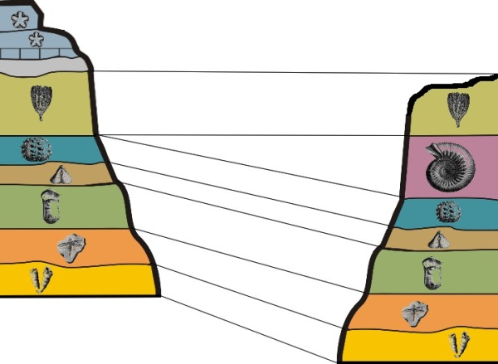

Outcrop A

Outcrop B

1

3

5

6

7

8

1

2

3

4

5

6

7

2

4

layer B 2 was eroded in Outcrop A explaining its absence. The area between A3 and A4 is known as unconformity.