**Year 10 Physical Science Week 2**

**Acceleration**

**Objectives:**

* Define acceleration as the change in velocity that occurs in a unit of time.
* Perform calculations using the relationship: 
* Realise that acceleration is caused by an unbalanced force.
* Draw/interpret a velocity-time graph
* * Extension only: Calculate displacement of an accelerating object using: 

**Acceleration** describes the rate of change of velocity. Acceleration is also a vector quantity, so direction must also be considered.

 where: a = acceleration (m s-2)

u = initial velocity (m s-1)

v = final velocity (m s-1)

t = seconds (s)

also v = u + at is an alternative formula.

When an object is undergoing **positive** acceleration it is going **faster**, when it is undergoing **negative** acceleration it is **slowing down**.

Example 1

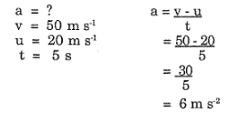

A car travelling at 20 m s-1 uniformly accelerates for 5 seconds. If its final velocity is 50 m s-1, then find its acceleration

Example 2

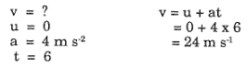A car is stopped at the traffic lights. When the lights change, the car accelerates at 4 m s-2 for 6 seconds. What is the final velocity of the car?

**Velocity-time** graphs can be used in the same ways as displacement-time graphs to summarise the motion of an object. From them we can:

* read directly from the graph
* use the gradient of the graph to find the acceleration of the object
* use the area under the graph to find the displacement of the object or the total distance travelled

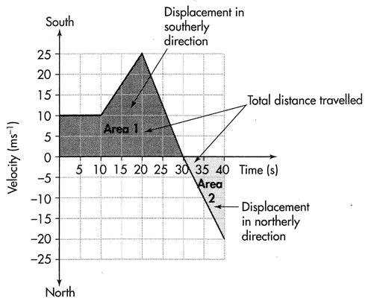Example 3

The graph tells us that:

* the object travelled at a constant velocity of

10 m s-1 for 10 s, then

* the object accelerated at 1.5 m s-2 south for the next 10 s (the gradient of the graph), increasing its speed to 25 m s-1, then
* slowed down at 2.5 m s-2 until it stopped (at time 30 s), then
* accelerated at the same rate in a northerly direction until its velocity was 20 m s-1 north.
* The object travelled 100 m in the first 10 s (the area under the graph)
* The total distance travelled by the object was 500 m (the total area under the graph = area 1 + area 2)
* The maximum displacement of the object was 400 m south (area 1)
* The total displacement of the object was 300 m (area 1 – area 2; remember it changed direction at t = 30 and started to go back towards where it started)
* The average velocity of the object was 7.5 m s-1 south (total displacement divided by total time)
* The average speed of the object was 12.5 m s-1 (total distance travelled divided by total time taken.)

Example 4

A truck uniformly accelerates from zero to 16 ms-1 in 4 seconds.

Calculating acceleration:

gradient = rise

run

= 12 - 4

3 – 1

= 4 m s-2

The ***displacement*** is the area under the line of the graph.

area = ½ base x height

area = 0.5 x 4 x 16

area = 32 m

So displacement, s = 32 m

a = v – u = 16 – 0

t 4

a = 4 ms-2

s = ut + ½ at2

s = (0 x 4) + ½ x 4x 42

s = 2 x 16

s = 32 m

Therefore:

1. acceleration can be calculated by change in velocity over time.
2. the displacement is the area under the line of the graph.
3. the slope of the graph gives acceleration.

**\*Extension only - Displacement** can also be calculated using the formula:

**s = ut + ½ at2**where: s = displacement (m)

a = acceleration (m s-2)

u = initial velocity (m s-1)

t = seconds (s)

Example 5

A car, starting from rest, reaches a velocity of 63 km h-1 in 3.5 s. If the average acceleration was 5.0 m s-2, how far did the car travel?

u = 0 s = ut + ½ at2

v = 63 kmh-1 = 0 + ½ x 5 x 3.52

= 17.5 m s-1 s = 30.6 m

a = 5.0 m s-2 s = 3.06 x 101 m

t = 3.5 s

s = ?

**Questions**

1. A rally driver is driving down a straight road at 90.0 km h-1 when she approached a bend and rapidly slowed to 12.0 ms-1 in 0.905 s. Calculate the acceleration of the car.
2. Exercise**:** Consider thefollowing graph of a remote controlled toy car and then describe the journey.

The toy car starts from rest with a positive uniform acceleration of ________________ for ______ second. It then continues at a positive constant ___________ of _______________ for _______ s. The car then uniformly accelerates at ____________________ for ________s and is now ________ m from where it started. Finally the car accelerates at __________________ for _______ s at which point it has returned to its starting point.

1. Exercise**:** Graph the following journey. A car travelling at 20 m s-1 slows to 15 m s-1 in 5 seconds. It then continues its journey for 10 seconds when it increases it velocity to 25 m s-1 in 7 seconds.

Calculate the displacement.