**Year 10 Physical Science Week 8, 9 and 10**

**Electricity and Power**

**Objectives:**

* Define current as the rate of flow of charge through a conductor; Unit = Amperes (A)
* Define voltage as the potential for the charge to flow (the source of the energy); Unit = voltage (V)
* *Define resistance for ohmic and non-ohmic components as the ratio of potential difference across the component to the current in the component. This includes applying the relationship:*

*R = V*

*I*

* Correctly use ammeters and voltmeters to determine current through and voltage across a component
* Draw/interpret Ohms Law-graph (V vs. I) and use the gradient of the slop to calculate R.
* Define power as the rate at which energy is transformed; Unit = Watts (W)
* Power enables quantitative analysis of energy transformations in the circuit. This includes applying the relationship:

*P = W = V I*

*t*

* Realise that power can be used in electrical and mechanical situations

**Current**

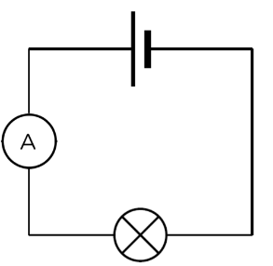

When charged particles move, they form an electric current. We can say that current is the rate of transfer of charge or the rate of flow of electrons.The unit of electric current is the ampere (A). If one coulomb of electric charge passes any one point in one second, it is said to form one ampere (A) of current.

The ammeter, as shown in the circuit diagram on the right, is drawn as a circle with the letter A inside and is always connected in series with a component. If the ammeter reads 1 Ampere, then the current (I) equals 1 Ampere at that point in the circuit.

**Voltage**

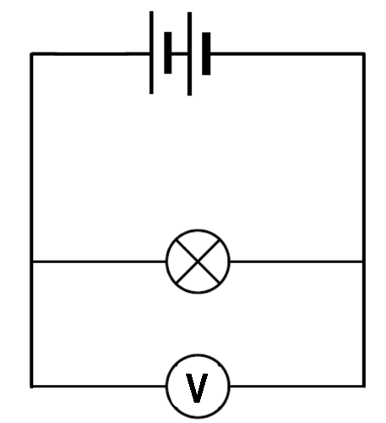

Voltage is defined as the electrical energy provided per unit of charge. The unit of voltage is the volt (V).

The voltmeter, as shown in the circuit diagram on the right, is drawn as a circle with the letter V inside and is always connected in parallel with the component. The voltmeter is said to be connected across the component, where the word "across" means "in parallel with".

A reading of 1 Volt on a voltmeter in parallel with a component tells you that 1 Joule of energy is provided for each Coulomb of charge passing through the component.

**Resistance**

When current flows in a circuit, there is a hindrance to the flow that results in energy losses from the electric circuit. This hindrance is known as resistance. The bigger the resistance, the smaller the current. Materials that block or slow down the flow of electrical current are called resistors**.** The unit of resistance is the Ohm (Ω).

**Ohm’s Law**

Ohm's Law states that the current flowing in an electric circuit is directly proportional to the applied voltage and inversely proportional to the resistance of the material.

Ohm's law is explained by the following statements:

* A change in the voltage applied to a circuit will cause the current flowing in the circuit to change. If the resistance is constant, the current change will follow the pattern of the voltage change. Doubling the potential difference therefore doubles the current.
* Current varies inversely with resistance. Changing the resistance in a circuit will also cause a change in current flow. If the voltage applied to a circuit is held constant and the resistance in the circuit is increased, with more opposition to current flow in the circuit, the circuit current will decrease. On the other hand, if the resistance is decreased the amount of current flow in the circuit will be increased.

Ohm’s law can be represented by the following equation:

Where:

V = IR

* V is voltage measured in volts (V)
* I is current measured in amperes (A)
* R is resistance measured in ohms (Ω)

Example 1

How much voltage will be dropped across a 40.0 Ω resistor with a current of 2.50 A?

R = 40.0 Ω V = I R

I = 2.50 A = 2.50 x 40.0

V = ? = 100 V

Example 2

What current is drawn by a 470 Ω kettle connected to a 24.0 V power supply?

R = 470 Ω V = I R

V = 24.0 V 24.0 = I x 470

I = ? I = 24.0/470

I = 0.0511 A

= 5.11 x 10-2 A

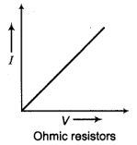**Ohmic and Non-Ohmic Components**

If the resistance of a component is constant, then the relationship between voltage and current when graphically represented, as shown in the diagram on the right, will be a straight line. The gradient of the line can be used to determine the value of the resistance. Components that obey Ohm’s law are said to be Ohmic.

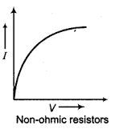

Some components do not obey Ohm’s law. In reality, in many components, an increase in current through a component will change its temperature and so the resistance will increase over time, thus decreasing current. Thin filament light globes and thermistors are examples of non-ohmic components. The graphical diagram on the right shows a typical graph for a thin filament light globe.

Example 3

Use the graph below to determine the resistance of the component graphed.



* Choose two points from the line of best fit that are not points from your data table. I’ve chosen (3,1) and (6.6, 2.2)
* Calculate the gradient.

Gradient = = = = = 0.333

* Due to the voltage being on the horizontal axis in this graph, the gradient is equivalent to current ÷ voltage which is the inverse of the resistance. In order to obtain the resistance of the component we therefore need to invert the gradient.

R = 1/gradient = 1/0.333 = 3 Ω

**Power**

Power is the rate at which energy (work) is produced or used, therefore power is equal to the work done (change in energy) divided by the time taken. The unit for power is the watt (W).

The equation for Power is:

Where:

* P is power measured in Watts (W)
* ∆E is change in energy measured in Joules (J)
* t is time measured in seconds (s)

However, since 1 Volt = 1 Joule per Coulomb and 1 Amp = 1 Coulomb per second then Watts = Volts x Amps, or Power = Voltage x Current. Therefore, a second equation for Power is:

Where:

* P is power measured in Watts (W)
* V is voltage measured in Volts (V)
* I is current measured in Amperes (A)

Using Ohm’s Law, V = IR, two other formulas for power can be derived:

P = I2R

and

*NOTE: These last two formulas will not be given to you in your data sheet.*

Example 4

A motor car’s two headlights are each rated at 50.0 W and operate on a 12.0V power supply. Calculate the:

1. current flowing in each headlight when they are in use.

P = 50 W P = V I

V = 12.0 V 50 = 12 x I

I = ? I = 50/12

I = 4.17 A

1. The total energy consumed by the two headlights during a 2.00 hour night journey.

P = 2 x 50 W P = E/t

= 100 W 100 = E/7200

t = 2.00 hours E = 100 x 7200

= 7200 s = 720000 J

= 7.20 x 105 J

**Questions:**

* 1. A light bulb has a current of 1.50 A when 240 V is applied. What is the resistance of the bulb filament?
  2. An electric bell has a resistance of 25.0 Ω and will not operate on a current of less than 250 mA. What voltage is needed?
  3. Find the current through a 20.0 Ω light bulb if the voltage is 230 V.

* 1. What is the current drawn by a 2.50 x 103 W electric kettle if is operates on a 240 V supply?
  2. If the kettle in question 4 is used for 2.80 minutes, how much electrical energy will it use?
  3. A heating appliance is rated at 2.40 kW with a current of 10.0 A. Determine the voltage across the appliance.
  4. Plot the data in the table on the graph below and draw a line of best fit.

|  |  |
| --- | --- |
| **Voltage (V)** | **Current (A)** |
| 0 | 0 |
| 0.5 | 0.6 |
| 1 | 1.1 |
| 1.5 | 1.8 |
| 2.5 | 2.5 |
| 2 | 3 |
| 3 | 3.5 |
| 3.5 | 4.2 |

* 1. Using non-table values from your line of best fit, determine the gradient of the line.
  2. Use the gradient to determine the resistance of the component.

|  |  |
| --- | --- |
|  |  |
|  |  |