**RSHS**

**HUMAN BIOLOGY**

**Unit 3**

**ANSWER KEY**

Name: _______________________________________________________

Circle Teacher: **Rafei Ferrara Panzich Johansen Williams**

***TIME ALLOWED FOR THIS PAPER***

Reading time before commencing work: Ten minutes

Working time for the paper: Three Hours

***MATERIALS REQUIRED/RECOMMENDED FOR THIS PAPER***

**To be provided by the supervisor:**

* This Question/Answer Booklet
* Multiple Choice Answer Sheet

**To be provided by the candidate:**

* Standard items: Pens, pencils, eraser or correction fluid, ruler, highlighter, ruler.
* Special items: Calculators satisfying the conditions set by the Schools

Curriculum and standards authority for this subject.

***IMPORTANT NOTE TO CANDIDATES***

* No other items may be taken into the examination room. It is **your** responsibility to ensure that you do not have any unauthorised notes or other items of a non-personal nature in the examination room. If you have any unauthorised material with you, hand it to the supervisor **before** reading any further.

***Structure of this paper***

|  |  |  |  |  |  |
| --- | --- | --- | --- | --- | --- |
| Section | Suggested working time | Number of questions available | Number of questions to be attempted | Marks | Percentage |
| SECTION ONE:  Multiple-choice | 50 minutes | 30 | All | 30 | 30 |
| SECTION TWO:  Short answers | 90 minutes | 8 | All | 100 | 50 |
| SECTION THREE:  Extended answers | 40 minutes | 3 | 2 | 40 | 20 |
|  |  |  | Total marks | 170 | 100 |

**Instructions to candidates**

1. The rules for the conduct of Western Australian external examinations are detailed in the *Year 12 Information Handbook 2018.* Sitting this examination implies that you agree to abide by these rules.

2. Answer the questions according to the following instructions.

Section One: Answer all questions on the separate Multiple-choice Answer Sheet provided. For each question shade the box to indicate your answer. Use only a blue or black pen to shade the boxes. If you make a mistake, place a cross through that square, do not erase or use correction fluid, and shade your new answer. Marks will not be deducted for incorrect answers. No marks will be given if more than one answer is completed for any question.

Sections Two and Three: Write your answers in this Question/Answer Booklet.

3. You must be careful to confine your responses to the specific questions asked and to follow any instructions that are specific to a particular question.

4. Spare pages are included at the end of this booklet. They can be used for planning your responses and/or as additional space if required to continue an answer.

* Planning: If you use the spare pages for planning, indicate this clearly at the top of the page.
* Continuing an answer: If you need to use the space to continue an answer, indicate in the original answer space where the answer is continued, i.e. give the page number. Fill in the number of the question(s) that you are continuing to answer at the top of the page.

**Multiple choice answers**

|  |  |  |  |
| --- | --- | --- | --- |
| **1** | C | **16** | D |
| **2** | D | **17** | B |
| **3** | A | **18** | A |
| **4** | B | **19** | A |
| **5** | D | **20** | B |
| **6** | B | **21** | D |
| **7** | A | **22** | C |
| **8** | D | **23** | A |
| **9** | C | **24** | C |
| **10** | B | **25** | D |
| **11** | C | **26** | C |
| **12** | D | **27** | C |
| **13** | D | **28** | D |
| **14** | B | **29** | A |
| **15** | C | **30** | B |

**Section One: Multiple-choice 30% (30 Marks)**

1. The endocrine gland that is correctly matched to the hormone it releases and its function

is:

* 1. Anterior pituitary lobe, oxytocin, contraction of uterus.
  2. Thymus, thymosins, maturation of B-lymphocytes.
  3. Pineal, melatonin, regulates sleep patterns.
  4. Thyroid, Thyroid stimulating hormone, regulates metabolism.

1. Which of the following is a homeostatic response?
   1. The release of oxytocin, which contracts the uterus, to push the foetus towards the cervix.
   2. The body fighting an infection with a fever.
   3. Platelets releasing chemicals to cause blood clotting.
   4. Walking into a shady area in an attempt to cool down.

The next two questions refer to the diagram below.

Stimulus: Rising body temperature

A

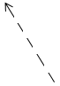

D

B

C

1. The diagram above represents a feedback cycle. In general terms, B and C refer to the
   1. modulator and effector.
   2. receptor and response.
   3. receptor and effector.
   4. modulator and response.
2. An appropriate modulator in this cycle would be
   1. Medulla oblongata
   2. Hypothalamus
   3. Pituitary gland
   4. Thyroid gland
3. The difference between white and grey matter within the brain is:
4. The white matter is on the outside away from the nerve tracts, whilst the grey matter is on the inside.
5. The grey matter contains the unmyelinated nerve fibres and the white matter contains the cell bodies.
6. The white matter contains the dendrites of neurons, the grey matter contains the nerve fibres.
7. The grey matter contains the cell bodies of neurons and the white matter contains the myelinated nerve fibres.
8. Voluntary motor nerve impulses travel from the motor cortex located in the
   1. cerebellum, to the skeletal muscles.
   2. frontal lobe of the cerebrum, to the skeletal muscles via the somatic efferent neurons.
   3. parietal lobe of the cerebrum, to the skeletal muscles via the autonomic efferent neurons.
   4. temporal lobe, to the smooth and cardiac muscles via the autonomic efferent neurons.
9. The part of the human brain that regulates hunger, thirst and sleeping patterns is the
   1. hypothalamus.
   2. cerebrum.
   3. cerebellum.
   4. medulla oblongata.
10. The pituitary gland produces and secretes all of the following hormones except for
    1. growth hormone.
    2. thyroid stimulating hormone.
    3. prolactin.
    4. antidiuretic hormone.

**Refer to the list below to answer the next question. This information shows some normal physiological changes in the human body.**

A. Dilation of pupils

B. Increased heart rate

C. Increased secretion of saliva

D. Increased secretion from sweat glands

E. Dilation of blood vessels blood vessels to the skeletal muscles

F. Decreased levels of adrenalin in blood

1. Which of the changes in the above list would result from stimulation by the sympathetic division of the autonomic nervous system?
   1. A, B, C and D
   2. A, C, D and E
   3. A, B, D and E
   4. B, D, E and F
2. An individual contracted malarial parasite after a mosquito took a blood meal from them. Which of the following methods would describe how this disease was transmitted?
   1. By contact
   2. By a vector
   3. By body fluids
   4. By ingestion
3. Which of the following is not an example of a non-specific defence?
   1. Oily sebum contains substances that kill some bacteria.
   2. The beating motion of cilia within the respiratory system.
   3. Cerumen found in stomach juice kills most bacteria that are swallowed.
   4. The vagina has acidic secretions that reduce growth of micro-organisms.
4. The cerebrospinal fluid provides protection to the central nervous system by absorbing any shock to the head. The cerebrospinal fluid is found between the
   1. cranial bones and cerebrum.
   2. outer dura mater and the inner pia mater.
   3. middle arachnoid and the outer dura mater.
   4. inner pia mater and middle arachnoid.
5. The following event and subsequent response that best describes what happens during anti-body mediated immunity, would be the
   1. T lymphocyte presents the antigen to the B lymphocyte; the B lymphocyte produces clones and memory cells.
   2. B lymphocyte is activated by an antibody; the B lymphocyte produces clones and memory cells.
   3. B lymphocyte is activated by an antigen; the B cells can become either a plasma, suppressor or memory cell.
   4. B lymphocyte is presented with an antigen; the B lymphocyte may become a clone that secretes specific antibodies.
6. Herd immunity is most easily achieved by providing
   1. natural passive immunity.
   2. artificial active immunity.
   3. artificial passive immunity.
   4. natural active immunity.
7. Which of the following is true regarding a spinal reflex?
   1. They occur under the conscious control of the cerebrum.
   2. They are only learnt through repetition.
   3. They are not spontaneous
   4. They are regulated by positive feedback.
8. Many micro-organisms produce antibiotic substances. Actinomycetes are bacteria that produce a substance that can penetrate a cell membrane and disrupt protein synthesis, stopping the unicellular organism from reproducing. This type of substance is referred to as an/a
   1. antiviral drug.
   2. narrow-entry antibiotic.
   3. bactericidal antibiotic.
   4. bacteriostatic antibiotic.
9. Aerobic respiration is a chemical reaction that produces a number of waste products which are detected by different sensory receptor to maintain homeostasis. Those receptors that would be most sensitive to these wastes would be
   1. osmoreceptors, chemoreceptors and pancreatic alpha cells.
   2. peripheral and central chemoreceptors, and osmoreceptors.
   3. thermoreceptors, osmoreceptors and pancreatic beta cells.
   4. peripheral and central chemoreceptors.

The next two questions refer to the diagram below

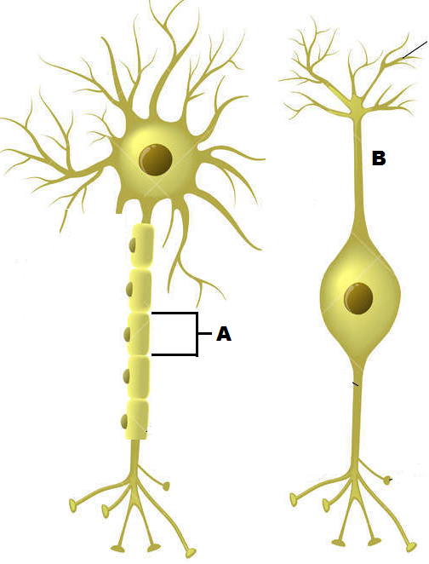

1. The cell labelled A has the following function.
   1. Forms the myelin sheath.
   2. Provides a conducting surface.
   3. Secretes neurotransmitters.
   4. Speeds up hormonal impulses.
2. The cell labelled B is a:
   1. sensory bipolar neuron.
   2. sensory multipolar neuron.
   3. motor bipolar neuron.
   4. unipolar interneuron.
3. The role of histamine is to:
4. prevent clotting.
5. make the walls of the blood capillaries more permeable.
6. decrease the blood flow to the infected area.
7. attract thrombocytes to the infected area.
8. Increasing the carbon dioxide concentration in the blood will
   1. increase the pH of the blood.
   2. incur hyperventilation.
   3. stimulate a nervous impulse through the vagus nerve.
   4. trigger a response from the chemoreceptors before a decrease in oxygen concentration.
9. Glucagon will maintain blood glucose at homeostatic levels by
   1. decreasing the production of glycogen.
   2. increasing the formation of glycogen.
   3. increasing the catabolism of glycogen.
   4. increasing the anabolism of glycogen.
10. Choose the best description of a bacteriophage
    1. A virus that reproduces within bacteria.
    2. A bacterium that is resilient to viral infections.
    3. Bacteria that are injected with a virus to produce insulin.
    4. Bacterium that have a specific rod shape and flagella.

**The following information relates to answer the next FOUR questions.**

A patient has complained of the following symptoms to their doctor:

* Feeling a lack of energy
* Unexplained weight gain
* Feeling cold, even though the surrounding temperature is around 25ᵒC

In response, the doctor had the patient’s Thyroid Stimulating Hormone (TSH) levels tested over five consecutive days. The patient’s results, measured in milli-international units per litre (mlU/L), can be seen in the table below.

|  |  |  |  |  |  |
| --- | --- | --- | --- | --- | --- |
| Day | 1 | 2 | 3 | 4 | 5 |
| TSH concentration (mlU/L) | 2.0 | 2.5 | 2.9 | 2.8 | 2.3 |

A normal range is between 0.4 and 4.0 mlU/L.

1. The mean TSH concentration in the patient’s bloodstream over the five days was
   1. 2.0
   2. 2.3
   3. 2.5
   4. 2.6
2. The range and median for the patient’s TSH level was
3. 2.0 to 2.9 with a median of 2.6
4. 2.1 to 2.9 with a median of 2.3
5. 2.0 to 2.1 with a median of 2.9
6. 2.0 to 2.9 with a median of 2.5
7. The percentage change in the patient’s TSH concentration level from the first day to the third day was a
8. 15% increase.
9. 15% decrease.
10. 45% increase.
11. 45% decrease.
12. Based on the information the patient provided, the disease the doctor was most likely checking for was
13. type 1 diabetes
14. type 2 diabetes
15. hypothyroidism
16. hyperthyroidism
17. Complete the following sentence by choosing the correct sequence of words.

*Once a hormone has produced the required effect, it needs to be broken down. This mostly occurs in the _______ and the ________. This process is known as ___________*

* 1. target cells; liver; enzyme amplification
  2. kidney; liver; negative feedback
  3. target cells; kidney; hormone clearance
  4. liver; kidney; hormone clearance

1. Choose the best description of a virus
   1. A protein coat surrounding either DNA or RNA.
   2. A protein coat with both RNA and DNA.
   3. A non-living entity that causes disease.
   4. An organism that invades and multiplies within bacteria.
2. A soccer player, having received a blow to the head, has come off the field without a bleed. He complains of having blurred vision more so in the left eye. The most likely point of contact would have been the
   1. frontal lobe
   2. occipital lobe
   3. the left-hand side of the head
   4. the right-hand side of the head

**Section Two: Short answer 50% (100 Marks)**

This section has **eight (8)** questions. Answer **all** questions. Write your answers in the spaces provided.

Spare pages are included at the end of this booklet. They can be used for planning your responses and/or as additional space if required to continue an answer.

* + Planning: If you use the spare pages for planning, indicate this clearly at the top of the page.
  + Continuing an answer: If you need to use the space to continue an answer, indicate in the original answer space where the answer is continued, i.e. give the page number. Fill in the number of the question(s) that you are continuing to answer at the top of the page.

Suggested working time: 90 minutes.

**Question 31 (12 marks)**

The diagram below shows a section of skin with a number of parts that are involved in maintaining homeostasis.

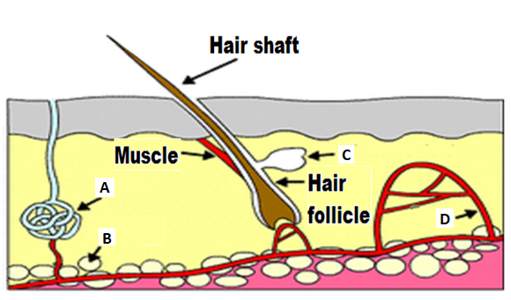

* + - 1. Identify the parts in the above diagram

A Sweat gland

B Fat/adipose cell

D Blood Capillary (3 marks)

* + - 1. There are two classifications of glands in the body. State the type of gland/s that can be seen in the diagram above and explain why they are classified into their particular group.

Both glands (sweat + sebaceous) = **exocrine** glands (1)

Exocrine = secrete into ducts that lead to the surface/opening (1)

(2 marks)

1. A marathon runner completes a race in hot weather. By the end of the race he is sweating, breathing heavily, feels thirsty and his skin is red and hot.

Complete the following table to summarise why the runner experiences the symptoms stated. The first row has been completed as an example. (7 marks)

|  |  |  |  |  |  |
| --- | --- | --- | --- | --- | --- |
| **Symptoms** | **Stimulus** | **Receptor** | **Modulator** | **Effector** | **Response** |
| Sweating | Increased body temperature | Thermoreceptor | Hypothalamus | Sweat gland | Sweat released onto surface of the skin. |
| Breathing heavily | *Increased carbon dioxide levels*  *OR high H+ ion/low pH*  *(1)* | Chemoreceptor | *Medulla Oblongata*  *(1)* | Diaphragm and intercostals | Increased rate and depth of breathing |
| Thirsty | *Increased osmotic pressure*  *(1)* | *Osmoreceptor*  *(1)* | Hypothalamus | *Cerebrum / cerebral cortex*  *(1)* | Conscious decision to have a drink |
| Red and hot skin | Increased body temperature | Thermoreceptor | Hypothalamus | *Skin blood vessels*  *(1)* | *Vasodilation*  *(1)* |

**Question 32 (17 marks)**

Scientists wanted to test the hypothesis that neurotransmitters released from a specific group of nerve cells (called the NTS) found within the medulla oblongata, increases long term memory retention in humans. The NTS are ascending tracts that link to the amygdala, which is a part of the brain responsible for emotional memories.

To investigate this theory, scientists exposed two rats to inhibitory avoidance training. To do this experiment, each rat was tested separately. They were placed into a box, facing a closed sliding door. The box was well lit with white light. Once the rat turned away from the door, the door was opened, allowing free access to a separate darker, secluded box. The moment the rat turned to face the open door, a timer was started and once the rat had completely entered the dark room, the door was closed and the time was stopped and recorded. Upon entering the dark room, a footshock (weak electrical current passed into the rat’s foot via the floor) was administered. Immediately after the footshock, the rat was removed from the dark box and given a dose of lignocaine into the NTS. Lignocaine is an anaesthetic that binds to sodium-gated channels and prevents them from opening.

Memory for the footshock training is assessed by retesting the rat from 24 to 96 hours later. In this test, the rat is placed in the well-lit box as before, the door is opened once the rat looks away and the time taken for the rat to enter the dark box where the footshock was received earlier is recorded. The time recorded is used as an indicator of the level of memory retention.

The results from the experiment can be seen below.

|  |  |  |
| --- | --- | --- |
| Time passed since rat given lignocaine  (hours) | Time passed before rat entered dark room (seconds) | |
| Rat not given lignocaine | Rat given lignocaine |
| 12 | 180 | 181 |
| 24 | 150 | 152 |
| 36 | 135 | 132 |
| 48 | 138 | 130 |
| 60 | 152 | 128 |
| 72 | 220 | 125 |
| 84 | 260 | 120 |
| 96 | 300 | 118 |

1. Identify the
   1. Independent variable: Administration of lignocaine (1)
   2. Dependent variable: Time passed before rat entered dark room (1)

(2 marks)

1. State why the scientist provided a rat with inhibitory avoidance training, but did not administer lignocaine.

* Control group (1)
* Allowed scientist to compare the response time to the rat that had their NTS blocked (1) (2 marks)

1. Plot a graph of the information contained in the table. (6 marks)

* Appropriate Title *(states that ‘Lidocaine injections used on rats compared to no injection’ (1), states measured on time taken/passed before entering dark room (1)*
* Correct plotting (1)
* Appropriate/correct scale on both axis (1)
* Correct X-axis (time passed since given injection, in hours) and Y-axis (time passed before entered dark room, in seconds). (1)
* Legend / key provided to distinguish each line (1)

1. What conclusions can be drawn from the results?

* As more time passed since the injection of lignocaine, the retention of long term memory decreased. (1) and rats that were not given an injection of lignocaine, the retention of long term memory increased. (1)

(2 marks)

1. Name the process that would have been inactivated by the lignocaine in the NTS and explain why the post-synaptic knobs in the amygdala would have not been stimulated.

* Action potential (1)
* The sodium ions remain on the outside of the cell (1) (given the lignocaine stops the sodium-gated channels from opening) and
* the potassium ions remain on the inside of the cell, (1)
* leaving the cell polarised (1)
* The polarised cell cannot stimulate the cells of the amygdala / cannot cause an action potential to occur / cannot stimulate the neurons. (1)

(5 marks)

**Question 33 (17 marks)**

Refer to the diagram below and answer the questions that follow.

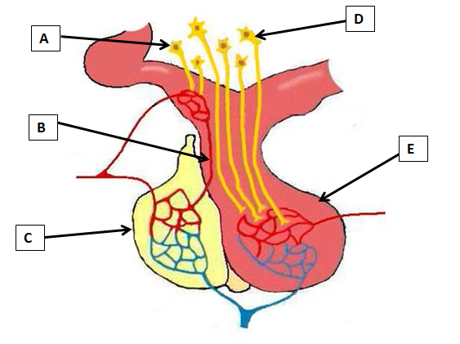

1. Identify the parts labelled (C, D and E) in the diagram above.

C Anterior lobe of pituitary gland (1)

D Long neurosecretory cells (of the Hypothalamus) (1)

E Posterior lobe of pituitary gland (1) (3 marks)

1. Explain the different methods the hypothalamus uses to stimulate parts C and E, so they can release their respective chemicals.

* ANTERIOR: The anterior lobe is stimulated to release its hormones by inhibiting and releasing factors (1) which travel via blood vessels and stimulate/inhibit hormone release from the anterior lobe (1)
* POSTERIOR: Hormones are produced in the nerve cell bodies/neurosecretory cells in the hypothalamus (1) and then they pass along the nerve fibres to the posterior lobe where they are stored and released (1)

(4 marks)

1. Using the space below, draw a sequence diagram that shows how the organs shown in the diagram above regulate the water concentration in the bloodstream.

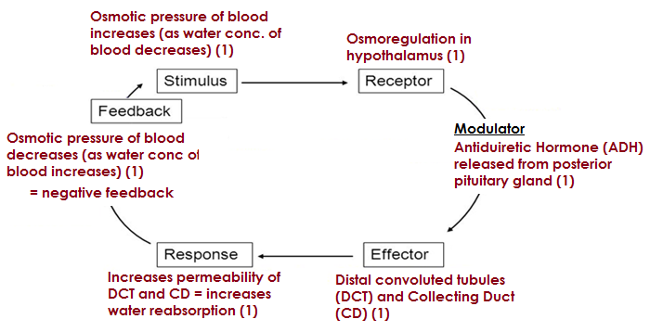

(6 marks)

1. The diagram below indicates two endocrine tissues labelled D and E. In the boxes provided for EACH tissue (D – E):
   1. Name ONE hormone secreted by that tissue
   2. State ONE principal action of that named hormone on the target tissue

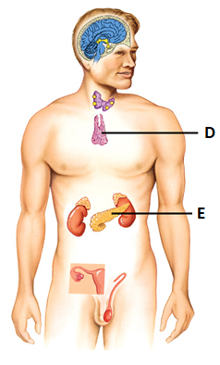

Tissue E

1. Insulin **OR** Glucagon (1 mark)
2. Insulin – Any one of following (first one taken)

Stimulates uptake of glucose by cells / glycogenesis (glucose converted to glycogen) / increases protein synthesis / converts glucose 🡪 fat/lipids

**OR**

Glucagon – Any one of the following (first one taken)

Stimulates glycogenolysis (breakdown of glycogen 🡪 glucose) / Breakdown fat/lipid 🡪 glucose (lipolysis) / Gluconeogenesis (amino acids/fats 🡪 glucose)

(1 mark)

Tissue D

1. Thymosins (1 mark)
2. Stimulates development and maturation of T lymphocytes

(1 mark)

**Question 34 (16 marks)**

Nicole is highly allergic to shellfish and if she accidentally consumes any product with shellfish in it, she can go into anaphylactic shock. Symptoms of anaphylaxis include a red and hot rash, throat or tongue swelling, difficulty breathing, vomiting and low blood pressure. In the event she does go into anaphylactic shock, she carries an EpiPen®, which can provide her with a dose of epinephrine (adrenaline) and alleviate the symptoms.

1. Name the protective reflex that occurs as a result of the anaphylactic shock and describe how it occurs.

* Vomiting (1)
* Contraction of the muscles of the abdomen and diaphragm that expels the stomach contents (1) *NB: no mark for just stating that ‘stomach contracts’.*  (2 marks)

1. State how the adrenaline would make breathing easier.

* Adrenaline dilates bronchioles to allow more air into the lungs (1)

(1 mark)

1. Adrenaline is classified as an amine hormone. Explain how this hormone acts on a cell and causes the cell to produce a particular protein.

* Attaches to receptor proteins in the cell membrane of the target cell (1)
* This causes a secondary messenger to diffuse through the cell (1) and
* Activate production of a specific protein/enzyme (1)

(3 marks)

1. An adult EpiPen® typically injects 0.3mg of adrenaline. If the device was to inject anymore, it would not have any further effect. Explain why.

* Adrenaline is dependent upon the receptor proteins in the cell membrane (1)
* There are a limited number of receptor proteins in the cell membrane(1)
* If every receptor is bound to an adrenaline molecule / if receptor saturation has been achieved, the cell’s rate of adrenaline uptake cannot increase any further (1)

(3 marks)

1. Complete the following table to distinguish between the Parasympathetic and Sympathetic divisions.

|  |  |  |
| --- | --- | --- |
|  | Parasympathetic | Sympathetic |
| Specific effect on the digestive system | *Increased activity / stimulates smooth muscle contraction (1)* | *Decreased movement (1)* |
| Specific effect on the bladder | *Contracts muscle of bladder wall / relaxes bladder sphincters (1)* | *Relaxes muscle of bladder wall / contracts bladder sphincters (1)* |

(4 marks)

**Question 35 (12 marks)**

Refer to the diagram below and answer the questions that follow.

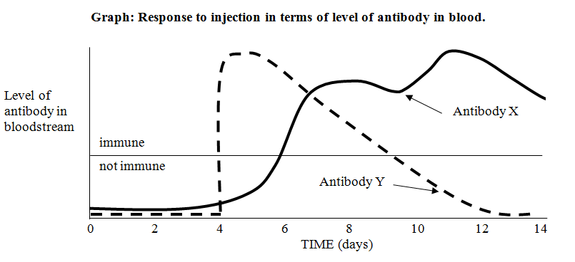

1. On what day/s were the injections given which caused the change in the level of

(i) Antibody X: Day 0-3 and again on Day 9 (1)

(ii) Antibody Y: Day 4 (1)

(2 marks)

1. Describe a situation in which a person might receive an injection such as the one which led to the change in the level of antibody Y.

For 1 mark: any relevant example that outlines a person at high risk of developing the disease and needing immediate immunity. e.g.

* Treading on a rusty nail (tetanus)
* Bite/scratch from a contaminated animal (rabies)
* A short stay in an overseas country where the disease is endemic e.g. hepatitis

(1 mark)

1. Describe three (3) ways antibodies provide protection in the body.

Any three (3) of the following (first 3x answers taken)

* Combine with foreign enzymes or bacterial toxins to inactivate them
* Bind to the surface of viruses and prevent them from entering cells
* Coat bacteria to make them easier to be consumed by phagocytes
* Agglutination, making phagocytosis easier
* Dissolves organisms
* Render soluble substances insoluble (3 marks)

1. The level of both antibodies decline after some time. Explain why they decline and why the level of antibody X declined more slowly than the level of antibody Y.

**Reason for decline:**

* Antibody levels decline due to being destroyed in process / engulfed by phagocytes / broken down after use (1)

*NB: Not accepting ‘antibodies die off’*

**Why levels decline more slowly in X than in Y:**

* Antibody X production results from an active immune response – therefore decline slower to plasma cells secreting antibodies over an extended period of time OR there has been a secondary response, where memory cells created from initial exposure continued to produce antibodies (1)
* Antibody Y level resulted from passive injection of antibody = no immune response (1)

(3 marks)

1. In order to ensure vaccines are safe to use on the general population, they are extensively trialled. Name and briefly describe one potential problem that could occur when providing a vaccine.

*Only one problem accepted (first answer taken). e.g.*

* Allergic reaction (1) = occurs due to the medium the vaccine was cultured in (1)
* Cross-species disease introduction (1) = it is impossible to completely isolate one virus from others within an animal tissue that is being used as a culture medium (1)

(2 marks)

1. When a new vaccine is first introduced, follow up studies are required to determine how long the vaccine will provide protection for. State the name given to this type of investigation.

Longitudinal study (1) (1 mark)

**Question 36 (15 marks)**

A freestyle diver is someone who swims under water without any breathing apparatus, to the deepest possible depth, before returning to the surface. In an effort to stay under water for as long as possible, they will hyperventilate. The danger of this sport, is the diver could lose consciousness and drown. This consequence is referred to as “blacking out”.

The two graphs below show the relationship between the levels of oxygen and carbon dioxide within a freestyle diver’s bloodstream. One of the graphs shows what happens to the gas levels without hyperventilating. The other shows what happens to the gas levels when the diver hyperventilates before diving. Study these two graphs and answer the questions that follow.

Graph 1

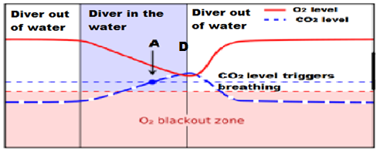

Graph 2

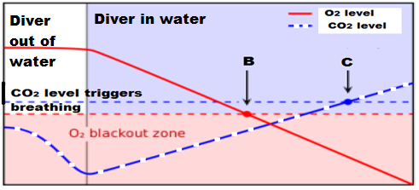

1. State which of the two graphs shows what happens to the gas levels when the diver has hyperventilated. Explain your answer.

* Graph 2 (1)
* The carbon dioxide level has been lowered before the swimmer has entered the water (1)

(2 marks)

1. Looking at the points indicated by the letters A, B and C on the graphs above, state how the diver’s body is responding and what the diver is doing

* Point A: The carbon dioxide level has built up to a point that they are being forced to take a breath, but the diver has not (1)
* Point B: The oxygen level has decreased to the point where the diver could lose consciousness, the diver is still holding their breath (1)
* Point C: The carbon dioxide level has built up to a point that they are being forced to take a breath, but they are still under water. (1)

(3 marks)

1. One of the graphs above shows where the diver has reached the surface and taken a breath. **Circle** and **clearly** label this area on the relevant graph above, using the **letter D**.

* See Graph 1 (green circle) (1 mark)

1. Hyperventilating can be brought on through physical stress. To help someone recover from hyperventilation, they can breathe into and out of a paper bag a number of times. Explain why this technique prevents someone from losing consciousness and allows them to regain control over their breathing rate.

* Paper bag allows patient to breathe in CO2 again (1)
* CO2 levels rise, which lowers pH (1)
* Lower pH stimulates peripheral chemoreceptors/aortic and carotid bodies (1)
* Medulla oblongata/inspiratory centre triggered (1)
* breathing rate increased / regulated (1) (5 marks)

1. Hyperventilation can lead to respiratory alkalosis. This disorder can bring about a decrease in potassium and calcium levels within the bloodstream, which then leads to uncontrollable muscle cramping.

Complete the following table to summarise how the endocrine system would respond to the decrease in potassium and calcium.

|  |  |  |  |  |
| --- | --- | --- | --- | --- |
| Gland | Hormone name | Hormone level raised or decreased? | Target Organ/s | Main effects |
| Parathyroid | Parathyroid hormone | Raised | Bones / kidneys | Increases level of calcium in the blood |
| (1) | | (1) | |  |
| Adrenal cortex | Aldosterone | Decreased | Kidney | Decreases removal of potassium from the blood |
| (1) | | (1) | |  |

(4 marks)

*Must have gland + correct hormone (1)*

*Must correctly identify target organ + if raised/decreased (1)*

***No ½ marks***

**Question 37 (14 marks)**

1. Complete the diagram below of a reflex arc, by drawing in and clearly labelling the appropriate neuron(s) in the space below. The neuron leading to the effector has already been drawn for you.

(3 marks)

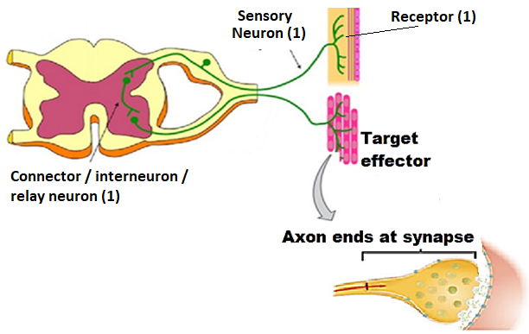

**(Skeletal muscle)**

1. To make it easier to describe the various functions of the peripheral nervous system, it has been classified into divisions and subdivisions.

Complete the following table to classify and describe the neural pathway shown in the diagram on the previous page.

1 mark for each correct column. (If only one correct per column = Zero marks)

|  |  |  |  |  |
| --- | --- | --- | --- | --- |
| Division(s) | Description of divisions(1) | Subdivision(s) | Description of subdivision(s) | Name of neurotransmitter(s) released |
| Afferent and  Efferent. | Afferent: carrying information into central nervous system (CNS)  Efferent: carrying information away from the CNS. | Somatic | Carrying messages to skeletal muscle  OR  Only one motor neuron carrying impulse from the CNS | Acetylcholine |

(5 marks)

1. Below is an action potential graph, showing the outcome from two different stimuli on the same neuron.

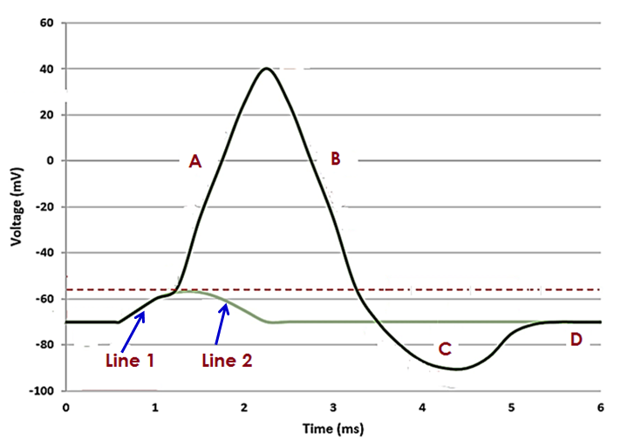

1. The first stimulus resulted in **Line 1** and the second stimulus results in **Line 2**, as shown on the diagram on the previous page.

Describe what occurred to result in Line 2 and state one reason why this has happened.

Students MUST have the following:

* The stimulus provided did not exceed the specific membrane potential threshold ( 1)

And then any one reason outlined (*first answer taken):

* Insufficient sodium ion gated channels were stimulated to open (1)
* Insufficient sodium ions moved across the membrane (1)
* Not enough neurotransmitters trigger gates to open (1)
* Effect of inhibitors (1)

(2 marks)

1. Describe the events occurring at the sections labelled A and C.

*No marks for just stating name of ‘stage’, must describe*

|  |  |
| --- | --- |
| Section A | * Sodium gates open (potassium closed) and sodium ions move/diffuse in to the neuron (1) * Makes environment inside more positive (1) |
| Section C | * Potassium gates were slow to close/remained open even after normal (1) * Causing a greater than normal change (more negative) in the membrane (1) |

(4 marks)

**Section Three: Extended answer 20% (40 Marks)**

**Question 38 (20 marks)**

1. Tuberculosis is a disease caused by a bacterium which invades and replicates inside the cells of their host. Subsequently, the body responds by disrupting the intracellular phase of the bacterial infection.

State the name of the specific immune response that would be triggered for this type of bacteria and explain the events that would occur to eradicate the disease in the short term and prevent its return in the future.

(10 marks)

* Cell-mediated immunity or cellular immunity (1)
* B-cells or macrophages present the antigen/bacterium to the T-cell (1)
* T-cells are sensitised, enlarge and divide to become clones (1) which,
* differentiate into three kinds of cell (1)
* Killer T cells attach to the bacterium and secrete a substance that destroys the bacterium (1)
* Helper T cells secrete a number of substances that:
  + cause lymphocytes at the infection to become sensitised (intensifying the response) (1)
  + attract macrophages to the infection site, which ingest the bacterium (1)
  + intensify the phagocytic activity of macrophages (1)
* Clone cells that remain in the lymph nodes become memory cells (1), which can initiate a faster response to any subsequent infections (1)

1. Jacinta travels from Australia to Siberia for a three-week skiing holiday and chance to see Lake Baikal, the world’s deepest lake. Even though she was aware and well prepared for the difference in climate, Jacinta really notices the cold whenever she is outside.
2. Name and describe the role of two hormones that would be released to regulate Jacinta’s body temperature during her stay in Siberia. Include in your answer, how the release of these hormones are controlled.

(6 marks)

* Hormone: Thyroxine (1)
  + Released from the thyroid gland due to effects of TSH (1)
* Hormone: Adrenaline/noradrenaline (1)
  + Released when Adrenal Medulla stimulated by the Hypothalamus (1)
* Both hormones increase the metabolic rate (increased cellular respiration) in the body (1).
* = increased heat energy produced (as by-product of reactions) = increases body temperature (1)
  + 1. Outline two behavioural responses that will be useful to employ and describe how these responses will help her stay warm.

(4 marks)

Any two behavioural responses (*first 2x taken) (2 marks max) + correct explanation how that response conserves heat / increases heat production (2 marks)

|  |  |
| --- | --- |
| **Behavioral Response/action** | **How it assists** |
| Increase voluntary movement / physical activity | Increased heat produced by skeletal muscles (cellular respiration) |
| Add layers / warm clothing | Insulates = reducing heat loss via radiation / convection |
| Shelter from cold wind | Avoiding cool air from convection |
| Hot shower | Heat gained via conduction |
| Consume hot drink / food | Heat gained via conduction |
| Curl up / decrease surface area | Reduce heat loss via radiation / convection |
| Turn on a heater | Heat gained via radiation / convection |

**Question 39 (20 Marks)**

Multiple sclerosis (MS) is an autoimmune disease, where T lymphocytes attack and destroy oligodendrocytes within the central nervous system. These cells serve the same function as the Schwann cell of the peripheral nervous system. Specific symptoms of this disease can include a decreased ability to detect stimuli, weakened muscles and loss of fine muscle coordination.

1. Compare and contrast the transmission of a nerve impulse along an unmyelinated and myelinated fibre and explain why myelinated fibres are faster.

(9 marks)

|  |  |
| --- | --- |
| **Similarity:**  In both unmyelinated and myelinated neurons, the nerve impulse always travels in one direction (1) | |
| **Differences:** | |
| **Unmyelinated** | **Myelinated** |
| Depolarisation of one area of the cell membrane causes an action potential (AP) to flow onto the membrane immediately adjacent to the stimulus. (1)  *(NB: not enough to just state continuous conduction = must describe)* | Depolarisation of one area of the cell membrane causes an AP to jump from one node of Ranvier to another. (1)  *(NB: not enough to just state salutatory conduction = must describe)* |
| The nerve impulse/exchange of ions (NOT action potential) moves along the entire length of the neuron/axon. (1) | The nerve impulse/exchange of ions (NOT action potential) only occurs at the nodes of Ranvier or cannot occur where the axon is myelinated. (1) |
| Lower concentration gradient of ions either side of the membrane. (1) | Higher concentration gradient of ions either side of the membrane at the nodes of Ranvier. (1) |
| The nerve impulse travels slower (1) | The nerve impulse can travel faster. (1) |

1. Explain how a healthy individual has the ability to distinguish stimuli of a different intensity, yet someone with MS gradually loses the ability.

(6 marks)

* The strength of a stimulus is determined by the number of nerve fibres that are stimulated (1) where
* A strong stimulus will cause the depolarisation / overcome the threshold value of more nerve fibres than a weak stimulus (1) and
* more nerve impulses will be generated within a given amount of time compared to a weak stimulus (1)
* Someone with MS loses the ability to distinguish between different stimuli as some of their sensory neurons have lost their myelin sheath. (1)
* Once a stimulus has been initiated, the speed/frequency of the impulse will be decreased (1) and hence

Any ONE of the following:

* the number of impulses reaching the brain/modulator (1)
* decreasing the persons response time / sensitivity (1)

1. Parturition (child-birth) involves the actions of the nervous and endocrine system. Describe three differences between the actions of these two systems during parturition and explain why it is possible for a woman with MS to still give birth, even though her muscles are weakened by the damaged motor neurons.

(5 marks)

Any three of the following five differences = 3 marks.

Each difference MUST be correctly matched for one mark.

|  |  |  |
| --- | --- | --- |
| Characteristic | Nervous system | Endocrine system |
| Nature of message | Electrochemical (electrical impulse and neurotransmitter) | Chemical (Hormone / oxytocin) |
| Transport of message | Along the membrane of neurons | Bloodstream |
| Target organ/cells affected | Impulses from the cervix to the brain/hypothalamus | Uterus |
| Time taken to respond | In a healthy person - rapid | Slower – seconds/hours |
| Duration of response | Stops as soon as the foetus is born and is no longer pressing against the cervix  *(NB: not enough to just state short-lived)* | Uterus continues to contract after the foetus is born (to expel placenta and can contract during initial breast feeding).  *(NB: not enough to just state long-lived)* |

* A woman can still give birth because, although she may have lost sensitivity, the impulses would still reach the brain/hypothalamus to stimulate the release of oxytocin (1)
* Her uterus would still contract, as it is being stimulated by the oxytocin that is delivered by the bloodstream and not by motor neurons (1)

**Question 40 (20 marks)**

1. To get a correct diagnosis on one of his patients, the doctor has requested a blood test to be performed. The patient was given strict instructions to fast (not consume any food) for at least six hours before getting the blood test.

Outline what is happening to the patient’s blood glucose levels over the fasting period and describe, in detail, how the levels are regulated in the body.

(12 marks)

What happens to patient’s blood glucose levels (BGL):

* Blood glucose levels (BGL) initially drop as glucose used/taken up by body cells (1)

Regulation:

* Alpha cells in the islets of Langerhans detect the low BGLs (1)
* Alpha cells release the hormone, **glucagon** (1)
* Adrenal cortex releases the hormone, **Cortisol** (1)
  + Following stimulation of Adrenocorticotrophic hormone from Ant. Pituitary (1)
* Adrenal medulla releases the hormone, **Adrenalin/noradrenaline** (1)
  + Following stimulation from hypothalamus via sympathetic nerves (1)
* **Glucagon, Cortisol and Adrenaline/Noradrenaline:**
  + acts on the liver (1)
  + promotes glycogenolysis (conversion of glucose to glycogen) (1)
  + promotes lipolysis / break down of fats/lipids into glucose (1)
  + promotes gluconeogenesis (conversion of lipids / amino acids to glucose in the liver) (1) *[NB: Adrenaline promotes glycogenolysis by stimulates the production of lactic acid from glycogen in muscle cells which can be used by the liver to manufacture glucose]*
* All processes/responses = raise/increase the levels of glucose in the blood (1)

1. An individual’s basal metabolic rate can be affected by an over or under active thyroid gland.

Identify and contrast these two conditions and despite having so many differences, explain why they both cause fatigue.

(8 marks)

|  |  |  |
| --- | --- | --- |
| Each contrasted difference must be appropriately linked for 1 mark. | | |
| **MUST HAVE**  **Hyperthyroidism** – over active thyroid gland | **MUST HAVE**  **Hypothyroidism** – under active thyroid gland | 1 |
| Any THREE of the following pairs of differences (must be correctly contrasted for 1 mark)  A maximum of 3 marks. *(NB: As the number of differences not specified in Q – any three accepted as long as correctly contrasted)* | | |
| Caused by immune response reaction | Lack of iodine available to thyroid gland | 1-3 |
| Rapid heart beat | Slow heart beat |
| Unexplained weight loss | Unexplained weight gain |
| Increased appetite | Decreased appetite |
| Increased core body temperature / reduced tolerance to hot climate | Decreased core body temperature / reduced tolerance to cold climate |
| Reasons for both causing fatigue.  A maximum of 4 marks | | |
| Over active thyroid gland 🡪 more thyroxine released 🡪 greater basal metabolic rate than necessary (1)  = greater consumption of glucose/food 🡪 low blood glucose concentration 🡪 fatigue (1) | Under active thyroid gland 🡪 less thyroxine released 🡪 slow basal metabolic rate (1)  = reduced cellular respiration 🡪 less energy / ATP produced 🡪 fatigue (1) | 1-4 |
| **Total marks possible** | | **8** |

**References**

Question 18-19

Image retrieved 26 September 2017 from

[https://www.dreamstime.com/stock-illustration-types-neurons-basic-neuron-unipolar-pseudo-unipolar-neuron-bipolar-multipolar-neuron-cell-body-different-image52092345#](https://www.dreamstime.com/stock-illustration-types-neurons-basic-neuron-unipolar-pseudo-unipolar-neuron-bipolar-multipolar-neuron-cell-body-different-image52092345)

Under the Dreamstime license

Question 31

Image retrieved 27 September 2017 from

<http://gcsebiologycore.blogspot.com.au/2014/09/homeostasis.html>

Under the Common Creative license

Question 33

Image retrieved 30 April from

<https://commons.wikimedia.org/wiki/File:Pituitary_gland_et_vessel.jpg>

Under the Free Images license

Question 33 (d)

Image retrieved 26 October 2017 from

[www.thinglink.com/scene/497504539574796289](http://www.thinglink.com/scene/497504539574796289)

Under the Common Creative license

Question 36

Image retrieved 27 September 2017 from

<http://tecidc.com/go-pro/dive-theory-english/idc-physiology/>

Under the Free Images license

Question 37

Image retrieved 3 October 2017 from

<https://www.thinglink.com/scene/647049245123149824>

Question 37

Image retrieved 30 April 2018 from

<http://tadpoles.org.uk/home/schools/a-level/nerve-impulses/>