**Year 10 Earth and Space Science Week 4 and 5**

**Objectives:**

**Earth systems**

* Define Biosphere, Atmosphere, lithosphere and hydrosphere,

**Carbon Cycle**

* Use the C cycle to describe the interactions between the Biosphere, Atmosphere, lithosphere and hydrosphere.
* Describe the main processes; photosynthesis, respiration, combustion, fossilisation (fossil fuels, limestone).
* Identify C reservoirs / sinks.

**Differences between Weather and Climate**

* Define weather and climate.

**Gases in the atmosphere**

* Identify the major greenhouse gases, CO2, H2O, methane, Nitrous oxides.
* Understand how the greenhouse effect helps to maintain earth’s ideal surface temperature.

**Natural Influences on Global Climate**

* Describe the factors affecting relative energy absorption on the surface of earth, eg tilt, latitude, reflection by different surfaces eg water, land, ice vegetation.
* Ocean currents, Surface and deep.

**Describe the factors driving the global conveyer belt (thermo-haline circulation).**

* Understand how ocean currents distribute heat around the earth.
* Global winds for surface (gyres)
* Temperature and salinity for deep.
* Understand that the combination of these factors drive the global conveyer belt.

**Earth Atmosphere**

The **atmosphere** is divided into five main layers:

* 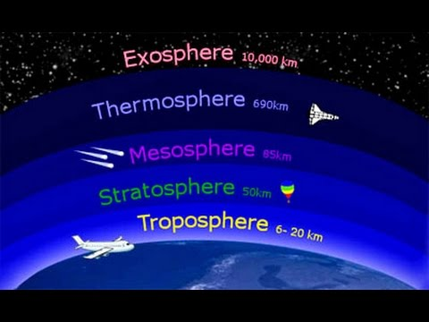Troposphere: Layer above the ground that contains almost all water and dust. Its responsible for determine our weather
* Stratosphere: The air in this layer is less dense and drier
* Mesosphere: Contains chemicals that absorb energy from the sun
* Thermosphere: upper atmosphere that satellites and space shuttle orbit within
* Exosphere: It is the outermost atmospheric layer. It has no definite outer limit as it merges with space.

Both mesosphere and thermosphere make up the ionosphere where free ionic particles reflect radio waves, enabling long distance communication.

Exosphere – it is the outermost atmospheric layer. It has no definite outer limit as it merges with space. Many satellites orbit the Earth within the exosphere at altitude of 500km above sea level.

**Earth Systems**

Matter and energy can cycle through four interconnected spheres:

1. The atmosphere, which is mostly made of gases.

2. The lithosphere, which is mostly made of rock.

3. The hydrosphere, which is mostly made of water.

4. The biosphere, which is mostly made of living things.

These spheres interact together to influence factors such as landscape, soil formation, change in temperature, biodiversity and salinity. For example, part of the lithosphere - the pedosphere (layer of dirt and soil) is the result of the interaction of all spheres. The atmosphere (wind) and hydrosphere (water & ice) cause weathering and erosion of rocks; the biosphere (plants & animal remains) adds its organic components to the eroded rocks to produce fertile soil. Another example of such an interaction is influencing temperature differences on Earth. The mountain ranges of the lithosphere are interacting with low air pressure from the atmosphere and snowy precipitation of the hydrosphere to produce an icy climate zone. This climate zone drives adaptations vital for organisms of the region’s biosphere.

**Carbon Cycle**

key events in the carbon cycle are respiration, photosynthesis, respiration, combustion, and fossilisation.

The key events in the carbon cycle are *respiration* and *photosynthesis*. Carbon in the form of CO2 is converted into sugars during photosynthesis, thereby moving from atmosphere into organisms (biosphere). Trees are good carbon sinks. When herbivores eat the plants carbon, flows from producers to consumers. When organisms respire, they release carbon back to the atmosphere in the from of CO2. Animals return carbon back to soil (pedosphere) through defecation. When an organism dies, as in the case of plants and animals, the carbon in their tissues is recycled by decomposers and returned the soil, and, in other cases it is stored as fossil fuel underground. When fossil fuels are burnt, CO2 is returned back to the atmosphere.

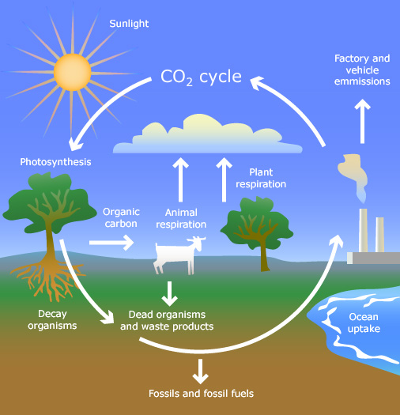The Carbon Cycle helps to visualise how Carbon is cycled through the range of process on earth.

**Carbon Sinks and Reservoirs**

By far, the chief reservoirs of CO2 are in the oceans and in rocks. CO2 dissolves readily in water. Once there, it may precipitate as calcium carbonate (limestone – CaCO3). Limestone reefs are actually huge deposits of carbon built by corals and algae. Molluscs store carbon in their shells.

**Weather and Climate**

Weather is the change in atmosphere with respect to its effect on life form and human activities. It consists of short-term changes in the atmosphere (minutes to months). Weather can be thought of in terms of wind, temperature, precipitation, storm, humidity, brightness, pressure and visibility.

Climate describes the predominant long-term pattern in weather in a particular region; e.g. desert has a dry and hot climate. The climate in the tropical region is hot and humid. Scientists define climate as the average weather for a particular region and time period, usually taken over 30 years.

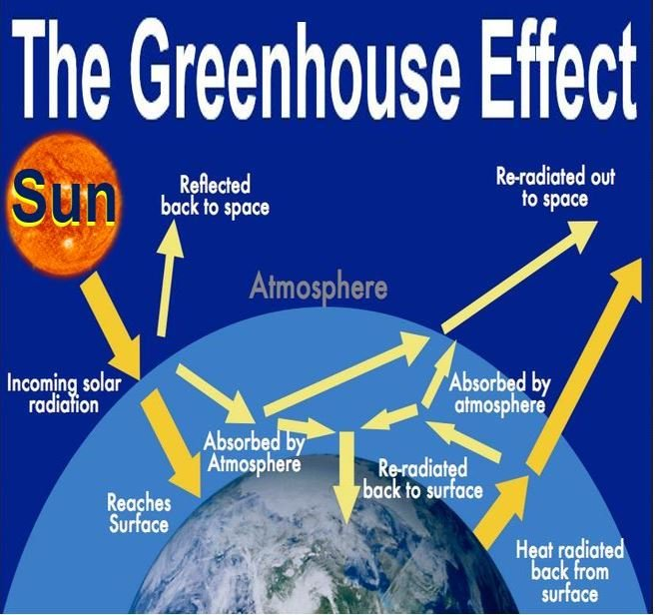

**Gases in the atmosphere**

The major Greenhouse gases in our atmosphere include Water Vapour, Carbon Dioxide, Methane, Nitrous oxide and Ozone.

**The Natural Greenhouse effect**

When sun’s radiation hits the ground some is reflected and some is absorbed and heats up the surface. The layer of CO2 prevents the heat from escaping. This layer of CO2 with its trapped heat warms the earth’s surface. Without CO2 the surface temperature will be much lower– about 35ºC cooler.

**Natural Influences on Global Climate**

**Tilt of earth axis** – the axis tilts at an angle of 23.5º with respect to its plane of orbit.

During solstices, incoming radiation is perpendicular to earth surface on either the latitude of Cancer or the latitude of Capricorn 23º north or south of the equator.

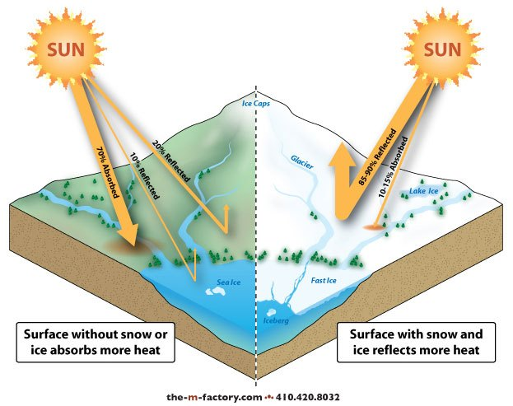

**Reflection on different surfaces (Albedo effect)** – Different surfaces reflect different amounts of sunlight. The amount of sunlight reflected from different surfaces, or the reflective power of a surface, is known as albedo effect. It is the ratio of reflected radiation from the surface to incident radiation upon it. It is expressed as a percentage and is measured on a scale from 0 to 1; 0 being a perfectly black surface and 1 being a very white surface.

**Latitude**

Positions of latitude determine the strength and directness of the sun's rays. Lower latitudes are closer to the equator and thus receive a higher concentration of sunlight.

The sun is the source of heat and light for the Earth. When sunlight strikes the Earth's atmosphere and ground, it heats both the ground and the air. At the equator and tropical zones, this sunlight is more concentrated, thus producing more heat and light. Therefore, the climate is warmer. Conversely, temperate and polar areas receive more scattered sunlight, leading to cooler climates.

Temperature, in turn, affects the rate of evaporation and precipitation. Warmer climates tend to be more humid because increased temperatures lead to more water vapor in the air. Warmer air can hold more moisture before becoming saturated and releasing the water as precipitation.

The interaction between warm and cold air creates different pressure areas, which lead to the development of storms. Tropical areas and oceans are prone to developing hurricanes especially along the path of jet streams. This is because currents carrying warm or cold air tend to interact more frequently.

**Global Winds**

Global wind pattern – global winds blow in the same direction all the time due to unequal heating of earth surface by the sun. More radiation strikes the equator than the polar regions.

This coupled with the rotation of the earth produces the predictable movement of winds which push water in surface currents in their direction.

Warm air around the equator rises and flows toward the North and South poles. Due to the Coriolis effect, it is deflected toward the right (N.P.) and left (S.P.). As it cools it descends near 30º latitude. The descending air blows from East to West. This wind is known as trade/prevailing wind. In middle latitudes (30º – 50º), wind blows West to East and are known as westerlies. The wind between 50º – 60º blow East to West and are known as polar easterlies.

**Altitude**

Air pressure and air temperature decrease with altitude. The closer molecules are packed together, the more likely they are to collide. Collisions between molecules give off heat, which warms the air. At higher altitudes, the air is less dense and air molecules are more spread out and less likely to collide. A location in the mountains has lower average temperatures than one at the base of the mountains.

**Topography**

The Topography of an area can greatly influence our climate. Mountain ranges are natural barriers to air movement. In California, winds off the Pacific-ocean carry moisture-laden air toward the coast. The Coastal Range allows for some condensation and light precipitation. Inland, the taller Sierra Nevada range rings more significant precipitation in the air. On the western slopes of the Sierra Nevada, sinking air warms from compression, clouds evaporate, and dry conditions prevail.

**The Global Conveyer Belt (thermo-haline circulation).**

The **thermohaline circulation** is a term for the global density-driven circulation of the oceans. Derivation is from [*thermo*](http://www.academickids.com/encyclopedia/index.php?title=Thermo&action=edit)*-* for heat and *-haline* for salt, which together determine the [density of sea water](http://www.academickids.com/encyclopedia/index.php?title=Density_%28sea_water%29&action=edit).

Wind driven surface currents (such as the Gulf Stream) head poleward from the equatorial Atlantic Ocean, cooling all the while and eventually sinking at high latitudes (forming North Atlantic Deep Water). This dense water then flows downhill into the deep water basins, only resurfacing in the northeast Pacific Ocean 1200 years later. Extensive mixing therefore takes place between the ocean basins, reducing differences between them and making the Earth's ocean a global system. On their journey, the water masses carry both energy (in the form of heat) and matter (solids, dissolved substances and gases) around the globe. As such, the state of the circulation has a large impact on the climate of our planet. The thermohaline circulation is sometimes called the **ocean conveyor belt** or, **global conveyor belt**.

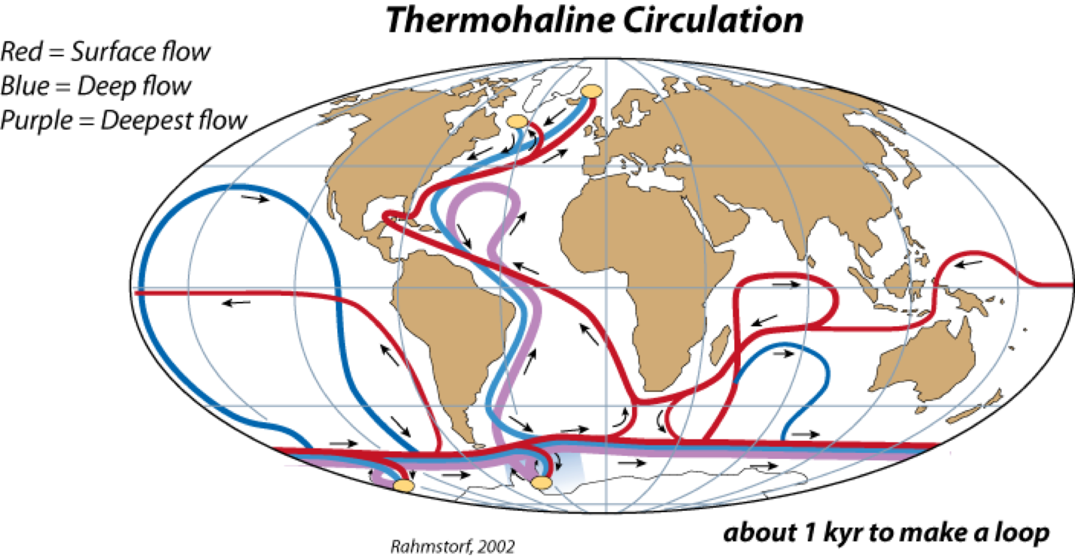

**Factors that drive the Global Conveyer Belt**

**Temperature and Salinity**

Oceanic water with lower salt concentration rises to the surface due to its lower density. Saltier water is denser and therefore sinks. When ice caps melt, the fresh water helps to reduce the salinity of the oceanic water and it rises to the surface. As the water travels to the tropics, heat from the sun evaporates the top layer of the ocean resulting in a higher salt concentration in the water, which forces the water to sink. Since both temperature and salinity drive the conveyer belt, it is known as the thermo-haline circulation.

**Questions:**

* 1. List the layers in our atmosphere and provide a brief description of the layer.

* 1. Name the Earth’s Major systems and their basic composition.
  2. In the diagram below, list the major events of the Carbon cycle



* 1. How is weather different to climate?
  2. List the gases that contribute to the Natural Greenhouse effect
  3. Describe the Greenhouse effect
  4. What are 3 natural influences of our global climate?
  5. What is the global Convey Belt/Thermo-Haline circulation? List the factors that drive this current

|  |  |
| --- | --- |
|  |  |
|  |  |