Year 10 Earth and Space Science Week 2 and 3

Objectives:
- Formation of the Solar System
- Recall the major star types – medium star, large star, red giant, super red giant, white dwarf, neutron star
- Life cycle of stars. Nebula. Super Nova. Black hole.
- Describe the process of nuclear fusion that occurs in the Sun.
- Recall that the Sun emits electromagnetic radiation of all frequencies (radio, microwave, infra-red, visible, UV etc.) but the Earth’s atmosphere/magnetosphere filters out most harmful radiations.
- Explain that UV exposure causes sunburn, skin cancer and ageing.
- List ways of protecting the skin from the sun.
- Ozone effect. Role of ozone in stratosphere
- Cause and effects of O₃ depletion, solutions to the problem.

Formation of the Solar System

The formation of the solar system began about 4.6 billion years ago, with a wispy cloud of stellar dust that was part of a bigger cloud called a nebula.

At some point, the cloud compressed in on itself—possibly due to a shockwave of a nearby exploding star, creating a disk of material surrounding it. The pressure caused by the material was so great that hydrogen atoms began to fuse into helium, releasing a tremendous amount of energy. This created our Sun.

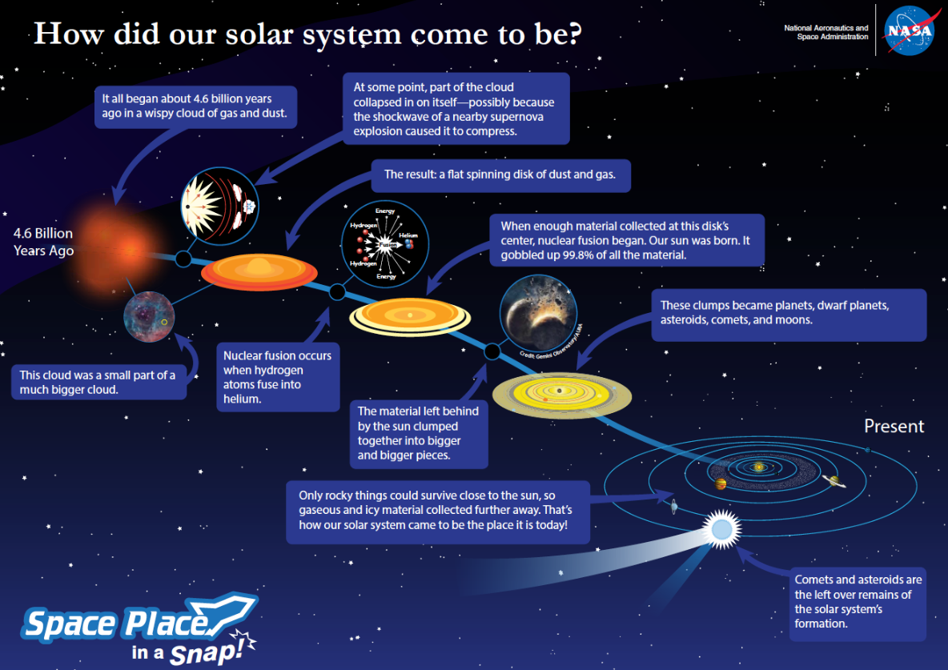

Ninety-nine percent of the gas and dust in the disk went into the Sun. The remnants began to clump together due to gravity. Eventually as object collided with object they eventually formed spheres which were the birth of planets and dwarf planets.

The rocky planets, like Earth, formed near the Sun, because icy and gaseous material couldn’t survive close to heat. The gas and ice bonded further away, creating the gas and ice giants. The asteroids in the asteroid belt and the comets in the outer reaches of the solar system are the bits and pieces of the early solar system that could never quite form a planet.

Life Cycle of Stars

Type of Star |  | Description
Nebula |  | Cloud of dust and gas
Protostar |  | A contracting mass of gas that represents an early stage in the formation of a star, before nuclear fusion has begun.
Failed Star | Brown Dwarf | Formed from clouds of interstellar gas but never reach sufficient mass, density and internal heat to start the nuclear fusion process.
Main Sequence Stars | Red Dwarf | Smallest main sequence star and relatively cool stars, with low mass, less than 40 - 50% of the mass of our Sun. Most common type of star with long lifetime due to a slow rate of fusion.
 | Yellow Dwarf | Our Sun is a yellow dwarf. These low mass stars are burning hydrogen fuel in their cores and typically these stars typically have a whiter colour. However, they do appear yellow when observed through the Earth's atmosphere.
 | White Star | Bright, main-sequence stars with moderate masses from 1.4 to 2.1 times the mass of the Sun
 | Blue Giant | Bright, massive stars, 10 to 100 times the size of the Sun, and 10 to 1,000 times as bright. They are short-lived and quickly exhaust their hydrogen fuel, ending as red supergiants or neutron stars.
Red  Giant |  | A low or intermediate mass star (red dwarf or yellow dwarf) which has fused all its hydrogen into helium expands to many times its previous volume becomes a red giant.
Red Super Giant |  | A massive star (white star or blue giant) which has fused all its hydrogen into helium expands to many times its previous volume to become a red supergiant, the largest star type in the universe in terms of volume.
White  Dwarf |  | Small, dense, burnt-out husks of stars, no longer undergoing fusion reactions, and representing the final evolutionary state of most of the stars in our galaxy.
Black  Dwarf |  | Hard to detect stellar remnants created when a white dwarf becomes cool and dark.
Supernova |  | A supernova is the explosion of a star caused by a change in the core of a star. As the massive star runs out of nuclear fuel, some of its mass flows into its core. Eventually, the core is so heavy that it collapses.
Black  hole |  | A super massive star which collapses, creating a volume of space-time with a gravitational field so intense that its escape velocity equals or exceeds that of light.
Neutron  Star |  | Stellar remnants that can result from the gravitational collapse of massive stars during a supernova event. They are composed almost entirely of crushed neutrons, and are very hot and very dense. They rotate very fast (especially soon after the supernova explosion) and some emit regular pulses of radiation and are known as pulsars.

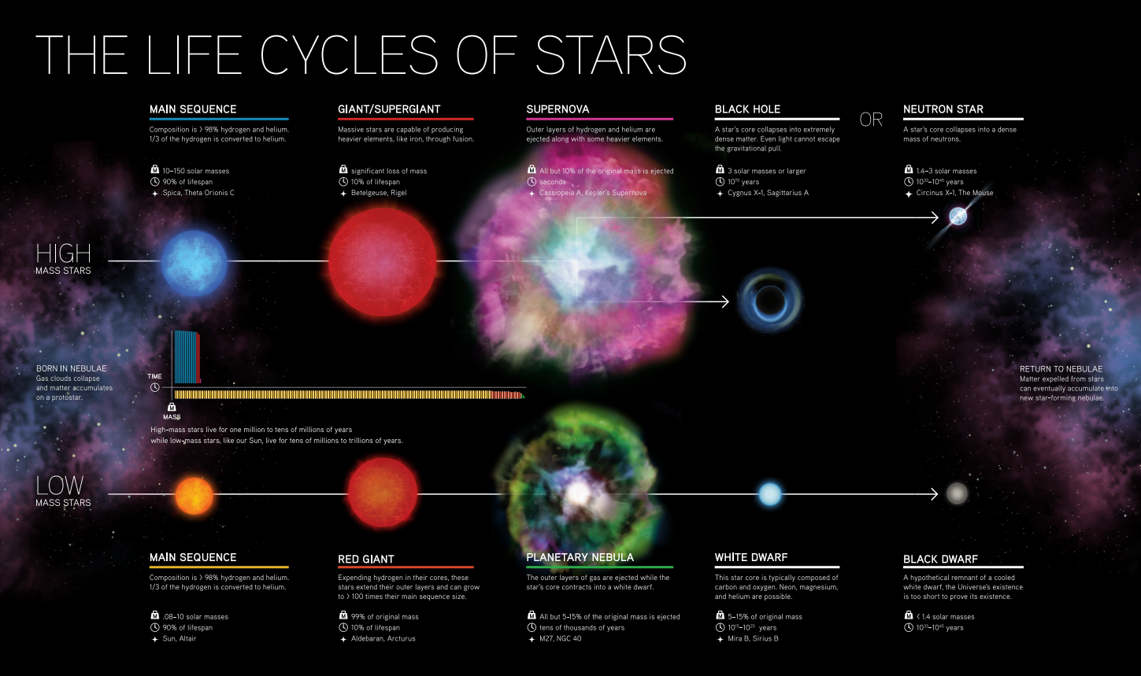

Nuclear Fusion

Nuclear fusion is the process which powers the Sun and other stars. In nuclear fusion, when smaller nuclei (like Hydrogen) combine to form larger nuclei (like Helium) energy is released. This is due to the difference in mass between the reactants and products in the nuclear reaction.

The diagram below shows the fusion reaction that powers the Sun.

Step 1. Two pairs of hydrogen nuclei fuse together to form two deuterium nuclei (heavy hydrogen). In order for this to occur one proton in each pair must decay to a neutron, emitting an electron and a neutrino in the process.

Step 2. Each of the deuterium atoms then fuse with another hydrogen atom to form Helium-3. Gamma radiation is released in this process.

Step 3. These two Helium-3 nuclei then fuse to form helium-4 which results in the release of energy along with two protons (Hydrogen nuclei) which can then be used in another fusion reaction.

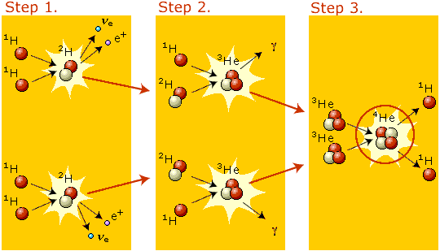

Electromagnetic Radiation from the Sun

Our Sun emits all forms of electromagnetic radiation, as can be seen in the spectrum below. However, some parts of the spectrum are blocked from entering Earth.
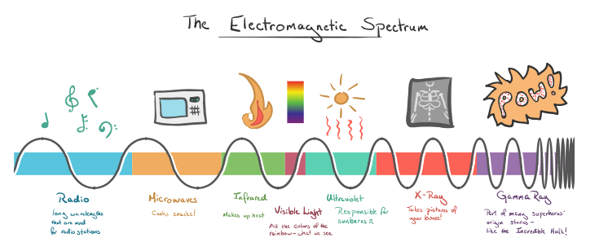
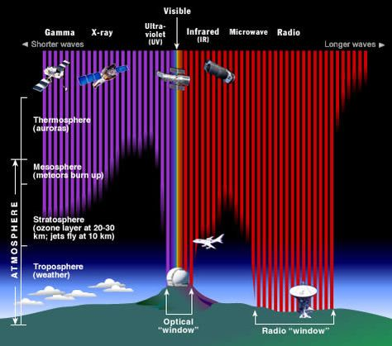
As can be seen in the diagram on the right, life on Earth is fortunate as our atmosphere blocks out harmful high-energy radiation like x-rays, gamma rays and most of the ultraviolet rays. The atmosphere also absorbs most of the infrared radiation which reaches the Earth from space which prevents Earth from being too hot to sustain life.

Only radio waves, visible light, some infrared and near UV radiation can penetrate through the troposphere to reach Earth’s surface.

Ultraviolet Radiation

Ultraviolet (UV) radiation is a type of energy produced by the sun and some artificial sources, such as solariums. Your body needs some exposure to UV light to produce vitamin D, however high exposure can lead to harmful effects. The Sun’s ultraviolet (UV) radiation can cause:
- skin cancer
- sunburn
- premature ageing and
- eye damage.

UV radiation isn’t like the Sun’s visible light or infrared radiation, which we can see and feel. Your senses cannot detect UV radiation, so you won’t notice the damage until it has been done.

Ways you can protect your skin from UV Exposure from the Sun:

- Slip – Slip on a shirt. Wear protective light weight clothing to protect your skin.

- Slop – Slop on some sunscreen. Apply SPF 30+ sunscreen every two hours to sun exposed skin.

- Slap – Slap on a hat. Wear a wide brimmed hat to ensure maximum protection of head, face and neck from the Sun.

- Seek – Seek adequate shade. During the hours of the day where UV radiation levels are high it is best to stay out of the Sun entirely.

- Slide – Slide on some sunglasses. Wearing close fitting wrap-around sunglasses filters UV radiation preventing eye damage.

How the Ozone Layer Protects Us
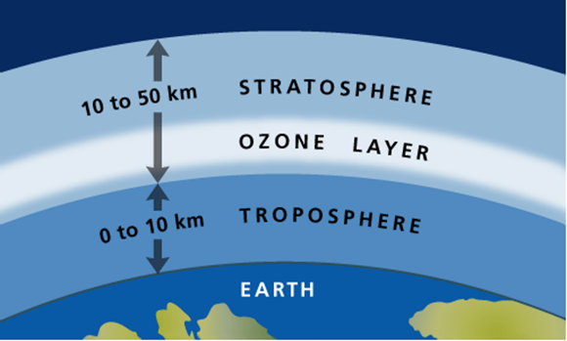
The Ozone layer is located in the stratosphere, approximately 20 – 30 km above the Earth as seen in the diagram on the right. It absorbs harmful ultra violet radiation, (UVB) from the Sun, preventing it from reaching the planet's surface.
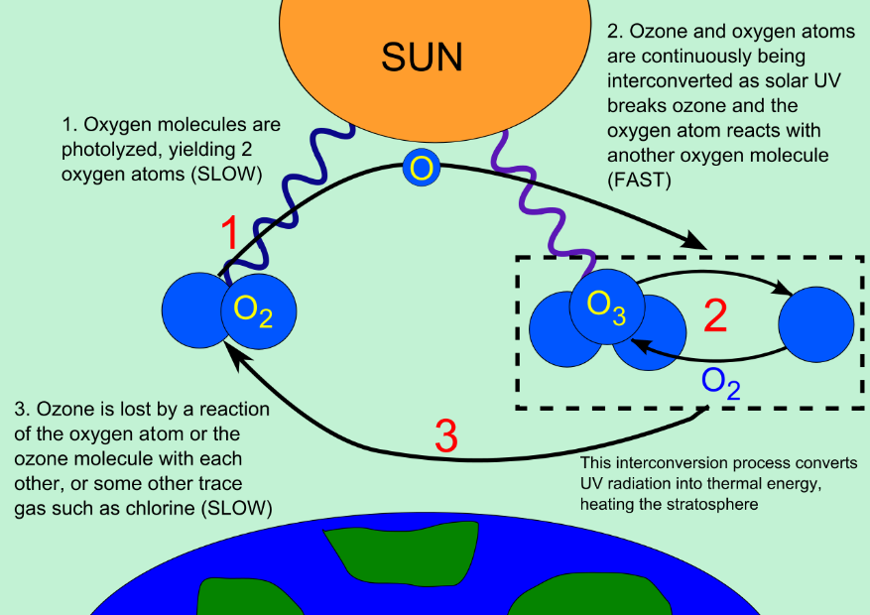
Ozone is a molecule that contains three oxygen atoms. They are formed when UV radiation is absorbed by O₂ molecules breaking them apart into single O atoms. These single O atoms then join with another O₂ molecule to create ozone. Ozone molecules can then absorb UV radiation breaking them apart into O2 and single O atoms. The cycle can then continue as shown in the diagram on the left.

The ozone molecules are constantly formed and destroyed in the stratosphere but the total amount has remained relatively stable during the time that it has been measured. However, in the 1970s, scientific evidence showed that the ozone layer was being depleted.

When chlorofluorocarbons (CFCs), hydro chlorofluorocarbons (HCFCs) and other ozone-depleting substances enter the stratosphere they are broken down by the ultra violet light entering our atmosphere. When they break down they release chlorine or bromine atoms which then deplete ozone. This process can be seen in the diagram below. These ozone-depleting substances can destroy ozone more quickly than it is naturally created.
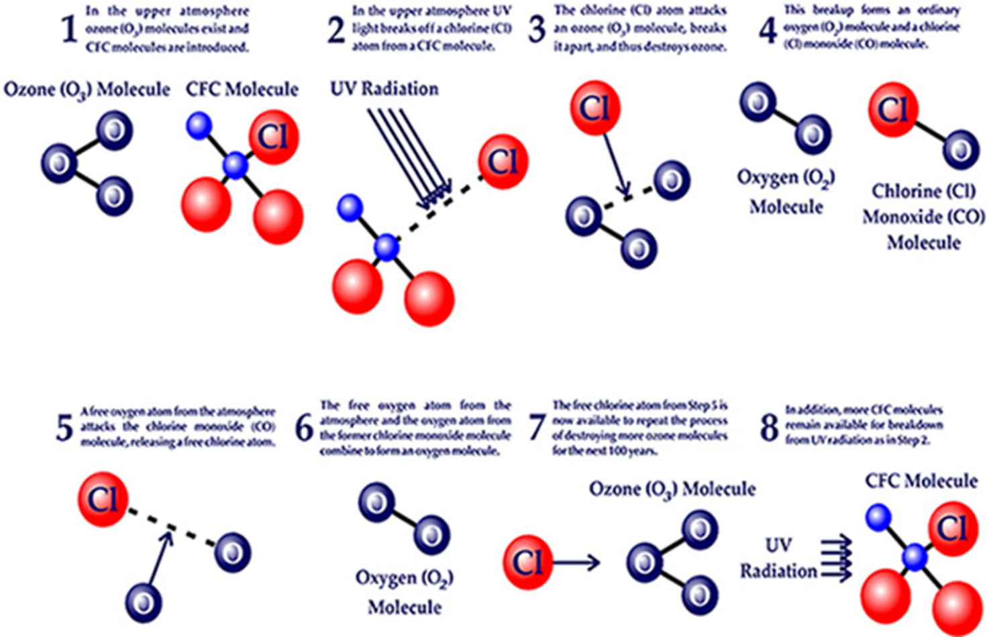

One example of ozone depletion is the ozone "hole" over Antarctica that has occurred since the early 1980s. This is not really a hole through the ozone layer, but rather a large area of the stratosphere with extremely low amounts of ozone. Ozone depletion is not limited to the area over the South Pole. Research has shown that ozone depletion includes areas over North America, Europe, Asia, and much of Africa, Australia, and South America.

In1987 the Montreal Protocol was established to reduce the use of CFCs and other ozone-depleting substances. This had led to an increase in the amount of ozone in the ozone layer and it is predicted that the ozone layer will return to its 1980s level by 2050.

Questions:

  - In your own words, briefly explain how our solar system was formed.

  - Explain why our Sun will not become a black hole. Use a flow diagram to assist your explanation.

  - What is nuclear fusion and why is it important to human life?

  - What is the ozone layer and how does it protect us?

The ozone layer is comprised of 3 oxygen that is chemically bonded

  - Despite our atmosphere, some UV radiation makes it to Earth. What are some of the negative consequences of too much UV exposure?

  - How can we protect ourselves from too much UV exposure?

