**Human Biological Sciences 3AB Revision**

**3B.1 Skeletal system**

1. Name the bones in the following diagram.

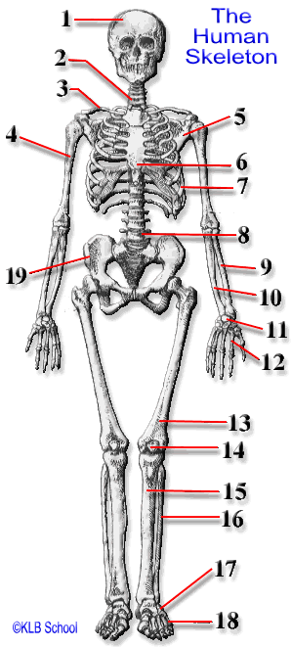

1. What are the functions of bone in the human body?

1. Sketch a long bone – include a labelled cutaway section showing the inner part of the long bone. Include any blood vessels that may be associated with the bone, and the different named **areas** of a long bone.
2. Sketch and label the microscopic Haversian Canal ‘system’ of bone.
3. What do each of the following cell do? Osteoclasts, osteocytes, osteoblasts.

1. Given your answer to question 5 above, what do you think chondrocytes and chondroblasts do.

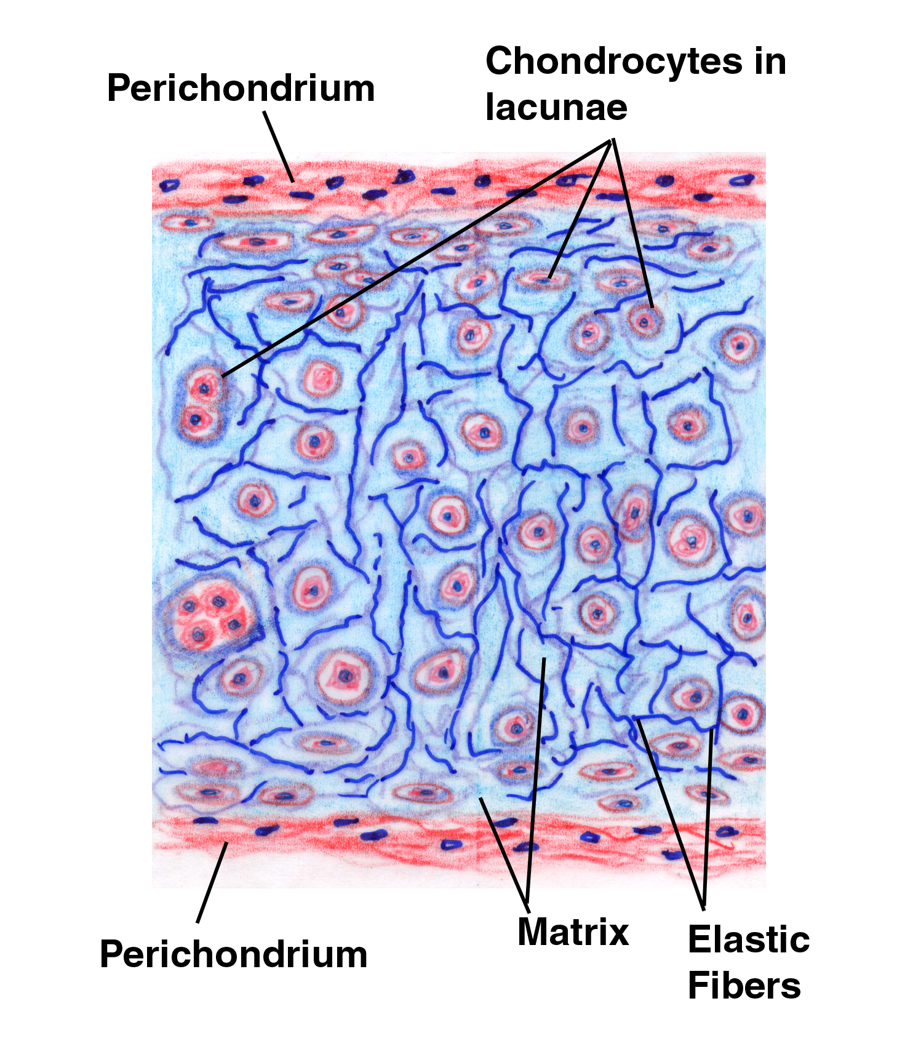

1. The following diagram shows hyaline cartilage. Label each of the parts indicated.

A

B

C

D

E

1. The following diagrams show the three types of cartilage. Identify each of the different types, give an area of the body where each are found, and state what their functions are in each of the areas named.

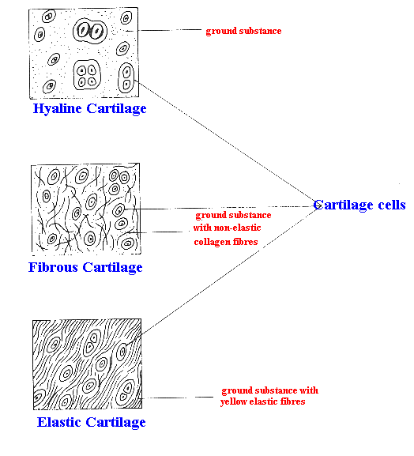

1. Fill in the following table.

|  |  |  |  |
| --- | --- | --- | --- |
| NAME OF JOINT  (Give any alternative names as well!) | | MOVEMENT ALLOWED | WHERE ARE THEY FOUND IN THE BODY? |
| IMMOVABLE | |  |  |
| SLIGHTLY MOVEABLE | |  |  |
| HIGHLY MOVEABLE | PIVOT |  |  |
| BALL AND SOCKET |  |  |
| HINGE |  |  |
| GLIDING |  |  |
| SADDLE |  |  |

1. Label the parts of the knee – a typical Synovial Joint.

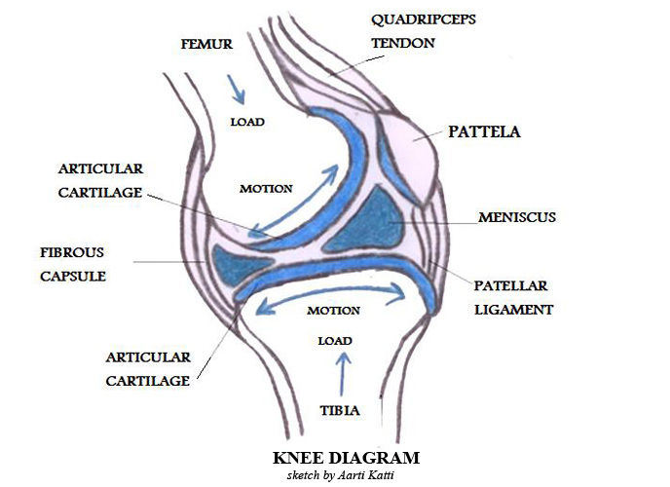



A

B

C

D

E

F

G

1. Label the Types of Movement

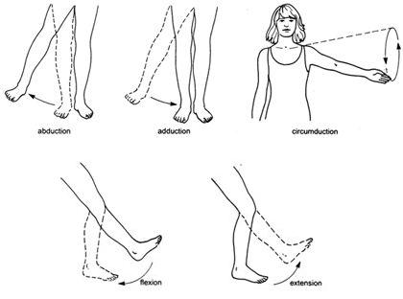



1. **Extended answer type:**

The diagram in question 10 shows the knee joint. Given that the bones are hollow, how is it that the lower limbs don’t collapse due to the weight of the upper body acting in part at this point?