Year 9 Science Name: ______________________________

Revision Sound and Light

**Waves**

1. Use the following words to fill in the blanks in the paragraph below:

rest compressions energy vacuum transverse amplitude crest trough longitudinal rarefactions medium perpendicular parallel

Waves are travelling ____________________. There are two types of waves - _______________________ waves, like sound, and __________________________ waves, like waves at the beach. All longitudinal waves require a _________________ to travel through. This is why there is no sound in space – space is a _________________. The _______________________ of a wave is the maximum displacement of a particle from its _______________ position. The _________________________ of a wave is the length, or distance, from one _______________ to the next, consecutive _________________.

In longitudinal waves, the particles of the medium vibrate ______________________ to the direction the wave is travelling. __________________________ are the parts of the wave where particles are closest together and ___________________________ are where they are farthest apart.

In transverse waves, the particles of the medium vibrate _______________________ to the direction the wave is travelling in. The highest point in a transverse wave is called a _________________ and the lowest point is called a _____________________.

**Sound**

1. What is the speed of sound and how does it compare to the speed of light? Give an example to support your answer.

|  |
| --- |
|  |
|  |
|  |
|  |

1. The speed of sound can be determined by measuring a distance and the time it takes for sound to travel that distance. Two students stand at opposite ends of a 50 m oval. One claps very loudly and the other uses a timer to measure the time between when she sees her friend clap and when she hears it. The time measured is 0.151 seconds. What is their calculated speed of sound in air?

|  |
| --- |
|  |
|  |
|  |
|  |

1. The picture below shows how a longitudinal wave can be represented by a transverse wave diagram. Use it to answer the following questions.
2. What do the letters C and R represent?
3. Label the amplitude of the wave.
4. Between which letters should be measured to find the wavelength?
5. If the middle picture shows the number of waves that pass a point in 1 second, what is the frequency of the wave?
6. Does the wave in the bottom picture have the same or a different frequency to the middle picture?

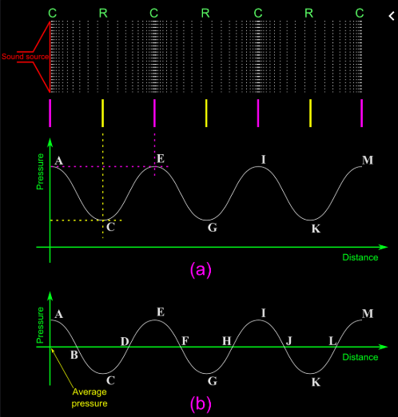

1. 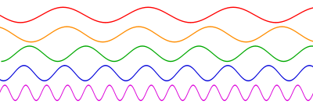Loudness and Pitch

A

B

C

D

E

Which of the following has:

1. the highest frequency
2. the longest wavelength
3. the loudest sound
4. the lowest pitch
5. the highest pitch
6. Name two animals that use echolocation to navigate, communicate or find prey.

|  |
| --- |
|  |
|  |
|  |
|  |

1. Name two human technologies that are based on echolocation.

|  |
| --- |
|  |
|  |

1. What is the collective term for the very small bones in the middle ear?

|  |
| --- |
|  |

1. What are common names for the malleus, incus and stapes?

|  |
| --- |
|  |

1. Use the picture of the ear below to help draw a flowchart of how a sound is heard, from the time it enters the pinna to the time it is registered by the brain. Include the function of each part.

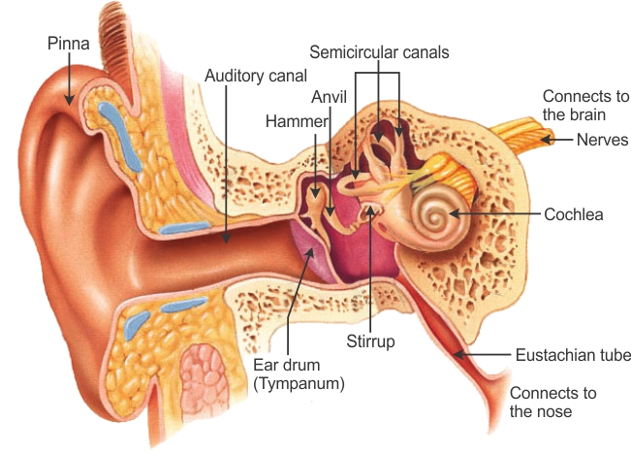

1. Which part of the ear allows the equalisation of pressure in the middle ear?

____________________________________

1. Which part of the ear is responsible for maintaining balance?

____________________________________

|  |
| --- |
| 1. When a room is emptied of its furniture, it echoes more than if the room contains soft chairs, couches and curtains. Explain why. |
|  |

**Light**

1. 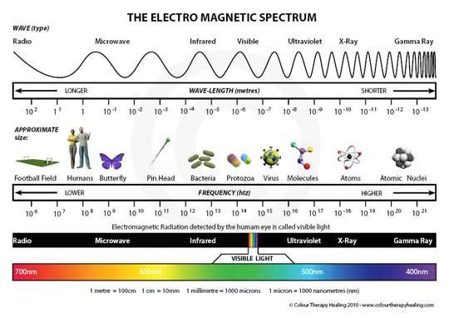The electromagnetic spectrum contains radio waves, microwaves, infrared waves, visible light, X-rays and gamma rays. Which of these:
2. has the shortest wavelength?
3. has the highest energy?
4. is visible to the human eye?
5. is invisible to the human eye?
6. is used in communications systems?
7. is the highest energy visible light?
8. 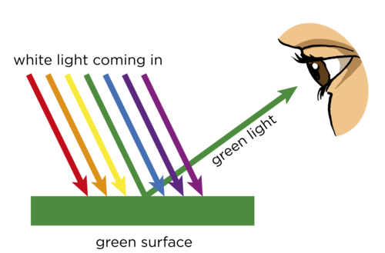Explain why shining white light on a green object makes it appear green but shining a red light on it makes it look black.

|  |
| --- |
|  |
|  |
|  |
|  |

1. Explain why white light shone through a prism creates a spectrum of colour as shown in the picture below. What is the name of this property? 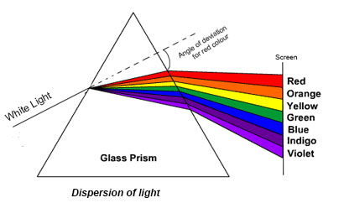

|  |
| --- |
|  |
|  |
|  |
|  |
|  |

1. Explain why the same thing doesn’t happen when a red filter is used and only red light is shone through the prism.

|  |
| --- |
|  |
|  |

1. The diagram below shows a light ray incident on a mirror. Complete the diagram, showing what happens to the ray when it reflects off the mirror. Draw in and label the following features: incident ray, reflected ray, normal, angle of incidence, angle of reflection.



1. Refraction is the bending of light as it passes from one medium to another. Light slows down as it enters a denser medium. Using the pictures below, explain how the path of light changes as it travels from a more dense to a less dense medium.

|  |
| --- |
|  |
|  |
|  |
|  |

1. 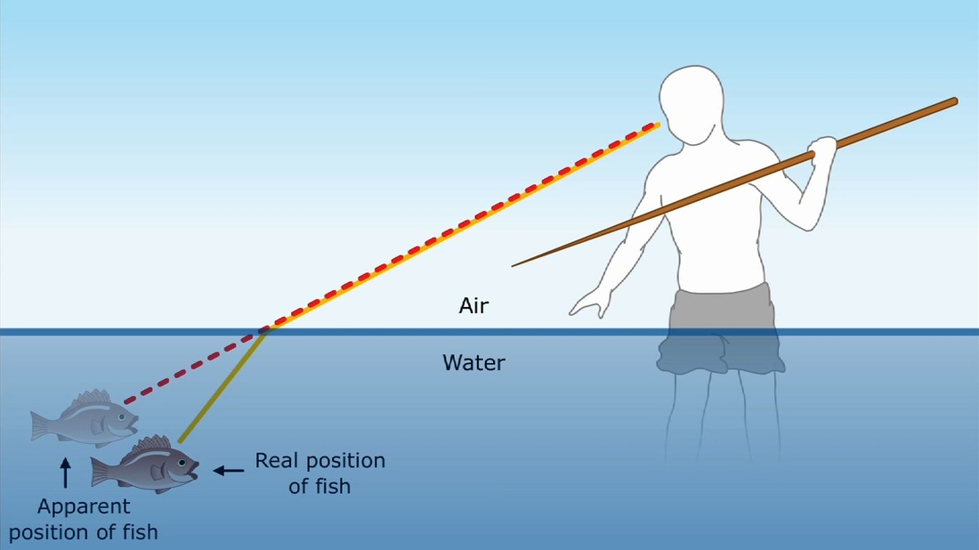Explain why the fisherman perceives the fish as closer to the surface of the water than the fish actually is.

|  |
| --- |
|  |
|  |
|  |

|  |
| --- |
|  |
|  |
|  |

1. In the space below, draw the path of light as it refracts through the different media.

Air

Water

Air

Water



1. Lenses refract light. Explain how a convex lens refracts light compared to a concave lens. Use the following words to help explain: focus, converge, diverge.

|  |
| --- |
|  |
|  |
|  |
|  |

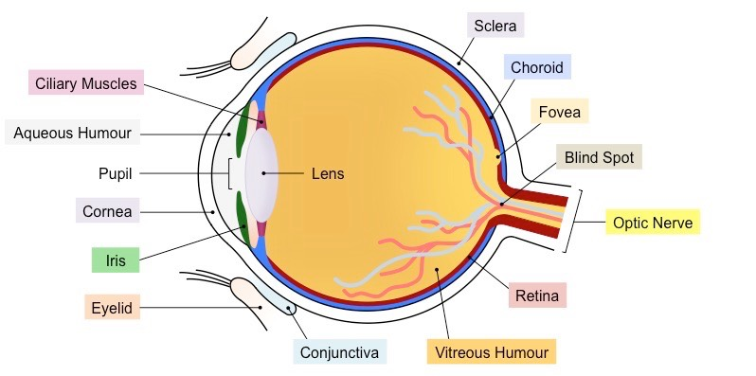

1. Draw a flowchart showing how vision works. Use the terms in the diagram to help explain what happens to the light as it enters the eye, including the function of each part.
2. Explain what myopia is, what causes it and how it can be corrected.

|  |
| --- |
|  |
|  |
|  |
|  |

1. Explain what hyperopia is, what causes it and how it can be corrected.

|  |
| --- |
|  |
|  |
|  |
|  |