**Year 10 Chemical Sciences**

**Week 1 - Atoms and Ions**

**Objectives:**

* Compare charge and mass for protons, neutrons, and electrons.
* Describe the composition of the nucleus and outer region.
* Define and show an understanding of Atomic number and Mass number.
* Use  notation to compare the composition of various atoms and isotopes.

# Compare the structure of an atom and its ion by considering the numbers of sub atomic particles and the electronic configuration using the 2,8,8 model.

# Relate electron configuration shells and valence electrons to position in the periodic table.

**Matter** is anything that takes up space and has mass and all matter is made of atoms. **Atoms** are the building blocks of matter, sort of how bricks are the building blocks of houses.

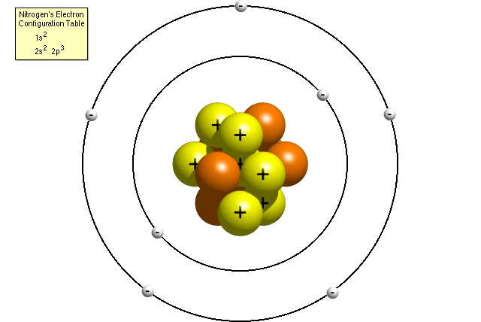

An atom has three parts:

* **Proton** = positive
* **Neutron** = no charge
* **Electron** = negative

The proton and neutron are found in the centre of the atom, a place called the **nucleus**. The **electrons** orbit the nucleus.

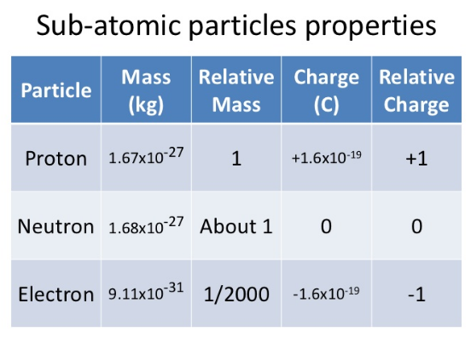

The table on the left outlines the properties of each of the particles in an atom.

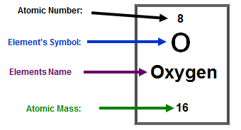**Atomic Number** is the number of protons in an element and also the number of electrons in a neutral atom of an element.

**Atomic Mass (mass number)** is the number of protons + neutrons in an isotope of an element.

These are represented on the periodic table as shown in the diagram on the right.

**[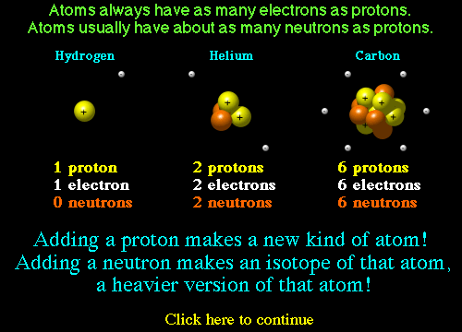](http://education.jlab.org/atomtour/fact3.html)**

**Isotopes** are atoms with the same number of protons but different number of neutrons. Different isotopes are named by their mass number as they weigh a different amount because of the different amount of neutrons they contain. Remember number of protons + neutrons = mass number.

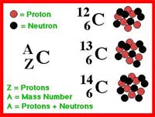

All carbons have 6 protons

C-12 has 6 neutrons

C-13 has 7 neutrons

C-14 has 8 neutrons

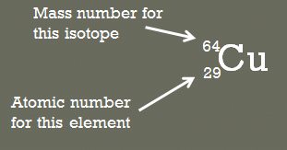Chemists often write out isotopes using a shorthand notation:



Where: A is the mass number

Z is the atomic number

X is the Element symbol

Electrons live in something called **shells or energy levels**. You can’t just shove all of the electrons in an atom into the first electron shell. Only so many can be in any certain shell as seen in the diagram below. The **electron configuration** of an atom shows the number of electrons in each shell. The electrons in the outer most shell of any element are called **valence electrons**. When an atom has an outer shell (valence shell) with **8** valence electrons then it is the most stable. That is why most atoms lose or gain electrons to form **ions** or share electrons with other atoms in order to be more stable.

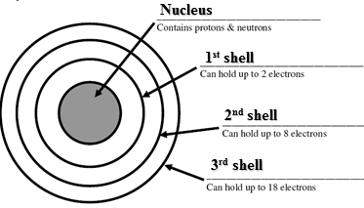

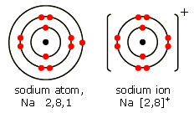For example, sodium (Na) contains 11 electrons, so a sodium atom would have an electron configuration of 2, 8, 1.

In order for sodium to be most stable it would need an electron configuration similar to the nearest noble gas. Therefore sodium loses 1 electron to have a full outer shell and becomes a positive ion in the process. The electron configuration for the sodium ion (Na+1) is therefore 2, 8

Names and Symbols of Monatomic Ions

|  |  |  |  |  |  |  |  |
| --- | --- | --- | --- | --- | --- | --- | --- |
| **1+** | | **2+** | | **3+** | | **4+** | |
| Hydrogen  lithium  sodium  potassium silver copper(I) gold(I) | H+ Li+ Na+  K+ Ag+ Cu+ Au+ | magnesium calcium barium manganese(II) iron(II) copper(II) zinc mercury(II) tin(II) lead(II)  strontium nickel(II) cobalt(II) cadmium(II) | Mg2+ Ca2+ Ba2+ Mn2+ Fe2+ Cu2+ Zn2+ Hg2+ Sn2+ Pb2+ Sr2+ Ni2+ Co2+ Cd2+ | aluminium iron(III) chromium(III)  gold(III) | Al3+ Fe3+ Cr3+ Au3+ | tin(IV) lead(IV) | Sn4+ Pb4+ |

|  |  |  |  |  |  |  |  |
| --- | --- | --- | --- | --- | --- | --- | --- |
| **1-** | | **2-** | | **3-** | |  |  |
| hydride fluoride chloride bromide iodide | H- F- CI- Br- I- | oxide  sulfide | O2- S2- | nitride | N3- |  |  |

Names and Formulae of Polyatomic Ions.

|  |  |  |  |  |  |
| --- | --- | --- | --- | --- | --- |
| **1–** | | **2–** | | **3–** | |
| hydroxide nitrate nitrite hydrogencarbonate hydrogensulfate ethanoate (acetate) permanganate cyanide *perchlorate  *chlorate  *chlorite  *hypochlorite | OH- NO3- NO2- HCO3- HSO4- CH3COO- MnO4- CN- ClO4- ClO3- ClO2- ClO- | carbonate  sulfate  sulfite  dichromate  chromate  hydrogenphosphate  oxalate  peroxide | CO32- SO42- SO32- Cr2O72- CrO42- HPO42- C2O42- O22- | phosphate | PO43- |
|  |  |  |  |  |  |
| **1+** | | **2+** | |  |  |
| ammonium | NH4+ | mercury(I) | Hg22+ |  |  |

* These names do not need to be learned.

**Week 1 Revision Questions**

1. Draw a labelled 2D sketch showing the components of a Lithium 7 atom
2. Complete the following table:

|  |  |  |  |  |  |  |
| --- | --- | --- | --- | --- | --- | --- |
| SYMBOL | NAME | ATOMIC NUMBER | MASS NUMBER | NUMBER OF PROTONS | NUMBER OF NEUTRONS | NUMBER OF ELECTRONS |
| 12  C  6 | Carbon | 6 | 12 | 6 | 6 | 6 |
| 16  O  8 |  |  | 16 |  |  | 8 |
|  | Nickel |  | 59 | 28 |  |  |
| 137  Ba  56 |  |  |  |  |  |  |
|  |  | 82 |  |  |  | 82 |
|  | Copper |  |  |  |  | 29 |
|  | Aluminium ion |  |  |  |  |  |
| 23 +  Na  11 |  |  |  |  |  |  |
|  | Sulphide ion |  |  |  |  |  |
| 14 3-  P  7 |  |  |  |  |  |  |

1. Complete the following table

|  |  |  |  |  |  |
| --- | --- | --- | --- | --- | --- |
| **Element name** | **Electron shell diagram of atom** | **Electron configuration of atom** | **Ion name** | **Electron shell diagram of ion** | **Electron configuration of ion** |
| lithium |  |  |  |  |  |
| oxygen |  |  |  |  |  |
| nitrogen |  |  |  |  |  |
| chlorine |  |  |  |  |  |
| calcium |  |  |  |  |  |
| aluminium |  |  |  |  |  |

**Year 10 Chemical Sciences**

**Week 2 – Elements and Metallic Bonding**

**Objectives:**

* Describe trends in reactivity across periods and up and down groups
* Show an understanding of this idea by classifying elements as metallic or non metallic according to their valency
* Differentiate between metal and non-metal elements. Consider:
* Physical properties such as: appearance, conductivity, malleability, and ductility, position in the periodic table, ion charge, ie only metal elements form positive ions (exceptions H+, NH4+), non metal atoms form negative ions.
* Describe the metallic bond and explain the physical properties of metals conductivity and malleability in terms of their bonding

The **Periodic Table** is a chart of all of the elements known. They are arranged in 18 **groups** (columns) and several **periods** (rows). Most of the elements known are metals and exist as solids (except mercury). The remainder of the Periodic Table are non-metals and many of these exist as gases at room temperature. There are some non-metals such as silicon (Si) that are called metalloids and they are non-metals, however they have some properties which are metallic.

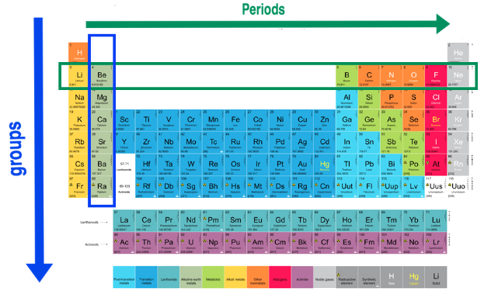

Elements in the same **group** have the same number of valence electrons in their outer shell. For example, metals in the alkali metals group (group 1) have **1** valence electron and form an ion with a **+1** charge e.g. sodium, Na+. Valence electrons are the electrons involved in bonding and therefore elements in the same group have similar properties.

Elements in the same period have the same number of electron shells.

An element that has undergone **oxidation** has **lost electrons**. Elements that lose electrons easily are strong reductants and are highly reactive. Likewise, an element that has undergone **reduction** has **gained electrons**. Elements that gain electrons easily are strong oxidants and are also highly reactive.

As elements move across the periodic table from left to right, the reducing strength decreases as the atoms give up their valence electrons less readily and the oxidising strength of these elements increases as elements gain electrons more readily.

Going down a group, the elements release their electrons more readily, making them stronger reductants. For example, potassium is a stronger reductant than sodium and therefore more reactive. See the diagram below for a graphical representation of reactivity trends.

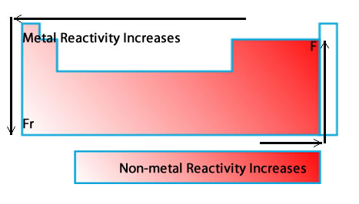

**Ionisation energy** is theenergy required to remove an electron from the outer energy level of an atom. Ionisation energy increases from left to right and from bottom to top on the periodic table.

**Electronegativity** is the ability of an atom to gain electrons. Electronegativity increases from left to right and from bottom to top on the periodic table.

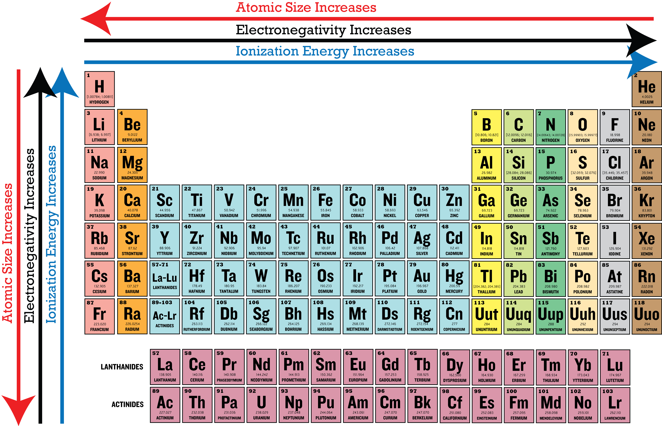

**Ions** are atoms with a **charge** and are formed by the loss or gain of **valence** electrons. **Metals** form **positive** ions with the loss of valence electrons to a **non-metal** that forms a **negative** ion. A **polyatomic** ion is an ion made up of more than one atom with a charge. For example carbonate is made up of carbon and 3 oxygen atoms with an overall charge of -2.

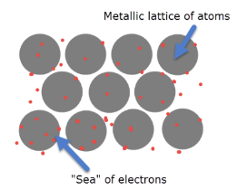

**Metals** have a **lattice** structure that is made up of positively charged cations, because the outermost or valenceelectrons are free to move away from the positively charged nucleus.

The delocalised electrons can carry a charge and therefore metals are great conductors of heat and electricity. The electrostatic attraction between the moving electrons and the cations holds the lattice structure together and means metals are very strong and apart from mercury (Hg), exist as solids. The delocalised forces of attraction in the lattice means that the metals if hit with a hammer will bend, without breaking.

The table below outlines the difference in properties of metals and non metals.

|  |  |  |
| --- | --- | --- |
| **Property** | **Metal** | **Non-metal** |
| Electrical and thermal conductivity | ***YES*** | ***NO*** |
| Hardness and strength | ***HARD*** | ***SOFT/ BRITTLE*** |
| Melting and boiling point | ***HIGH*** | ***LOW*** |
| Lustre | ***SHINY*** | ***DULL*** |
| Sound | ***SONOROUS*** | ***NON-SONOROUS*** |
| Malleable and ductile | ***YES*** | ***BRITTLE*** |

The table below outlines the properties of metallic bonds and explains why each property exists.

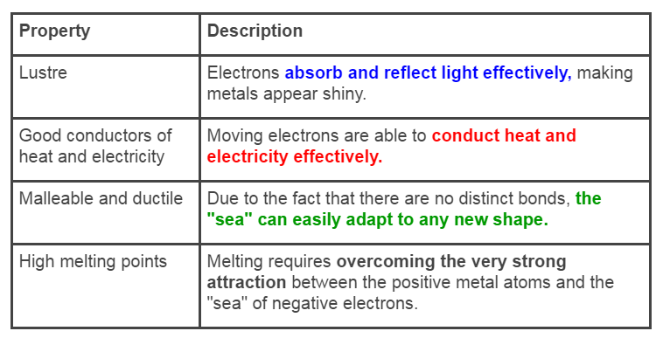

**Week 2 Revision Questions**

1. In terms of bonding, explain why aluminium is malleable.
2. In terms of bonding, explain why copper is a good conductor of electricity.

**Year 10 Chemical Sciences**

**Week 3 – Ionic Compounds**

**Objectives:**

* Show an understanding that ionic compounds consist of a combination of metal elements (or NH4+) and non metal elements, ie identify ionic compounds from their chemical formula.
* Show an understanding of the electron transfer between metal and non metal elements during the formation of ionic compounds.
* Describe the lattice structure of ionic compounds and relate this to their properties including: hardness, strength, conductivity, melting point, and boiling point
* Show an understanding that ionic compounds will be more stable than the elements from which they form because of the attraction between the opposite charged ions in the ionic lattice.
* Explain the properties of ionic compounds brittle, non conductors as solids, conductors in solution in terms of the ionic bonding
* Draw representations of ionic compounds using electron dot diagrams.
* Write balanced formula for ionic compounds using the following valencies:

H+, Na+, Mg2+, Al3+, K+, Ca2+, Cu2+, Zn2+, Ag+, Pb2+, Br-, I -, S 2-, Cl -, O 2-,F -, OH -, NO3-, CO32-, SO42-, NH4+, Fe2+, Fe3+, Ba2+, HCO3-, PO43-, CH3COO-

**Ionic** substances are made up of **positive** (usually metal) and **negative** (non-metal) ions chemically bonded. In the below diagram you can see that the sodium atom has donated its electron to the chlorine atom making the sodium atom become positively charged forming a sodium ion and the chlorine atom becomes negatively charged forming a chloride ion.

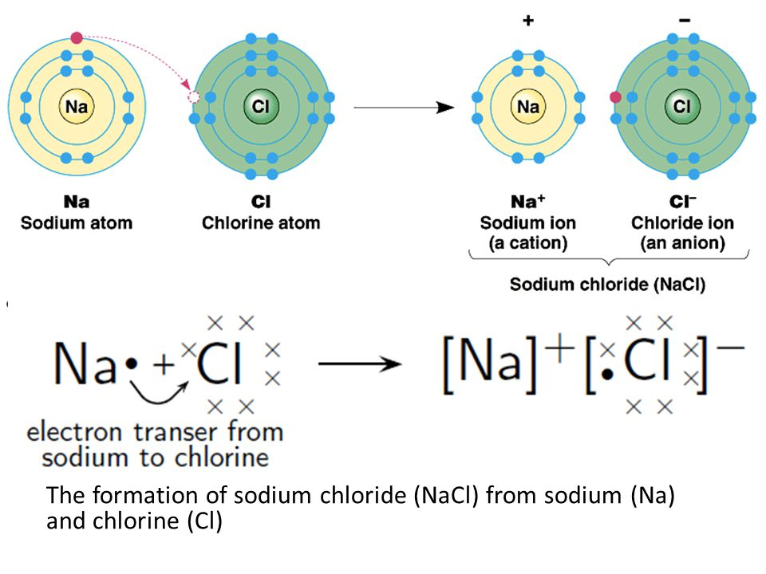

Electron **dot** diagrams (Lewis dot) show the electrons involved in **bonding**. It only shows the element symbol and its outer most shell of electrons. Transfer of electrons is involved in ionic bonding and brackets are drawn around the ions. The diagram below shows the process to creating the electron dot diagram for an ionic compound.

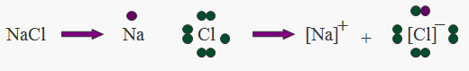

Electron dot diagrams of individual atoms

Formula of ionic compound

Electron dot diagram of ionic compound

The diagram below shows another example of the process to creating the electron dot diagram for an ionic compound.

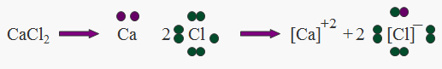

When drawing electron dot diagrams remember to:

* to only show outer shell electrons
* to put ion in brackets and show charge on the ion
* that metals lose electrons to form positive ions, so dot diagrams show***no valence electrons***and a***positive***charge
* that non-metals gain electrons to form positive ions, so dot diagrams have ***full outer shell*** and a ***negative*** charge

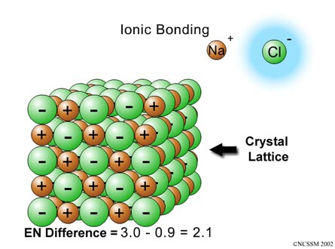Ionic substances have a **lattice** structure made up of alternating positive and negative ions, with the chemical formula indicating the smallest ratio of ions in the lattice. That is, for sodium chloride the smallest ratio of ions in the lattice is one sodium ion to one chloride ion as seen in the diagram on the right.

Ionic compounds are **hard** because of the strong electrostatic attraction between the negative and positive ions in the lattice. They are **brittle** because when pressure is applied to the lattice, ions of like-charge are forced to come close together. The repulsion force of like-charges is enough to break the lattice as seen in the diagrams below.

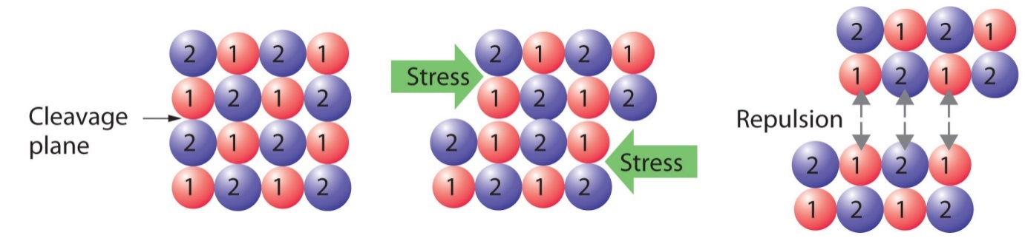

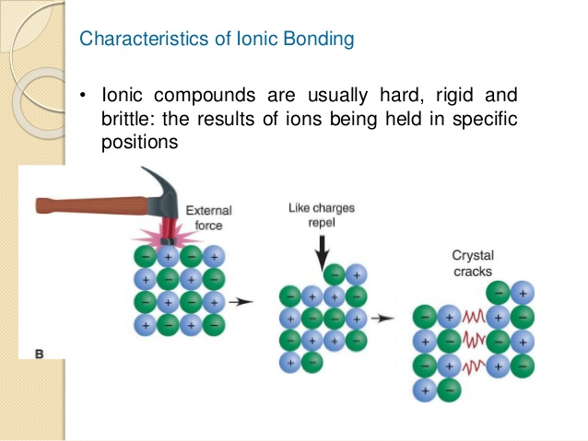

Ionic substances in their solid state **cannot** conduct electricity as the electrons are in fixed positions but if the ionic substances are **dissolved** in water (form electrolytes) or if **molten,** the ions are **free** to move and can conduct electricity.

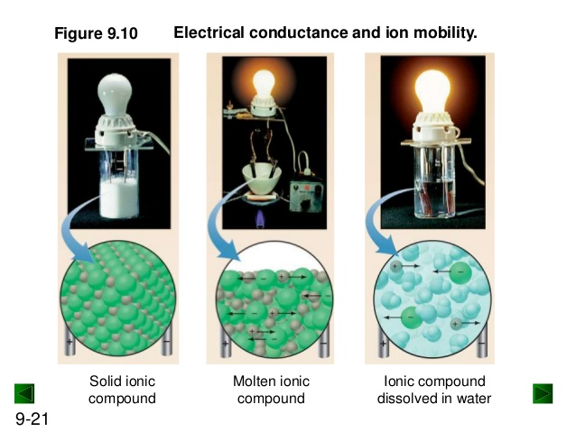

The bonding in ionic substances is formed by the **transfer** of valence electrons. This electrostatic force of attraction is very strong and means these substances *generally* have **high** melting and boiling points.

Ionic compounds are neutrally (zero) charged. That means when writing **chemical formula** for an ionic compound the amount of positive charge from the ions must equal the amount of negative charge from the ions.

When writing chemical formula the positive ion (**cation**) is always written first and the negative ion (**anion**) is always written second. The **charges** on the ions are **NOT** written in the chemical formula.

For example the compound formed from Na+1 and F-1 ions is called sodium fluoride and has the chemical formula **NaF.**

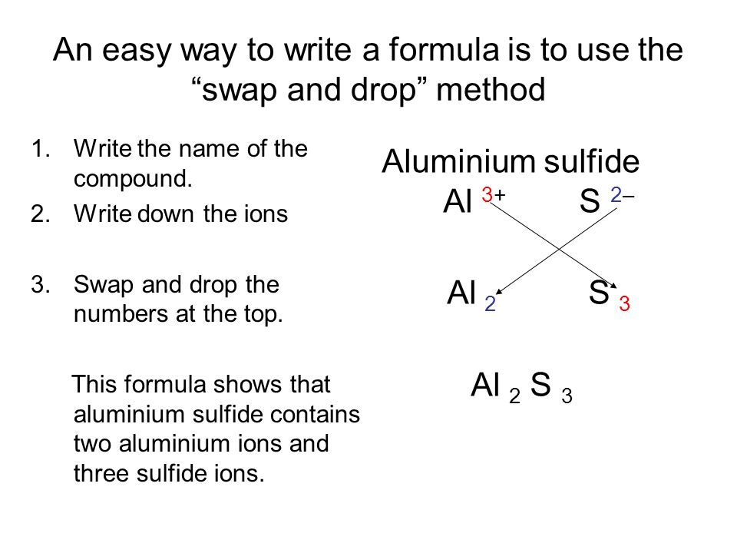

There are some simple rules to follow for naming of ionic formula

1. The positive ion is named first, then the anion (negative ion)
2. The positive ion, usually a metal, keeps its normal name
3. If the positive ion has several valencies possible, indicate its valency using roman numerals.
4. The negative ion,
   1. if it is **monatomic** (one type of atom) has the end of its name written as –ide (e.g. chloride)
   2. if it is **polyatomic** (more than one type of atom) keeps its polyatomic name (e.g. sulfate)

Examples:

|  |  |
| --- | --- |
| **Chemical Formula** | **Name of Compound** |
| NaF | sodium fluoride |
| Al2O3 | aluminium oxide |
| Mg(NO3)2 | magnesium nitrate |
| CuCl2 | copper (II) chloride |
| CuCl | copper (I) chloride |
| Fe2(SO4)3 | iron (III) sulfate |

**Week 3 Revision Questions**

1. Draw electron dot diagrams for the following ionic compounds.

3. Calcium oxide, CaO

2. Potassium chloride, KCl

1. Sodium fluoride, NaF

6. Magnesium oxide, _________

4. Lithium bromide, LiBr

5. Barium chloride, BaCl2

8. Aluminium fluoride, _______

7. Beryllium chloride, _______

9. Gallium chloride, _______

12. Caesium iodide, __________

10. Aluminium oxide, _________

11. Strontium chloride, _______

1. Complete the following word close using the terms provided in the box

bonding react electrons configuration bond compound stability shell

group shared outermost (valence) accepted

18 8 metal non-metal

Ionic ___________ involves electrons being donated or ___________ between _______ and ___________atoms.

___________ will be given and taken so that each ion in the ___________ ends up with ___________ electrons in its ___________ electron ___________.

We know there is special chemical ___________ attached to 8 electrons in the outermost (valence) e- shell because all Group _________ have this electron ___________ and do not ___________.

The only exception is He which only has 2 electrons in its outer (valence) shell.

1. Complete the following table by writing the correct **ionic chemical formula**.

|  |  |  |  |  |  |
| --- | --- | --- | --- | --- | --- |
|  | chloride | oxide | sulfate | sulfide | carbonate |
| Sodium |  |  |  |  |  |
| Potassium |  |  |  |  |  |
| Magnesium |  |  |  |  |  |
| Calcium |  |  |  |  |  |
| Hydrogen |  |  |  |  |  |
| Lead(II) |  |  |  |  |  |
| Silver |  |  |  |  |  |
| Ammonium |  |  |  |  |  |
| Copper(II) |  |  |  |  |  |
| Zinc |  |  |  |  |  |

1. Complete the following table by **naming** the ionic compounds formed

|  |  |  |  |  |  |
| --- | --- | --- | --- | --- | --- |
| Part 2 | OH-1 | SO42- | PO43- | NO3-1 | N-3 |
| Na1+ |  |  |  |  |  |
| Mn2+ |  |  |  |  |  |
| H1+ |  |  |  |  |  |
| Fe3+ |  |  |  |  |  |
| Zn2+ |  |  |  |  |  |
| Al3+ |  |  |  |  |  |
| Mg2+ |  |  |  |  |  |
| Cr3+ |  |  |  |  |  |
| K1+ |  |  |  |  |  |
| NH41+ |  |  |  |  |  |

1. In terms of bonding explain why Aluminium chloride is not malleable when Aluminium is.
2. Explain why sodium chloride does not conduct electricity in solid form but does conduct electricity when dissolved in water.

**Year 10 Chemical Sciences**

**Week 4 – Covalent Molecular Substances**

**Objectives:**

* Show an understanding that covalent molecular substances (elements or compounds) consist of a combination of non metal elements only, ie identify covalent molecular substances from their formula. (At this stage not expected to know covalent network exceptions).
* Describe covalent bonding between a pair of atoms in terms of a sharing of electrons.
* Use electron dot diagrams to represent simple singly bonded molecules.
* Describe the structure of a molecule in terms of two or more non metal atoms covalently bonded into a single entity.
* Compare the electrical conductivity of molecular solutions with ionic solutions
* Describe the structure of covalent molecular substances as consisting of a large number of molecules with very little attraction between the molecules.
* Know the names and formula for the following covalently bonded elements and compounds:

N2, O2, F2, Cl2, Br2, I2, H2O, CO2, CO, NO2, SO2, SO3, HNO3, HCl, H2SO4, H3PO4, CH3COOH.

**Covalent** bonding is the **sharing** of electrons between non-metal atoms to achieve a more stable state. To achieve this, atoms must attain the electron configuration of noble gases; I.e. eight electrons in their valence shell (***Octet Rule***).

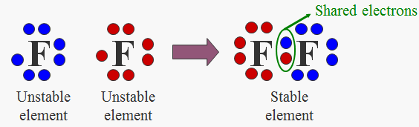This is achieved by the sharing of electrons between atoms. This creates a strong bond between atoms within the molecule (intramolecular) but the forces of attraction between molecules is usually weak and is the reason for the low melting and boiling points.

For electron dot diagrams in covalent bonding, **no** brackets are shown and all of the **valence** electrons are shown to indicate the **sharing** of electrons between the **non-metal** atoms. The example above shows the electron dot diagram for an atom of fluorine and the electron dot diagram for two atoms of fluorine bonding together.

The following are rules for correctly drawing the electron dot diagrams of covalent compounds:

* Step 1) Find valence electrons in all atoms involved. Add them together.
* Step 2) Find the ***octet*** electrons for each atom. Add them together.
* Step 3) Subtract step 1 from step 2. This will give you the bonding electrons.
* Step 4) Divide the number from step 3 by 2 (each bond is made up of 2e-).
* Step 5) Subtract step 3 from step 1. This will give you the non-bonding or lone electrons.

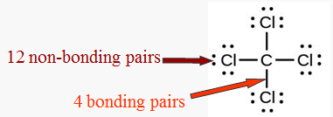Example 1 – draw Lewis structure for CCl4.

* Step 1) 4 +(7 × 4) = 32.
* Step 2) 8 × 5 = 40.
* Step 3) 40 – 32 = 8
* Step 4) 8 ÷ 2 = 4 (4 bonds)
* Step 5) 32 – 8 = 24 (12 non-bonding pairs of e-).

Covalent molecular substances are **soft** because the forces holding them together are **weak**. (weak intermolecular forces) If the forces holding the particles are weak, then little energy is required to separate the particles. This results in a **low melting point** and **low boiling point** for the substance.

Covalent molecular substances do not conduct electricity because there are **no free moving charged particles** (they are made up of atoms/molecules which are neutral). Most covalent molecular substances are insoluble in water. Those that do dissolve often react with the water or are capable of forming hydrogen bonds with the water and therefore are neutral molecules and do not conduct electricity. e.g. sugar

Rules for naming covalent compounds:

1. The element that is closer to the left side of the periodic table is named first and keeps its normal name. (If two elements are in the same group, the one closer to the bottom is named first)
2. The element closer to the right hand side of the periodic table is named second and has the end of its name changed to end in –ide.
3. Prefixes are used to indicate the number of atoms of that element present in the molecule

mono – 1, di – 2, tri – 3, tetra – 4, penta – 5

1. If there is only one atom of the first element present, the prefix mono is not used.
2. Molecules composed of only one element have the name of that element.

|  |  |
| --- | --- |
| **Chemical Formula** | **Name of Compound** |
| H2 | hydrogen |
| N2O4 | dinitrogen tetraoxide |
| PCl3 | phosphorous trichloride |
| CO2 | carbon dioxide |

**Week 4 – Revision Questions**

1. Draw electron dot diagrams for the following molecules.

1. Fluorine, F2

2. Chlorine, Cl2

3. Oxygen, O2

4. Hydrogen, H2

5. Hydrogen chloride, HCl

6. Nitrogen, N2

7. Iodine, I2

8. Methane, CH4

9. Carbon dioxide, CO2

10. Bromine, Br2

11. Fluorine chloride, FCl

12. Sulfur dioxide, SO2

1. Complete the following word close using the terms provided in the box

bonding react electrons configuration

bond 8 stability shell

group shared outermost (valence) non-metal

Covalent ___________ involves electrons being ___________between ___________ atoms.

___________ will be shared so that each atom in the ___________ends up with ___________ electrons in its ___________ electron ___________.

We know there is special chemical ___________ attached to 8 electrons in the outermost (valence) e- shell because all ___________18 have this electron ___________ and do not ___________.

The only exception is He which only has 2 electrons in its outer shell.

1. Complete the following table

|  |  |
| --- | --- |
| **Name** | **Chemical Formula** |
| oxygen |  |
|  | Cl2 |
| nitrogen |  |
|  | I2 |
| nitric acid |  |
|  | H2SO4 |
| hydrochloric acid |  |
|  | H3PO4 |
| carbon dioxide |  |
|  | SO2 |
| dinitrogen pentoxide |  |
|  | CCl4 |
| sulfur trioxide |  |
|  | P2O5 |

**Year 10 Chemical Sciences**

**Week 5 - Solutions**

**Objectives:**

* Define the terms, soluble, insoluble, solute, solvent and solution.
* Show an understanding of the dissolving process for a soluble ionic compound.
* Know that concentration of a solution can be expressed in mol L-1.
* Demonstrate an awareness of the independent nature of the ions in an ionic solution.
* Use a table of solubilities to predict the solubility of various ionic compounds.
* Use a table of solubilities to predict the formation of a precipitate when two ionic solutions are mixed.

|  |  |
| --- | --- |
| **Term** | **Definition** |
| Soluble | Substance that CAN be dissolved |
| Insoluble | Substance that CANNOT be dissolved |
| Solute | The substance dissolved in the solvent |
| Solvent | The liquid that the solute will be dissolved into |
| Solution | The mixture of solute and solvent |

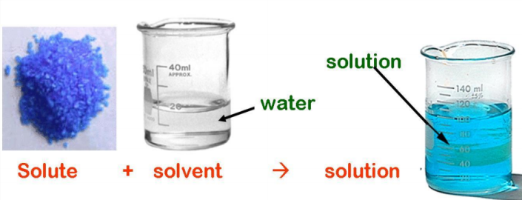A **soluble** substance is a substance that **dissolves**, such as sodium chloride (table salt) in water whereas an **insoluble** substance is a substance that **does not dissolve**, such as chalk in water.

**Solutions** form when the particles of the solute enter the solvent. The **solvent** is the substance that can dissolve other substances, such as water. The **solute** is the substance that has been dissolved in the solvent, such as sodium chloride.

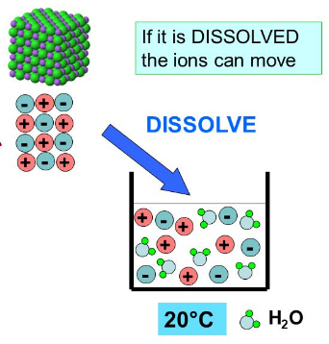Solutions have uniform properties. They may be coloured but are always clear.

When an ionic solid dissolves it breaks down to its component ions. (**dissociation**) These move freely throughout the solution and are capable of conducting an electric current (See diagram on the left).

Precipitation reactions occur when multiple soluble reactants combine to form an insoluble product, known as the **precipitate**.

A precipitate can be identified by checking the **solubility tables** to see if any of the products being formed from the reactants are insoluble.

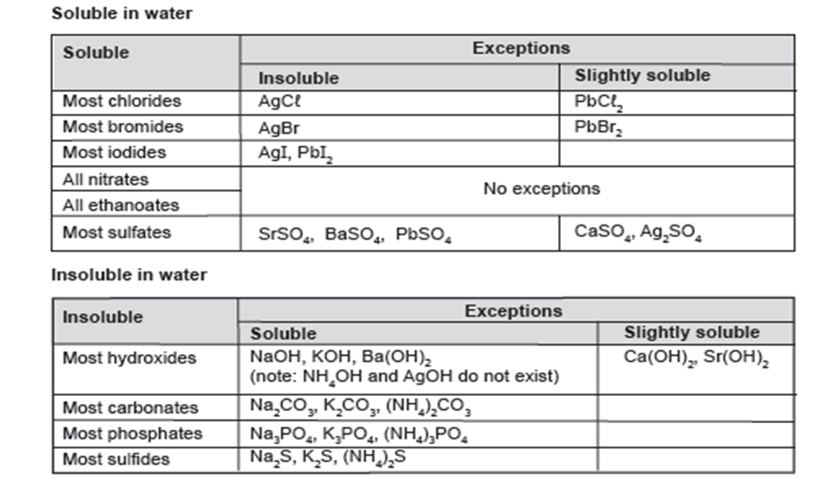

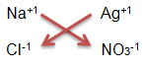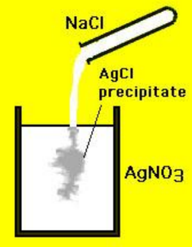If we mixed two solutions: sodium chloride solution (NaCl) with silver nitrate solution (AgNO3) we will produce a different combination of ions. The combination of Ag+1 and Cl-1 produces the precipitate, AgCl (silver chloride), seen in the diagram on the right as it is insoluble in water.

An **ionic equation** can be used to show this reaction. It only shows the species (molecules/ions/atoms) that undergo a change. In a precipitation reaction these are the ions forming the precipitate. They change from being free ions to ions locked into an ionic solid. Ionic equations are **balanced**! The other ions not included in the equation are known as **spectator ions** as they remain in solution.

Steps to writing an ionic equation:

1. Identify the precipitate
2. Write it as the product
3. Write the ions that react to form it
4. Check the equation balances

Therefore, the ionic equation for the above example is:

Ag+1(aq) + Cl-1(aq) → AgCl(s)

1. Use the solubility rules to determine if the following ionic solids are soluble or insoluble in water.

|  |  |
| --- | --- |
| **Ionic Solid** | **Soluble or Insoluble?** |
| CuCO3 |  |
| Ca3(PO4)2 |  |
| K2SO4 |  |
| MgCl2 |  |
| Ca(NO3)2 |  |
| Fe(OH)3 |  |
| BaSO4 |  |

1. For the ionic solids that are soluble in water from question 1, write ionic equations to show the ions that would be produced (dissociation).

1. Using a solubility table complete the following table. Write a balanced ionic equation leaving out the spectator ions. If there are no precipitates produced then write down no reaction.

|  |  |  |
| --- | --- | --- |
| AQUEOUS SOLUTIONS MIXED | BALANCED IONIC EQUATION | SPECTATOR IONS |
| Lead II nitrate and Potassium hydroxide |  |  |
| Copper II sulphate and aluminium chloride |  |  |
|  | 2Fe3+(aq) + 3CO32-(aq) 🡪 Fe2(CO3)3 (s) | SO42- and K+ |
|  | + 🡪 Fe3Sn2 (s) | CH3COO- and SO42- |
| Barium hydroxide and magnesium iodide |  |  |
| Strontium II iodide and Barium hydroxide |  |  |
|  | + 🡪 Ca3(PO4)2 | OH- and NH4+ |