**Year 10 Physical Science Week 1**

**Vectors and Scalars (distance, displacement, speed, velocity)**

**Objectives:**

* Explain that a description of motion requires the measurement of time intervals and distances.
* Define the differences between vectors and scalars.
  + Addition and subtraction of vectors
* Define displacement and distinguish between speed and velocity.
* Perform average velocity and average speed calculations using  and 
* Draw/interpret distance/time and displacement/time graphs

**Scalar** quantities are those which **only have a magnitude** (size or value), there is no direction for the quantity to act in, for example mass which is simply the amount of matter something has. Examples of scalar quantities are: time, mass, distance and speed.

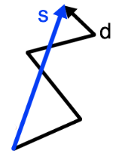**Vector** quantities are those that **have a magnitude and direction** as the direction in which they act is also important. For example, if you apply a force on something, it moves in the direction you apply the force, it can’t move in any other direction. Examples of vector quantities are: displacement, velocity, acceleration, force, work and weight.

**Distance** is a measure of the total journey from your starting position to your finishing position. (shown on the right by the black line)

**Displacement** is the shortest path from where you started to where you finished. (shown on the right by the blue line)

Example 1: Calculate the distance and displacement walked in the diagram below.

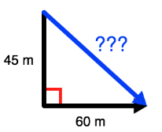

Distance = 45 + 60 = 105m

θ

To calculate displacement Pythagoras theorem is required.

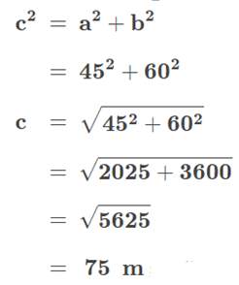

However, displacement is a vector quantity which requires a **direction**. The blue arrow is going in an approximate south-easterly direction. Therefore the actual direction will be south θ° east. We can use trigonometry to work θ out.

tanθ = opp = 60

adj 45

Θ = tan-1(1.33) = 53.1°

Therefore, the displacement is 75 m South 53.1° East.

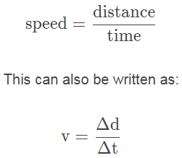**Speed** is the rate at which your distance changes. The **instantaneous** speed tells us how fast you are going at a particular instance in time. Your **average** speed is the total distance travelled divided by the total time taken for the journey. Speed is measured in metres per second (m s-1) and measurements need to be converted to these units. To convert from kmh-1 to ms-1 *divide by 3.6.*

Example 2: It took you 12 minutes to run 4.0 km to the bus, what was your average speed.

distance = 4 000 m speed (ave) = distance = 4000

time, t = 12 x 60 t 720

t = 720 s speed (ave) = 5.6 m s-1

**Velocity** is the rate of change of displacement. I**nstantaneous** velocity is your velocity at that moment in time. Your **average** velocity is your displacement divided by the total time taken for the journey.

Example 3: You run one kilometre west then 0.50 km east in 4.5 minutes. What is your average velocity for the run?

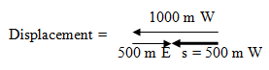

 

*v*av = 1.9 m s-1 west

s = 500 m W

t = 4.5 minutes

= 4.5 x 60

= 270 s

## Average velocity can also be calculated by finding the average of two velocities.

## Example 4: You run 4.6 ms-1 east then 6.5 m s-1 east, what is your average velocity?



*v*av = 5.6 m s-1 East

We can use **distance-time graphs** and **displacement-time graphs** to:

* Read directly from the graph to find the distance travelled or the displacement of an object at particular times, or vice versa; and to
* Calculate the speed or velocity of the object (from the gradient of the graph)

Example 5

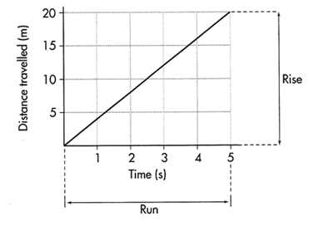

The graph on the right tells us that:

* the object travelled 20 m in 5 s
* from the gradient of the graph we get:

gradient = rise ÷ run

= distance ÷ time

= average speed

= 20 ÷ 5

= 4 m s-1

* because the gradient of the graph is constant, we can also say that the speed was constant

Example 6

The graph on the right tells us that:

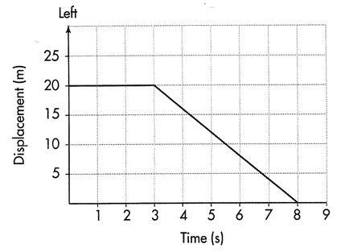

* the object was at a displacement of 20 m to the left of the zero displacement position at time zero and stayed there for 3 s
* at t = 3 s, the object moved towards the zero displacement position and arrived there at t = 8 s
* the total distance travelled by the object was 20 m
* the object covered the 20 m in 5 s
* its average speed while moving was therefore 4 m s-1
* its average velocity while moving was 4 m s-1 towards zero displacement or

4 ms-1 to the right (gradient has a negative slope)

Example 7

The graph on the right tells us that:

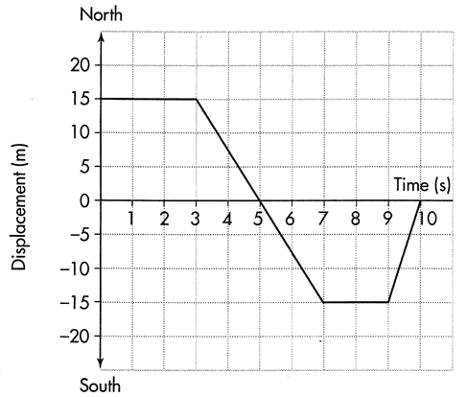

* the object was 15 m north of zero displacement for 3 s
* between 3 and 5 s it travelled south and reached zero displacement at 5 s
* in making this journey it travelled at a velocity of 7.5 ms-1 (the gradient) towards the south
* it kept going at this velocity until it was 15 m south of the zero displacement position
* it stopped for 2 s
* it then travelled north at 15 ms-1 for 1 s, which brought it back to the zero displacement position
* the object travelled a total distance of 45 m
* the displacement of the object for the whole journey was 15 m south

**Questions**

1. A student takes 45.0 minutes to walk to school which is 2.60 km, due west from her house.
   1. What is her average velocity?
   2. In reality the distance she travels is really 3.20 km, because of the route she takes, what is her average speed?
2. In an experiment on scalar and vector quantities, Tyler throws a ball 3.20 m east to Matthew who then throws it 4.50 m west to Daniel. The boys then measured the distance and displacement of the ball.
   1. What distance did the ball travel?
   2. What was the ball’s displacement?
3. A distance/time graph shows ______________________

Exercise: Consider the following graph of a families’ 3 hour journey (leave in km, h, kmh-1)

Describe the journey. ________________________________________________________________________________________________________________________________________________________

Calculate the speed in each of the three sections of the graph (leave in kmh-1, h and km)

* section one:
* section two:
* section three:



The problem with a distance/time graph is that it doesn’t show direction of motion. In actual fact, the family travelled to the shopping centre, bought their weekly shopping, and then returned home to put the shopping away. To determine the actual direction something moved, we need a displacement/time graph.

1. A displacement/time graph shows __________________________ 

This is shown in the graph below of our families shopping journey.

Exercise: The car travelled forward in the first hour, stopped to shop for an hour and then travelled back home in the last hour.

Now work out the velocity for each section (leave in kmh-1, hours and km)

section one:

section two:

section three:

You can now see that the sign in front of the velocity gives the direction.

1. Exercise: List the differences between the two graphs of the same journey.

______________________________________________________________________________________________________________________________________________________________________________________________________________________________________________________________________________________________________________________________________________________________________________________________________

1. Exercise: Alan is practicing for a bicycle race. He starts out from home and rides 50 km east in 4.0 hours; he then travels at a comfortable 20 km east in 3.0 hours, he stops for lunch for 2 hours, then returns to his home in 5 hours.

East

Draw the graph then calculate the velocity for each section of the graph (leave in kmh-1, hours and km)

__________________________________________________________________________________________________________________________________________________________________________________________________________________________________________

Calculate the total distance travelled = __________________________________________

and the total displacement = __________________________________________________

1. Exercise**:** Consider the following graph which shows the journey of a toy boat on a large pond travelling west.

Explain why this graph is curved then calculate this car’s acceleration using the values in the question and graph.

________________________________________________________________________________________________________________________________________________________________________________________________________________________________________________________________________________________________________________________

west

Describe the journey including the velocities.

____________________________________________________________________________________________________________________________________________________________________________________________________________________________________________________________

1. Exercise**:** To determine the acceleration of a car, officials measure how long it takes for the car to get from a standstill to 60 miles per hour (96.56 kmh-1).