



ATAR Chemistry Unit 1 : Bonding

**Year 11 Science**

ATAR Chemistry Unit 1 : Bonding

© Department of Education WA 2020

Except where indicated, this content is © Department of Education Western Australia 2020 and released under a Creative Commons CC BY NC licence. Before re-purposing any third-party content in this resource refer to the owner of that content for permission.

Requests and enquiries concerning copyright should be addressed to:

Manager Intellectual Property and Copyright

Department of Education

151 Royal Street

EAST PERTH WA 6004

Email: [copyright@education.wa.edu.au](mailto:copyright@education.wa.edu.au)



<https://creativecommons.org/licenses/by-nc/4.0/>

**Year 11 ATAR Chemistry Unit 1 2020**

**Topic: Bonding**

## ***Instructions to Students***

This resource package provides students with learning materials for the Chemistry ATAR Year 11 course. The package focuses on the topic **Bonding.**

This package is designed to support the program students are completing at their school. If feedback is required when completing this package, students should consult their teacher.

This resource package consists of:

* The **Notes/summary** which provides an explanation of syllabus content concepts. This section is designed to develop the knowledge component of the syllabus.
* The **Exercises** which provides an opportunity for students to check their understanding of the content.

It is recommended that students further investigate concepts covered in this resource package by conducting their own research using the text/s that they use at school/other resources available or the internet.

Statements inside a red box are Syllabus Points.

Chemical bonds are caused by electrostatic attractions that arise because of the sharing or transfer of electrons between participating atoms; the valency is a measure of the bonding capacity of an atom.

**BONDING**

Essentially, chemical bonds are the force holding atoms, ions or molecules together.

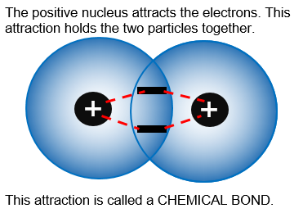

The forces are **electrostatic** - a balance of the attraction of oppositely charge particles and the repulsion of similarly charged particles.

Image by SB

There are three types of chemical bonding. The types of bonds formed depend on the outer electron configuration of atoms and the nature of the atoms which are being bonded.

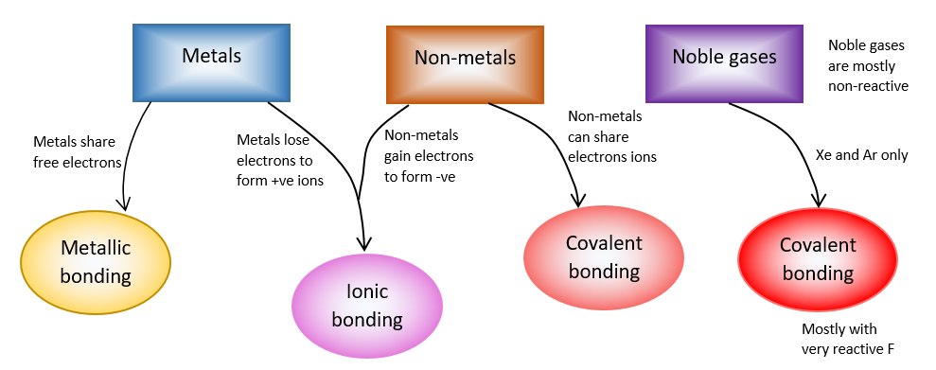

Image by SB

The structure of a substance depends on:

i. the nature of the particles present. ii. the force holding the particles together.

Bonding that occurs inside substances is due to INTRAMOLECULAR FORCES.

Elements can be classified into 4 groups:

i. metals,

ii. covalent molecular substances,

iii. covalent network elements.

iv. ionic substances

Melting points of most non-metal elements and most compounds tend to be low - exceptions include: carbon and silicon, SiC and SiO2.

Metallic elements have a wide range of melting points, but they are generally high. Compounds formed between metals and non-metals have high melting points.

**Metallic Bonding**

Metallic bonding can be modelled as a regular arrangement of atoms with electrostatic forces of attraction between the nuclei of these atoms and their delocalised electrons that are able to move within the three dimensional lattice.

Chemists have devised a model about the structure of metals:

i. the outermost or valence electrons in metal atoms move about freely with in a three-dimensional arrangement or lattice of positively charged metal ions.

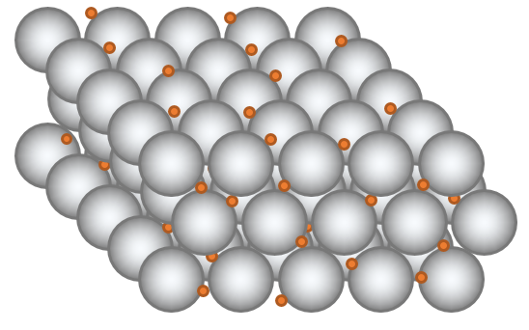ii. consists of positive ions surrounded by a ‘sea’ of electrons.

iii. valance electrons are delocalised - they are not associated with a particular metal ion and move through the lattice of metal ions. The number of electrons that are removed from each atom is related to the valence of the atom.

* 1. the negatively charged electrons are attracted to the positively charged metal ions in the lattice and this electrostatic attraction holds the lattice together - metallic bonding.

Image by SB

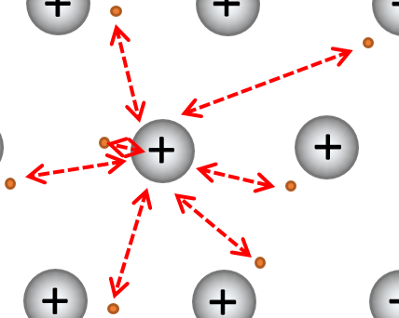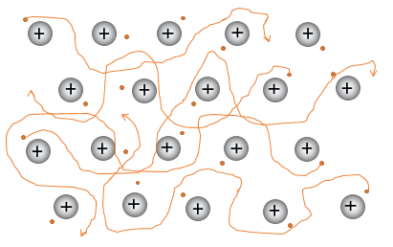

Images by SB

The metallic bonding model can be used to explain the properties of metals, including malleability, thermal conductivity, generally high melting point and electrical conductivity

**Metallic Properties**

All metallic substances tend to be solid at room temperature; with exception of liquid mercury.

Physical characteristics (properties) that all metals share include:

* good conductors of electricity
  + Metals conduct electricity because of the mobility of the electrons within the lattice.
  + Electrons entering one end of the metal cause a similar number of electrons to displaced from the other end and the metal conducts.

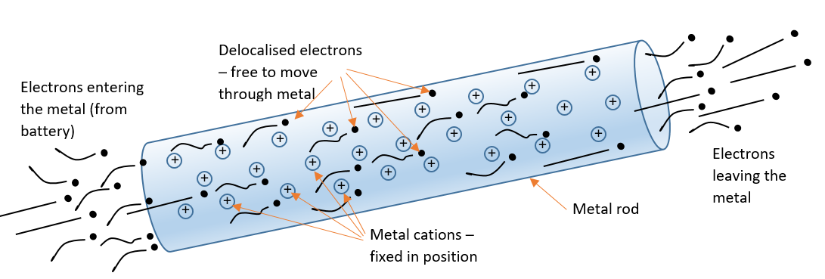

Image by SB

* good conductors of heat
* Metals contain delocalised electrons: electrons which are not associated with a particular metal ion and move through the lattice of metal ions - these mobile electrons acquire heat from a heat source and rapidly transfer it to cooler parts of the lattice.
* have shiny surface when freshly cut or cleaned (lustre)
* malleable and ductile
* Because the delocalised electrons do not belong to any particular atom, if enough force is applied, one layer of atoms can slide over another layer without disrupting the metallic bonding.
* Metals are malleable – they can be easily bent without breaking. This is because the delocalised electrons are not attached to one particular atom and the forces of attraction between the electrons and the positive ion are said to be non-directional. Any stress on the metal can push it out of shape but the very strong forces of attraction still exist.

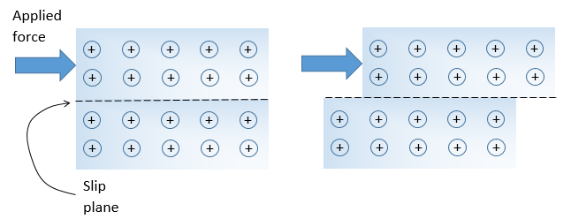

Image by SB

* relatively high melting points.
* Metals have high melting and boiling points due to strong electrostatic attraction between the positive metal ions and the delocalised electrons.
* Group II of the periodic table form the strongest metallic bonds because they tend to form di-positive metal ions and lose two electrons per atom.
* relatively dense solids.
* The above physical characteristics have enabled scientists to make a number of inferences about the metals:

i. The high densities indicate that the atoms are packed tightly together.

ii. Malleability and ductility indicates that there is only limited resistance to movement of atoms with respect to each other.

iii. Electrical conductivity indicates that metal contain mobile charged particles.

**Uses of Metals**

i. Aluminium - used in domestic utensils, drinks cans, cooking foil etc. Used due to its thermal conductivity, malleability and attractive lustre.

ii. Copper - electrical wiring; excellent conductors of electricity.

Watch these videos on metallic bonding <https://youtu.be/S08qdOTd0w0>

<https://youtu.be/eVv3TpaQ2-A> <https://youtu.be/yfuNUtZgI4A>

**Exercise 1: Problem Set –** these questions are to assist your understanding. Complete the following then check your answers at the back of the book.

1. For an element to be a metal what is the major characteristic of the valence electrons of the element?
2. List four properties of metals and show how these properties can be explained in terms of the ‘delocalised electrons’ model of metallic bonding.
3. Mercury has a melting point of -38.9 oC and tungsten has a melting point of 3410 oC. What does this indicate about the metallic bond?
4. Explain why:
5. copper is used in wiring a house
6. titanium is used in the production of airplanes.

**IONIC COMPOUNDS**

Ions are atoms or groups of atoms that are electrically charged due to a loss or gain of electrons; ions are represented by formulae which include the number of constituent atoms and the charge of the ion   
(for example, O2–, SO42–).

The basic particles which make up ionic compounds are ions: electrically charged atoms which have lost or gained electrons.

**Simple Ions**

**Cations** - positively charged atoms which are formed when one or more electrons are removed from an atom.

**Anions** - negatively charged atoms which are formed when one or more electrons are gained by an atom.

Elements that are cations are metallic elements - exception hydrogen and ammonium. Anions are non-metal atoms.

**Polyatomic Ions**

Polyatomic ions are groups of atoms bonded to one another which have a net positive or negative charged.

Examples include: phosphate, PO43-, carbonate CO32-, ammonium NH4+.

The types of bonds holding the atoms within the polyatomic ion together are chemical bonds similar to those involved in molecules (i.e. covalent bonds).

The formulae of ionic compounds can be determined from the charges on the relevant ions.

**Writing formulae for ionic compounds**

Ionic compounds are electrically neutral.

Total positive charge must equal total negative charge.

* + Sodium chloride
  + Na+ has a +1 charge, Cl- has a -1 charge.
  + A crystal of sodium chloride has the ratio of Na to Cl as 1:1 – NaCl.
  + Magnesium chloride
  + Mg2+ has a +2 charge, Cl- has a -1 charge.
  + A crystal of magnesium chloride needs two chlorines for each magnesium and has the ratio of Mg to Cl as 1:2 – MgCl2.

The system used for naming ionic compounds:

i. The name of the positive ion is written first.

ii. The name of the negative ion is written second and ends in –ide.

iii. Where the ionic compound has water molecules of crystallisation, the number of water molecules is indicated.

Example: Sodium carbonate-10-water = Na2CO3.10H2O

Students should be able to recognise and write the formula of the following ions and molecules:

|  |  |  |  |  |
| --- | --- | --- | --- | --- |
| **Ion name** | **Formula** |  | **Ion name** | **Formula** |
| 1+ ions | |  | 1- ions | |
| ammonium |  |  | bromide |  |
| caesium |  |  | chloride |  |
| hydrogen |  |  | cyanide |  |
| lithium |  |  | dihydrogenphosphate |  |
| potassium |  |  | ethanoate (acetate) |  |
| rubidium |  |  | fluoride |  |
| silver |  |  | hydrogencarbonate |  |
| sodium |  |  | hydrogensulfate |  |
| 2+ ions | |  | hydroxide |  |
| barium |  |  | iodide |  |
| calcium |  |  | nitrate |  |
| cobalt(II) |  |  | nitrite |  |
| copper(II) |  |  | permanganate |  |
| iron(II) |  |  | 2- ions | |
| lead(II) |  |  | carbonate |  |
| magnesium |  |  | chromate |  |
| manganese(II) |  |  | dichromate |  |
| nickel(II) |  |  | hydrogenphosphate |  |
| strontium |  |  | oxalate |  |
| zinc |  |  | oxide |  |
| 3+ ions | |  | sulfate |  |
| aluminium |  |  | sulfide |  |
| chromium(III) |  |  | sulfite |  |
| iron(III) |  |  | 2- ions | |
|  |  |  | nitride |  |
|  |  |  | phosphate |  |

Remember these valances.

This video is on Naming Compounds <https://youtu.be/PPfLDdIfOVA>

**Exercise 2:** these questions are to assist your understanding. Complete the following then check your answers at the back of the book.

Write the ionic formula for the following:

potassium chloride lead oxide

sodium sulphate  aluminium oxide

nickel hydrogen phosphate iron (III) oxalate

Name the following ionic compounds:

Na2SO3  Al2(Cr2O7)3

CrN  (NH4)2CO3

CuNO2  NaHSO4

The structure of an ionic solid can be best described by using an example such as sodium chloride NaCl:

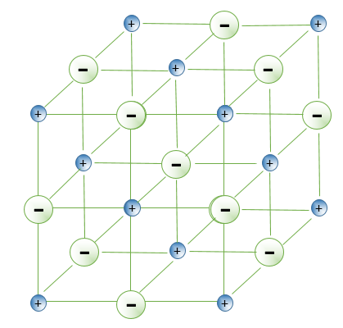

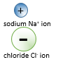i. ions in the crystal are arranged in a regular three-dimensional lattice.

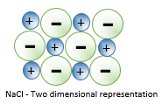ii. each sodium ion is surrounded by six negative chloride ions and each negative chloride ion is surrounded by six positive sodium ions.

iii. when a solid, the position of the ions is fixed.

In ionic solids ions are held in the crystal lattice by strong electrostatic attraction to the oppositely charged ion around it - called ionic bonding.

Image by SB

Ionic compounds form between metal and non-metal elements. All substances formed when metals from groups I and II of the periodic table react with non-metals from groups VI and VII are ionic compounds.

Watch this video on Giant Ionic structures <https://youtu.be/PNKsbnH1vw8>

Ionic bonding can be modelled as a regular arrangement of positively and negatively charged ions in a crystalline lattice with electrostatic forces of attraction between oppositely charged ions.

**Formation of Ionic Compounds**

An ionic compound forms when a metal and a non-metal element react. During this reaction the metal atoms lose electrons to form positive ions and the non-metal atoms gain electrons to form negative ions.

Ionic compounds are generally formed between two atoms that have a large difference in their electronegativity. An atom like Na has a low electronegativity and will not attract electrons. Cl has a high electronegativity and strongly attracts electron.

In this exchange of electrons, both metal and non-metal atoms achieve a noble gas electron configuration (octet rule).

Take NaCl as an example:

* Na (2,8,1) lose one electron to become Na+ (2,8) ; same e- configuration as Ne (noble gas)
* Cl (2,8,7) acquires an electron to become Cl- (2,8,8) ; same e- configuration as Ar (noble gas)

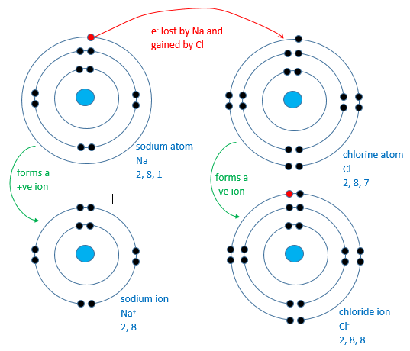

Image by SB

The electrostatic attraction between the billions of positive Na+ ions and negative Cl- ions form into an orderly array

Image by SB

The ions create a massive crystal lattice, rather than individual molecules. The ratio on Na’s to Cl’s is 1:1, hence the formula NaCl.

The ionic bonding model can be used to explain the properties of ionic compounds, including high melting point, brittleness and non-conductivity in the solid state; the ability of ionic compounds to conduct electricity when molten or in aqueous solution can be explained by the breaking of the bonds in the lattice to give mobile ions.

**Properties of Ionic Compounds**

The physical properties of ionic compounds are:

* Hard and brittle
* Strong attractive force exists between oppositely charged ions; if a layer of crystal is forced to slide past another layer, the orderly arrangement of ions is disturbed. Ions of similar charge are forced closer to another with an increase in repulsive forces and decrease in attractive forces - the crystal fractures.

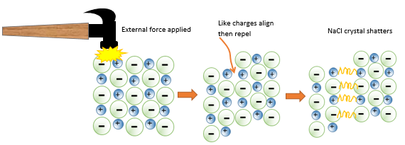

* This makes ionic compounds:

i. hard

ii. brittle, and

iii. difficult to cut

Image by SB

* Non-conductors of electricity in the solid state, but good conductors when molten or in aqueous solution.
* An ionic solid does not conduct electricity; the ions are in fixed positions and cannot move. However, molten ionic compounds and ionic compounds dissolved in water conduct electricity because the ions are free to move. They do not conduct electricity as well as metals.

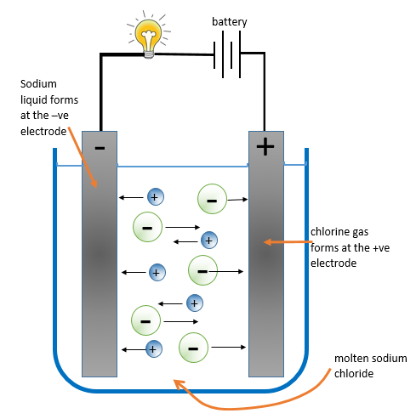

* The conductivity of molten ionic compounds suggests that ionic substance contain positively charged metal ions and negatively charged non-metal ions. Particles which are free to move when in the molten state.

classroomclipart.com and SB

* High melting and boiling points.
* Strong electrostatic forces of attraction extend throughout lattice keeping ions in fixed positions, high temperature needed to disrupt bonds.
* Solubilities in water vary but they are not soluble in non-polar solvents like oil.

**Exercise 3:** these questions are to assist your understanding. Complete the following then check your answers at the back of the book.

Why will a magnesium sulphate crystal shatter when you hit it with a hammer but magnesium will not? Explain fully. (Use diagrams to assist you)

Watch these videos on Ionic Compounds and their properties <https://youtu.be/TxHi5FtMYKk> <https://youtu.be/1QUFlYa5jjI>

**Electron dot diagrams of Ionic Compounds**

Electron dot diagrams are a simple way of showing the arrangements of valence electrons around atoms and the changes that occur as atoms react with each other.



**Exercise 4:** these questions are to assist your understanding. Complete the following then check your answers at the back of the book.

Draw the electron dot diagrams for the following atoms:

H Na Mg Cl O

Electron dot diagrams can be used to represent the formation of ions in ionic bonds eg.

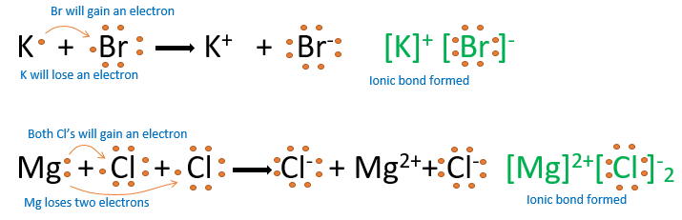

**Exercise 5:** these questions are to assist your understanding. Complete the following then check your answers at the back of the book.

Draw the electron dot diagrams of the following:

Magnesium oxide

Aluminium oxide

Calcium Iodide

Watch the following video on ionic bonding <https://youtu.be/zpaHPXVR8WU>

**Exercise 6:** these questions are to assist your understanding. Complete the following then check your answers at the back of the book.

Predicting the elements in an ionic compound

* Only consider the elements which gain or lose electrons to become like the Noble Gases for these questions.
* From a formula of an ionic compound you can work out what the possible charges are on the pair of ions.
* For example P2Q tells us that P is positively charged (because it is written first) and its charge is HALF the value of the negative charge on Q (the one written second). So P could be +1 and Q be -2, this would give a formula P2Q. But P could also be +2 with Q -4, this would also give P2Q.
  1. If we have a formula PQ3 and the electronic configuration of both ions is 2, 8 then what are the possible identities of P and Q?
  2. If the formula of a simple salt made up of just two elements is JX2 and the ions have the same electron population of Argon then what are the possible identities of J and X?
  3. Krypton has the same electron configuration as both ions in an ionic substance whose identity is hidden in a general formula ZD. What are THREE possible element combinations that agree with this formula ratio?
  4. What is the identity of the two elements in ionic substance RA3 where the metallic element is like neon in its electronic configuration and the non-metal ion is like Krypton?
  5. What is the identity of the elements in GL if the cation has electron population 2, 8, 8 and the element L has electron population 2, 8, 6?

6. Explain why in potassium chloride there must be the same number of potassium ions and chloride ions whereas in magnesium chloride there are twice as many chloride ions as magnesium ions.

Covalent bonding can be modelled as the sharing of pairs of electrons resulting in electrostatic forces of attraction between the shared electrons and the nuclei of adjacent atoms.

**COVALENT COMPOUNDS**

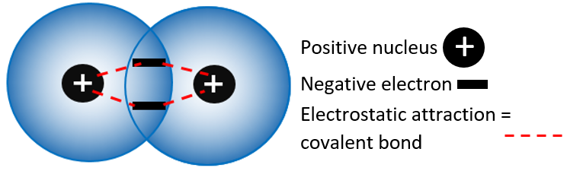

**Covalent bond** - occurs when non-metal atoms in a molecule share electrons and is held together by the directional electrostatic attraction between the shared electrons and the nuclei of adjacent atoms.

Image by SB

Covalent bonds are formed between atoms that have similar electronegativities. No atom is strong enough to pull away the electrons in a bond so they are shared.

A covalent bond can be represented in a number of ways, as shown with chlorine, Cl2.

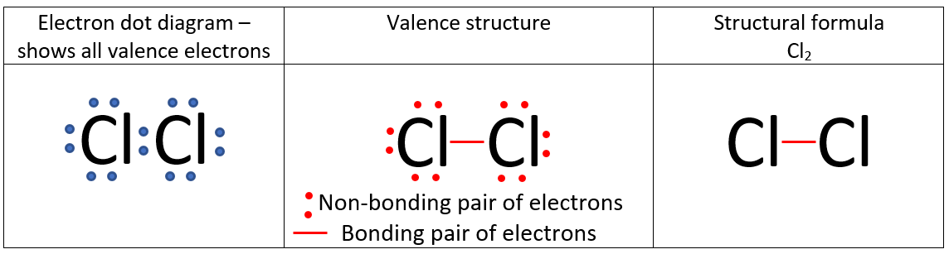

A covalent bond is created by the sharing of a **pair of electrons**.

The electrons are arranged so that each atom has atom has a share of 8 e-’s. This creates an octet – a very stable arrangement. (Smaller atoms like H will share 2 e-’s.)

These are known as bonding electrons.

Other electrons surrounding the F atom are non-bonding electrons, also known as **lone pairs**.

Sometimes atoms will share more than 2 e-’s to become stable. These arrangement of electrons create multiple bonds, double bonds or triple bonds.

The atoms will bond to have a share of 8 e-’s.

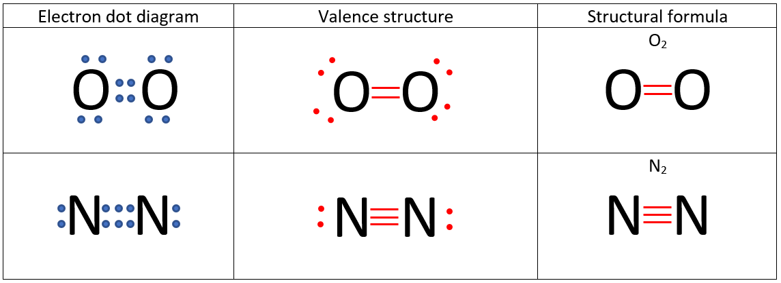

Covalent compounds are divided into two different groups:

1. **Covalent molecular substances**
2. **Covalent network substances**

Watch this video on ionic and covalent bonding <https://www.youtube.com/watch?v=QqjcCvzWwww&feature=emb_title>

The properties of covalent molecular substances, including low melting point, can be explained by their structure and the weak intermolecular forces between molecules; their non-conductivity in the solid and liquid/molten states can be explained by the absence of mobile charged particles in their molecular structure.

**Covalent molecular substances**

Many elements exist in nature as simple molecules. A molecule is a group of two or more atoms held together by chemical bonds. Some elements which exist as molecules include:

Hydrogen gas - H2

Oxygen gas - O2

Nitrogen - N2

Fluorine - F2

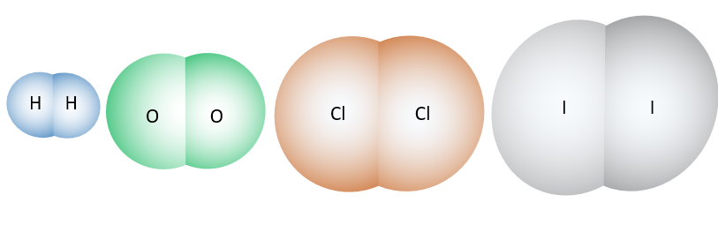

H2 O2 Cl2 I2

Image by SB

hydrogen oxygen chlorine iodine

These are diatomic molecules: molecules which consist of two atoms bonded together.

Other non-metal elements exist as polyatomic molecules: consist of several atoms bonded together in the molecule. Examples include - phosphorous, P4, and sulphur, S8.

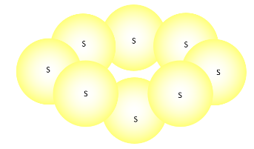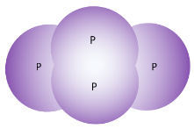

Images by SB

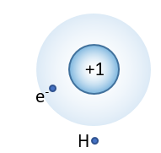Forming a molecule, for example, Hydrogen gas.

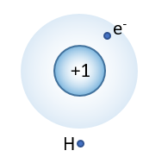

i. both hydrogen atoms have an electron configuration of 1s1 or 1.

ii. both need one electron to attain the electron configuration of helium.

ii. both need one electron to attain the electron configuration of helium.

iii. both have the same ionisation energies so electron transfer cannot occur.

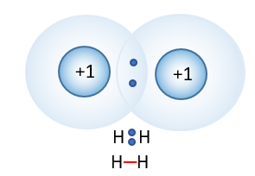iv. instead each H atom shares it single 1s1 electron - each atom has the stable electron configuration of He.

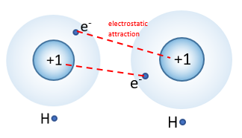

Images by SB

hydrogen atom hydrogen atom hydrogen molecule

Noble gases exist as simple atoms since all the orbitals of are fully occupied, so no covalent bond formation is possible.

Examples of molecules and noble gas atoms:

|  |  |  |  |
| --- | --- | --- | --- |
| **Name** | **Formula** | **Name** | **Formula** |
| Argon  Bromine  Chlorine  Helium  Hydrogen  Fluorine  Iodine | Ar  Br2  Cl2  He  H2  F2  I2 | Krypton  Neon  Nitrogen  Oxygen  Ozone  Phosphorous  Sulphur | Kr  Ne  N2  O2  O3  P4  S8 |

**Properties of Covalent Compounds**

Covalent molecular substances have the following properties in common:

1. They have low melting points and boiling points – many are liquids or gases at room temperature.

*The forces that attract the molecules to each other are weak.*

1. They are non-conductors of electricity in both solid and liquid states.

*No charged particle that are free to move.*

1. They form solids that are generally quite soft and often have a waxy appearance.

*The forces that attract the molecules to each other are weak.*

1. Tend to be malleable rather than shatter.

*The forces that attract the molecules to each other are weak so molecules can easily move relative to each other.*

1. They exist as molecules.
2. Many are insoluble in water but soluble in non-polar solvents like petrol.

*Solubility depends on intermolecular forces between molecules, which can vary.*

1. Many have an odour.

Watch this video on Properties of Covalent Structures <https://youtu.be/d2ogZgGmMDY>

**Exercise 7:** Problem Set. These questions are to assist your understanding. Complete the following then check your answers at the back of the book.

1. Why does a covalent molecular substance not conduct electricity?
2. Why does sulphur (S8) melt at 115.2 °C and carborundum (SiC) at 2730 °C? Explain fully.
3. Name four properties of covalent network substances.

**Names and formulae of Covalent Molecular Substances**

In covalent molecular compounds the formula represents the number of atoms of each element in one molecule of the compound:

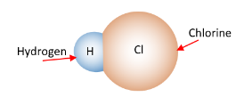

i. hydrogen chloride:

HCl - contain 1 atoms of hydrogen and 1 atom of chlorine.

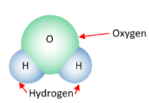ii. water:

H2O - contains 2 atoms of hydrogen and 1 atom of oxygen

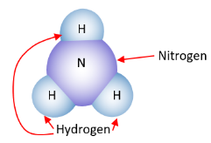

iii. ammonia:

NH3 - contains 1 atom of nitrogen and 3 atoms of hydrogen

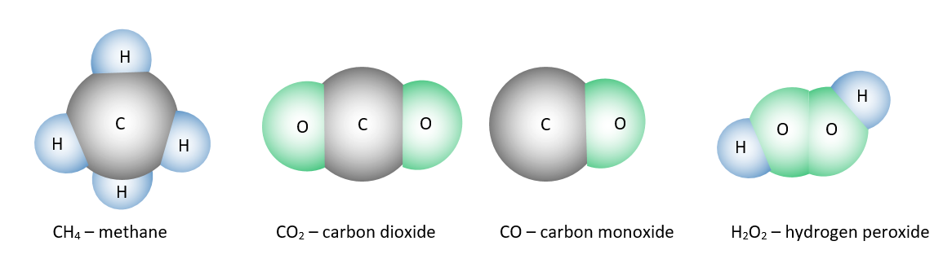

Images by SB

The procedure used to name molecular compounds:

1. The name of the elements closer to the bottom or left hand-side of the periodic table is written first.
2. The second part of the name is obtained by adding the suffix, ‘ide’, to the stem of the name of the second element.
3. Where a molecule contains more than one atoms of one type the number of atoms is indicated by a prefix:

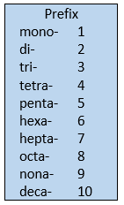

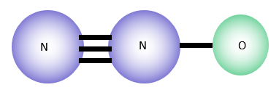Naming molecular compounds.

Example: N2O

* Name the first element: nitrogen
* Name the second element using ‘ide’: oxide
* Add prefixes: dinitrogen monoxide

Common molecules that have non-systematic names:

|  |  |
| --- | --- |
| **Molecule name** | **Formula** |
| ammonia |  |
| water | O |
| hydrogen peroxide |  |
| ethanoic acid |  |
| hydrochloric acid |  |
| nitric acid |  |
| carbonic acid |  |
| sulfuric acid |  |
| sulfurous acid |  |
| phosphoric acid |  |

This video is naming covalent compounds <https://youtu.be/HYmRIbLya_8>

**Exercise 8:** Problem Set. These questions are to assist your understanding. Complete the following then check your answers at the back of the book.

Complete this table:

|  |  |  |
| --- | --- | --- |
| Molecular Formula | Systematic Name | Common Name |
| CO |  |  |
| CO2 |  |  |
| N2O |  |  |
| NO |  | Nitric oxide |
| NO2 |  |  |
| N2O4 |  |  |
| SO2 |  |  |
| H2O |  |  |
| H2O2 |  |  |
| H2S |  |  |
| HF |  |  |
| HCl |  |  |
| NH3 |  |  |
| CCl4 |  |  |

For a summary on bonding have a look at the following URL <https://www.bbc.co.uk/bitesize/guides/zwxp8mn/revision/1>

**Intramolecular and Intermolecular forces**

* **Intramolecular forces**: The internal bonding that exists within compounds. These include covalent molecular substances (e.g. iodine):

1. 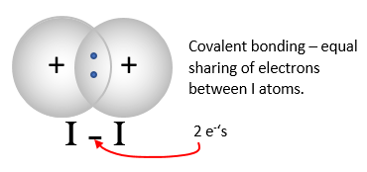Exist as directional electrostatic forces between the nuclei and the shared electron pairs.
2. Large amount of energy is required to separate iodine molecules into individual atoms (break covalent bond):

Images by SB

I2 (g) → 2I (g)

1. Strong bonding forces exist between iodine atoms within the iodine molecules.

* **Intermolecular forces**: The external force that exists between molecules which is weak; indicated by low melting and boiling points.

**Covalent Bonds and Valence Electrons**

The number of covalent bonds formed by an element depends on the number of electrons in its valence or outer energy level.

The electron pairs forming the covalent bond are called **bonding electron pairs**.

The remaining electron pairs which are not involved in the formation of covalent bonds are called **non-bonding electrons pairs** or **lone pairs**.

The number of bonding electrons pair and non-bonding electron pairs are shown below in the water molecule:

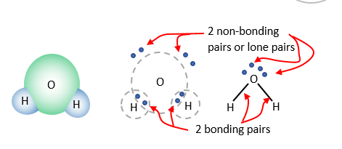

Molecular formulae represent the number and type of atoms present in the molecules.

Images by SB

**Electron dot diagrams**

Electron dot diagrams (like below) are often used to illustrate covalent bonds. Shared electron pairs can also be represented with a line (Lewis diagrams).

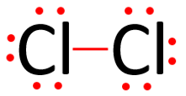

Chlorine Cl2

There are several ways to represent the bonding arrangement in chlorine.

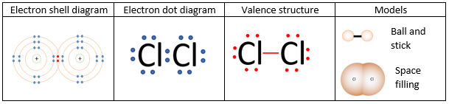

Image

by SB

Cl2 is the molecular formula for chlorine gas. It suggests that two chlorine molecules are bonded to each other.

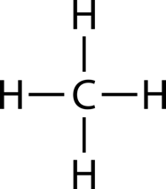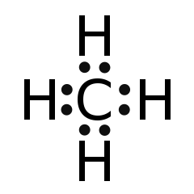CH4 is the molecular formula for methane gas. It suggests that one carbon atom has four hydrogen atoms bonded to it.

Note: ionic compounds are not molecules. The formula NaCl suggests that the ratio of Na+ to Cl- is 1:1. Covalent network compounds are not molecules. The formula SiO2 suggests that the ratio of Si to O is 1:2.

CO32-

4 + 3x6

+2 = 24 e-

C

O C O

O

e.g H2O

2 + 6 = 8 e-

O

H O H

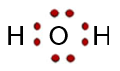

Rules for electron dot diagrams.

* + Add up all the valence e- for each atom in the molecule.
  + Add one for each - charge, take one for each + charge.
  + Choose the central atom – usually the least E.N. atom (never H).
  + Arrange the atoms around the central atom.
  + Insert pairs of e-’s for each atom bonded together.
  + 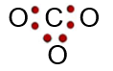Arrange the rest of the electrons around each outer atom so that each atom has an octet.
  + 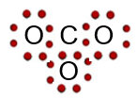If e-’s remain, place them around the central as lone pairs.
  + 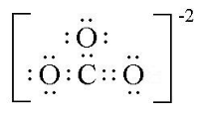If the central atom does not have an octet, rearrange e-’s from an outer atom until the central atom is satisfied.

Watch this video on Electron Dot Diagrams <https://youtu.be/t7vaGo-MZDs>

**Exercise 9**: These questions are to assist your understanding. Complete the following then check your answers at the back of the book.

Show the covalent bonds in the following compounds using an electron dot diagram:

Cl2 H2O CCl4

**Multiple Covalent Bonds**

A double covalent bond - a covalent bond in which there is two shared pairs of electrons.

For example, an oxygen molecule has a double bond.

i. each oxygen atom is two electrons short of a valence electron octet.

ii. each oxygen atom accepts a share in two electrons belong to the other oxygen atom.

iii. hence 4 electrons are shared by the two oxygen atoms and occupy the valence energy level of both.

**Example:** Show the double covalent bond in O2 using a dot diagram and a Lewis diagram.

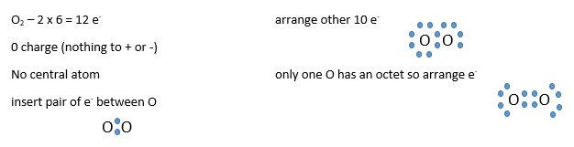

The molecule can be represented in several ways. Sometimes, the electrons are represented as crosses from one atom and dots from another.



Image by SB

The type of covalent bond that forms between nitrogen atoms is a triple covalent bond, since with nitrogen there are three valance electrons short of a valance electron octet.

Watch this video on Lewis Diagrams Made Easy <https://youtu.be/cIuXl7o6mAw>

**Exercise 10**: These questions are to assist your understanding. Complete the following then check your answers at the back of the book.

Complete a Lewis Diagram and an electron dot diagram for the following:

* 1. Nitrogen (N2)
  2. Carbon dioxide (CO2)
  3. Ethene (CH2CH2)
  4. Ethyne (CHCH)

This video looks at more complicated electron dot diagrams <https://youtu.be/Egj2LnC4vX4>

The properties of covalent network substances, including high melting point, hardness and electrical conductivity, are explained by modelling covalent networks as three-dimensional structures that comprise covalently bonded atoms.

**Covalent Network Substances**

Substance such as diamond (C) and silica (SiO2), consist of three dimensional network structures wherein all the atoms are linked together by strong covalent bonds.

These covalent bonds are continuous throughout the structure and results in a very hard structure with high boiling points.

Covalent network substances have the following characteristic properties:

1. Very high melting and boiling points.

*The covalent bonds that hold the atoms together are very strong.*

1. Non-conductors of electricity.

*No charged particles that are free to move.*

1. Extremely hard and brittle

*The covalent bonds that hold the atoms together are very strong, so the solid is hard to scratch but impact forces can disrupt the* ***directional*** *bonds causing it to shatter.*

1. Chemically inert.
2. Insoluble in water and most other solvents.

*No attraction between atoms in the network and water (or solvents).*

Silicon dioxide (SiO2) forms a network structure with the properties listed above. The ratio of Si to O in the network is 2:1, hence SiO2. Silicon dioxide forms quartz.

The properties listed above are the result of strong covalent bonding giving strength and high melting points. The highly localised electrons prevent the conduction of electricity, except for graphite which has one delocalised electron from each carbon atom.

This video includes the properties of covalent networks <https://youtu.be/d2ogZgGmMDY>

Elemental carbon exists as a range of allotropes, including graphite, diamond and fullerenes, with significantly different structures and physical properties.

**Allotropes of carbon**

Allotropes of carbon are diamond, graphite and fullerenes.

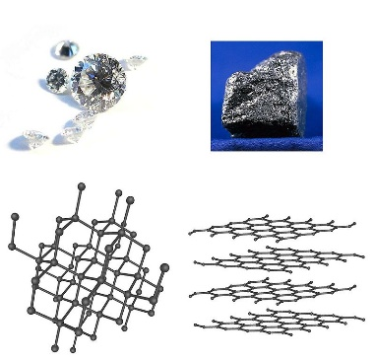

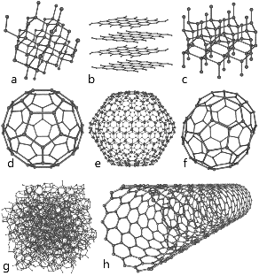 Diamond Graphite

Fullerenes

 Bonding in Bonding in

diamond graphite

An allotrope is different forms of the same element.

This video looks at allotropes of carbon <https://youtu.be/w_3fvq4EYpE>

**DIAMOND**

In diamond, the carbon atoms are arranged in a large crystal lattice. It has amazing physical qualities, most of which originate from the strong covalent bonding between its atoms. Each carbon atom in a diamond is covalently bonded to four other carbons in a tetrahedron. These tetrahedrons together form a three-dimensional network of six-membered carbon rings. This stable network of covalent bonds and hexagonal rings is the reason that diamond is so incredibly strong as a substance.

As a result, diamond has the highest hardness and thermal conductivity of any material. In addition, it avoids contamination by many elements, it cannot get wet by water and it does not generally react with any chemical reagents, including strong acids and bases. Uses of diamond include cutting, drilling, and grinding; jewellery; and in the semi-conductor industry.

**GRAPHITE**

Graphite is an electrical conductor and a semi-metal. It has a layered, planar structure and within each layer, the carbon atoms are arranged in a hexagonal lattice. The hexagonal graphite may be either flat or buckled.

Graphite can conduct electricity due to the delocalised electrons within the carbon layers. As the electrons are free to move, electricity moves through the plane of the layers. Graphite also has self-lubricating and dry lubricating properties. Graphite has applications in heat-resistant materials as it can resist temperatures up to 3000 °C.

**FULLERENES**

A single layer of graphite is called graphene. This material displays extraordinary electrical, thermal, and physical properties.

Graphene is the basic structural element of carbon allotropes such as graphite, charcoal, carbon nanotubes, and fullerenes. Graphene is a semi-metal or semiconductor, allowing it to display high electron mobility at room temperature.

Fullerenes (also called buckyballs) are molecules of varying sizes composed entirely of carbon that take on the form of hollow spheres, ellipsoids, or tubes. Buckyballs and buckytubes have unique chemistal and technological applications, especially in materials science, electronics, and nanotechnology.

Carbon nanotubes are cylindrical carbon molecules that exhibit extraordinary strength and unique electrical properties and are efficient conductors of heat. Carbon nanobuds are newly discovered allotropes in which fullerene-like “buds” are covalently attached to the outer side walls of a carbon nanotube. Nanobuds therefore exhibit properties of both nanotubes and fullerenes.

This video relates to covalent networks <https://youtu.be/zABECvvLpb4>

**Summary of bonding**

**Ionic:**

|  |  |
| --- | --- |
| **Structure** | **Properties** |
| * formed from electrostatic attraction between two oppositely charged atoms * basic particles which make up ionic compounds are ions: electrically charged atoms which have lost or gained electrons. * exist between metallic and non-metallic ions * form a regular lattice of ions * valence electrons taken from one atom (metal) and kept mainly around another atom (non-metal). * resulting electron configuration stable as each atom appears to have full outer shell. | * brittle as compounds containing ionic bonds are crystalline solids with every ion strongly bonded to its neighbours, and the whole is thus held in a rigid lattice with a specific shape. * high melting and boiling points because the very strong bonding associated with ionic compounds means that much energy is required to break bonds. * soluble in water because water is a so-called ionising solvent, because of polar nature. * conducts electricity when in solution or molten because both solution and molten compound contain mobile ions which conduct electricity. Solid ionic compound cannot as ions held in their rigid lattice, and are not free to move. |

# Metallic:

|  |  |
| --- | --- |
| **Structure** | **Properties** |
| * outermost or valence electrons move about freely within a three-dimensional arrangement or lattice of positively charged metal ions. * consists of positive ions surrounded by a ‘sea’ of electrons * valance electrons are delocalised - not associated with a particular metal ion, move through the lattice of metal ions. * negatively charged electrons attracted to positively charged metal ions in lattice - electrostatic attraction holds lattice together | * high densities indicate that the atoms are packed tightly together. * malleability and ductility indicates limited resistance to movement of atoms with respect to each other. * Electrical conductivity indicates that metal contain mobile charged particles. * strength of metallic bond gives most metals high melting and boiling points. * metals insoluble in water because they are incapable of bonding chemically with it. * examples: zinc, copper, aluminium. |

**Covalent:**

|  |  |
| --- | --- |
| **Structure** | **Properties** |
| * most compounds between non-metals * atoms held together by electrostatic attraction between shared electrons and nuclei of adjacent atoms * atoms combine to form molecules which share electrons so outer energy level has eight electrons – octet rule. * single covalent bond formed when two atoms share a pair of valence electrons which allow each atom to acquire noble gas electron configuration | * molecules uncharged and electrons localised in covalent bonds, doesn’t contain ions so can’t conduct electricity * molecules held together by strong covalent bonds but bonds between different molecules relatively weak, therefore easily broken. * weak intermolecular bonds result in low boiling and melting points * water is a polar molecule whereas many covalent molecular compounds are non-polar e.g. iodine. Only polar molecules dissolve in water |

**Covalent Network:**

|  |  |
| --- | --- |
| **Structure** | **Properties** |
| * giant molecule with millions of covalent bonds * consists of three dimensional network structure wherein all the atoms are linked together by strong covalent bonds. * covalent bonds are continuous throughout the structure and result * examples are diamond (C) and silica (SiO2) | * hard – covalent bonds are continuous throughout the structure * chemically inert * high melting and boiling points – due to strong covalent bonds * generally non-conductors (graphite exception) – most electrons fixed in bonds so prevents conductivity. Exception is graphite which has one delocalised election that can move so conduction occurs. * usually insoluble in water due to many strong covalent bonds. |

**Exercise 11:** Review Questions. These questions are to assist your understanding. Complete the following then check your answers at the back of the book.

1. Consider the following solids: A: metallic; B: Ionic; C: Covalent network; D: Covalent molecular. Select the structure A, B, C, D most likely to show the following properties.
   * 1. Silvery-grey solid that conducts electricity when solid and liquid. Melts at 6600C.
     2. Brittle yellow solid melts at 1130C. Solid and liquid non-conductors.
     3. Hard, brittle, white solid melts at 6600C. Solid non-conductor, liquid conductor.
     4. Hard, white, crystalline solid melts at 16100C. Solid and liquid non-conductors.
2. Two Chlorides, XCl2 and YCl2. XCl2 melting pt 7720C, boiling pt 14000C. YCl2 melting pt -230C, boiling pt 760C. What type of substance is each?
3. Explain why molten KCl conducts an electric current but solid KCl does not.
4. Identify the charged species which will conduct an electric current in the following:

• molten NaI • molten Cu

• solid Al • molten Mg(NO3)2

• a solution of Al(NO3)3

1. Consider the following: CO2, Zn, Al2O3, C, CH4, brass, KF, I2, Fe, SiO2. Which are:

Ionic:

Metallic:

Covalent molecular:

Covalent network**:**

1. Explain why metals are malleable while ionic solids are not.
2. The melting points of the ionic solids sodium fluoride and magnesium oxide are 993oC and 2852oC respectively.
   1. Identify the ions present in the two substances.
   2. Both compounds have high melting points. What other physical properties do they have in common.
   3. Explain the higher melting point of magnesium oxide compared to sodium fluoride.
3. Describe what is meant by ionic bonding.
4. List four properties of ionic solids and explain these properties using the ionic bonding model.
5. Write molecular formulas for the following:

|  |  |  |  |
| --- | --- | --- | --- |
| Ammonia |  | Sulfur tetrafluoride |  |
| Nitrogen dioxide |  | Sulfur hexafluoride |  |
| Hydrogen sulfide |  | Dinitrogen pentoxide |  |
| Hydrogen peroxide |  | Nitrogen triodide |  |

1. Write names for the compounds represented by the following molecular formulas:

|  |  |
| --- | --- |
| CO | CO2 |
| HF | CH4 |
| SO3 | PCl3 |
| N2O3 | BrF3 |

1. Write formulas for the following:

a. zinc metal

b. molecular elements:

i. nitrogen

ii. sulphur

iii. phosphorous

iv. dinitrogen pentoxide

c. covalent network element: boron

Carbon

Silicon dioxide

d. Ionic compounds:

i. ammonium sulphide

ii. calcium sulphate-2-water

iii. aluminium sulphate

iv. magnesium nitride

1. Name the following substances:

a. N2O3

b. PCl3

c. Mg(HSO4)2

d. Na2CO3.10H2O

e. AuCN

f. NaHSO3

1. Classify each of the following as an either an element or a compound:

N2, He, C2H5OH, KI, C, NH4NO3 Cl2

1. Name the 3 allotropes of carbon.
2. Classify the following substances as metals, ionic substances, covalent network substances or covalent molecular substances:
   1. **Substance A:** Has a low melting point and a negligible conductivity in both the solid and molten states.
   2. **Substance B:** Has a high melting point and a high conductivity in both the solid and molten state.
   3. **Substance C:** Has a high melting point. It does not conduct electricity in the solid state, but the molten state has high conductivity.
   4. **Substance D:** Has a very high melting point and a negligible conductivity in both the solid and molten states.
3. Classify the following substances on the basis of their composition as metals, ionic substances or covalent molecular substances:

a. calcium oxide (CaO)

b. carbon dioxide (CO2)

c. neon (Ne)

d. silver (Ag)

e. copper II chloride (CuCl2)

f. mercury

* 1. What is a covalent bond?
  2. What forces are responsible for holding the atoms together in a simple molecule such as F2?
  3. What valence electron configuration does an atom usually attain when it combines with other atoms?
  4. Why is this valence electron configuration generally stable?
  5. Draw an electron dot diagram showing the bonding in F2.
  6. Identify the bonding and non-bonding pairs in F2 in the above diagram.
  7. Where are the bonding electrons in F2 localised most of the time?

1. “*In covalent molecular substance the force within molecules are strong but the force between molecules are weak*.”

Explain what is meant by this statement, illustrating your answer with chlorine (Cl2) which has a melting point of -101oC but does not break into separate atoms except at very high temperatures.

1. List the properties of covalent molecular substances and give an explanation for each property.
2. A. Draw electron dot diagrams for the following substances:
3. Br2 d. HF
4. CH3OH e. PCl3
5. CCl2F2 f. CH3CH3

B. In the molecules HF, CH3OH and Br2 identify the bonding and non-bonding pairs.

C. Write formulas, using a straight line between atoms to represent a covalent bond for the molecules listed above.

1. How many electrons are shared in the formation of each of the following?
2. a single covalent bond b. a double covalent bond c. a triple covalent bond
3. Show the bonding in the following molecules using:

(i). electron dot notation, (ii).the straight line bond notation

a. HCN c. CS2

b. C2H2 d. HCHO

1. Draw electron dot diagrams for the following molecules and identify and single covalent bonds, double covalent bonds.

a. N2O c. SO3

b. SO2  d. CO

**Answers to Exercises**

**Exercise 1: Problem Set**

1. **Low ionisation energies – easily removed - become delocalised electrons**
   1. **Good conductors of heat – mobile electrons transfer heat**
   2. **Good conductors of electricity – mobile electrons transfer charge**
   3. **Malleable and ductile – metallic bonds non-directional**
   4. **High melting and boiling points – strong electrostatic attraction between the positive metal ions and delocalised electrons**
2. **Strength of metallic bond varies quite a bit**
   1. **Copper – Excellent conductor of electricity**

**Cheap, Excellent ductility, Can’t rust**

* 1. **Titanium – light weight**

**Very high tensile strength, Can’t rust**

**High lustre, Excellent malleability**

**Exercise 2:**

potassium chloride **KCl** lead oxide **PbO**

sodium sulphate **Na2SO4** aluminium oxide **Al2O3**

nickel hydrogen phosphate **NiHPO4** iron (III) oxalate **Fe2(C2O4)3**

Na2SO3 **sodium sulphite**  Al2(Cr2O7)3 **aluminium dichromate**

CrN **chromium nitride**  (NH4)2CO3 **ammonium carbonate**

CuNO2 **copper (I) nitrite**  NaHSO4 **sodium hydrogen sulfate**

**Exercise 3:**

**Strong directional attractive force exists between oppositely charged ions (Mg2+ and SO42-)**

**If a layer of a magnesium sulfate crystal is hit and forced to slide past another layer, the orderly arrangement of ions is disturbed.**

**Ions of similar charge are forced closer to another with an increase in repulsive forces and decrease in attractive forces - the MgSO4 crystal fractures.**

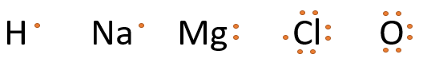

**Exercise 4:**

**Exercise 5:**

Magnesium oxide :



Aluminium oxide: or



Calcium Iodide : or

**Exercise 6:** Predicting the elements in an ionic compound

1. **P would probably be from group 13 (loses 3 e-)and row 3 – removed its 3rd shell = Al.**

**Q would be from group 17 (gains 1e-) and row 2 – fills its 2nd shell = F.**

1. **J = Ca and X = Cl.**
2. **Kr = 2 8 8 18. Ionic substances need to be +1/-1, +2/-2 and +3/-3 from Kr.**

**I.e. Rb Br, Sr Se, Y and As.**

1. **R = +3 (Al) and A = -1 (Br) = Al Br3.**
2. **G = calcium, L = sulphur 🡪 Ca S.**
3. **To make a neutral compound, the number of positive charges must equal the number of negative charges.**

**With KCl, the respective charges are +1 and -1 so K and Cl combine in the ration of 1:1 to create a neutral compound.**

**However, with MgCl2 the Mg has a 2+ charge so must combine with Cl in the ratio of 1:2 to create a neutral compound.**

**Exercise 7:** Problem Set

1. **Free electrons or ions are required to conduct electricity.**

**Molecular covalent substances consist of molecules where all electrons experience directional electrostatic forces of attractions.**

**No free electrons available – no conduction of electricity**

1. **Sulfur is a covalent molecular substance.**

**The molecule is held together by a strong intramolecular bond (covalent bond) where the electrostatic force of attraction between the shared electrons and the adjacent nuclei hold the molecule together.**

**The molecules experience weak intermolecular forces between the molecules which require a small amount of energy to break this bond – low melting point (115.2 °C)**

**Carborundum is a covalent network substance.**

**The network is held together by a strong intramolecular bond (covalent bond) where the electrostatic force of attraction between the shared electrons and the adjacent nuclei hold the network together.**

**There are no weak intermolecular forces and therefore it requires a large amount of energy to break this covalent bond – high melting point (2730 °C)**

1. **Very high melting and boiling points**

**Non-conductors of electricity**

**Extremely hard and brittle**

**Chemically inert**

**Insoluble in water and most other solvents.**

**Exercise 8:** Problem Set

Complete this table:

|  |  |  |
| --- | --- | --- |
| Molecular Formula | Systematic Name | Common Name |
| CO | carbon monoxide |  |
| CO2 | carbon dioxide |  |
| N2O | dinitrogen monoxide | Nitrous oxide(laughing gas) |
| NO | nitrogen monoxide | Nitric oxide |
| NO2 | nitrogen dioxide |  |
| N2O4 | dinitrogen tetroxide |  |
| SO2 | sulphur dioxide |  |
| H2O | dihydrogen monoxide | Water |
| H2O2 | dihydrogen dioxide | Hydrogen peroxide |
| H2S | dihydrogen sulfide | Hydrogen sulphide |
| HF | hydrogen fluoride | Hydrofluoric acid |
| HCl | hydrogem chloride | Hydrochloric acid |
| NH3 | nitrogen trihydride | Ammonia |
| CCl4 | carbon tetrachloride | Tetrachloro methane |

**Exercise 9**:

Cl2 H2O CCl4

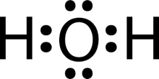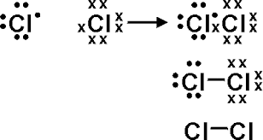

**Exercise 10**:

**

a.

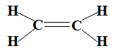

b. c. d.



**Exercise 11:** Review Questions

* + 1. **A**
    2. **D**
    3. **B**
    4. **C**

1. **XCl2 Ionic YCl2 covalent molecular**
2. **In molten state, K+ and Cl- ions are mobile whereas in solid KCl they are not.**
3. • **Na+ I-** • **electrons**

• **electrons** • **Mg2+ NO3-**

• **Al3+ NO3-**

1. Ionic: **Al2O3 KF**

Metallic: **Zn brass Fe**

Covalent molecular: **CO2 CH4 I2**

Covalent network**: C SiO2**

1. **Metallic are malleable because metallic bonds are non-directional and the lattice structure can be deformed without disrupting the metallic bonds. When ionic crystals are distorted, similarly charged ions are brought close to each other and the crystal fractures.**
   1. **Na+ F- Mg2+ O2-**
   2. **Both are hard and brittle:**

**Both are non-conductors when solid yet will conduct electricity in the molten state**

* 1. **The magnesium oxide lattice contains doubly charged ions leading to a stronger electrostatic attraction between the ions and hence higher boiling points**

1. **Ionic bonding is the electrostatic attraction between oppositely charged ions**

* **Hard and brittle – ions tightly bound by strong electrostatic attraction**
* **Non-conductors when solid – ions occupy fixed positions in the lattice, as no movement, can’t conduct electricity.**
* **Conduct when molten or in aqueous solution – mobile ions transfer charge so conduct electricity**
* **High melting and boiling points – ions tightly bound by strong electrostatic forces**

|  |  |  |  |
| --- | --- | --- | --- |
| Ammonia | **NH3** | Sulfur tetrafluoride | **SF4** |
| Nitrogen dioxide | **NO2** | Sulfur hexafluoride | **SF6** |
| Hydrogen sulfide | **H2S** | Dinitrogen pentoxide | **N2O5** |
| Hydrogen peroxide | **H2O2** | Nitrogen triodide | **NI3** |

1. Write names for the compounds represented by the following molecular formulas:

|  |  |
| --- | --- |
| CO **carbon monoxide** | CO2 **carbon dioxide** |
| HF **hydrogen monofluoride** | CH4 **carbon tetrahydride** **(methane)** |
| SO3 **sulfur trioxide** | PCl3 **phosphorous trichloride** |
| N2O3 **dinitrogen trioxide** | BrF3 **bromine trifluoride** |

a. **Zn**

b.

i. **N2**

ii. **S8**

iii. **PCl5**

iv. **N2O5**

c. boron **B** Carbon **C** Silicon dioxide **SiO2**

d.

i. (**NH4)2S**

ii. **CaSO4.2H2O**

iii. **Al2(SO4)3**

iv. **Mg3N2**

a. **dinitrogen trioxide**

b. **phosphorous trichloride**

c. **magnesium hydrogen sulfate**

d. **sodium carbonate-10-water**

e. **gold (I) cyanide**

f. **sodium hydrogen sulfite**

1. N2, He, C2H5OH, KI, C, NH4NO3 Cl2

**E E C C E C E**

1. **Graphite, diamond, buckyballs**

a. **Substance A: Covalent molecular**

b. **Substance B: metal**

c. **Substance C: Ionic compound**

d. **Substance D: Covalent network**

a. calcium oxide (CaO) **ionic**

b. carbon dioxide (CO2) **covalent molecular**

c. neon (Ne) **element**

d. silver (Ag) **metal**

e. copper II chloride (CuCl2) **ionic**

f. mercury **metal**

a. **Bonds in which adjacent atoms share electrons. Electrostatic**

**attraction such that atoms share electrons between nuclei.**

* 1. **Electrostatic attraction between shared pair of electrons and nuclei of atom**
  2. **An octet – eight valence electrons. Common exception is hydrogen.**
  3. 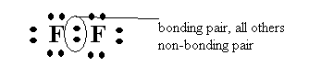**It represents the electron configuration of noble gas with complete s and p subshells.**

1. **The bonding electrons are located between the two nuclei most of the time.**
2. **COVALENT BONDING. Two kinds of forces. Covalent bonds – forces of attraction within molecules which hold atoms together. Intermolecular forces – force of attraction between molecules which hold atoms together.**

**In chlorine attractive forces between chlorine molecules in solid state are weak as indicated by the low melting point. However, the forces which hold the two chlorine atoms together as a chlorine molecule are very strong as indicated by the high temperature required to separate the atoms.**

* 1. **Low melting and boiling points – forces between molecules are weak so little energy is required to break bonds.**
  2. **Non-conductors of electricity in the solid and molten state – molecules are uncharged and electrons are localised so unavailable to conduct electricity.**
  3. **Solids are generally soft – forces between molecules are weak.**

1. A. Draw electron dot diagrams for the following substances:



1. Br2 d. HF





1. CH3OH e. PCl3



1. CCl2F2 f. CH3CH3 

B. Bonding shown as xo, non-bonding xx or oo.

C.

1. **Two** b. **Four** c. **Six**



1. a. HCN c. CS2



b. C2H2 d. HCHO