**WEATHERING**

After they have formed, rocks far below the surface of the Earth do not change much. It is only when they are at or near the surface that weathering of rocks can begin. There are two types of weathering:

1. PHYSICAL WEATHERING. (or MECHANICAL WEATHERING)

This is the breakdown of large pieces of rock into smaller pieces and then eventually soil particles.

1. CHEMICAL WEATHERING.

This is the breakdown of rock by chemicals such as acids to form new substances.

In the next two activities you should discover some ways in which rocks can be broken down.

**ACTIVITY 12: PHYSICAL WEATHERING BY TEMPERATURE CHANGE**

***Equipment:***

* Safety glasses
* Bunsen burner and matches
* Two pieces of glass rod
* Ice water
* Tongs
* Metal can
* Bench protective board

***DO NOT REHEAT A CRACKED GLASS ROD!!!!***

PROCEDURE:

1. Put on your safety glasses and follow your teacher’s safety instructions.
2. Heat a piece of glass rod for about one minute then drop it into a can filled with water from the tap.
3. Heat another piece of glass rod for the same time and *carefully* drop the glass into a can filled with ice water.
4. Closely examine the pieces of glass that were cooled. Observe how the heating and rapid cooling affected the glass rod.

QUESTIONS: Write the answers in your notebooks

1. What happens when brittle materials, like glass, are heated and then cooled rapidly?
2. What happened to the hot glass rod when it was put into water at room temperature?
3. What happened to the glass rod when it was put into the ice water?
4. Talk this question over with your group as it will show your understanding of science. Explain how continuous heating and cooling of rocks help to break them down. Use science terms in your answer. Hint: What happens to the length of a material when you heat it and cool it?
5. In what areas of Western Australia might temperature changes be important in the weathering of rocks.

**Exfoliation** is the scientific term for the formation of these sheets of rock that split from the surface - a good place to find centipedes, lizards and millipedes.

**ACTIVITY 13: PHYSICAL WEATHERING by freezing water**

You might be surprised to learn that very cold weather can sometimes cause rocks to crack open.

**AIM:** To determine if freezing water causes rocks to break up.

***Equipment:***

* Drinking straw
* Plasticine
* Freezer
* Beaker of water

PROCEDURE:

1. Place one end of the straw in a beaker of water.
2. Fill the straw with water by sucking the water up.
3. Hold your tongue over one end to prevent the water from escaping while you insert a plasticine plug into the other end of the straw.
4. Remove your tongue and plug that end with another piece of plasticine.
5. Lay the straw in the freezer overnight.
6. Remove the straw and observe the ends.

QUESTIONS:

1. What happens to water when it freezes? This is very queer or anomalous behaviour!
2. Explain how freezing water can break down rocks. Talk it over with your group.
3. Have you accidentally put a glass bottle of drink in the freezer and left it there. What happens and why?

**ACTIVITY 14: CHEMICAL WEATHERING**

*WHAT WILL HAPPEN IF ACID SOLUTION IS POURED ONTO A ROCK SAMPLE?*

*(Copy this question into your notebook as a heading)*

HYPOTHESIS: Write an answer to the above question. Your answer is a hypothesis you will test.

THE TEST: Design your own investigation using the following equipment.

***Equipment:***

* Six test tubes
* Test tube rack
* Two pieces of granite
* Two pieces of limestone
* Two pieces of sandstone
* Water
* 2 mol per litre hydrochloric acid (HCl(aq))

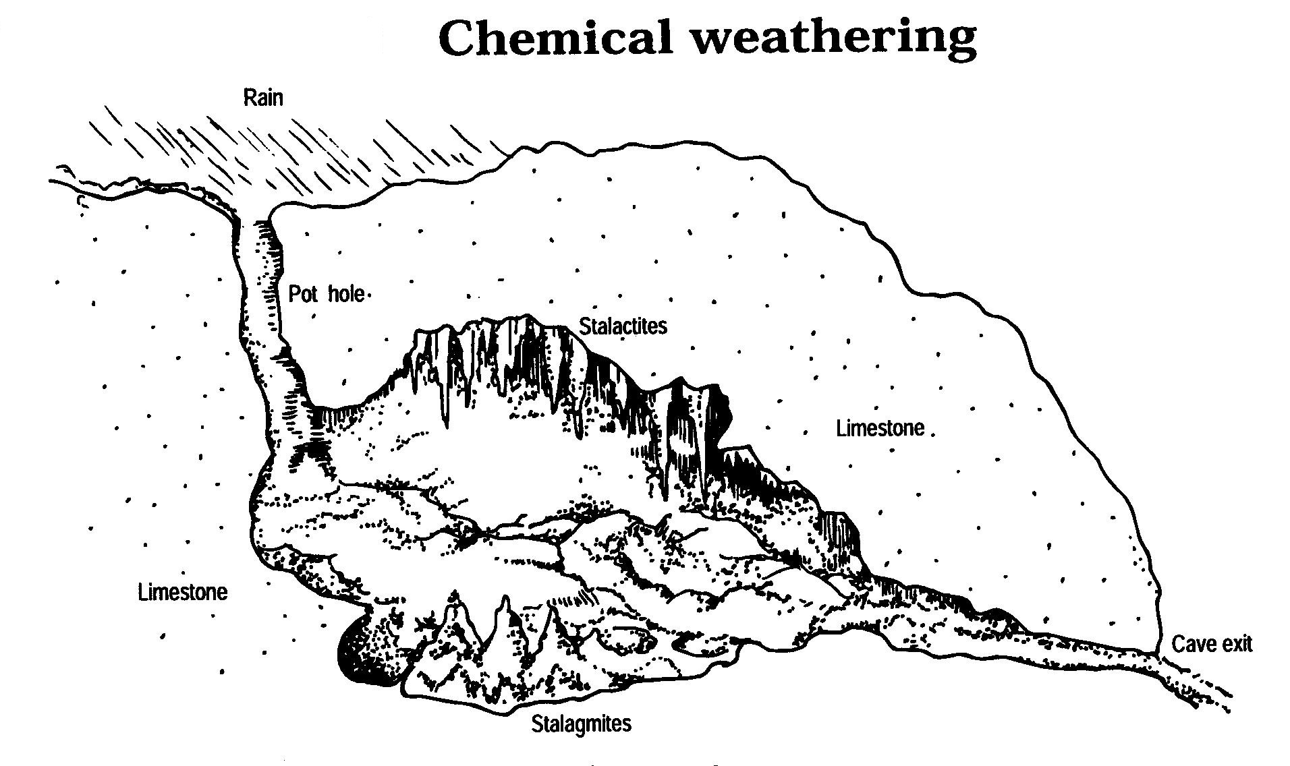

**ACTIVITY 32: MATCHING ROCK LAYERS**

**AIM:** To match the layers of a sedimentary rock formation from profile information gathered at four related sites.

**C**

**B**

**D**

**A**

Mt Magnet

IRWIN RIVER

IRWIN RIVER

TOWN

Cliff

**PROCEDURE:** You are to compare each of the rock profiles below to find out which profile contains the oldest sedimentary rock formation and which is the youngest. Refer to a layer by its site followed by the layer e.g. Site 1, Layer iv.

Site 4

Core Sample

4

Site 3

Core Sample

3

Site 2

Core Sample

2

Site 1

Core Sample

1

|  |  |  |  |  |  |  |
| --- | --- | --- | --- | --- | --- | --- |
| 🐕 |  | 🏕👪 |  | 🏠 |  | 🏝 |

i.

ii.

iii.

iv.

i.

ii.

iii.

iv.

v.

vi.

i.

ii.

iii.

iv.

i.

ii.

iii.

iv.

v.

vi.

To compare the sedimentary rock formations you will have to assume three things:

1. Successive layers are laid down on top of the preceding layers. The reverse order of deposition can never occur unless the earlier layers are inverted by folding.
2. When deposition takes place, it produces horizontal layers only. If layers are observed to be inclined, then the rocks have been moved since deposition.
3. Naturally formed layers do not have abrupt ends, or have gaps within them. Gaps and abrupt ends indicate movement of the original deposits after formation e.g. by faulting.

Before starting, consider the following:

1. The ground levels do not have to be the same for each rock formation.
2. You should try to compare the layers in the separate sedimentary formations, two at a time.
3. You should assume that there has been no faulting.
4. You should assume that the more strata a sedimentary rock has the older it is.

**CORRELATION OF ROCK LAYERS**

*The diagrams below represent two rock outcrops found several kilometres apart. A geologist will match layers in the two sites by the fossils found in the layers. This matching process is called ‘correlating’.*

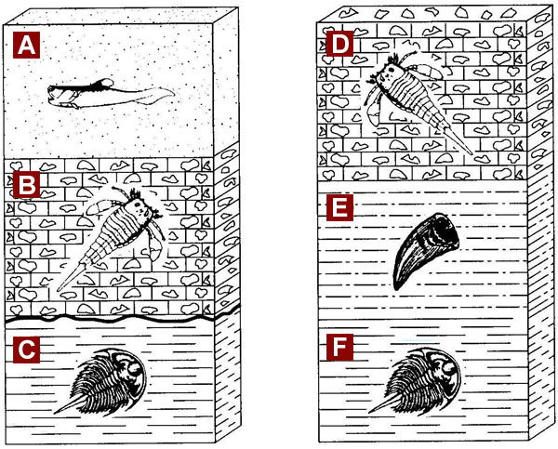

Use the geologic profiles above to answer the following questions.

Top of Form

1. Which layers are the same?   
  
2. Of the rock layers E and F, which is the oldest?   
  
3. What is the correct sequence of rock layer from oldest to youngest?   
  
4. An unconformity (buried erosional surface) is represented by the interface between

which two layers?

5. What type of rock is layer A?

**CORRELATION ACTIVITY**

**PROBLEM:** How can the principles of stratigraphy be used to do relative age dating?

**Exercise I.** This drawing shows a cross-section, or a side view, of the rock layers below the Earth’s surface. The trees and water show where the surface is. Each rock layer is identified by a letter. Some of the rock layers contain fossils. Using the principles of stratigraphy, answer the following questions about the cross section.

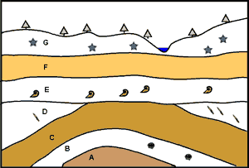

1. Which rock layer is the oldest?
2. Which rock is the youngest?
3. Which principle helped you determine your answer?
4. Between what two layers has erosion occurred? How can you tell?
5. Which rock units have been affected by mountain building? How can you tell?
6. Which type of fossil is the oldest?
7. Which stratigraphic principles helped you answer this question?

**Exercise 2**

Consider the rock strata exposed in cliff faces at Site 1 and 2 shown in the diagram below

**Site 1**

**Site 2**

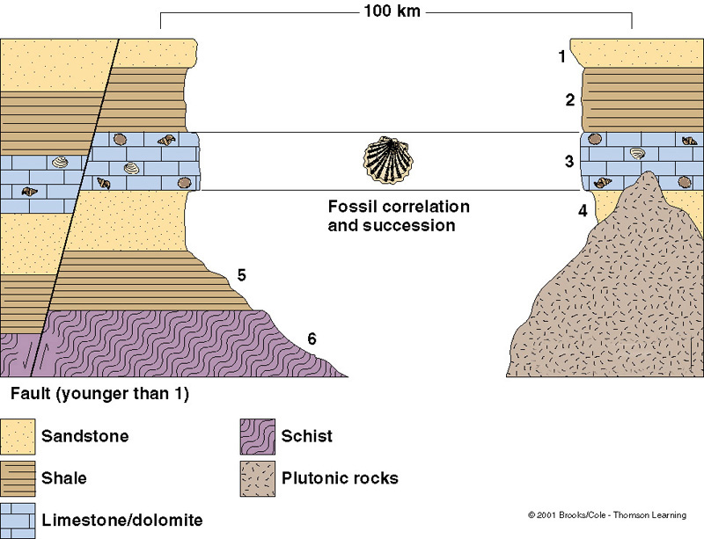

1. Is the fault shown older or younger than Layer 1?
2. Is the intrusion of plutonic rock older or younger than Layer 3?
3. The fossils shown in the Layer 3 are the same in both sites. What can be

concluded about the age of this fossil layer at Site 1 and 2?

1. What must have happened to the sediments between Site 1 and Site 2?