Homeostasis: Body Temperature & Blood Glucose
Q1. List ways the body gains heat

Q2. List ways the body loses heat.

Q3. What is normal body temperature and why must the body maintain this temperature?

Q4. What are the receptors that detect change in body temperature? Where are they located?

Q5. Label the following skin section.
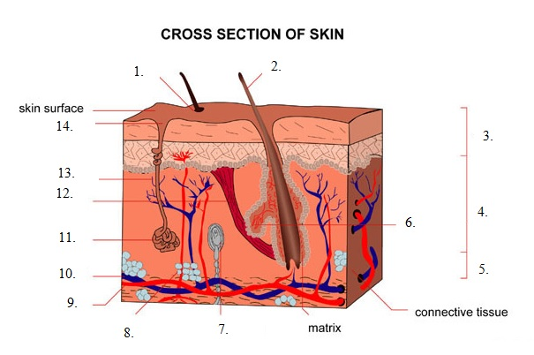
Q6. When the body gets too hot, there are 2 main body processes/homeostatic mechanisms that occur in response. Complete the table below.
Name of process | Describe what occurs (you may wish to draw a diagram) | How does it assist the body to regulate temperature?

Q7. When the body gets too cold, there are 2 main body processes/homeostatic mechanisms (the 3rd (piloerection) is irrelevant in humans) that occur in response. Complete the table below.
Name of process | Describe what occurs (you may wish to draw a diagram) | How does it assist the body to regulate temperature?

Q8. What it the part of the body that acts as the control centre for temperature regulation? What is the name of the centre?

Q9. Using the information above, draw 2x detailed feedback loops (one for high body temp and low body temp as stimulus).

Q10. a) Other than the homeostatic mechanisms mentioned above – what else can occur in the body that will affect body temperature? Why does it affect?

b) What are the hormones involved in Question (a) & where are they produced/secreted?

c) Draw 2x feedback loops for the effect of hormones on Metabolic Rate (one with high body temp and one for low body temp as stimulus).

Q10. List 3x behavioural responses for high body temp and 3x for low body temp.

Q11. Describe the problems/conditions associated with very high body temp or very low body temp.

_______________________________________________________________________________________________
Q12. What are the normal levels for Blood glucose (aka: blood sugar levels (BSL)) in the body? What is glucose used for in the body?

Q13. What are the hormones involved in maintaining blood glucose levels? For each, identify the glands/cells it is secreted from and their target organs.

Q14. Outline what happens to your blood glucose levels:
a) after finishing a meal?
b) during or after exercising?
c) after waking up in the morning?
d) while fasting?
e) in between meals?
Q15. After you have eaten a meal – describe the pathway of glucose until it arrives at the liver.

Q16. The liver is the ‘effector’ for glucose regulation. Describe what occurs at the liver:
a) due to the release of insulin.

b) due to the release of glucagon.

c) due to release of glucocorticoids (cortisol) & adrenaline.

Q17. Draw 2x detailed feedback loops (1x for low BSL and 1x for high BSL as the stimulus).

Q17. Diabetes Mellitus is a disease affecting Individuals who have abnormally high blood glucose levels (hyperglycaemia). Complete the table below about Diabetes Mellitus:
 | Type I | Type II
Onset? Affects who? (Age/gender).

Cause/s
(need to give detail)

Insulin dependent? Yes or No
Treatment

