



ATAR Chemistry, Unit 1 - Gases

**Year 11 Science**

ATAR Chemistry, Unit 1 – Organic Chemistry

© Department of Education WA 2020

Except where indicated, this content is © Department of Education Western Australia 2020 and released under a Creative Commons CC BY NC licence. Before re-purposing any third-party content in this resource refer to the owner of that content for permission.

Requests and enquiries concerning copyright should be addressed to:

Manager Intellectual Property and Copyright

Department of Education

151 Royal Street

EAST PERTH WA 6004

Email: [copyright@education.wa.edu.au](mailto:copyright@education.wa.edu.au)



<https://creativecommons.org/licenses/by-nc/4.0/>

**Year 11 ATAR Chemistry Unit 1 2020**

**Topic: Organic Chemistry**

## Instructions to Students

This resource package provides students with learning materials for the Chemistry ATAR Year 11 course. The package focuses on the topic **Organic Chemistry.**

This package is designed to support the program students are completing at their school. If feedback is required when completing this package, students should consult their teacher.

This resource package consists of:

* The **Notes/summary** which provides an explanation of syllabus content concepts. This section is designed to develop the knowledge component of the syllabus.
* The **Exercises** which provides an opportunity for students to check their understanding of the content.

It is recommended that students further investigate concepts covered in this resource package by conducting their own research using the text/s that they use at school/other resources available or the internet.

Statements inside a red box are Syllabus Points.

Molecular structural formulae (condensed or showing bonds) can be used to show the arrangement of atoms and bonding in covalent molecular substances.

**Organic Chemistry – The Chemistry of Carbon**

Covalent molecular compounds containing hydrogen and carbon are called **hydrocarbons.**

Carbon based compounds are numerous due to:

* + 1. the ability of each carbon atom to form four covalent bonds.
    2. pairs of carbon atoms can form multiple bonds.
    3. the strength of the C to C and C to H covalent bonds.

Intermolecular forces (called dispersion forces) - occur between hydrocarbon molecules. They are weak for small molecules and increase in strength with increasing molecular size due to increase in number of protons and electrons.

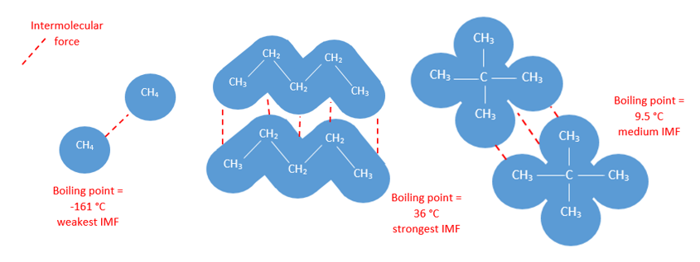

Images by SB

Boiling and melting points increase with increasing molecular size - due to increasing dispersion forces.

Hydrocarbon molecules are non-polar - therefore soluble in non-polar solvents; insoluble in polar liquids e.g. oil (non-polar) doesn’t dissolve in water (polar)

**Bonding in Carbon Compounds**

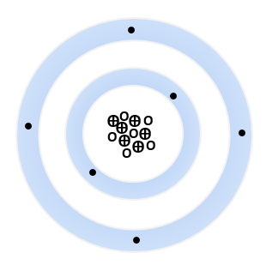

In ground or lowest energy state - carbon atoms have an electron configuration of 2, 4 (or 1s2 2s22p2).

Suggests that the four valence electrons, two 2s electrons and two 2p electrons are involved in the bonding and as a result carbon has a diversity of carbon based compounds.

Carbon forms very stable (strong) covalent bonds with itself and other elements such as hydrogen, oxygen, nitrogen and the halogens.

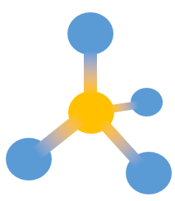

The bonding options for carbon atoms are:

* four single covalent bonds with other carbon atoms, hydrogen, oxygen, nitrogen and the halogens. A tetrahedral structure is the basic shape.

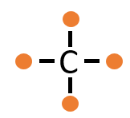

C sharing 1 electron pair with 4 other atoms.

**4 single bonds**.

Images by SB

* 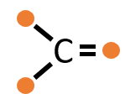 double covalent bonds with other carbons or oxygen.

C sharing 2 electron pair with 2 other atoms.

**4 double bonds**.

C sharing 1 electron pair with 2 other atoms and 2 pairs of electrons with 1 other atom.

**2 single bonds, 1 double bond.**

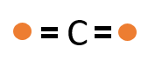

* triple covalent bonds with other carbons.

C sharing 1 electron pair with 1 other atom and 3 pairs of electrons with 1 other atom.

**1 single bond, 1 triple bond.**



Images by SB

Some simple bonding rules for carbon-based compounds are as follows:

a. Carbon atoms must form 4 bonds.

b. Halogen atoms must form 1 bond.

c. Oxygen atoms must form 2 bonds.

d. Nitrogen atoms must form 3 bonds.

e. Hydrogen atoms must form 1 bond.

When representing carbon based molecules, there are a number of models that can be used.

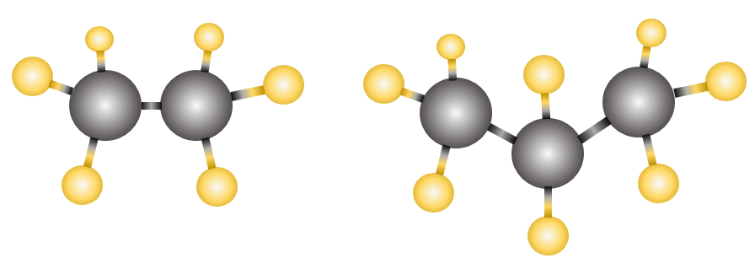

Ball and stick model.

Structural formula.

Space-filling model.

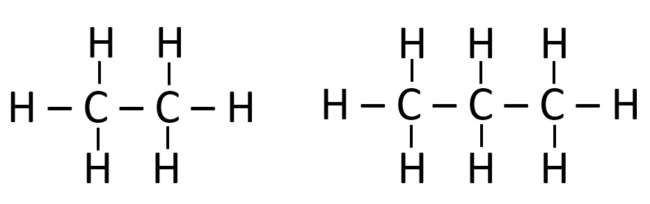

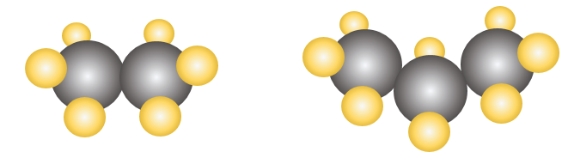

Images by SB

Ethane Propane

Organic molecules are difficult to draw in 3D, so the structural formula model is mostly used. This does not show the true arrangement of atoms and bond angles.

**HYDROCARBONS**

Hydrocarbons are compounds that contain **only** carbon and hydrogen.

Three major groups of hydrocarbons:

a. aliphatic hydrocarbons: open-chain molecules.

b. alicyclic hydrocarbons: the carbon atoms form closed rings.

c. aromatic hydrocarbons: based on a six-membered carbon ring.

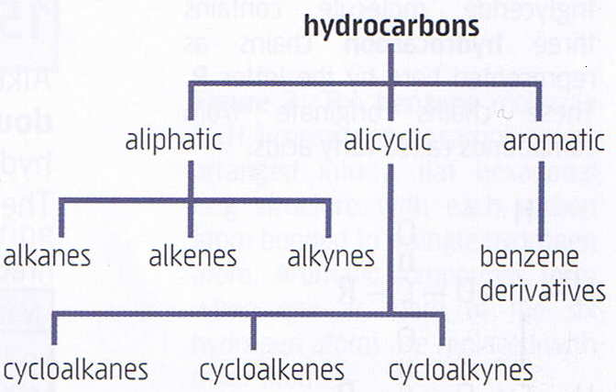

**Cyclic**

**Benzene**

**Straight chain**

Hydrocarbons are classified according to the nature of the bonding between carbon atoms:

**Alkanes -** Saturated Hydrocarbons

Saturated = cannot fit any more H’s in!

* Contains only single bonds between carbon atoms
* All bond angles are 109.5o.
* general formula CnH2n+2.

methane propane

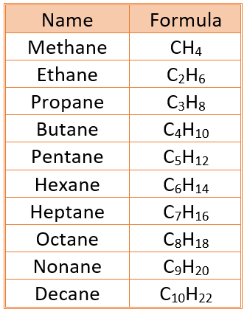

The first ten members of the alkane family.

Unsaturated = can fit in more H’s!

**Alkenes** - unsaturated Hydrocarbons

* contains at least one double bond between carbon atoms
* general formula CnH2n

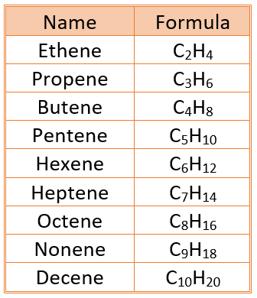The first nine members of the alkene family.

**Alkynes** – unsaturated Hydrocarbons

* contains a least one triple bond between carbon atoms;
* general formula CnH2n-2

(Alkynes are not in the Year 11 Chemistry course.)

**Alkyl Groups** – monovalent (one valence) groups derived from alkanes

* + alkanes that are missing a hydrogen atom.
  + They attach to other carbon chains at the point where they are missing the hydrogen atom.
  + Form side chains.

|  |  |  |  |
| --- | --- | --- | --- |
| **Number of Carbons**  **in Chain** | **Alkane** | **Alkene** | **Alkyl Atoms** |
| 1  2  3  4  5  6  7  8  9  10 | methane  ethane  propane  butane  pentane  hexane  heptane  octane  nonane  decane | -  ethene  propene  butene  pentene  hexene  heptene  octene  nonene  decene | methyl  ethyl  propyl  butyl  pentyl  hexyl  heptyl  octyl  nonyl  decyl |



-CH3  -CH2CH3

methyl ethyl

Below is a link to a video summarising alkanes and alkenes

<https://youtu.be/Sfm3eHe57PU>

**Alicyclic Groups** – closed rings.



cycloalkane cycloalkene

**Cycloalkanes**

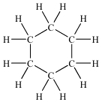

Alkanes in which ends of the chain are linked to form rings.

Small differences in physical properties from normal straight chain alkanes; chemical properties the same.

General formula: CnH2n and the name is prefixed by ‘cyclo’. e.g. C6H12 – cyclohexane

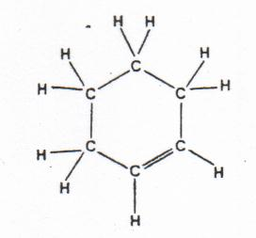**Cycloalkenes**

Alkenes can form rings; have fewer hydrogen atoms

than in corresponding straight chain alkenes.

General formula: CnH2n-2

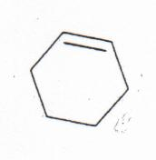Named with prefix ‘cyclo’ added.

eg. Cyclohexene

* Sometimes represented in shorthand as shown, missing the atom symbols.

**Aromatic Groups** – benzene derivatives.

Term used to describe compounds found to contain a six-carbon cyclic group with molecular formula C6H6 – attached to variety of other functional groups with parent compound benzene (C6H6).

Benzene is the simplest member of the **aromatic** hydrocarbons. It is a colourless liquid produced from the distillation of coal tar.

****Benzene is a six-sided flat ring which consists of alternating three single bonds and three double bonds in which the double bonds oscillate between two equivalent structures. (Sometimes called resonant structures.)



shorthand form aromatic compound

The angles between the bonds are 120° and forms a regular hexagon.

Below is a link to Crash Course Chemistry: Introduction to Hydrocarbons

<https://youtu.be/UloIw7dhnlQ>

IUPAC nomenclature is used to name straight and simple branched alkanes and alkenes from C1- C8.

**Naming Simple Organic Compounds Using IUPAC Rules**

1. Identify the longest continuous carbon chain.

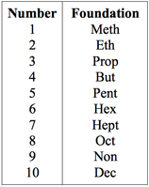2. Number the chain from the end which gives the lowest possible number to the double or triple bond or if they are absent, any attached group.

DOUBLE AND TRIPLE BONDS HAVE PRIORITY.

3. Number all attached groups using the order from (2) above.

4. Use the appropriate prefix or suffix to name each attached group.

5. Use ONE word to name the compound. Names of each group are preceded by a number indicating where it is found on the main chain. Alphabetical order is used when more than one group is involved.

6. Numbers are separated from words by a hyphen (-); and from other number by a comma (,).

7. When more than one group is attached to a carbon chain, the following prefixes are used:

2 - di 3 - tri 4 - tetra 5 - penta 6 - hexa

8. When halogens are attached to a chain, the following prefixes are used:

Cl chloro

Br bromo

F fluoro

I iodo

|  |  |  |
| --- | --- | --- |
| **Example:** use the IUPAC rules to name the organic compounds shown below. | | |
| Steps | Compound 1 | Compound 2 |
| Identify the longest continuous carbon chain. It must incorporate any functional groups. This chain determines the stem name. | 5 carbons in longest chain.  Stem name **pentane**. | The longest carbon chain with all the functional groups is 4.  A longer chain of 5 carbons does not incorporate the functional groups.  Stem name is **butane.** |
| Identify any functional groups attached to the main chain. | Two methyl groups attached | 2 bromo groups.  1 chloro group.  1 double bond.  1 ethyl group. |
| Number the carbons in the main chain so that the lowest number is given to the carbons attached to the functional groups. The lowest number goes to the group that has the highest priority. |  | Double bond has priority. |
| Name – alphabetical order,  numbers,numbers  letters-numbers | 2,3-dimethylpentane | 4,4-dibromo-4-chloro-2-ethyl-3-methyl-1-butene |

**Naming Alkanes –** Names have the suffix **-ane**.

**Example:** Name the following organic compounds:

a.CH3⎯ CH⎯CH2⎯CH2­⎯CH3

CH3

1. Longest chain is located; the above contains 5 carbon atoms and only single bonds, so stem name is **pentane.**
2. Contains an additional **alkyl** group which has one carbon atoms - so this is called **methyl.**
3. This methyl group is attached to the second carbon atom from the left so it is assigned the number **2.**
4. Therefore, the name of this compound is: **2-methylpentane.**

b. CH3

CH3⎯ CH⎯CH⎯CH3

CH2

CH3

1. Longest chain - 5 carbon atoms: **pentane.**

2. Two alkyl groups attached: **dimethyl**

3. Name: **2,3-dimethylpentane**

**Example**: Name the following structural formula:

**5**

**6**

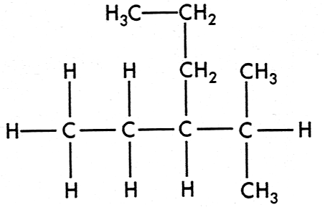

**longest chain = 6: hexane**

**side groups: methyl, ethyl**

**4**

**3–ethyl–2–methyl hexane**

**2**

**3**

**1**

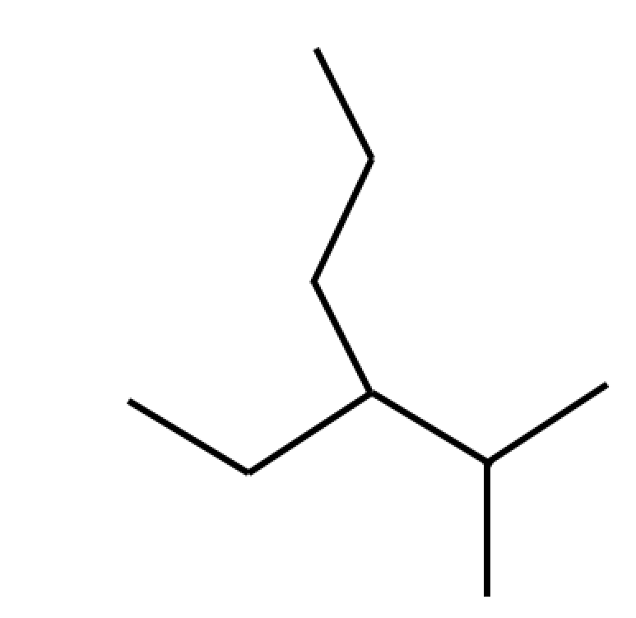Below is a link to a video for naming alkanes. Note – some chemists use a stick model to identify a carbon chain. The molecule above, 3–ethyl–2–methyl hexane, could be represented by the following diagram.

<https://youtu.be/QzDli_Llo9A>

Exercise 1: Draw the structural formulas for the following organic compounds:

Below are some questions to assist your understanding. Complete Exercise 1 and check your answers at the end of the book.

a) ethane e) 1,4–diethylcyclohexane

b) methylpropane f) ethylpentane

c) 2,3–dimethylhexane g) 1,3–dimethylcyclopentane

d) 3–ethyl–4–methyloctane h) tetramethylbutane

**Exercise 2**: Name the following organic compounds.

Below are some questions to assist your unders tanding. Complete Exercise 2 and check your answers at the end of the book.

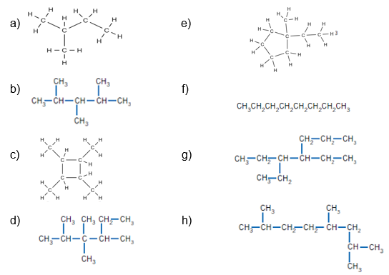

**Structural Isomers of alkanes**

Structural isomers - compounds having same **molecular formula** but different **structural formula**.

**Example**: hexane C6H14

CH3-CH2-CH2-CH2-CH2-CH3 Structure 1



CH3-CH-CH2-CH2-CH3 Structure 2 (2-methylpentane)

⏐

CH3



CH3-CH-CH-CH3 Structure 3 (2,3-dimethylbutane)

⏐ ⏐

CH3 CH3

Isomers with greater branching in their molecules have lower dispersion forces, so boiling points reduced.

Isomers can be **positional isomers** which retain the same length of carbon chain but functional groups are placed on different carbon atoms e.g. 2-methyloctane and 3-methyloctane . Or they can be **chain isomers**, the number of carbons in the base group change e.g. hexane and 2-methypentane.

**Exercise 3:** Draw and name, all the structural isomers for C7H16

**Naming Alkenes –** Names have the suffix **-ene.** The double bond must be included in the longest carbon chain.

**Example:** Name the following organic compounds:

a. CH3⎯CH2⎯CH=CH⎯CH3

1. The stem have 5 carbon atoms with a double bond, so is **pentene**.
2. The double bond has priority so receives the lowest number.
3. Name of compound is: **2-pentene**. **pent–2–ene**



b.

1. The main chain has 4 carbon atoms - it must include the double bond. The longer chain of 5 carbon atoms is not used: **butene.**
2. The double bond has numbering priority. The other functional groups are an **ethyl** and **methyl** group.
3. Name of compound is: **2-ethyl-3-methyl-1-butene**.

**Exercise 4**: Name the following organic compounds.

Below are some questions to assist your understanding. Complete Exercise 4 and check your answers at the end of the book.

 a.



b.



c.



d.

**Exercise 5**: Draw structural formulae for the following:

Below are some questions to assist your understanding. Complete Exercise 5 and check your answers at the end of the book.

a. 1,1-dichloro-2-pentene

b. 5,6,6,7-tetramethyloct-3-ene

c. 3-chloro-2,3-difluoro-1-butene

**Structural Isomers of Alkenes**

Similar to alkanes, but in numbering branched-chain alkenes, the lowest number is

assigned to the double bond and **not** the substituent group:



3-methyl-1-butene

(correct)

**NOT**

2-methyl-3-butene

(incorrect)

The double bond has priority, so the carbons are numbered to give the carbons attached to the double bond the lowest number possible.

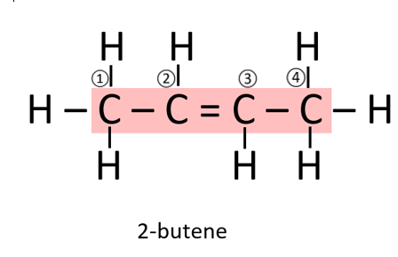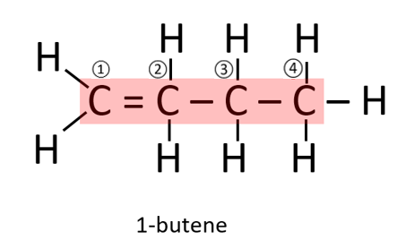

**Alkene - Geometric Isomers**

Geometric isomers only occur in alkenes: compounds having same molecular formula and structural formula but different geometry.

Different geometry is due to resistance to rotation along the axis of the double bond.

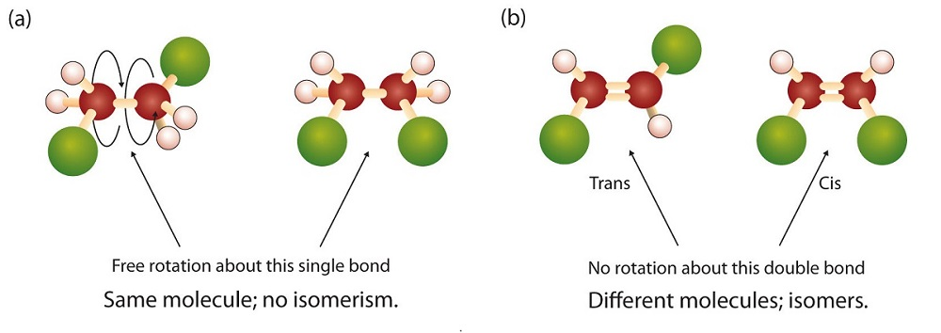

https://courses.lumenlearning.com/suny-mcc-organicchemistry/chapter/geometric-stereoisomers-cistrans/

Geometric forms known as **cis** and **trans** isomers.

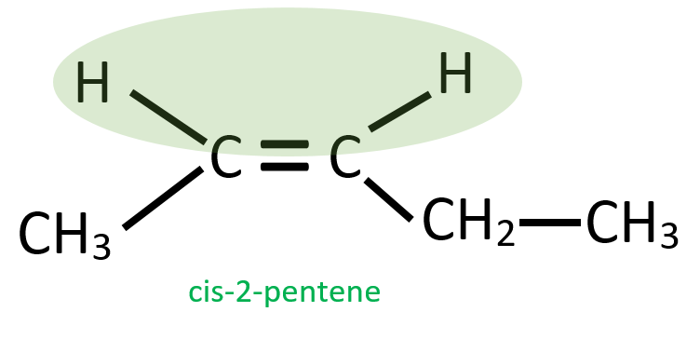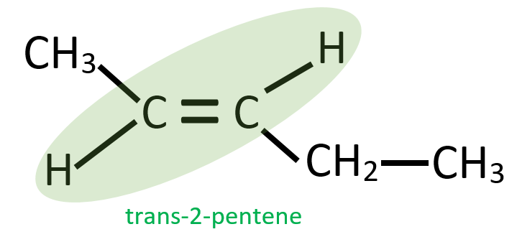

The terms cis and trans are from Latin.

Cis means ‘this side of’ – both are on the same side of the double bond

Trans means ‘that side of’ – one is across the double bond to the other.

Many alkenes have geometric isomers; to do so requires:

* a carbon-carbon double bond.
* dissimilar groups on each of the carbon atoms which form the double bond.

A D

C=C Geometric isomer only if

A≠B and D≠E and C is a

B E carbon atom.

**Exercise 6**: Name the following compounds using “cis” and “trans”.

Below are some questions to assist your understanding. Complete Exercise 6 and check your answers at the end of the book.

****a.



b.



c.



d.

e.



f.



g.

**Exercise 7**: Draw the cis and trans isomers of each of the following:

Below are some questions to assist your understanding. Complete Exercise 7 and check your answers at the end of the book.

a. 2-heptene

b. 1,2-dichloropropene

c. 1,2-dichloroethene

d. 1-chloro-1-pentene

e. 1-heptene

**Naming aromatic hydrocarbons**:

C6H6 is called benzene.

http://www.chemguide.co.uk/basicorg/conventions/chlorobenz.GIF

Chlorobenzene – one hydrogen is removed and replaced by a chlorine atom.

It has a formula of C6H5Cl.

http://www.chemguide.co.uk/basicorg/conventions/methylbenz.GIF

Methylbenzene – has a benzene ring with a methyl group attached.

It has a simplified formula of C6H5CH3.

This arrangement is also called toluene.

A benzene ring with one H removed is called a phenyl group.

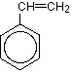This is similar to a methane missing a H being called a methyl group.

An ethene molecule with a benzene group attached to it is called phenyl ethene.

**Exercise 8**: Name the following molecules.

Below are some questions to assist your understanding. Complete Exercise 8 and check your answers at the end of the book.

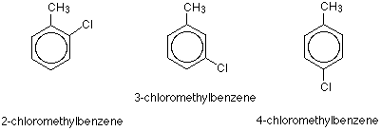

1. b) c)

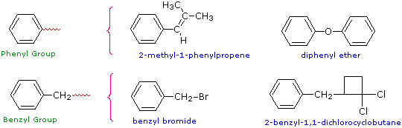

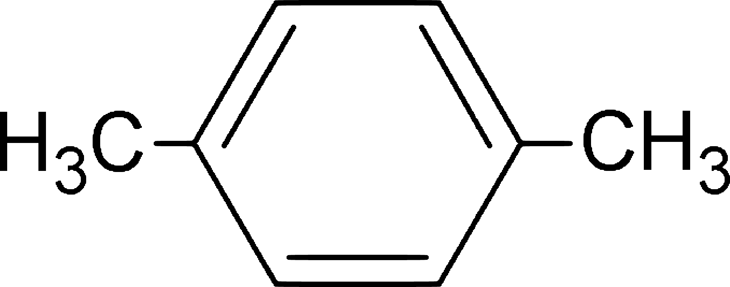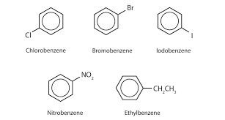d) e) f)

Hydrocarbons, including alkanes, alkenes and benzene, have different chemical properties that are determined by the nature of the bonding within the molecules.

Alkanes, alkenes and benzene undergo characteristic reactions such as combustion, addition reactions for alkenes and substitution reactions for alkanes and benzene.

**ALKANES**

**Physical Properties**

Differences in physical properties are due to differences in number of carbon atoms.

Compounds with short chain lengths (1 to 4) are gases; medium chain lengths (5 to 21) are liquids. beyond this; semi-liquid and solids.

Other physical properties:

* colourless
* short chain alkanes are odourless and need foul smelling gas to be added to detect them. Chains of ~8 smell like petrol.
* low melting and boiling point
* non-conductor of electricity
* solid alkanes are soft
* solid alkanes are malleable
* insoluble in water but dissolve in organic solvents

**Reactions of Alkanes and Cycloalkanes**

Alkanes and cycloalkanes have achieved maximum bonding capacity - saturated

hydrocarbons.

They undergo reactions in which bonds are broken and new, stronger bonds formed:

1. substitutions reaction
2. combustion reaction

**Substitution reaction**

These are reactions which break a C-H bond and replace the hydrogen atom with another element.

They occur when an alkane is combined with a non-metal like a halogen: Cl2 or Br2 causing replacement of one or more H atoms with Cl or Br.

Reaction very slow due to high energy required.

Product formed is called a haloalkane.

Only alkanes undergo substitution reactions.

The number of replaced hydrogen atoms depends on reaction conditions; with excess Cl2 or Br2 complete replacement can occur.

The following shows reaction between Cl2 (g) and CH4(g) when **exposed to UV light**.

Observations

Cl2 – green/yellow, pungent, choking

CH3Cl – colourless, sweet odour, toxic

CH2Cl2 – colourless, sweet aroma

HCl – colourless, choking

Cl2 (g) + CH4 (g) → CH3Cl (g) + HCl (g)

chloromethane

Cl2 (g) + CH3Cl (g) →CH2Cl2 (g) + HCl (g)

dichloromethane

**Combustion**

Combustion in excess oxygen gas (O2) results in **complete combustion** - produce carbon dioxide and water vapour and considerable energy (highly exothermic).

The general equation for this reaction where “n” in the equation represents the number of carbon atoms is:

CnH2n+2 + **3n + 1** O2 → **n**CO2 + **(n + 1)**H2O + heat

**2**

e.g. 2C4H10 + 13O2 → 8CO2 + 10H2O + 5 754 kJ

Combustion in limited oxygen gas results in **incomplete combustion**. This produces carbon monoxide and less energy:

2C4H10 + 9O2 → 8CO + 10H2O

Alkanes are relatively inert so unaffected by hot nitric acid, hot caustic alkalis and strong oxidising agents.

**Exercise 9**: Write an equation showing the reaction that occurs in each of the following:

Below are some questions to assist your understanding. Complete Exercise 9 and check your answers at the end of the book.

a. A little bromine water is added to excess ethane.

b. Ethane and excess chlorine gas are combined and reacted until no further reaction takes place. If conditions are appropriate (i.e. in this case the chlorine is in excess), then addition will continue until complete: all the H atoms have been replaced with Cl atoms.

c. Butane is mixed with excess oxygen and ignited.

**Exercise 10**: Alkanes revision.

Below are some questions to assist your understanding. Complete Exercise 10 and check your answers at the end of the book.

1. Use IUPAC rules to name the following organic compounds.

a.



b.



c.



d.

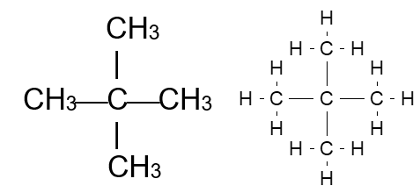

e.



f.

2.

a. 3,4-dimethylhexane

b. 1,1,1-trichloroethane

c. 2,3,3,4-tetramethyloctane

d. 4-chloro-2,3-dimethyloctane

e. 3-chloro-2,3-difluorobutane

3. Write balanced equations for the following reactions:

a. C4H10 + F2 + U.V. light →

b. C7H16 + I2 + U.V. light →

c. pentane + iodine water + U.V. light →

4. Write equations for the chlorination of ethane where the only organic product is:

a. chloroethane.

Write obsevations for this reaction.

b. hexachloroethane.

5. Write equations for the combustion of butane to:

a. carbon dioxide and water.

b. carbon monoxide and water.

6. Draw structural formulas for the following:

a. methylbutane

b. 2,2-dimethylpentane

c. 2,3-dimethylpentane

d. 2,2,4-trimethylpentane

e. ethylhexane

f. tetramethylbutane

7. Why are no numbers required to determine the structures of ethylhexane and tetramethlybutane?

8. Name the following compounds:

a.

b. (CH3)2CHCH(CH3)2

c. CH3CH2C(CH3)2CH(CH2CH3)CH2CH2CH3

9. There are nine structural isomers with the molecular formula C7H16. Remember that isomers can be **positional isomers** which retain the same length of carbon chain but functional groups are placed on different carbon atoms e.g. 2-methylpentane and 3-methylpentane . Or they can be **chain isomers**, the number of carbons in the base group change e.g. hexane and 2-methypentane.

a. Draw structures for two isomers which are chain structural isomers.

b. Draw structures for two isomers which are position structural isomers.

10. Draw structural formulas for the following:

a. ethylcyclopentane

b. 1,3,5-trimethylcyclohexane

**ALKENES**

**Physical Properties:**

Similar to alkanes – similar trends in melting point, boiling point, density and state under normal conditions.

* C2 to C4 gases
* C5 to C15 liquids
* C16 and above are solids.

All alkenes are insoluble in water but will dissolve in non-polar and organic solvents.

**Reactions of Alkenes and Cycloalkenes**

**Combustion reaction**

Undergo combustion in a plentiful supply of oxygen to form carbon dioxide and water.

General equation:

CnH2n + nO2 → nCO2 + nH2O + heat

Example:

C2H4 + 3O2 → 2CO2 + 2H2O + 1 323 kJ

Incomplete combustion in limited air supply - carbon monoxide and less energy produced.

**Addition Reactions**

Alkenes are more reactive than alkane, due to unsaturated bonds.

Alkenes undergo addition - the unsaturated bonds are replaced by bonds to:

**Hydrogenation**: Alkene, with hydrogen, heated in presence of metal catalyst e.g. Nickel.

CH2=CH2 + H2 → CH3CH3

 ethene ethane

**Halogenation**: Halogen (Cl2, Br2 or I2) reacts with alkene

H3C ⎯ CH=CH2 (g) + Br2 (l) → CH3CHBrCH2Br (l)

propene 1,2 – dibromopropane



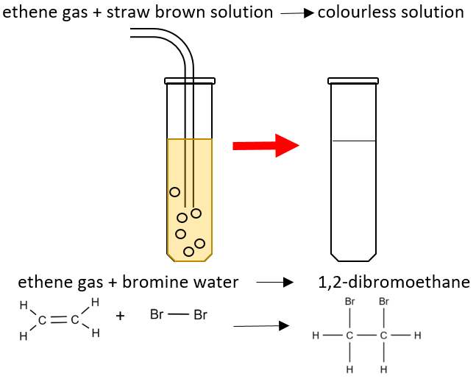

* Note: these reactions will not occur with alkanes under normal conditions.
* **Test for an alkane or alkene**: These reactions could be used to determine whether a sample of gas was an alkane or and alkene as the alkene would cause a colour change but the alkane would not.
* Below is a link to a video that demonstrates the use of bromine water to identify alkenes.

<https://youtu.be/vBMGNzRYngk>

**Hydrohalogenation**: hydrogen halides also react with alkene e.g. HBr, HCl, HI

H2C=CH2 (g) + HBr (g) → CH3CH2Br (l)

ethene bromoethane



**Hydration**: Reaction of alkenes with water (catalyst sulfuric acid) to produce an alcohol.

CH2=CH2 + H2O → CH3CH2OH

ethene ethanol



**Markovnikoff’s Rule**

When HCl, HBr or HI react by addition, there may be two possible products. The most likely product is when the added H atom will attach to the carbon atom of the multiple bond already having the **most** attached hydrogen atoms.

This is known as the **Markovnikoff’s rule.** Non-hydrogen atoms usually add to the carbon with the lesser number of hydrogen atoms.

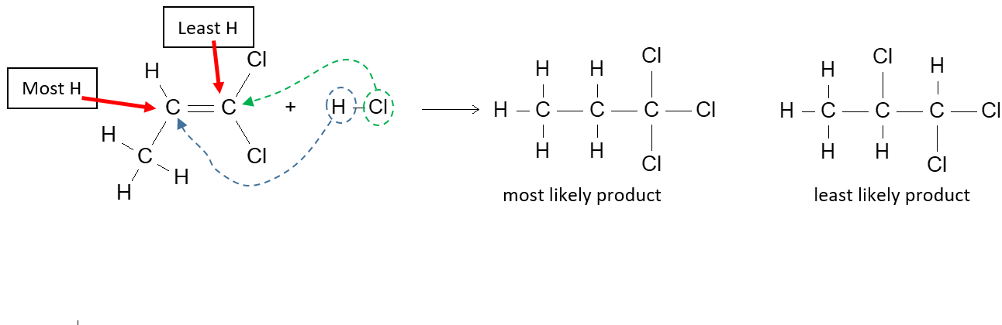

**Exercise 11**: Alkenes revision.

Below are some questions to assist your understanding. Complete Exercise 11 and check your answers at the end of the book.

1. Why do alkanes not exhibit geometric isomerism?

2. Draw structural formulas for the following:

a. methylpropene

b. cis-2-butene

c. trans-1,2-dichloro-1-butene

d. 2-methyl-2-pentene

3. Name the following compounds:



a.

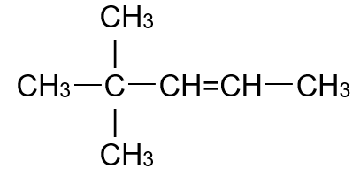

b.



c.



d.

4. Explain why the Markovnikoff’s rule would not have to be used to predict the products of

hydrochlorination of cis-2-butene.

5. Write balanced equations for the following reactions.

a. C2H4 + Cl2 →

Observation –

b. 1-propene + H2 →

c. C4H8 + HCl →

6. Write equations for the following reactions and name the product formed in each case:

a. the chlorination of propene.

b. the bromination of 1-heptene

c. the hydrogenation of 2-butene

**Reactions of aromatic hydrocarbons**:

Aromatic compounds undergo substitution reactions in which a hydrogen or substituent group attached to a carbon atom in the ring is replaced by another substituent group.

**Halogenation:** Substitution with a halogen in the presence of a catalyst (e.g. FeBr3)

NOTE: only one of the halogen atoms attaches:

C6H6 + Br2 → C6H5Br + HBr

benzene + bromine bromobenzene hydrogen bromide





**Alkylation:** Substitution with an alkyl in the presence of a catalyst (e.g. AlCl3)

C6H6 + CH3CH2CH2Cl → (CH3CH2CH2)C6H5 + HCl

 benzene 1-chloropropane propylbenzene hydrogen chloride



**Nitration:** Substitution with a nitro group in the presence of a catalyst (e.g. H2SO4)

C6H6 + HNO3 → C6H5NO2 + H2O

benzene nitric acid nitrobenzene water



or



**Combustion:** Same products – CO2 and H2O

Fossil fuels (including coal, oil, petroleum and natural gas) and biofuels (including biogas, biodiesel and bioethanol) can be compared in terms of their energy output, suitability for purpose, and the nature of products of combustion.

**Fossil Fuels**

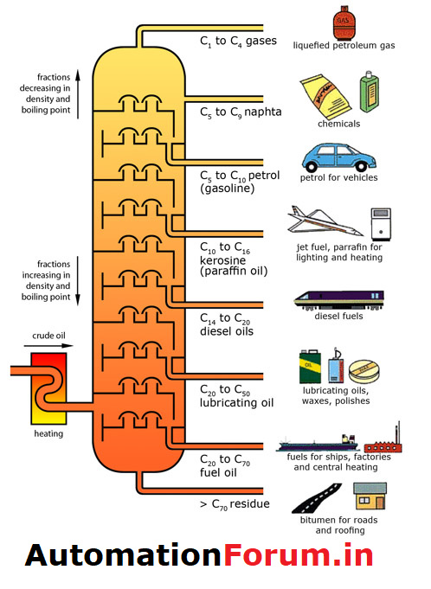Fossil fuels are fuels formed millions of years ago from the remains of plankton and other organic material. Fossil fuels include coal, oil and natural gas.

Crude oil is a complex mixture of hydrocarbon compounds from which fuels such as petrol and diesel are extracted. It is mined, then separated into

different fractions by fractional distillation. Crude oil is heated to over 300 °C and the various fractions of the crude are separated.

FRACTION

Liquefied natural gas (LNG)

Liquefied petroleum (LPG)

Petrol

Kerosene

Diesel

Lubricating oil

https://automationforum.in/t/crude-oil-refining/7385

Bitumen

Natural gas is found with petroleum (crude oil) and is the remains of plankton and other sea

creatures. It is mainly methane with a little ethane.

Chemists have found that the large molecules in the heavier fractions can be broken down into

smaller and lighter molecules. This process is called cracking. During the process of cracking one of the products is always an alkene.

Cracking has 3 uses:

* + To make more fuel. People use less of the larger fractions. So they are broken into smaller, more useful fractions like petrol and kerosene.
  + To make alkenes.
  + To make hydrogen.

**Major Hydrocarbon Constituents of Petrol, Kerosene, And Natural Gas.**

Natural gas, petroleum and coal are the major sources of hydrocarbons on Earth.

Energy traced back to solar energy is stored by plants in photosynthesis

Fossil fuels provide most of world’s current energy needs as well as major source of hydrocarbons used to manufacture a huge range of organic consumer products.

**Natural Gas:**

Has its origin in marine living things which accumulated as organic sediment. Over time organic matter reduced to hydrocarbons.

Vast quantities are liquefied and exported overseas as liquefied natural gas (LNG). Main component of natural gas is methane – CH4.

Ethane, propane, butane also present in varying amounts depending on source. Ethane is extracted and used in petrochemical industry.

Propane and butane extracted and liquefied under pressure to produce liquefied petroleum

gas (LPG).

**Petrol:**

Petrol is obtained from crude oil by fractional distillation. It Contains many straight-chain alkanes – C5 to C12.It is used in engines.

Straight-chain hydrocarbons don’t burn uniformly so modification needed for smooth running of engines. To improve octane number (higher the better), additions are made e.g. addition of branched-chain alkanes, aromatics, some oxygen-containing organic compounds and tetraethyllead.

**Kerosene:**

Produced by fractional distillation of crude oil – fraction C12 to C16

**Biofuels**

Biofuels are fuels that can be made from this biomass – materials such as crops, wood or organic waste material. Biofuels are created from living or recently dead materials and are considered to be a more sustainable source of fuel.

**Biogas**: a gas released form the breakdown of organic materials, usually by digestion. Bacteria can be used to break down complex molecules like carbohydrates into simpler molecules like carbon dioxide or methane.

**Bioalcohol**:Alcohols are organic compounds made by fermenting plant materials like sugar. Ethanol (CH­3­CH2OH) is the alcohol in alcoholic drinks but can be used as an additive to petrol (up to 10%). E10 is 10 % ethanol and 90 % unleaded petrol.

Below is a link to a video related to converted sorghum to bioethanol.

<https://youtu.be/QJSZ4Ox_I30>

**Biobutanol**: Butanol can be produced by fermentation of carbohydrates (such as wood, corn or sugar cane) using a bacterium.

**Biodiesel**: Biodiesel can be produced from biomass such canola, sunflower or rapeseed oil. The chemicals that make up biodiesel are organic compounds called esters. The biodiesel can be used to run trucks, cars, trains and ships. It is not usually used on its own and can be mixed with traditional diesel from crude oil.

**Comparing fuels**

Energy output

|  |  |
| --- | --- |
| Fossil Fuel | MJ per tonne |
| Natural gas | 54 000 |
| Petroleum | 48 000 |
| Diesel | 45 000 |
| Coal | 34 000 |
| Biofuel | MJ per tonne |
| E10 | 44 000 |
| Biodiesel | 42 000 |
| Bioethanol | 30 000 |
| Biogas | 26 000 |

**Suitability**

For a fuel to be useful it must be easy to store and transport, as well as produce energy.

Solid fuels, like coal and wood, are easy to store and transport. Liquids, like petrol and diesel, are also easy to store and transport. Gases like natural gas need to be compressed or condensed into a liquid form for storage and transport.

**Products**

All of the fuels mentioned so far contain carbon. When they combust in excess oxygen, they create carbon dioxide (a greenhouse gas) and water. When there is insufficient oxygen present, toxic carbon monoxide and soot (C) can be produced.

Some fossil fuels can contain impurities like sulphur. When burnt, sulphur dioxide (SO­­2) can be produced which can form acid rain when reacted with water.

**Exercise 12: Energy from fuels**

Below is a question to assist your understanding. Complete Exercise 12 and check your answers at the end of the book.

Methane (CH4) produces 880 kJ of energy per mol. Butane (C4H10) produces 2900 kJ per mol. Octane (C8H18) produces 5500 kJ per mol.

When burnt in excess oxygen, they all produce CO2.

1. Write a balance equation for the combustion of each fuel.
2. Determine the amount of energy released per mol of CO2 produced for each fuel.
3. Which fuel produces the most energy per mol of CO2?

**Useful videos**

**Hydrocarbons**

[**https://youtu.be/YjkJ1XYNNRM**](https://youtu.be/YjkJ1XYNNRM)

**Alkanes**

[**https://youtu.be/bad9rBstpVo**](https://youtu.be/bad9rBstpVo)

**Alkenes**

[**https://youtu.be/bS1jZA9FXNc**](https://youtu.be/bS1jZA9FXNc)

**Naming alkane and alkenes**

[**https://youtu.be/Ud9HChymJqI**](https://youtu.be/Ud9HChymJqI)

**Isomers**

[**https://youtu.be/ELOH3fjoG5U**](https://youtu.be/ELOH3fjoG5U)

**Hydrocarbon reactions**

[**https://youtu.be/_iJBZ2grfs4**](https://youtu.be/_iJBZ2grfs4)

**Could you live without oil?**

[**https://education.abc.net.au/home#!/media/30906/**](https://education.abc.net.au/home#!/media/30906/)

**Answers to Exercises**

**Exercise 1:**

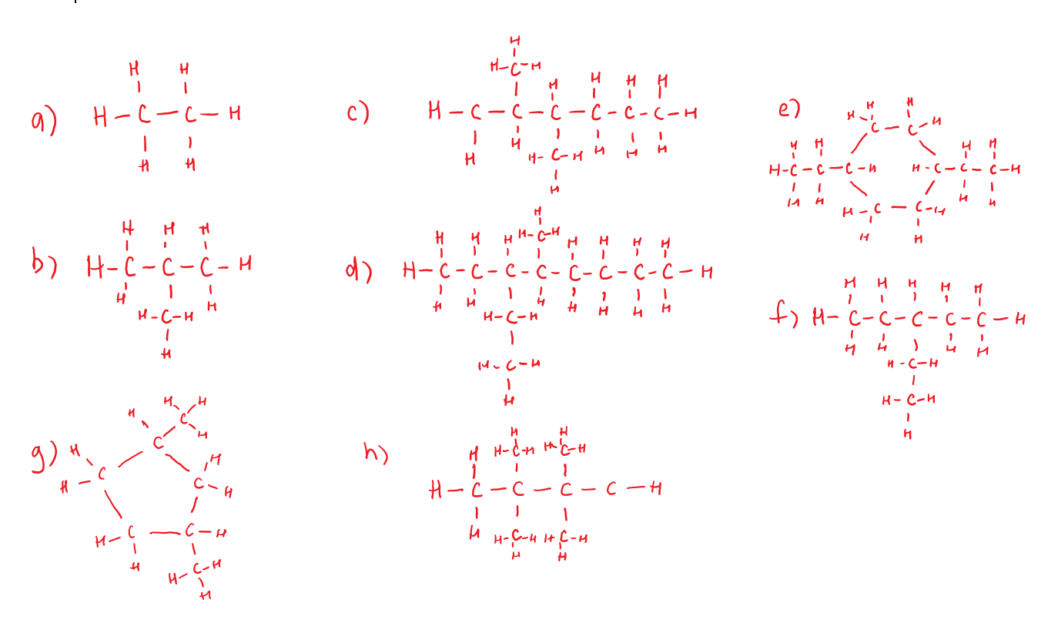

**Exercise 2:**

a. 2-methylbutane (or just methylbutane) b. 2,3,4-trimethylpentane

c. 1,2,3,4-tetramethylcyclobutane d. 2,3,3,4-tetramethylhexane

e. 1-ethyl-1-methylcyclopentane f. octane

g. 3,4-dimethylheptane h. 2,4,7-trimethyloctane

**Exercise 3:**





**heptane 2,2 – dimethyl pentane 3,3 – dimethyl pentane**





**2 – methylhexane 2,3 – dimethyl pentane 3 – ethylpentane**



**3 – methylhexane 2,4 – dimethyl pentane 2,2,3 - trimethylbutane**

**Exercise 4**:

a. **1–butene or but–1–ene**

b. **1,3–dibromo–4–chlorohex–2–ene or 1,3–dibromo–4–chloro–2–hexene**

c. **2–ethyl–3–methylpent–1–ene or 2–ethyl–3–methyl–1–pentene**

d. **1,2–difloro–2–methylhex–3–ene or 1,2–difloro–2–methyl–3–hexene**

**Exercise 5**:

a. b.



c.

**Exercise 6**:

a. **cis–3–chloro–3–hexane or cis–3–chloro–hex–3–ene**

b. **cis–2,3–dichloro–2–butane or cis–2,3–dichloro–but–2–ene**

c. **trans–1,4–dichloro–2–butane or** **trans–1,4–dichlorobut–2–ene**

d. **cis–1,2–dibromo–1–butene** **or cis–1,2–dibromo–but–1–ene**

e. **trans–2,3–difluoro–2–butane or** **trans–2,3–difluoro–but–2–ene**

f. **trans–2,3–diiodo–2–butene** **or** **trans–2,3–diiodo–but–2–ene**

g. **1,1–dichloroethene**



**Exercise 7**:

a.

 b.



c.



d.

 e.

**Exercise 8**:

a. **CH3CH3 + Br2 → CH3CH2Br + HBr**

b. **CH3CH3 + 6Cl2 → CCl3CCl3 + 6HCl**

c. **2CH3CH2CH2CH3 + 13O2 → 8CO2 + 10H2O**

**Exercise 9**:

a) **2–chloromethylbenzene** b) **3–chloromethylbenzene** c) **4–chloromethylbenzene**

**2–chlorotolunene**

d) **1,4–dimethylbenzene** e) **ethylbenzene** f) **2-methyl-1-phenylpropene**

**Exercise 10**: Use IUPAC rules to name the following organic compounds.

1.

a. **ethane**

b. **pentane**

c. **1 – chloropropane**

d. **3 – methyl octane**

e. **dimethylpropane**

f. **hexabromoethane**

2.

a.



b.



c.



d.

e.

3.

a. **C4H9F + HF**

b. **C7H15I + HI**

c. **C5H12 + I2 + U.V. light🡪 C5H11I + HI**

4.

a. **CH3CH3 + Cl2 → CH3CH2Cl + HCl**

**Observation – colourless, odourless gas and yellow/green pungent gas create colourless gas with pungent ether-like odour and a colourless pungent, choking gas.**

b. **CH3CH3 + 3Cl2 → CCl3CCl3 + 3H2**

5.

a. **2C4H10 + 13O2 → 8CO2 + 10H2O**

b. **2C4H10 + 9O2 → 8CO + 10H2O**

6.

a. methylbutane

b. 2,2-dimethylpentane

c. 2,3-dimethylpentane

d. 2,2,4-trimethylpentane

e. ethylhexane

f. tetramethylbutane

7. **The numbers are not needed because these are the only ways that these molecules can form.**

**If the alkyl groups are attached to other C’s then it will change the structure.**

8. Name the following compounds:

a. **3 – methylpentane**

b. **2,3 - dimethylbutane**

c. **4 - ethyl -3,3 – dimethyl heptane**

9.

a.

b.

10.

a.

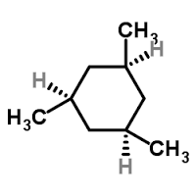

b.

**Exercise 11**:

1. **Because a geometric isomer of an alkane will be the same structure.**

2.

a.



b.



c.



d.

3.

a. **but–1–ene****1–butene**

b. **4,4–dimethyl–2–pentene 4,4–dimethylpent–2–ene**

c. **2–methyl–1–butane 2–methylbut–1–ene**

d. **trans–2–pentene trans–pent–2–ene**

4. **The added H atom will attach to the carbon atom of the multiple bond already having the most attached hydrogen atoms. The product formed has a symmetry such that it doesn’t matter where the Cl attaches – it will be the same.**



5.

a. C2H4 + Cl2 → **CH2ClCH2Cl**

**A colourless odourless gas is mixed with a yellow/green pungent gas to create a colourless, pleasant smelling liquid.**

b. 1-propene + H2 → **CH3CH2CH3**



c. C4H8 + HCl → **CH3CH2CHClCH3**

6. Write equations for the following reactions and name the product formed in each case:

a. the chlorination of propene.

**1,2 - dichloropropane**

b. the bromination of 1-heptene



c. the hydrogenation of 2-butene **1,2 - dibromoheptane**



**Exercise 12: Energy from fuels**

**(a) CH4(g) + 2O2(g) → CO2(g) + 2H2O(g)     E = 880 kJ mol-1**

**880 kJ per mol of CO2. Most energy.**

**(b) 2C4H10(g) + 13O2(g) → 8CO2(g) + 10H2O(g)**

**C4H10(g) + 13/2O2(g) → 4CO2(g) + 5H2O(g)     E = 2900 kJ mol-1**

**725 kJ per mol of CO2.**

**(c) 2C8H18(g) + 25O2(g) → 16CO2(g) + 18H2O(g)**

**C8H18(g) + 25/2O2(g) → 8CO2(g) + 9H2O(g)     E = 5500 kJ mol-1**

**688 kJ per mol of CO2. Least energy.**