Student worksheet answers

7.5 Force equals mass × acceleration

Pages 164–165

Newton's second law: Fnet = ma

1 Describe Newton’s second law.

Students’ answers should include that the acceleration of an object is directly related to the size and direction of the force acting on the object. The second law also introduces the formula of force equals mass multiplied by acceleration (F = ma).

2 What is the difference between mass and weight?

Mass refers to the amount of matter an object has while weight is the force of gravity acting on an object.

3 What formula can be used to calculate net force?

Net force (Fnet) = mass (m) × acceleration (a)

4 Complete the equation triangle for net force below and describe how it works.

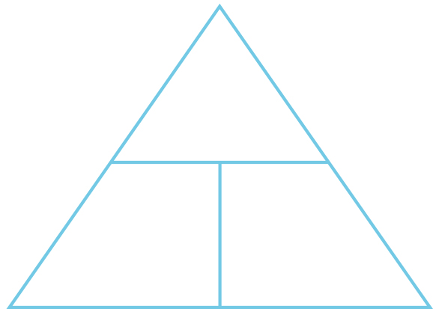

To use the triangle, students need to cover the quantity they wish to calculate. The remaining two quantities will form the formula.

Where necessary below, use g = 9.80 m s–2. Unit conversions: 1000 grams = 1 kilogram and 1000 kilograms = 1 tonne.

5 How much horizontal net force is required to accelerate a 1200-kg car at 1.5 m s–2?

,

6 A net force of 16 N gives a bowling ball an initial acceleration of 2.5 m s–2. What is the mass of the bowling ball?

, ,

7 A speed skater has a mass of 64 kg. She is providing a driving force of 400 N, and there is a frictional force of 240 N against her. Draw these two forces acting on her and then determine her acceleration.

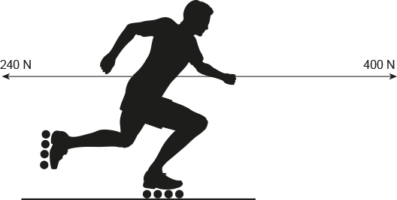

, ,

Extend your understanding

8 A skydiver of mass 85 kg is falling through the air at terminal velocity (constant speed).



a What is the weight force acting on the skydiver?

, ,

b How much air resistance is acting on the skydiver?

At terminal velocity the skydiver is falling at a constant speed. This means that his acceleration is zero and hence the net force is also zero.

The two forces acting on the skydiver are weight (acting down) and air resistance (acting up), and these two forces are equal in size and opposite in direction.

This means that force of air resistance acting on the skydiver must be equal to 833 N.

9 The Airbus A380 has a mass at take-off of 575 tonnes. During take-off, its four engines provide a total thrust of 1300 kN. Its take-off speed is 270 km h–1 and it takes 72 seconds from rest to reach this speed.

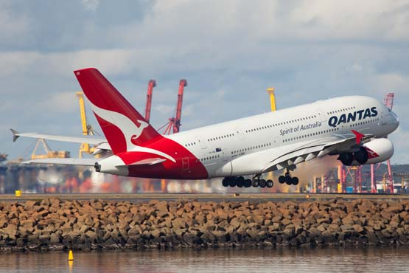

a What is the average acceleration of the A380 during its take-off run? Give your answer correct to two decimal places.

, ,

b What is the average total resistive force acting against the A380 during its take-off run?

From part a, ; and m =