Student worksheet answers

1.6 Alleles can produce dominant or recessive traits

Pages 14–15

Alleles

1 What is an allele?

The different versions of a gene

2 Describe the difference between the terms genotype and phenotype.

Genotype is the allelic symbols given to a gene. Phenotype is the physical expression of a trait resulting from the genotype and environmental influence.

3 The diagram below is of a pair of chromosomes and shows the alleles for hair colour.

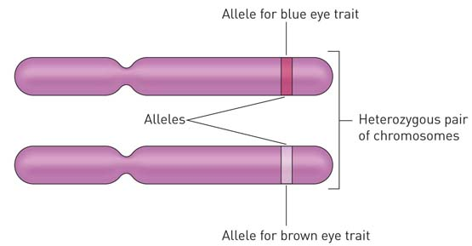

For eye colour (B) of this individual, determine

a genotype: Bb

b phenotype: Brown eyes

4 Write definitions for the following terms.

|  |  |
| --- | --- |
| Term | Definition |
| Gene | A section of DNA that codes for a characteristic. |
| Loci | The position of a gene along a chromosome. |
| Chromosome | A molecule of DNA containing genes that is coiled around histone proteins. |
| Carrier | A heterozygous individual that has a dominant phenotype but carries a recessive allele. |

5 Attached earlobes (E) is dominant to unattached earlobes. Write down the possible genotypes of

a attached earlobes: Ee or EE

b unattached earlobes: ee

c carriers: Ee

6 Long eyelashes (L) is dominant to short eyelashes. A woman and man, both with long eyelashes, have two children. The daughter has long eyelashes and the son has short eyelashes. Write the possible genotypes for each parent and child.

a Mother: Ll

b Father: Ll

c Daughter: LL or Ll

d Son: ll

7 Right-handedness (H) is dominant to left-handedness. A right-handed man and a right-handed woman have two children that are both left-handed. Complete the Punnett square below and indicate how two right-handed parents can have two left-handed children.

|  |  |  |  |  |
| --- | --- | --- | --- | --- |
|  |  | Father | |  |
|  |  | H | h |  |
| Mother | H | HH | Hh |  |
| h | Hh | hh | There is a 25% chance of each child being left-handed. |

Extend your understanding

8 Short hair is dominant over long hair in guinea pigs. A student has a female guinea pig with short hair. The student wants to purchase a male guinea pig and breed the guinea pigs safely and ethically to produce only short-haired babies.

a What phenotype male guinea pig would the student need to buy?

A short-haired male

b Explain why the student could not guarantee that all the babies will also have short hair.

The student would not know whether each parent is a carrier for long hair or not until he or she breeds them. The student only needs one parent to be homozygous dominant and they will never produce any long-haired guinea pigs. However, if both are carriers and heterozygous for short hair, there is a 25% chance of each baby being long-haired and eventually the student will produce some long-haired babies.