Student worksheet answers

1.4 Mitosis forms new somatic cells

Pages 10–11

Mitosis

1 Match each term with the correct definition.

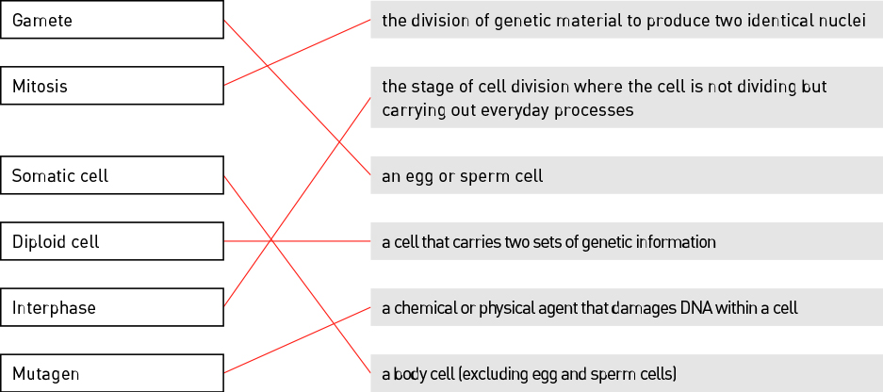

2 Identify the stage of mitosis shown in the following image.

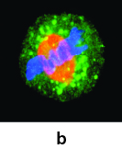

Metaphase

3 Describe what occurs during this stage of mitosis.

The chromosomes line up along the centre of the cell in a single line.

4 Why do somatic cells need to undergo mitosis?

For an organism to grow and to repair damage

5 Identify three ways a cell’s DNA can become damaged:

Radiation, viruses and mutagens

6 Explain why a cell undergoes apoptosis.

Apoptosis is programmed cell death. This occurs because it is a programmed part of a cell’s DNA as a cell cannot continue to survive and carry out mitosis indefinitely. Apoptosis is also carried out if an error occurs within a cell.

7 Fill in the blanks.

The processes of mitosis and cytokinesistogether produce two new, genetically identical daughter cells.

8 Explain why a cancerous cell continues to carry out mitosis rather than being destroyed by apoptosis.

Cancerous cells have damaged DNA that has not been identified by the cell, and so the cancerous cell continues to carry out mitosis even though apoptosis should have occurred.

9 Label the stages of mitosis shown in the image below.

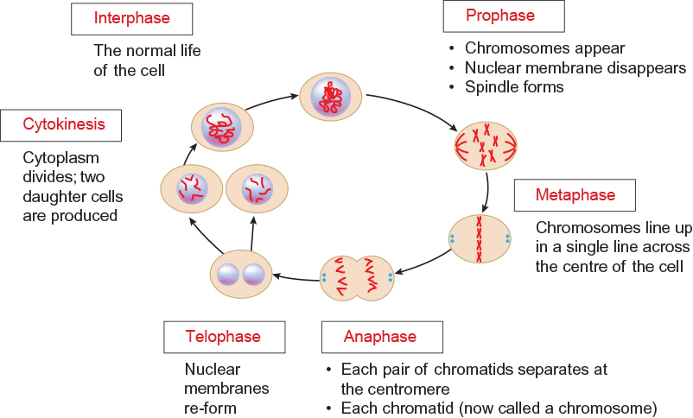

Extend your understanding

10 Identify the cell types that undergo mitosis by writing ‘yes’ or ‘no’ in the table.

|  |  |
| --- | --- |
| Cell type | Mitosis? (yes or no) |
| Bone cell | Yes |
| Egg cell | No |
| Intestinal cell | Yes |
| Nerve cell | Yes |
| Sperm cell | No |

11 Explain why only some of the cells listed in the table above undergo mitosis.

Only somatic cells carry out mitosis, which is required for growth, repair and replacement. Egg and sperm cells are gametes and are involved in reproduction, so these cells do not undergo mitosis.