**Electromagnetic Radiation**

**Watch:** [**https://www.youtube.com/watch?v=jjy-eqWM38g&list=PL8dPuuaLjXtPAJr1ysd5yGIyiSFuh0mIL&index=24**](https://www.youtube.com/watch?v=jjy-eqWM38g&list=PL8dPuuaLjXtPAJr1ysd5yGIyiSFuh0mIL&index=24)

**Light contains which two fields:**

1. **______________________________________________**
2. **______________________________________________**

**The distance between the crests in the light wave are called: ___________________________________**

**On the diagram below label a wavelength:**



**It is important to know the wavelengths of electromagnetic radiation because the wavelength relates to the lights _________________________________.**

**Circle the correct term:**

1. **Lights with shorter wavelengths have more/less energy.**
2. **Lights with longer wavelengths have more/less energy.**

**A spectrum is defined as: ______________________________________________________________________________________________________________________________________________________________________________**

**Our eyes have evolved to detect the type of light the sun emits most strongly.**

**This is called: _____________________________________**

**Name some types of light which exist, yet cannot be detected by our eyes:**

**_______________________________________________________________________________________**

**Under the diagram below (in the box) draw an arrow which indicates the level of energy from lowest to highest:**

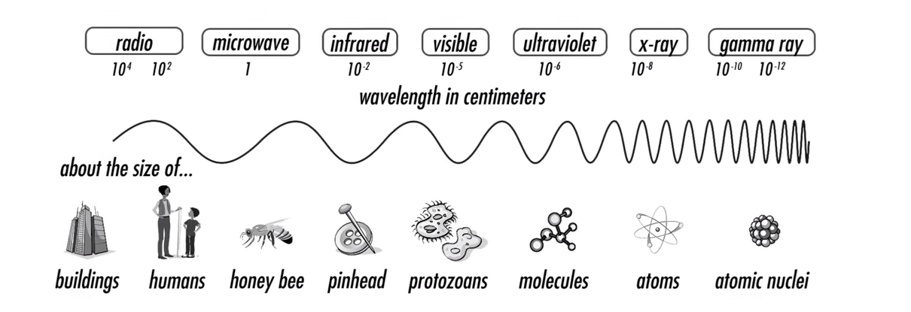

**The kind of light that an object emits depends on which factor? _________________________________**

**Hotter objects emit light with _______________________ energy. This type of light has a __________________________ wavelength.**

**Different atoms emit different ______________________________________, therefore if we can measure that light, in principle we can determine what an object is made of, even if we can’t touch it.**

**What is a spectrometer? ______________________________________________________________________________________________________________________________________________________________________________**

**The sun emits electromagnetic radiation of all frequencies, some of which are harmful to humans. Why is it that we are not affected by these forms of radiation from the sun here on Earth? (some research may be required)**

**_______________________________________________________________________________________**