|  |
| --- |
| **Year 10 Accounting 2016**    **FYA $20 Boss Presentation** |

**Task:**

Create and run a small cash business from the $20 loan you will be provided by the NAB. There are two components to the $20 Boss challenge:

1. Create, market and run a small cash business, individually or in small groups.
2. PowerPoint presentation or video which outlines your $20 Boss journey.

**Part One:**

Part one will run from week 2 to week 9 of Term 3. Most of the planning will be done in class but the business will be conducted in students own time.

It will consist of the following:

* You will create an original small cash business
* You will use various techniques to market your business
* You will document ALL your expenses and sales
* You will take photos/videos and other forms of documentation to utilise in your presentation (part two)
* Trading will run from 23 August to 9 September
* You will need to abide by school rules and policies
* Each participant will repay $21 to NAB by on conclusion of trading.

**Part Two:**

Part two will be presented to the class during weeks 9 and 10 of Term 3. It can be in the form of a PowerPoint presentation or in a video. It will need to include the following:

* A description of your business:
  + What is the problem you are solving
  + What skills and passions are you using to do this
  + How are you solving the problem
  + Name and how you decided on this
  + Your target market
* What the most exciting part of your business was
* What is next for your business
* What the biggest challenge was during the program
* Your financial summary:
  + Budget income statement
  + Actual income statement
  + Analysis of actual to budget
  + Ratio analysis (profit and expense)
* Marketing techniques used, including market research you undertook
* How your enterprise is addressing challenges in the community or environment
* Photos of you in action.

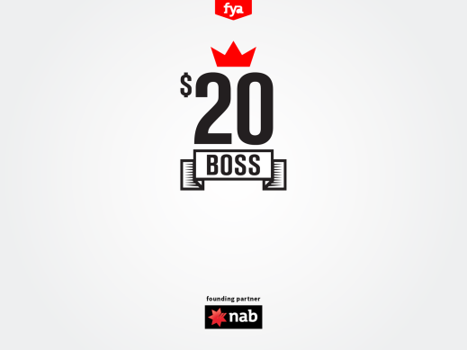

|  |
| --- |
| **FYA $20 Boss Presentation Marking Guide** |

**Business Name: ____________________________________________________________**

**Concept: __________________________________________________________________**

**Group Members: ___________________________________________________________**

|  |  |
| --- | --- |
| **$20 Boss Idea**   * Originality * Brainstorming * Business name * Description of business | /2  /2  /2  /5 |
| **Planning and preparation:**  **Marketing:**   * Market research and findings documented * Clear target market * Marketing techniques documented   **Goal and Objective Setting:**   * Clear financial goals and objectives * Clear budget estimate | /5  /4  /5  /4  /2 |
| **Running the business:**   * Challenges overcome * Breakdown of expenses and income shown through income statement * Profit Ratio * Expense Ratio | /2  /8  /2  /2 |
| **Presentation:**   * Vibrant and eye catching * Eye contact * Spoke fluently and clearly | /3  /1  /1 |
| **Total:** | /50 |

Comments:

|  |
| --- |
|  |
|  |
|  |
|  |
|  |