7.2 Atoms are made of subatomic particles

Student worksheet answers (pages 136–137)

The structure of atoms
1 Which 2 sub-atomic particles does the nucleus of an atom contain?
neutrons and protons
2 What is the charge on a proton?
positive
3 What is the charge on a neutron?
no charge
4 What is the overall charge on the nucleus of all atoms?
positive
5 What surrounds the nucleus, what charge do these have?
electrons, negative
6 What masses do protons, neutrons and electrons contain?
Protons and neutrons have an equal mass of 1 and electrons are so much smaller that their mass is zero.
7 What is the overall charge on an atom? Explain why this is.
Neutral: all atoms have the same number of positve and negative particles.
8 What assumption can you make about the number of protons and electron in an atom?
They are equal.
9 What is the majority of an atom is made up of?
empty space

10 What was the difference between Thomson's and Rutherford’s models of the atom? Explain how Rutherford was able to refute Thomson's model?
Thomson: An atom is similar to a plum pudding of positive charge with negatively charged electrons scattered through it like raisins. Rutherford: Atoms have a central core or nucleus which is positively charged.
Rutherford refuted Thomson’s model by proving that atoms must contain a great deal of space, but that some part of the atom must contain a relatively large amount of positive charge (the nucleus).

EXTEND YOUR UNDERSTANDING
11 On the periodic table, the atomic mass of an element is located beneath it. This indicates the number of protons and neutrons in an atom. Each element's atomic number is located above it on the periodic table. This indicates the number of protons that it contains. You can calculate the number of protons and neutrons in an element by using these numbers.
For each of the following elements, draw how they appear on the periodic table in the left column, then calculate how many protons and neutrons are in their nucleus in the right column.
NB: As there is no such this as half of a proton or neutron, you will need to round off your mass numbers.
a | Nitrogen | 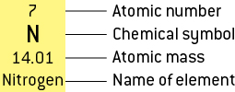 | Number of protons = 7  Atomic mass = 14  Number of neutrons = 14 – 7 = 7
b | Oxygen | 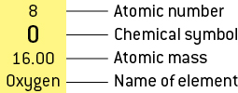 | Number of protons = 8  Atomic mass = 16  Number of neutrons = 16 – 8 = 8
c | Calcium | 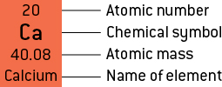 | Number of protons = 20  Atomic mass = 40  Number of neutrons = 40 – 20 = 20
d | Sodium | 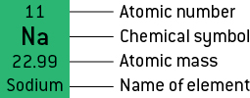 | Number of protons = 11  Atomic mass = 23  Number of neutrons = 23 – 11 = 12
e | Sulfur | 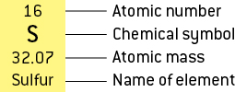 | Number of protons = 16  Atomic mass = 32  Number of neutrons = 32 – 16 = 16
f | Chlorine | 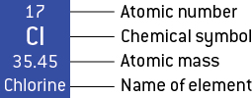 | Number of protons = 17  Atomic mass = 35  Number of neutrons = 35 – 17 = 18

