**Year 9 Chemistry Mid Topic Test Revision**

1. What do the A and Z represent in the following diagram?

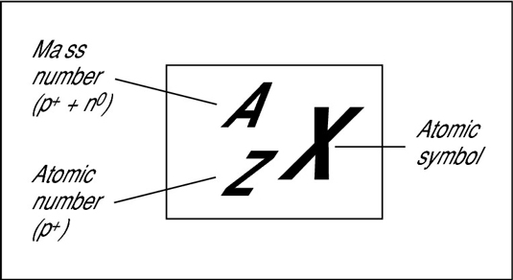

|  |
| --- |
| “Z” – atomic number = the number of protons |
| “A” = mass number = the number of protons and neutrons |
|  |

1. How is the number of neutrons in an atom calculated?

|  |
| --- |
| A – Z = number of neutrons OR |
| Mass number – atomic number |

1. State the charge of each of the following

|  |  |
| --- | --- |
| Protons | Positive |
| Neutrons | Neutral |
| Electrons | Negative |

1. Complete the following table

|  |  |  |  |  |
| --- | --- | --- | --- | --- |
| Name of Element | Symbol | Number of protons | Number of neutrons | Number of Electrons (in neutral atom) |
| Helium | He | 2 | 2 | 2 |
| Aluminium | Al | 13 | 14 | 13 |
| Hydrogen | H | 1 | 0 | 1 |
| Calcium | Ca | 20 | 20 | 20 |
| Lithium | Li | 3 | 4 | 3 |

1. Complete the following table

|  |  |  |  |
| --- | --- | --- | --- |
| Symbol | Number of Electrons | Electron Configuration | Does this species have the same number of electrons as the neutral atom or has it gained or lost some |
| Cu | 29 | 2, 8, 18, 1 | same |
| Cu2+ | 27 |  | Lost 2 |
| H+ | 0 | - | Lost 1 |
| Cl | 17 | 2, 8, 7 | Same |

1. On the periodic table what is a group and a period?

|  |
| --- |
| Group – a vertical column in the periodic table |
| Period – horizontal row in the periodic table |
|  |

1. Explain how the groups of the periodic table relate to the valency of an ion?

|  |
| --- |
| Group number is equal to the number of valence electrons. Therefore they form the |
| Same types of ions and have similar reactivity |
|  |

1. Fill out the following table

|  |  |  |
| --- | --- | --- |
| **Group Name** | **Group Number(s)** | **Properties** |
| Alkali Metals | 1 | Very reactive metals, soft metals with low densities |
| Alkali Earth Metals | 2 | Reactive metals, form compounds that are a major component of the Earth’s crust |
| Transition Metals | 3-12 | Reactivity varies, hard metals, good conductors of heat & electricity, high melting points and boiling points, form coloured compounds, can form compounds with more than one formula, for example iron (II) oxide, FeO, and iron (III) oxide, Fe2O3. |
| Halogens | 17 | Reactive non-metals, varying colours |
| Noble Gases | 18 | Exist as single atoms, very unreactive (ie. noble) elements, all gases at room temperature. |

1. State the six rules for naming and writing ionic formula

|  |  |
| --- | --- |
|  | **Rule** |
| 1 | When writing the formula of a compound the positive ion (the left most element in the periodic table) is written first. |
| 2 | The first ion is named as if it was an element |
| 3 | Elements forming negative ions will end in ide |
| 4 | The small numbers in a chemical formula indicate the number of the atom or ion immediately in front of the number |
| 5 | Polyatomic ions remain grouped in a formula |
| 6 | When there is more than one polyatomic ion in a formula, the polyatomic ion must have brackets around it and the number of the ion present is shown by a small number after the brackets |

**REVISE VALENCIES!!**