**Digestive System**

**Functions:** 1. Ingestion 2. Mechanical Digestion 3. Chemical Digestion 4. Movement along the tract 5. Absorption 6. Elimination

**Nutrient Digestion and Absorption**

Carbohydrates

Protein

Lipids

Water

Minerals

Vitamins

Definitions

Mechanical Digestion

Chemical Digestion

Absorption

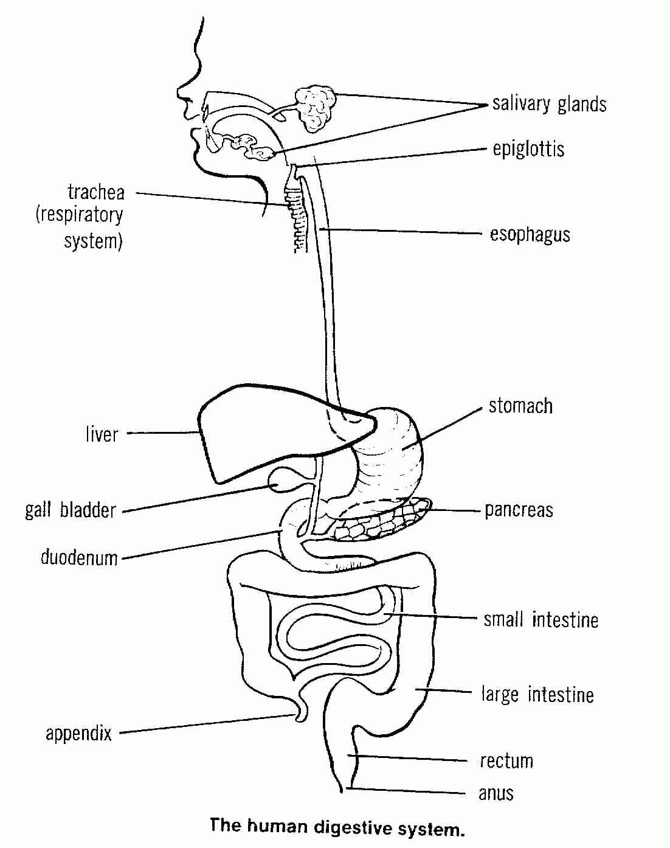

**Large Intestine, Rectum and Anus**

Structure and Function

Absorption

Elimination

**Stomach**

Structure and function

MD –

CD –

**Oesophagus**

Structure and function

**Mouth, Teeth and Salivary Glands**

Structure / Function

MD –

CD –

**Villus Structure**

**Small Intestine**

Structure and Function

CD –

Absorption -

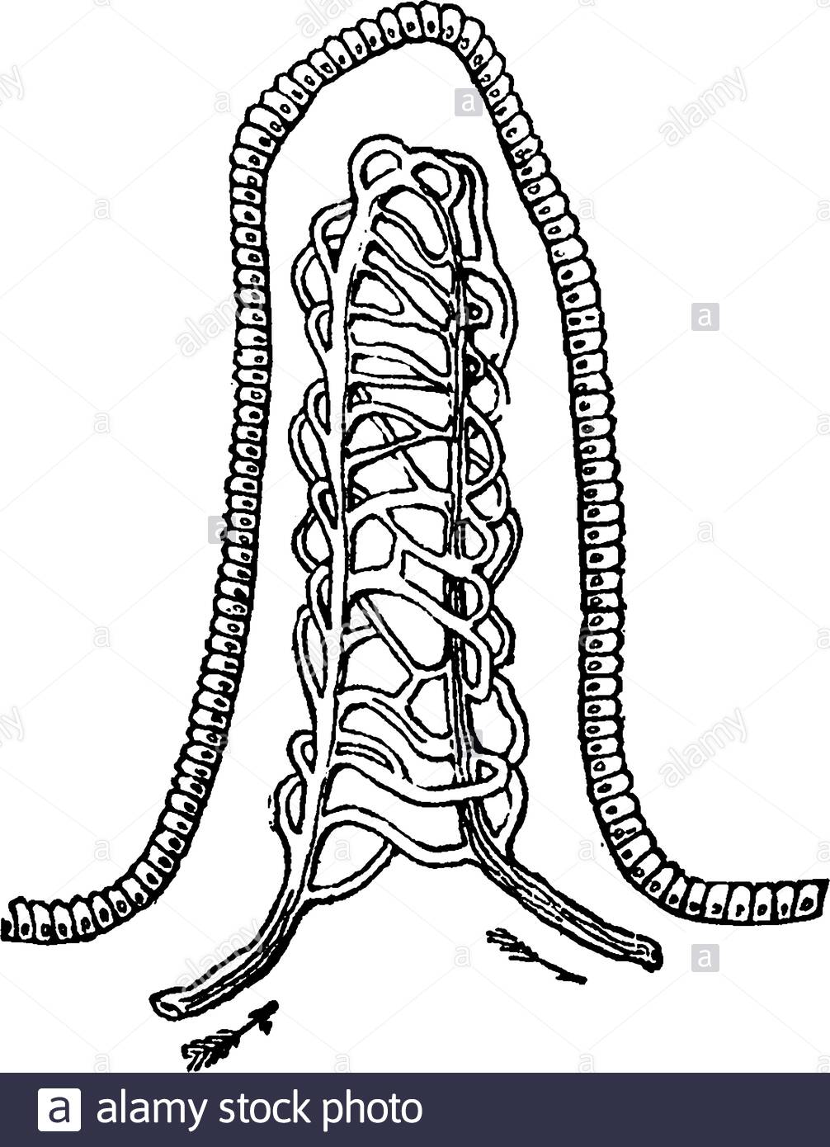

**Pancreas**

Structure and Function

**Liver and Gall Bladder**

Structure and Function