Year 10 Science – Test 1 Revision Sheet

- What is the big bang theory?

The theory of the beginning of the universe and the ongoing changes still happening to it today.
All time / space, energy / matter originated in a small, hot, dense point.
It was triggered to rapidly expand for an unknown reason.
The universe continues to expand and cool down.

- Briefly describe the evidence that supports the Big Bang Theory.

There are three main pieces of evidence for the Big Bang Theory:
Cosmic Microwave background radiation – the Big Bang had incredibly hot origins. It was expected that remnants of that heat energy should be present everywhere. This is true of microwave radiation which comes from all directions of space.
Red and Blue Shift of stars and galaxies – similar to the Doppler effect, light spectra emitted by stars and galaxies are shifted when they are moving away (red-shift) or towards (blue-shift) the Earth. Red-shift has been observed from distant stars indicating that they are still moving away from us.
Abundance of Light Elements (hydrogen and helium) – The first matter was formed from condensed energy and reactions between those early particles. Hydrogen and Helium account for most of the matter in the universe and the relative proportions of the two is supportive of the rapid expansion described in the Big Bang Theory.

- Explain the process that produces the tremendous amount of heat and light generated by the Sun.

Nuclear fusion powers the sun (and all stars).
Fusion of Hydrogen atoms in the core of stars to eventually form Helium releases many particles that perpetuate the reaction and high energy radiation (gamma radiation). As that radiation encounters particles on its journey away from the core, it gradually loses energy until it is released in a continuous spectrum of light including visible light.

- Place the letters next to the correct terms in the life cycle of a low mass star.

LOW MASS STAR

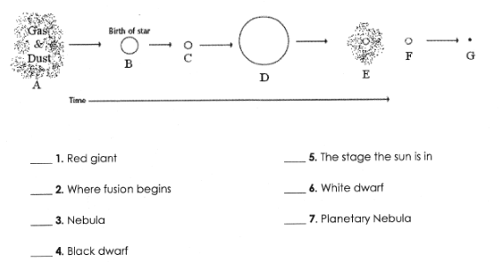
A 3, B 2, C 5, D 1, E 7, F 6, G 4

- Place the letters next to the correct terms in the life cycle of a high mass star.

HIGH MASS STAR

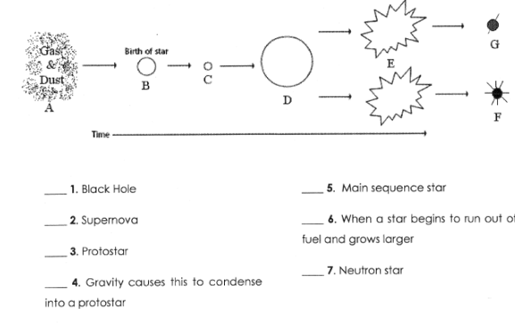

A 4, B 3, C 5, D 6, E 2, F 7, G 1

- Explain how our solar system was formed.

The solar system was formed ~ 4.6 billion years ago when a cloud of gas and dust was disturbed causing it to start to collapse on itself. Forming a spinning disc. Matter accumulated at the centre until there was enough there, hot and dense enough, for fusion to begin. This was the start of the sun. The matter that had not accumulated in the centre, condensed to form the planets and other bodies that continue to orbit the sun.
Heat and solar winds stripped the inner planets of thick gaseous atmospheres and ice resulting in the terrestrial inner planets, while the outer planets are the gaseous planets.

- How does the Sun affect our skin?

The UV radiation from the sun can have both positive and negative effects on our skin.
Positive – can help people with skin conditions such as psoriasis
Vitamin D is converted to an active form in our skin that is beneficial to our bones and general health
Negative – Exposure and tanning lead to skin aging
Acute sunburn can result from excess exposure in short periods of time
Skin cancers (melanoma, Basal cell carcinoma and Squamous cell carcinoma) are all increased by UV exposure

- What can we do to reduce the damage from the Sun?

Governments have taken action to stop ongoing damage to the Ozone layer that helps to protect us from UV exposure and provide regulation around ‘Sun Protection Factors’ of sunscreens and fabrics in particular. They are also responsible for most public awareness campaigns regarding the risks and what individuals can do for sun protection.
Individuals can engage in ‘Slip, Slop, Slap, Seek, Slide’ behaviours resulting in personal protection. They are ‘slipping’ on a shirt / clothing, ‘slopping’ on sunscreen and frequently reapplying, ‘slapping’ on a hat, ‘seeking’ shade and ‘sliding’ on sunglasses to protect eyes from UV exposure which can cause cataracts and pterygia.

- What is the ozone layer and why is it important to life on Earth?

The Ozone layer is a layer of the stratosphere in which Ozone (O₃) is concentrated. Ozone interacts with UV radiation reaching the Earth. This process absorbs the UV radiation and cycles Ozone to Oxygen and back again. The UV radiation absorbed is therefore prevented from reaching the surface of the Earth. It filters predominantly the shorter wavelengths of UV radiation that are harmful to living organisms while allowing some of the longer wavelength (UVA) through. UVA is important for photosynthesis in plants as well as Vitamin D production in animals.

