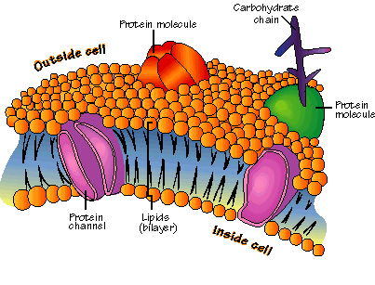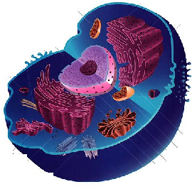 [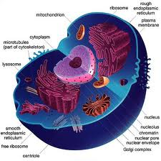](http://www.google.com.au/imgres?imgurl=http://www.animalport.com/img/Animal-Cell.jpg&imgrefurl=http://www.animalport.com/animal-cells.html&usg=__6c24oQmWVSr1DCR5-SvL0Em0HNs=&h=449&w=452&sz=58&hl=en&start=0&zoom=1&tbnid=NteguPUe1Te3RM:&tbnh=129&tbnw=130&ei=GdJUTe__HMikcZu56YsN&prev=/images?q=Cell&um=1&hl=en&biw=1259&bih=587&tbs=isch:1&um=1&itbs=1&iact=hc&vpx=539&vpy=97&dur=374&hovh=224&hovw=225&tx=129&ty=105&oei=GdJUTe__HMikcZu56YsN&page=1&ndsp=20&ved=1t:429,r:3,s:0)[](http://www.google.com.au/imgres?imgurl=http://www.animalport.com/img/Animal-Cell.jpg&imgrefurl=http://www.animalport.com/animal-cells.html&usg=__6c24oQmWVSr1DCR5-SvL0Em0HNs=&h=449&w=452&sz=58&hl=en&start=0&zoom=1&tbnid=NteguPUe1Te3RM:&tbnh=129&tbnw=130&ei=GdJUTe__HMikcZu56YsN&prev=/images?q=Cell&um=1&hl=en&biw=1259&bih=587&tbs=isch:1&um=1&itbs=1&iact=hc&vpx=539&vpy=97&dur=343&hovh=224&hovw=225&tx=106&ty=139&oei=GdJUTe__HMikcZu56YsN&page=1&ndsp=20&ved=1t:429,r:3,s:0)CELL TRANSPORT

_____________ Process

__________________________________

_____________________________

___

_____________ Process

__________________________

__________________________

Materials move in and out of the cell enclosed as vesicles.

A passive process the moves substances from high to low concentration. The substances are moved through the membrane by carrier proteins (by binding to the carrier, which changes shape, before being released on the other side.

The movement of WATER from an area of high water concentration to an area of low water concentration, through a semi-permeable membrane

The movement of substances from an area of high concentration to an area of low concentration.

The removal of a material in a vesicle through the cell membrane

The enclosing of a material by a fold of the cell membrane and the formation of a vesicle.

The engulfing of liquid particles

The engulfing of solid particles (eating)

The movement of substances from an area of low concentration to an area of high concentration by a carrier molecule across the membrane