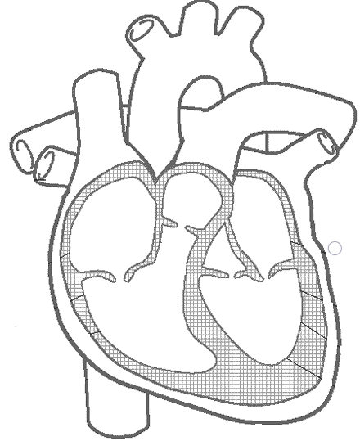

**Pulmonary vein**

**Pulmonary artery**

**Left atrium**

**Left ventricle**

**Aorta**

**Inferior vena cava**

**Right ventricle**

**Right atrium**

**Superior vena cava**