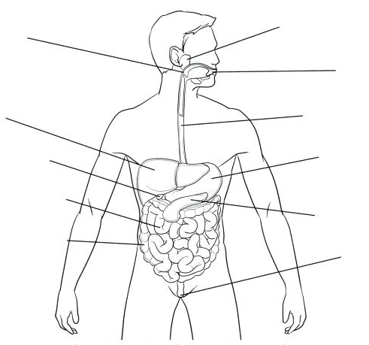

**Large Intestine (Colon)** – The shortest of the intestines. Food from the small intestine enters here.

The large intestine absorbs water and vitamins forming faeces. Contains bacteria for further digestion.

**Rectum and Anus** – Undigested material is eliminated from the body here.

**Small Intestine –** This is the longest of the intestines. Food from the stomach enters here. Sloshing of food occurs here - called segmentation. This is a mechanical process. Bile from the liver emulsifies fats here.

Enzymes from the pancreas as well as enzymes secreted by the walls of the intestine chemically break down carbohydrates, proteins and fats.

Nutrients are absorbed here into the bloodstream.

**Pancreas** – Food does not travel through the pancreas, but the pancreas produces enzymes which break down carbohydrates, proteins and fats when secreted into the small intestine.

**Gall Bladder** - Store bile from the liver before it is secreted into the small intestine.

**Liver –** Food does not travel through the liver, but the liver produces bile which is secreted into the small intestine so that it can mechanically break down fats (lipids). This process is called emulsification.

**Stomach –** The stomach mechanically churns food and chemically breaks down proteins using enzymes. The stomach is acidic - containing hydrochloric acid.

**Oesophagus –** Move food from the mouth into the stomach. Muscular movements called peristalsis move the food in the correct direction.

**Mouth –** Food is ingested here. Contains teeth and the tongue which are necessary for chewing and swallowing to occur. Food is broken down into smaller pieces mechanically and chemically.

**Epiglottis -**  A flap located at the back of the throat which closes the windpipe when swallowing. This ensures no food/water travels into your airways

**Salivary Glands** - Produce and secrete saliva which contains an enzyme for chemically digesting carbohydrates. Saliva helps to form the bolus which is easily swallowed.