A Closer Look at Tropical Rainforests
Name: ____________________________
Tropical Rainforest
http://wwf.panda.org/about_our_earth/deforestation/importance_forests/tropical_rainforest/
- How much of the Earth’s surface is covered by tropical rainforests?
________________________________________________________________________________________

Spatial distribution of tropical rainforests
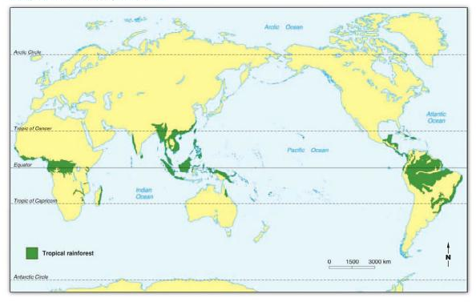

- Where are tropical rainforests located?
________________________________________________________________________________________________________________________________________________________________________________________________________________________________________________________________________

- How much rainfall do they receive a year?
________________________________________________________________________________________

- What is the temperature range of tropical rainforests?
________________________________________________________________________________________

- What percentage of species out of all the known living species in the world live in tropical rainforests?
________________________________________________________________________________________

- Tropical forests have the largest living biomass and boast some of the highest rates of terrestrial biodiversity. Provide a definition for what biomass is.
________________________________________________________________________________________

- How much tropical rainforest is destroyed each year? Why are people clearing rainforests?
________________________________________________________________________________________
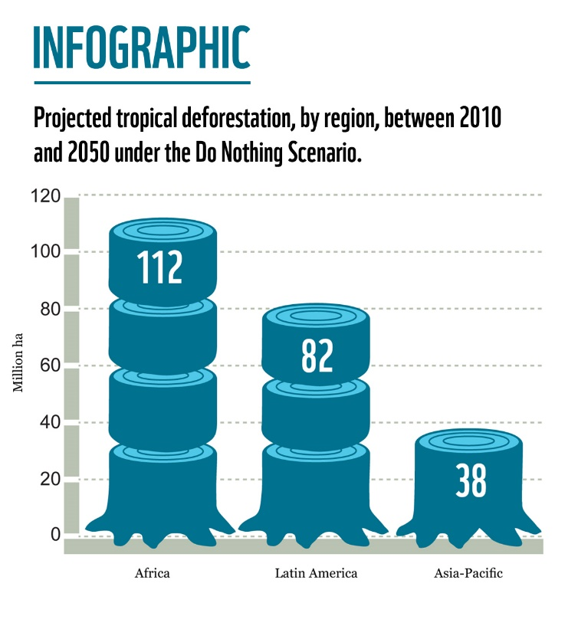
- For the following question in square kilometres. If humans don’t do anything about the current rate of deforestation, what is the projected amount of tropical rainforest loss by 2050 in …..
- Africa? _______________________
- Latin America? _______________________
- Asia Pacific? _______________________

The Amazon
http://www.worldwildlife.org/places/amazon
- Where is the Amazon?
________________________________________________________________________________________________________________________________________________________________________________

- How large is the Amazon Rainforest? Convert this to square km
________________________________________________________________________________________

- Why is the Amazon an important ecosystem?
________________________________________________________________________________________
________________________________________________________________________________________________________________________________________________________________________________
________________________________________________________________________________________

- How many different types of the following species can be found in tropical rainforests?
- Plant species ____________
- Freshwater fish species ____________
- Reptiles ____________
- How do local indigenous communities depend on the Amazon?
________________________________________________________________________________________
________________________________________________________________________________________

- What is the main reason the Amazon rainforest is being cleared?
________________________________________________________________________________________
________________________________________________________________________________________
________________________________________________________________________________________

- What is the impact of building hydroelectric dams within the Amazon Basin?
________________________________________________________________________________________
________________________________________________________________________________________
________________________________________________________________________________________

- How else are people having a negative impact on the Amazon rainforest
________________________________________________________________________________________
________________________________________________________________________________________
________________________________________________________________________________________

The Heart of Borneo: Asia’s last great rainforest
http://www.wwf.org.au/our_work/saving_the_natural_world/forests/forests_work/heart_of_borneo/threats/
- Describe the location of Borneo
________________________________________________________________________________________
________________________________________________________________________________________
________________________________________________________________________________________

- Summarise the threats to the existence of Borneo’s rainforests
