Year 10 Physical Science
Mid-Topic Test Revision Questions

- Classify the following units of measurement as scalars or vectors.
mass, force, velocity, distance, weight, displacement, time, acceleration, speed

Scalar | Vector

- Ella walked 105m west in 75 seconds to her nearest pokéstop where she stopped for 35 s to spin the stop and catch a squirtle. She then walked 650m east in 8.10 minutes to meet her friends for a 5-star raid battle at a pokégym.

  - Draw a distance time graph for this scenario on some graph paper.

  - What total distance did Ella walk?

  - What was Ella’s average speed?

  - Draw a vector diagram of this scenario

  - What was Ella’s final displacement?

  - Draw a displacement time graph for this scenario on some graph paper.

  - What was Ella’s average velocity when walking to the pokéstop?

  - What was Ella’s average velocity when walking to the pokégym?

  - Draw a velocity time graph for the scenario on some graph paper.

  - What was the Ella’s average velocity for the entire journey?

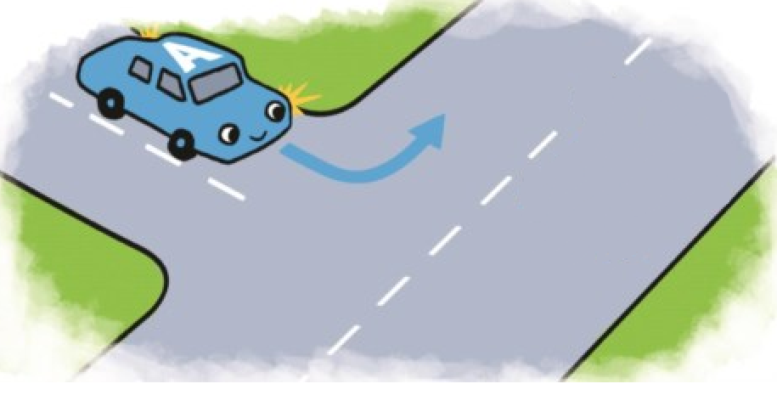
- A car driving at 25 kmh⁻¹ south rounds a corner and accelerates to 60 kmh⁻¹ east in 4.50 seconds.

  - Draw a vector diagram showing the change in velocity of the car.

  - Calculate the acceleration of the vehicle.

  - If the car had a mass of 1100 kg, what net force was required to achieve the acceleration?

  - What is the weight of the vehicle?

  - Explain, using physics principles, why the car would take longer to accelerate to the same velocity if it was fully loaded.

  - The car travelling at 60kmh⁻¹ now brakes suddenly. Explain, using physics principles, what happens to a box sitting on the back seat of the car.

  - If the car, travelling at 60kmh⁻¹, has a retardation of 9.68 ms⁻², how long does it take to come to rest?

- Sebastian is standing on the balcony of the maths building. James, standing directly below, threw a ball up to Sebastian with a velocity of 8.50 ms⁻¹. Sebastian catches the ball 0.75 seconds later. What is the velocity of the ball as Sebastian catches it?

- A 20 g bullet is shot out of a rifle barrel in 2.50 milliseconds. The force on the bullet is 3500 N.

  - What is the speed of the bullet as it leaves the gun barrel?

  - Explain, using Physics principles, why the gun pushes back into the shoulder of the person firing it when the bullet is fired.

