Year 10 Chemical Sciences

Week 5 - Solutions

Objectives:
- Define the terms, soluble, insoluble, solute, solvent and solution.
- Show an understanding of the dissolving process for a soluble ionic compound.
- Know that concentration of a solution can be expressed in mol L-1.
- Demonstrate an awareness of the independent nature of the ions in an ionic solution.
- Use a table of solubilities to predict the solubility of various ionic compounds.
- Use a table of solubilities to predict the formation of a precipitate when two ionic solutions are mixed.

Term | Definition
Soluble | Substance that CAN be dissolved
Insoluble | Substance that CANNOT be dissolved
Solute | The substance dissolved in the solvent
Solvent | The liquid that the solute will be dissolved into
Solution | The mixture of solute and solvent

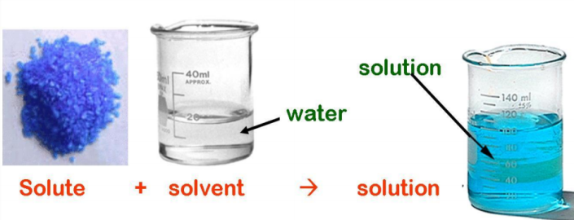
A soluble substance is a substance that dissolves, such as sodium chloride (table salt) in water whereas an insoluble substance is a substance that does not dissolve, such as chalk in water.

Solutions form when the particles of the solute enter the solvent. The solvent is the substance that can dissolve other substances, such as water. The solute is the substance that has been dissolved in the solvent, such as sodium chloride.
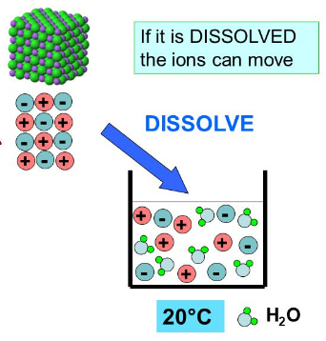
Solutions have uniform properties. They may be coloured but are always clear.
When an ionic solid dissolves it breaks down to its component ions. (dissociation) These move freely throughout the solution and are capable of conducting an electric current (See diagram on the left).

Precipitation reactions occur when multiple soluble reactants combine to form an insoluble product, known as the precipitate.

A precipitate can be identified by checking the solubility tables to see if any of the products being formed from the reactants are insoluble.
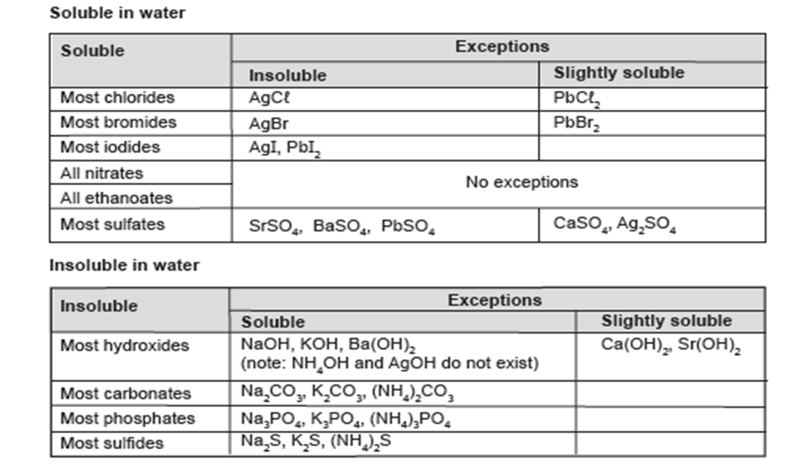

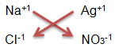
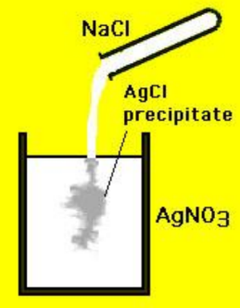
If we mixed two solutions: sodium chloride solution (NaCl) with silver nitrate solution (AgNO₃) we will produce a different combination of ions. The combination of Ag⁺¹ and Cl⁻¹ produces the precipitate, AgCl (silver chloride), seen in the diagram on the right as it is insoluble in water.

An ionic equation can be used to show this reaction. It only shows the species (molecules/ions/atoms) that undergo a change. In a precipitation reaction these are the ions forming the precipitate. They change from being free ions to ions locked into an ionic solid. Ionic equations are balanced! The other ions not included in the equation are known as spectator ions as they remain in solution.

Steps to writing an ionic equation:
- Identify the precipitate
- Write it as the product
- Write the ions that react to form it
- Check the equation balances

Therefore, the ionic equation for the above example is:

Ag⁺¹_{(aq)} + Cl⁻¹_{(aq)} → AgCl_{(s)}

- Use the solubility rules to determine if the following ionic solids are soluble or insoluble in water.

Ionic Solid | Soluble or Insoluble?
CuCO₃
Ca₃(PO₄)₂
K₂SO₄
MgCl₂
Ca(NO₃)₂
Fe(OH)₃
BaSO₄

- For the ionic solids that are soluble in water from question 1, write ionic equations to show the ions that would be produced (dissociation).

- Using a solubility table complete the following table. Write a balanced ionic equation leaving out the spectator ions. If there are no precipitates produced then write down no reaction.

AQUEOUS SOLUTIONS MIXED | BALANCED IONIC EQUATION | SPECTATOR IONS
Lead II nitrate and Potassium hydroxide
Copper II sulphate and aluminium chloride
 | 2Fe³⁺_{(aq)} + 3CO₃²⁻_{(aq)} Fe₂(CO₃)_{3 (s)} | SO₄²⁻ and K⁺
 | + Fe₃Sn_{2 (s)} | CH₃COO⁻ and SO₄²⁻
Barium hydroxide and magnesium iodide
Strontium II iodide and Barium hydroxide
 | + Ca₃(PO₄)₂ | OH⁻ and NH₄⁺

