HUMANITIES AND SOCIAL SCIENCES

FINANCIAL MANAGEMENT

SEMESTER 2 REVISION

1. Compare and contrast sole traders, partnerships and companies.

Structure | Definition | Advantages | Disadvantages
Sole Trader

Partnership

Company

2. Decide what form of business ownership is most appropriate for the following:
Scenario | Most Appropriate Ownership Structure | Reason
A family run fruit and veg shop.

A national hotel chain that would require $200 million dollars to establish

A suburban café

A law practice

3. Define entrepreneurship.

4. What are the four basic consumer rights?

5. What does the term caveat emptor mean? How is this relevant to consumers?

6. List the organisations that provide assistance to consumers.

7. What elements must be present for there to be a legally binding contract?

8. Classify the following as strengths, weaknesses, opportunities or threats of a business.

Statement | Element
Strong cash flow

Availability of new technology that reduces cost of production

Personal customer service

Lack of managerial talent

Operating inefficiencies

Strong brand recognition

Economic downturn

High staff turnover

Environmental regulations

Growing population

9. Explain the difference between a proportional, progressive and regressive tax.

Tax Classification | Definition | Example
Proportional

Progressive

Regressive

10. Define the different tax types.

Tax Type | Definition
Income

Goods and Services

Company

Fringe Benefits

Capital Gains

11. Which of the following amounts listed below would be included as assessable income?

Income | Assessable? Yes/No
Proceeds from the sale of stock
Cash prize on a game show
Proceeds from a garage sale
Profit made by a business
Commission a salesperson receives

12. Which of the following expenses listed below would you consider is an allowable deduction?

Expenses | Allowable? Yes/No
Donation of $1 to an approved charity
Dry cleaning of compulsory work uniform
Cost of protective overalls for a mechanic
Cost of taking a taxi to work because there is a bus strike
Amount paid to a tax agent for preparation of tax return

13. Fred is a 40-year-old who is single and employed as solicitor. During the 2015/16 financial year the following occurred:
- He earned a salary of $90,000
- Received rent of $10,000 from his investment property
- Made a net capital gain of $10,000
- Received dividend of $7,000
- Received $10,000 of income from a family trust he is a beneficiary of
- Attended a law seminar costing $800
- Repaired the fence at his investment property costing $6,000
- Pay AS You Go Withholding of $21,000

Using the table provided complete Fred’s tax return.

 |  | $
 | Gross Income
Less: | Exempt Income
= | Assessable Income
Less: | Allowable Deductions
= | Taxable Income
X | Tax Rate
= | Gross Tax Payable
Less: | PAYG Withholding
= | NET TAX PAYABLE / (REFUNDABLE)

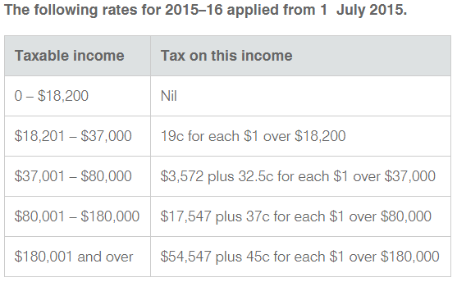

Financial Management
Semester 2
Mindmap

