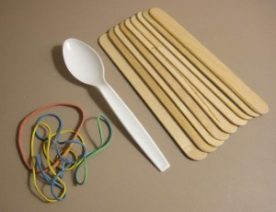
Materials – per catapult
- 9 Popsicle
- 4-6 rubber bands
- 1 plastic spoon

Instructions
Step 1 – Take 7 of the craft sticks and tie a rubber band tightly around one end.
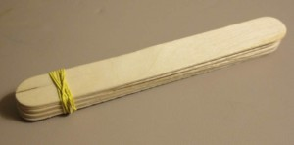
Step 2 – Tie another rubber band tightly around the opposite end so all 7 sticks are bound together.
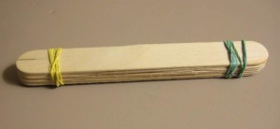
Step 3 – Take the remaining 2 sticks and tie a rubber band on one of the ends. Try to tie the band close to the edge of the sticks.
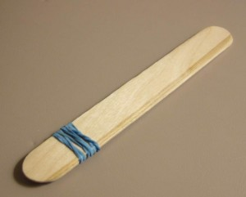
Step 4 – Insert the 7 sticks banded together through the 2 stick bundle as shown in the illustration below.
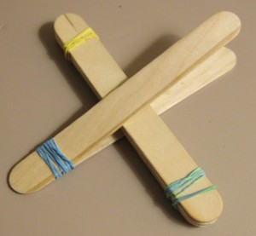
Step 5 – Tie a rubber band in a cross fashion joining the two pieces. The closer the 7 stick bundle gets to the edge, the more leverage the catapult will have.
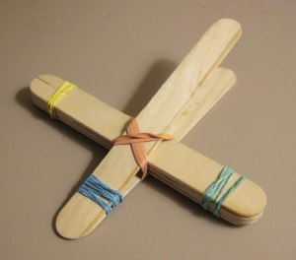
Step 6 – Use a few rubber bands and attach the plastic spoon on the end.
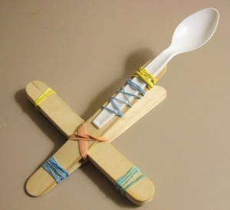
If these instructions helped you in anyway, please leave me a comment or link to this page so others can find these instructions as well.

