Year 10 Chemical Science End of Topic Practice Test

Name: ____________________________ Mark: ________/50 _______%

Time allowed: 50 minutes

Multiple Choice – 10 marks

- In one mole of ammonia, NH₃, there are about:

  - 6 x 10²³ atoms
  - 4 atoms
  - 1.8 x 10²⁴ atoms
  - 2.4 x 10²⁴ atoms

- The molar mass of oxalic acid, H₂C₂O₄. 2H₂O is:

  - 110 gmol⁻¹
  - 126 gmol⁻¹
  - 90 gmol⁻¹
  - 78 gmol⁻¹

- If 5.0 mol of NH₃ and 10.0 mol of O₂ react until one of the reagents is completely used up, how many moles of nitrogen dioxide would be produced? (Assume no change in reaction conditions)
4NH₃ + 7O₂ → 4NO₂ + 6H₂O

  - 4.0 mol
  - 5.0 mol
  - 5.7 mol
  - 10.0 mol

- Which of the following equations is NOT balanced?

  - 2H₂S + 3O₂ 2H₂O + 2SO₂
  - 2C₂H₆ + 7O₂ 4CO₂ + 6H₂O
  - HCl + NaOH H₂O + NaCl
  - 3NO + 2O₂ 3NO₂

- The reaction of sodium sulfite with hydrogen chloride may be represented by the following equation
Na₂SO₃ _{(aq)} + 2HCl _{(aq)} → 2NaCl _{(aq)} + H₂O _{(aq)} + SO₂ _{(g)}

On the basis of the information that is provided in the equation, which of the following
statements is correct?

- When one mole of is treated with acid one mole of sulfur monoxide will always be produced
- and must always be present in the mole ratio 1:2 for a reaction to take place
- The ratio by mass of to in a reaction mixture of stoichiometric proportions is 1:2
- 0.4 moles of water will be produced when 0.8 moles of reacts completely with excess

- Which one of the following does not change during any chemical reaction?

- total number of molecules in the system
- total volume of the system
- total mass of the system
- temperature of the system

- 160 g of calcium contains as many atoms as

  - 28 g of carbon
  - 92 g of sodium
  - 160 g of silver
  - 256 g of sulfur

- Which of the following contains the greatest number of atoms?

- 12 g of water
- 17 g of ammonia
- 2 mol of nitrogen molecules
- 6 x 10²³ oxygen molecules

- Consider the reaction between magnesium metal and dilute hydrochloric acid:

Mg(s) + 2HCl(aq) MgCl₂(aq) + H₂(g)

A student wants to see what effect temperature has on the rate of this reaction. She performs this experiment at two different temperatures and measures the volume of hydrogen gas produced over time.

Using your knowledge of reaction rates, which graph best represents the expected results of this experiment?
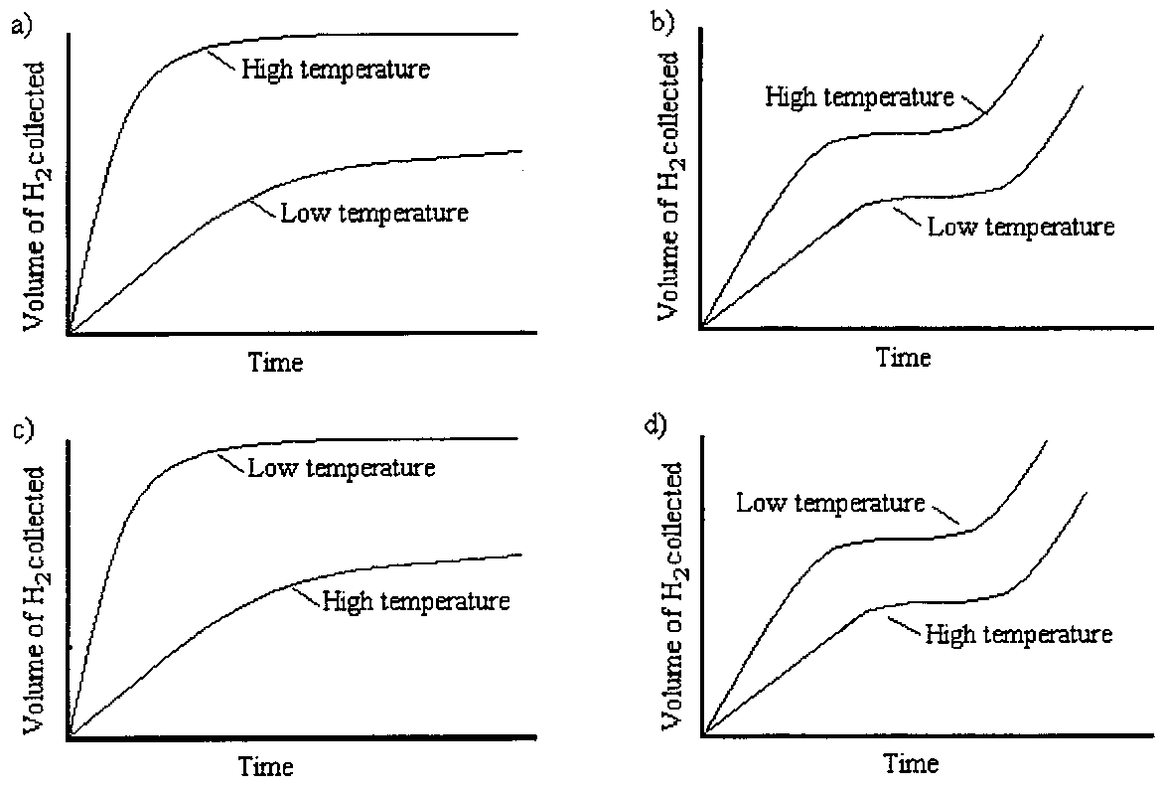

- Consider the reaction between marble chips (calcium carbonate) and dilute hydrochloric acid:

CaCO₃(s) + 2H⁺(aq) Ca²⁺(aq) + CO₂(g) + H₂O(l)

Which one of the following would increase the rate at which the marble chips react?

  - Decreasing the concentration of the hydrochloric acid.
  - Adding more water to the solution.
  - Crushing the marble chips into powder form.
  - Decreasing the temperature of the acid solution added.

Short Answer – 33 marks

- For each of the following substances, determine whether it is soluble or insoluble, and assign a state (or subscript?) to each.
(3 marks)
  - KCl

  - PbSO₄

  - Al(OH)₃

- Use the solubility table to write an IONIC equation if a chemical reaction takes place when the following solutions are combined. If no precipitate forms write NR (No reaction).
(5 marks)
  - barium nitrate + potassium chloride

  - ammonium sulfide + aluminium nitrate

  - sodium hydroxide + magnesium iodide

- Name a pair of substances that could be used to produce the following salts
(2 marks)
  - Iron (II) sulfate

  - Barium ethanoate

- Write balanced chemical equations for each of the following reactions
(10 marks)

- Phosphoric acid is added to sodium carbonate.

________________________________________________________________

- Hydrochloric acid and calcium carbonate

_______________________________________________________________

- The action of heat on barium hydrogen carbonate.

________________________________________________________________

- A neutralisation equation which results in aluminium chloride being produced.

__________________________________________________________________

- An acid is added to a substance. Two products of this reaction are hydrogen gas and magnesium sulphate.

__________________________________________________________________

- To make some carbon dioxide a chemist put some large pieces of marble in a 0.10 M solution of hydrochloric acid. The rate of production of carbon dioxide was too slow.

List 4 ways in which the chemist could alter the conditions so that the carbon dioxide is produced more rapidly. Explain how each way would speed up the production of carbon dioxide.
(8 marks)

Method_____________________________________________________________

Explanation__________________________________________________________

___________________________________________________________________

___________________________________________________________________

___________________________________________________________________

Method_____________________________________________________________

Explanation__________________________________________________________

___________________________________________________________________

___________________________________________________________________

___________________________________________________________________

Method_____________________________________________________________

Explanation__________________________________________________________

___________________________________________________________________

___________________________________________________________________

___________________________________________________________________

Method_____________________________________________________________

Explanation__________________________________________________________

___________________________________________________________________

___________________________________________________________________

___________________________________________________________________

- A group of students decided to conduct an investigation into reaction rate. The reaction between sodium thiosulfate solution and hydrochloric acid produces tiny particles of sulphur which are suspended in water. When the amount of S becomes too high, the solution becomes opaque.

Na₂S₂O₃(aq) + 2HCl(aq) → S(s) + SO₂(g) + H₂O(l) + 2NaCl(aq)

An ionic equation better shows the chemistry involved.

S₂O₃⁻²(aq) + 2H⁺(aq) → S(s) + SO₂(g) + H₂O(l)

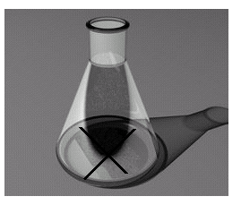
The time it takes to hide a black cross marked on a piece of paper under the flask is used as a measure of reaction rate. The less time taken for the cross to disappear the faster the reaction rate.

The students used 0.250 mole L⁻¹ Na₂S₂O₃ solution, 2.0 mole L⁻¹ HCl and some distilled water.

The total volume of Na₂S₂O₃ solution, distilled water and HCl in each conical flask was kept at 50.0mL. The students always added 5.0 mL of the HCl to each flask and the remaining 45.0mL volume was a combination of set amounts of Na₂S₂O₃ solution and distilled water.

- What was the dependent and independent variable in this investigation?
(2 marks)

Dependent _________________________________________________________

Independent ________________________________________________________

- What was a variable that the students controlled?
(1 mark)

Controlled__________________________________________________________

- What is a hypothesis the students could have been testing in this investigation?
(2 marks)

___________________________________________________________________

___________________________________________________________________

___________________________________________________________________

Calculations – 7 marks

- Calculate the number of moles in the following:
(2 marks)
  - 364 grams of KOH

  - 9.03 x 10²⁴ atoms of aluminium

- Calculate the number of moles of sulfur in 260 g of Fe₂S₃
(3 marks)

- What is the mass of 4.36 moles of magnesium bromide?
(2 marks)

END OF TEST

