Student worksheet answers

7.4 An object in motion remains in motion until a force acts on it
Pages 162–163

Newton’s first law: Inertia
1 Which of the two shopping trolleys shown in the diagram below has the greatest inertia? Explain your answer.
The shopping trolley full of groceries has a greater inertia than the empty trolley because the full trolley has a greater mass.
2 The diagram below shows a stack of five coloured circular disks made of smooth, polished wood. Describe the motion of the coloured disks when the plunger is hit quickly and firmly by the hand.
Due to the law of inertia, objects at rest will stay at rest until acted upon by an unbalanced force. In this instance, the plunger will provide an unbalanced force on the red disk pushing it to the right. The other disks will sit on top of the plunger without having moved forward.
3 The photograph below shows a 4.0-kilogram penguin sliding across a large, flat icy surface with a constant velocity of 2.0 m s^{–1}. Assuming that the surface is frictionless, what size force is required to keep the penguin travelling at this speed?
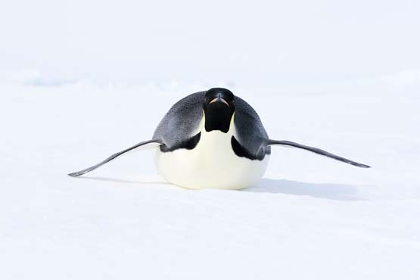
Given that there is no friction acting against the penguin’s motion, there is no need for any additional force to be applied to the penguin to keep it moving. It will continue to move across the ice in the same direction at 2.0 m s^{–1}.
This is because of the law of inertia, which states that an object will travel with a constant velocity (speed and direction) until it is acted upon by unbalanced force.4 In the diagram below, will the cyclist be travelling in a state of constant motion? Explain your answer.
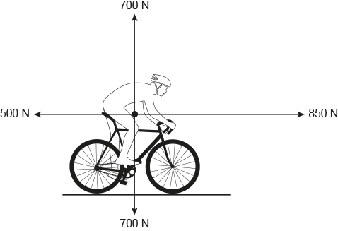
The cyclist in the diagram is not in a state of constant motion. This is because the forces acting on him are unbalanced. Horizontally the net force acting on the cyclist is 850 N – 500 N = 350 N to the right. So the cyclist will accelerate (increase velocity) in this direction.

Extend your understanding
5 Use your understanding of Newton’s law of inertia to explain how the cyclist got to the position he is in in the following photograph.
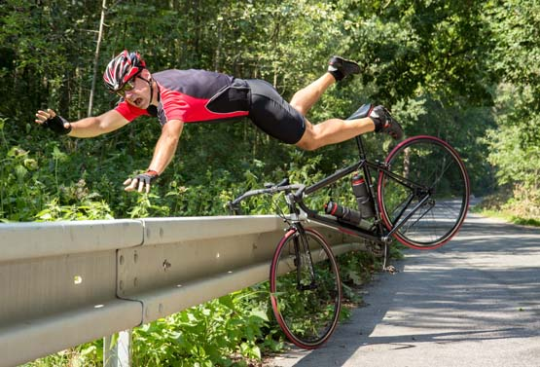
In the situation shown, the bike and its rider have collided with the safety barrier. The safety barrier has stopped the bicycle. However, it did not stop the cyclist and, due to his inertia, he has continued to travel forward beyond his bike and over the safety barrier.
6 Michaela took a ride on an amusement park ride called the ‘Space Shot’. At ground level at the start of the ride, Michaela said that she felt like she was being pushed very hard downwards into her seat – but that this confused her as she knew that she was moving upwards very quickly. Explain the physics of what Michaela experienced at the start of the ride.
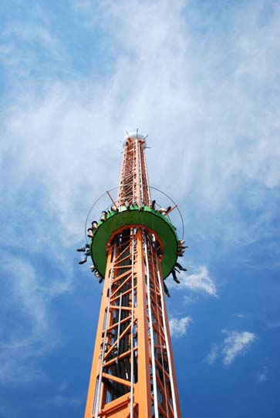
Initially, Michaela was at rest on the seat. Due to her inertia, her body ‘wants’ to remain at rest. When the ride starts and the seats accelerate upwards, Michaela’s seat pushes and accelerates her upwards. According to Newton’s third law, Michaela will push back her seat with the same amount of force that it is pushing her with – this is what is causing Michaela to feel as if she is being pushed very hard back into her seat.

